**Review Information for Unit 2 test (Chapter 2.3-2.4)**

**Cell functions involve specific chemical reactions**

Single celled organisms, like protists, need to perform all the necessary life functions that a larger organism must perform. (ex. digest food, remove waste, communicate, movement, etc.) We learned this when we discussed the Cell Theory (Cells are the basic unit if structure and function.).

Cell functions involve specific chemical reactions. A chemical is reaction is when chemical bonds are created or broken.

When atoms have bonded together and they all have 8 electrons in their outer shell, the molecule is very stable. It can exist on the surface of the Earth without changing, like salt or water.

There are three basic types of chemical bonds.

* A covalent bond is formed between atoms when one or more electrons are shared between the atoms. Ex. Water H2O
* An ionic bond is formed when electrons are given from one atom to another atom. Ex. Table salt NaCl
* A hydrogen bond is a weak bond formed between water molecules.

When atoms “bond” they are physically held together by the attraction of their opposite charges, similar to a magnet. When these bonds are formed, a certain amount of energy is stored in the bond. This energy can be released and used for other purposes if the bond is broken.

The process of making and breaking chemical bonds are called chemical reactions. A cell must perform numerous chemical reactions to maintain life.

The chemical reactions necessary for life often center around four molecules called carbon compounds (aka: biomolecules or organic molecules)

Notice that each of the four biomolecules is built around a chain (or skeleton) of carbon atoms. This is why scientists call life on Earth “carbon-based life forms”.

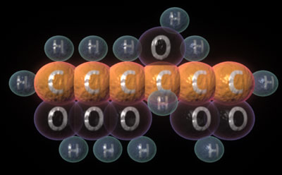 **Carbohydrate**

Carbohydrates (starches) are made of chains of monosaccharides. A monosaccharide is a small sugar. Contain Carbon, Hydrogen (C,H,O), Oxygen, 1:2:1 ratio.

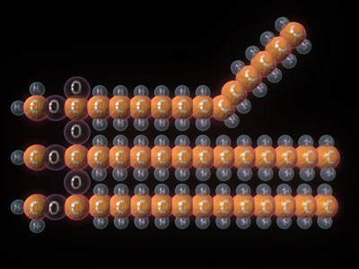 **Lipid**

Lipids (fats) are made of long chains of fatty acids and glycerol, except steriods which are made of carbon rings. Contain Carbon, Hydrogen, Oxygen (C,H,O), (low oxygen compared to carbon & hydrogen).

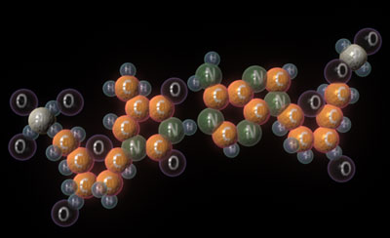 **Nucleic Acid**

Nucleic Acids (DNA or RNA) are made of long chains of nucleotides. (C, H, O, N, P)

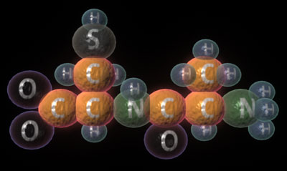 **Protein**

Proteins are made of long chains of amino acids. Protein have up to 4 levels of structure and have 20 R groups attached to the 6 o’clock position of the amino acid. R groups are organized into several “cliques”; hydrophobic, hydrophilic (acid and bases). (C,H,O,N,S)

Each biomolecule has a specific function in the cell.

* Proteins are for building and doing things
* Lipids are for membranes
* Carbohydrates are fuel
* Nucleic acids are the instructions that make all the activities possible.

**Food molecules taken into cells provide the chemicals needed to synthesize other molecules.**

We must eat the four main biomolecules to survive. Our bodies breakdown these molecules and use the atoms to build other molecules that we need. We also use the energy stored in their chemical bonds to power own chemical reactions.

Most important lipid:

The phospholipids that make up a cell membrane have a unique structure that both attracts and repels polar molecules. Notice that the image below has phospholipids made of black phosphate heads and orange fatty acid tails.

A polar molecule has a positive end and a negative end. (Similar to a battery or magnet) Push two magnets together and the opposite sides will attract each other, but the same sides will repel each other. Phospholipids work in a similar way because the phosphate heads will attract other polar molecules., but the fatty acid tails will repel polar molecules and tend to clump-up together.

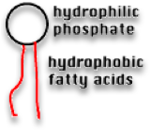Each phospholipid has a polar phosphate head that attracts water and other polar molecules. (Hydrophilic means, “water loving”) Attached to each phosphate head are two nonpolar fatty acid tails that repel water and other polar molecules. (Hydrophobic means, “water repelling”.) These molecules will naturally orient themselves in a watery environment in groups so that the tails are toward the center and the heads are on the outside. These molecules can be found naturally in the environment.

Water is a great example of a polar molecule. The end of the water molecule with the oxygen tends to be more negatively charged then the end with the hydrogen atoms. This happens because oxygen has possession of hydrogen’s electron more often within the molecule.

**Enzymes function in a cell. (chapter 2.4)**

Enzymes catalyze (speed up) both the breakdown and synthesis in the cell.

What is an enzyme?

* Most enzymes are proteins (long chains of amino acids).

Enzymes are substances that speed up chemical reactions, reduce the amount of energy needed to start a chemical reaction, and control the release of energy from those reactions. In order to live, we need chemical reactions to happen very fast and continuously in our bodies.

* Example, CO2 in the blood will slowly react with H2O to form H2CO3 (carbonic acid). Around 2000 molecules per day will form naturally. This is too slow to maintain life. Carbonic anhydrase (enzyme) in the blood will increase the speed of this reaction to 600,000 molecules per second.
* Fresh pineapple contains the enzyme, bromelin. If fresh pineapple is added to Jell-O it will dissolve the Jell-O.

How do enzymes work?

Because enzymes are proteins they each have a very specific shape. Each enzyme will work with only one specific type of substance.

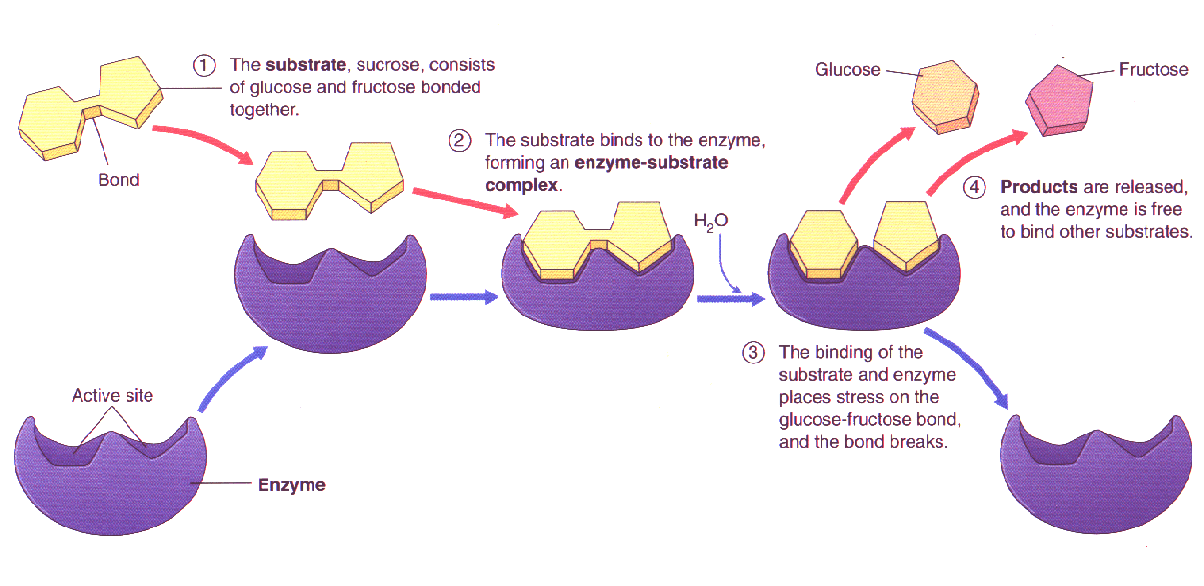

Enzymes work to catalyze or speed up chemical reactions. They also reduce the activation energy. (Amount of energy needed to start the reaction.)

Activation energy is the amount of energy needed to start a chemical reaction.

Example: Adding heat to make popcorn pop, or striking a match.

More energy is needed to start a chemical reaction if enzymes are not present.

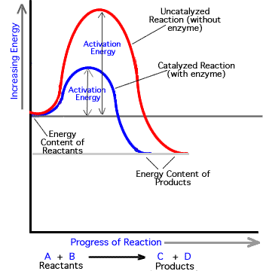

Enzymes (biological catalysts) lower the activation necessary to start a reaction in an organism to safe temperatures. There are two types of reactions endergonic (energy absorbing- products have more potential energy than reactants) and exergonic (energy releasing (products have less potential energy than reactants).

Temperature, pH, and salinity can affect the efficiency (ability to do work) of an enzyme. Concentration of substrate can also affect the rate of reaction of an enzyme.

The DNA contains the instructions for making and using each of these molecules. When a particular molecule is needed, that part of the DNA is accessed. Only parts of the DNA instructions will be used at any given time. Large sections of DNA are used only occasionally or even never.

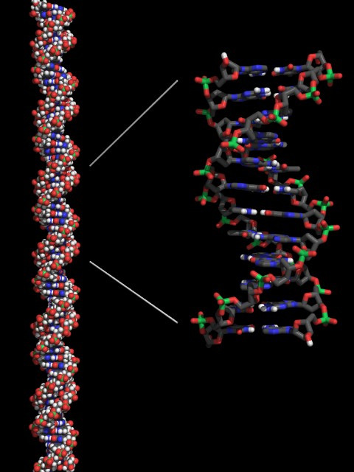

Every cell in your body contains the exact same information in its DNA. When cells divide each new cell must also have a complete set of the DNA. This process of DNA replication and cell division is called the cell life cycle.

Why do cells divide?

1. To allow the organism to grow larger.
2. To repair damaged or worn-out cells.
3. To reproduce.