The Story of Dinosaur Evolution:

(adapted from <http://sciencecases.lib.buffalo.edu/cs/collection/detail.asp?case_id=439&id=439> )

Case Objective:

• Distinguish between ornithischians, sauropodomorphs, and theropods on the basis of physical characteristics.

• Trace the ancestry of individual dinosaur species from the common ancestor.

• Interpret a complex evolutionary tree which includes extinctions, speciation events, and changes in the number of taxa over time.

• Write a short story of “The Story of Dinosaur Evolution.”

Directions:

1. Break up into groups of 3-4 students such that each group “becomes” one of the three dinosaur groups.

2. As a class, become familiar with the names of 3 groups of dinosaurs: ornithischians (“bird-hipped croppers”), sauropodomorphs (“long-necked titans”), and theropods (“bipedal predators”).

3. Receive Handout I, which is copy of Figure 3 from the research article by Sereno (1999).

4. As a class, address the question “Which dinosaur is yours?” by visually identifying each as either an ornithischian, a sauropodomorph, or a theropod.

5. In groups, create a list of “Distinguishing Characteristics” for a group of dinosaurs based on the figure in Handout I (all student groups make a list for your specific dinosaur group). The figure legend uses highly technical language, so use the “Anatomical Dictionary” provided and also focus attention on the pictures. (you have 4 minutes)

6. As a class, briefly share work from step 5 (4 minutes)

7. Receive Handout II, which is a copy of Figure 1 from the article by Sereno (1999). Using the figure in Handout II, create a list of “Evolutionary Events” that took place during the evolution of a group of dinosaurs (all student groups make a list for their specific dinosaur group). In other words, “What has happened to your group of dinosaurs over time?” (5 minutes)

8. As a class, briefly share work from step 7.

9. Write a story* about the evolution of your group of dinosaurs based on the following criteria: (you have 10 minutes)

• Pretend that you are a particular dinosaur describing your family history.

• Tell your “evolution story” from the common ancestor of all dinosaurs all the way

to your extinction.

• Include dates (“million years ago”).

• Include the word ornithischian, sauropodomorph, or theropod.

• Include at least 3 characteristics of your dinosaur (from Figure 3 provided in Handout I).

• You may choose to tell the story of your entire group (of dinosaurs) or an individual family (i.e., Ornithurae) within your group.

10. As a class, address the question, “What are the commonalities of all stories of evolution?”

11. Post your story on the class blog <http://grochaccbiology.blogspot.com/> leave at least 2 comments on other group stories. Read stories aloud for open critique and comment by the class.

*Links to elements of a good “short” story:

<http://users.aber.ac.uk/jpm/ellsa/ellsa_elements.html>

<http://www.aaronshep.com/youngauthor/elements.html>

<https://www.msu.edu/course/tc/842/SevenElements%20Story.htm>

<http://www.copyblogger.com/cinderella-content-marketing/>

<https://www.skotos.net/articles/GoodStorytelling.html>

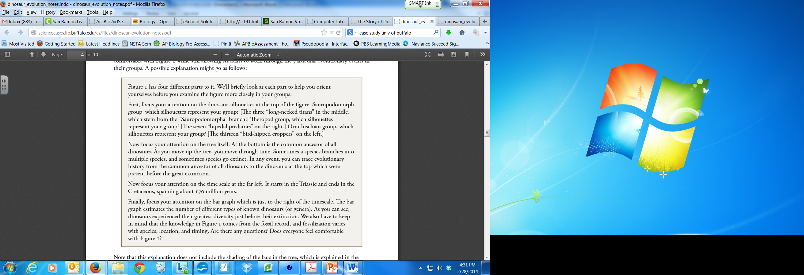

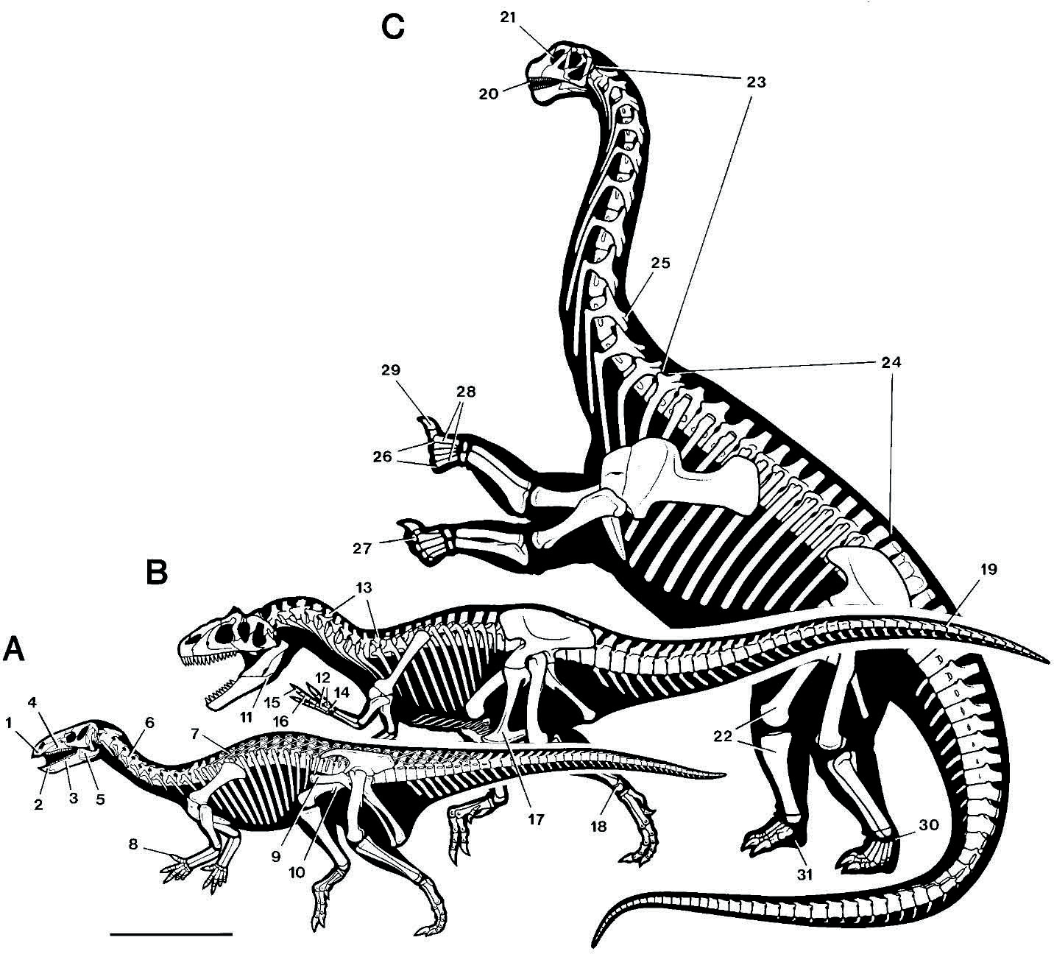

**Fig.3.** Skeletal innovation in the three major clades of dinosaurs (Ornithischia, Th eropoda, and Sauropodomorpha) as shown by contemporaneous species from the Upper Jurassic (Kimmeridgian) Morrison Formation of North America. Labeled features evolved at various nodes as described in thetext. Scalebar, 1m.

(**A**) *Camptosaurus dispar*, an ornithischian.

(**B**) *Allosaurus fragilis*, a theropod.

(**C**) *Camarasaurus lentus*, a sauropodomorph

Skeletal innovations are as follows:

1. horny beak for cropping;

2. predentary bone for lower bill support;

3. cheek depression for oral processing of plant matter;

4. leaf-shaped crowns with wear facets and a symmetrical enamel for shearing plant matter;

5. coronoid process for attachment of robust jaw-closing muscles;

6. opisthocoelous cervicals with reduced neural spines for fl exibility;

7. ossifi ed tendons to stiff en trunk;

8. rigid digit I with subconical ungual for defense;

9. pubis with pre-pubic process and postero-ventrally directed post-pubic process opening posterior

trunk;

10. pendant fourth trochanter for enhanced caudal hindlimb retractors;

11. intramandibular joint for flexible bite;

12. metacarpal extensor depressions for manual raking;

13. hollow skeleton to reduce bone weight;

14. semilunate carpal simplifying wrist action to maneuver large hands;

15. manual digit II longest, emphasizing inner digits;

16. long penultimate phalanges enhancing grasping capability;

17. pubic foot for body support at rest;

18. astragalar ascending process uniting tibia and tarsus;

19. elongate prezygapophyses unite distal tail forming a dynamic stabilizer;

20. crowns with regular V-shaped wear facets indicate precise occlusion for slicing vegetation;

21. nares enlarged and retracted;

22. columnar limb posture for weight support at large body size;

23. 12 or more opisthocoelous cervical vertebrae composing a longer neck;

24. 11 or fewer dorsal vertebrae shortening the trunk;

25. bifurcate neural spines accommodating a robust median elastic ligament;

26. arched ligament-bound metacarpus for digitigrade manual posture;

27. manual/pedal phalanges reduced in number for a more fleshy foot pad;

28. manual digits I and V weight-bearing to broaden support;

29. manual digit I ungual enlarged possibly for intraspecific rivalry;

30. distal tarsals unossifed increasing shock-absorbing cartilage in joints;

31. elephantine pes for weight support at large body size.

**Credit:** Reprinted with permission from “Th e Evolution of Dinosaurs” by Paul Sereno, *Science* 284, 25 JUNE

1999, 2137–2147. Copyright 1999 aaas. Readers may view, browse, and/or download the material on this page for temporary copying purposes only, provided these uses are for noncommercial personal purposes. Except as provided by law, this material may not be further reproduced, distributed, transmitted, modified, adapted, performed, displayed, published, or sold in whole or in part, without prior written permission from

the publisher (http://www.sciencemag.org).

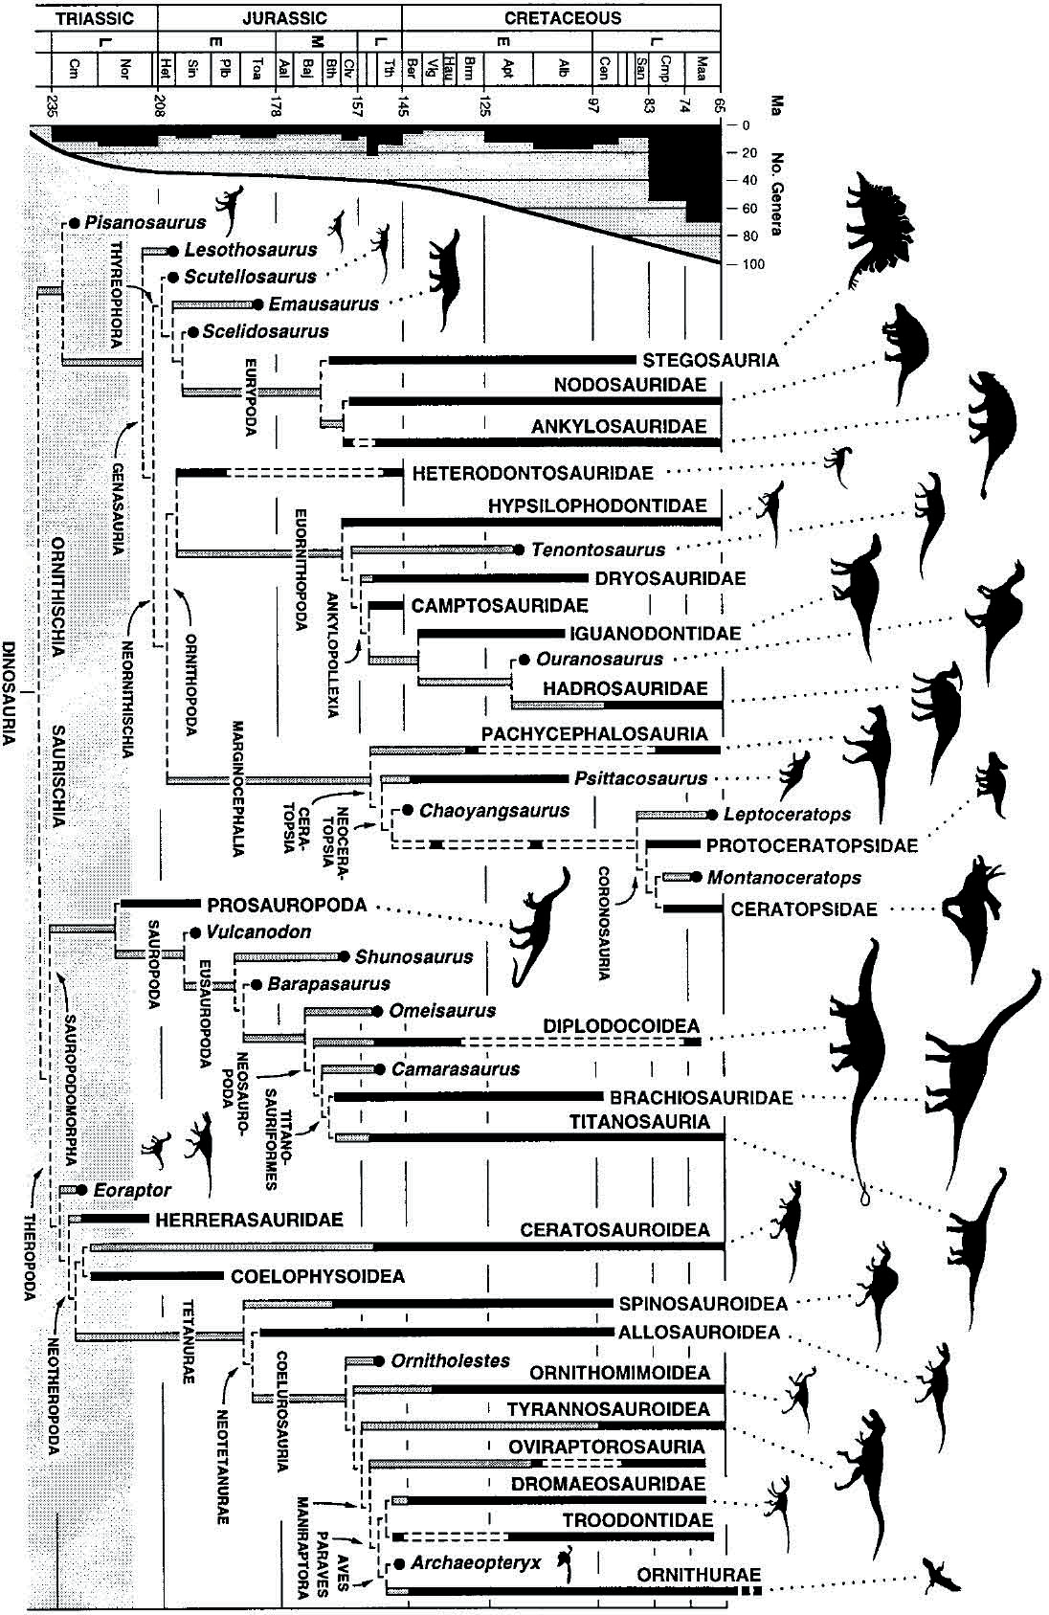

**Fig. 1.** Temporally calibrated phylogeny of Dinosauria, showing known temporal durations (solid bars), missing ranges (shaded bars), and ranges extended by fragmentary or undescribed specimens (dashed bars). At left is tabulated the number of recorded nonavian dinosaurian genera per stage and an estimated curve of generic diversity, taking into account available out crop area (87). Basal or primitive taxa, in general, appear earlier in time than more derived members of a clade. Long missing ranges result from preservational bias against small body size (less than 2 m), which truncates the early record of many clades, and from intervals for which there is little corresponding exposed terrestrial rock (such as the Middle Jurassic). The shaded zone (bottom) indicates the initial stage of the dinosaurian radiation before their dominance of land faunas in taxonomic diversity and abundance.

Helpful links:

* http://skeletaldrawing.com/psgallery/gallery.htm
* http://www.skeletaldrawing.com/shdguide/shdgmain.htm
* http://www.enchantedlearning.com/subjects/dinosaurs/anatomy/
* http://planetdi.startlogic.com/dinosaur_anatomy.htm