Chemical Reactions and Energy

The following is a tutorial on the relationship between chemical reactions and energy. This is really important stuff! You must do each question for the next one to make sense. The questions build on each other and require you to apply each one to the next. You may use resources (textbook and internet), but the majority of the questions require to THINK and apply the information given and what you already know in order to answer them.

1. State the first law of thermodynamics.

2. What is chemical energy? Explain where the energy is in a molecule. How could energy be added to a molecule? How could energy be released from a molecule?

3. The first law of thermodynamics applies to all energy transformations including chemical reactions. This means that a chemical reaction can release or absorb energy, but it can never create or destroy energy. What would happen if a chemical reaction released energy? How might you be able to tell that a chemical reaction released energy?

4. Why does a chemical bond form? Explain in terms of stability of atoms.

5. You can think of a chemical bond sort of like two magnets sticking together. The positive pole of one magnet is attracted to the negative pole of the other. If you move them next to each other they will naturally stick together (it won’t require any energy to get them to do so). Once the magnets are joined it would require energy (the ability to do work = a force applied over a distance) to separate them.

Using the above analogy:
a. Does making chemical bonds release or require energy? Why? Relate this to stability of the
atoms (question #1).

b. Does breaking chemical bonds release or require energy? Why? Relate this to the stability of
the atoms (question #1).
6. A chemical reaction always involves both breaking bonds (of the reactants) and making bonds (of the products). Therefore a chemical reaction may absorb energy overall or release energy overall (compare how much energy is required to break reactants to how much energy is released when products form).

Endo = within Exo = outside Ergonic (from the Greek ergon) = work

Write a definition for the following types of reactions:
- Endergonic

- Exergonic

7. Which type of reaction would involve stronger (more stable) bonds in the products than in the reactants? Which would involve stronger (more stable) bonds in the reactants than in the products?

8. The following are energy diagrams for endergonic and exergonic reactions. Next to each diagram write out in words what the graph is telling you.
Endergonic
Exergonic

↑
Energy

↑
Energy

Reaction time
Reaction time

9. Energy is a driving force of chemical reactions. Look at the diagrams above. Which type of reaction do you think tends to occur on its own (spontaneous) and which type tends to not occur on its own? Explain your answer. Hint: think of the graph like a hill and the chemical reaction as a ball that rolls up or down the hill.

10. The second driving force of chemical reactions is entropy. Define entropy.

11. State the second law of thermodynamics.

12. Explain how each of the following is an example of increasing entropy:

a. Liquid water being heated until it all evaporates as a gas

b. Sugar being broken down in cells to release energy to do work (cellular respiration). Hint: The
overall chemical equation for this is C₆H₁₂O₆ + 6O₂ → 6CO₂ + 6H₂O

c. A log being burned
13. Give two examples of chemical reactions or processes that living organisms undergo that decreases the entropy of their cells or bodies.

14. The natural direction of change is always toward more entropy. How is it then that organisms are able to become more organized? Are they defying the laws of the universe? Explain your answer.

Now let’s put it all together… Gibbs Free Energy

15. Free energy is the energy of a system that is available to do work. Gibbs free energy (ΔG) is a measure of the useful energy of a system. Calculating Gibbs free energy requires both the change in heat energy (ΔH) and the change in entropy (ΔS) of the system.
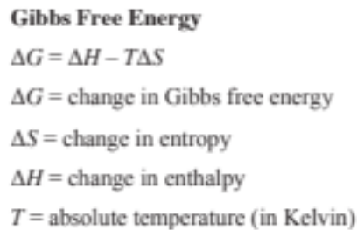

Determine whether each of the following reactions will be spontaneous or nonspontaneous:

ΔG < 0

ΔG = 0

ΔG > 0

16. Energy coupling links reactions.
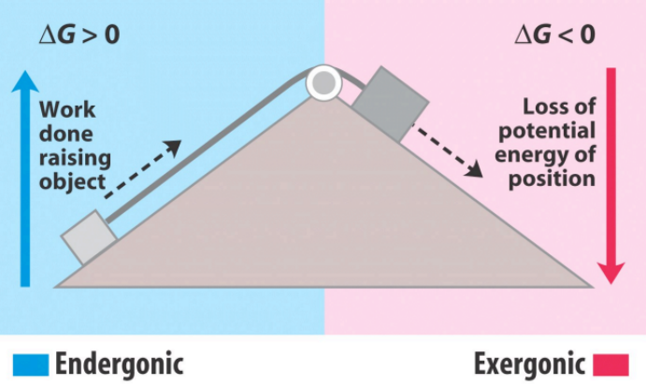

How could a spontaneous reaction be used to drive a nonspontaneous reaction?

