Making a Bar Graph using Excel 2007
- Organize your data in Excel.

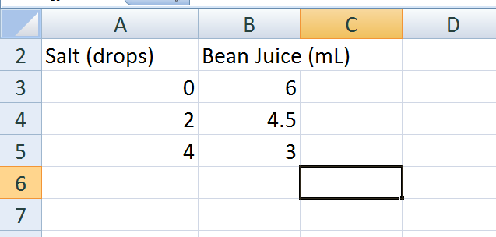
- Highlight data, go to Insert, select Column data
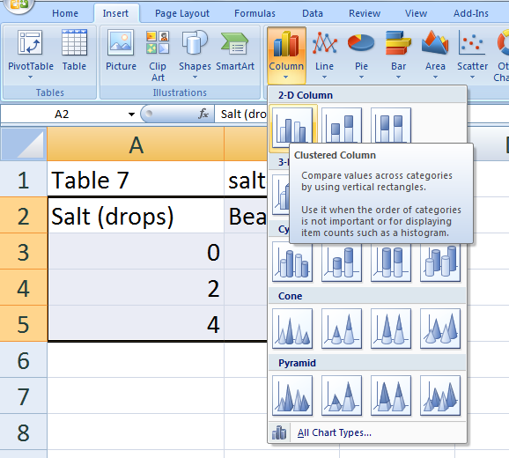
- Select the Layout Options that gives you a title and axes (Layout 6 or 9)

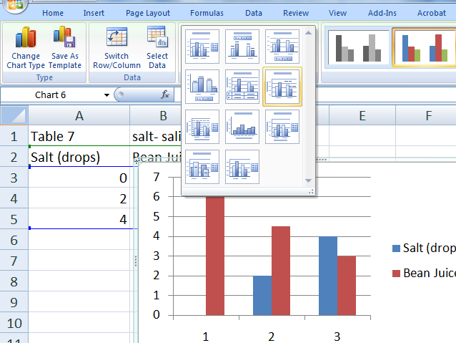

- Should look like this now:
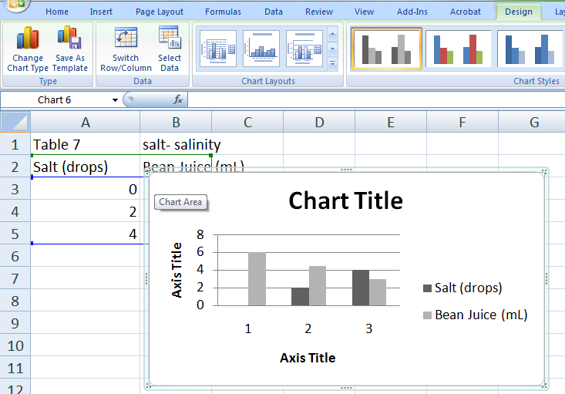
- Right click on the body of the graph and select “select data” from the pop up window

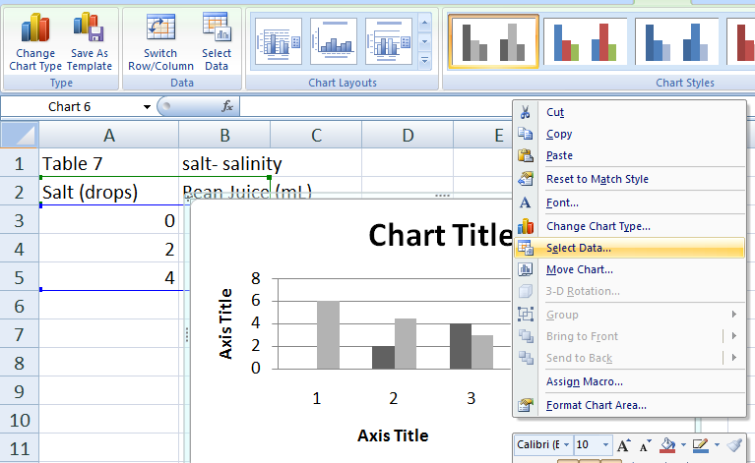
- Click on the x axis information (salt drops in this example), then click remove. Then click on Edit of the Horizontal (Category) Axis Labels….
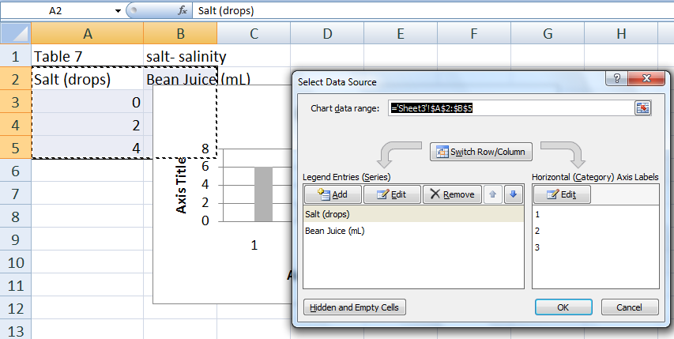
- The Axis labels box will pop up, highlight the x axis labels and then click okay twice to close both pop up windows.
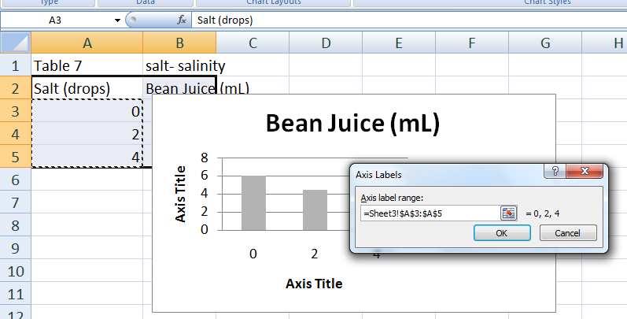

- Label the title and axes by clicking on the titles and editing.

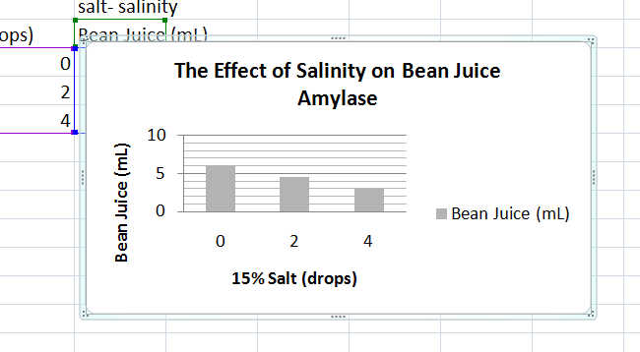

- Copy and paste into your lab write up.

