Bioinformatics
(from Kristin Tran: Blue River Valley Junior-Senior High School (New Castle, IN))

How does an evolutionary biologist describe how closely related different species are? The simplest method way is to compare the physical (morphological) features of the two species. However there are much more accurate ways to measure relatedness! One of the most accurate ways to determine evolutionary relationships is using DNA or protein sequences. In this lab, you will compare the hemoglobin beta chain protein (hemoglobin helps carry oxygen through your bloodstream!) in different organisms to analyze their relatedness.

Procedure Part I (record your information on binder paper)

- What morphological features do bats share with mammals? With Birds? Fill in table 1. Add two more morphological features to the list and fill in the table for them. Your response in each box should be Yes or No.

Feature | Birds | Bats | Mammals
Presence of hair
Presence of feathers
Presence of mammary glands
Presence of wings
Homeothermy
Four Chambered Heart
Table 1

- Based on morphology, are bats more similar to birds, or mammals? _____________

- As scientists, it is always desirable to provide multiple ways of supporting a hypothesis. You are going to generate a distance matrix for the beta-hemoglobin chain for 2 bird species, 2 bat species, and 2 non-bat mammal species into a word processing worksheet. Follow the steps below to do this:

Step 1. Swiss-Prot is a database of amino-acid sequences of many proteins from many species. Begin by going to the website for the Swiss-Prot database at: http://www.expasy.org/

Step 2. At the top right of the page, there is a search bar (see Figure 1 below). In the blank, type in “beta hemoglobin”. Then press
Go.



Figure 1: The Search Page

Step 3. A list of sequences will appear after a time. There’s a small hyperlink near the top right that says “Customize Display.” Click on it.
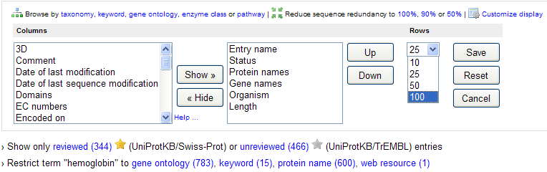

Figure 2: How to Customize your Display

Step 4. Click on the drop-down menu under where it says “Rows.” Then select 100. Then hit the save button. Your screen will re-load.

Step 5. Below where you clicked on “Customize Display”, there is a blue hyperlink that says “protein name.” Click on it.

Step 5. There should now be many items listed on your screen. These are different organisms for which we have a sequence on file for their beta-hemoglobin protein. The species name is located on the right side of the screen for each entry.

Step 6. Locate a species you can use for the first part of this activity (it must be a bird, a bat, or a mammal). It also must be listed as “Hemoglobin Subunit Beta” with the abbreviation HBB or hbb. It cannot have any numbers after the word beta (no beta-1, etc). Remember there are several pages of entries!

Step 7. Look for the species you need (2 bats, 2 birds, 2 mammals). When you find one you want to use, click the box in the far left. Then record in Table 2: The Common Name, the Scientific Name, and the “Accession” code (the blue digits on the far left for each entry).

Species | Common Name | Scientific Name | Accession Code
Bat Species #1
Bat Species #2
Bird Species #1
Bird Species #2
Mammal Species #1
Mammal Species #2
Table 2. First Comparison Data

Step 8. Once you have all of the boxes checked (the bottom left of the screen should say “6 selected”, then press the “retrieve” button in the lower right.

Step 9. On the screen that appears, select “Open”, under the heading FASTA as seen below.

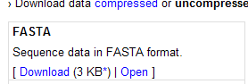

Figure 3. Opening in FASTA

Step 10. A new screen will appear that has a TON of information. These are the amino acid sequences for beta hemoglobin of all the creatures you selected. Copy and paste the entire page’s contents into Microsoft Word. Save it with your names as the file name.
Accession Number

Step 11. Each data entry in your Word document consists of many things:
Scientific Name
Amino acid seque-nce

>sp|P14388|HBB_ANTPA Hemoglobin subunit beta OS=Antrozous pallidus GN=HBB PE=1 SV=1
VHLTADEKSAVTGLWGKVNVEEVGGEALGRLLVVYPWTQRFFESFGDLSNAGAVMGNAKV
KAHGKKVLNAFSDGLKNLDNLKGTFAKLSELHCDKLHVDPENFRLLGNVLMIVLARHFGK
EFCPPVQAAFQKVSLGVATALGHKYH

Step 12. To find out how similar the sequences are, go to the following site: http://fasta.bioch.virginia.edu/fasta_www2/fasta_www.cgi?rm=lalign

Step 13. Copy and paste one sequence from your word document into the first sequence box, and another sequence into the second box as shown in Figure 5. For simplicity’s sake, just copy the amino acid’s sequence, not any of the identification information. However, make sure you keep track of which two species’ data you have entered! You can always use your Accession Number or Scientific Name that you wrote down in Table 2 to help you.

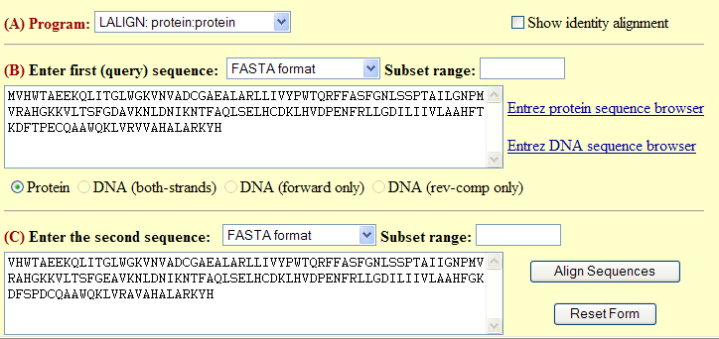

Figure 5. Example of an LALIGN entry

Step 14. Click on “Align Sequences” (right of the 2nd sequence window).

Step 15. Soon, the computer will return a set of information including the “percent similar” Record this percentage in Table 3. This is the percent of amino acids that are similar or identical between the two sequences. (See Figure 6). (if you scroll down you will see the actual sequences of amino acids aligned)
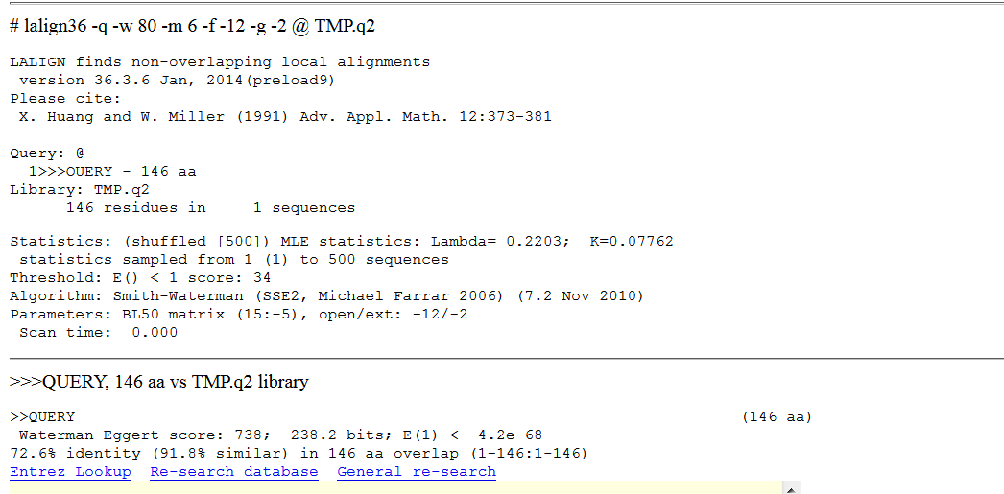

Figure 5. Alignment Results

Step 16. A distance matrix is a table that shows the pair-wise comparisons between species. Press the back button and continue to make all pair-wise comparisons until Table 4 is filled. There is no need to fill in the shaded boxes, as they will be repeated information.

 | Bat #1 | Bat #2 | Bird #1 | Bird #2 | Mammal #1 | Mammal #2
Bat #1 | 100%
Bat #2 |  | 100%
Bird #1 |  |  | 100%
Bird #2 |  |  |  | 100%
Mammal #1 |  |  |  |  | 100%
Mammal #2 |  |  |  |  |  | 100%
Table 3. Distance Matrix for Part I.

Step 17. Use the data from Table 3 to answer the following questions:
- Which 2 species have the most similar beta-hemoglobin chains?

- Which 2 species have the least similar beta-hemoglobin chains?

- For Bat #1, make a list of species that have the most similar beta-hemoglobin sequence, to the least similar.

1.

2.

3.

4.

5.

- For Bat #2, make a list of species that have the most similar beta-hemoglobin sequence to the least similar.

1.

2.

3.

4.

5) Does the information seem consistent with the hypothesis that bats are mammals? Are bats more closely related to mammals than to birds?

Part II

Help a college student figure out what the feet of the ancestors of whales are like! The student knows that whales are mammals, and that scientific evidence shows that they evolved from terrestrial four-legged hoofed mammals (ungulates) which somehow moved and adapted to life at sea. She heard that whales evolved either from perissodactyl (odd-toed) or from artiodactyls (even-toed) ungulates. Unfortunately whales do not have feet so she cannot examine the morphology of whales to figure out which is the more likely scenario. Help her use hemoglobin beta chain sequence data to evaluate these two hypotheses!

Perissodactyl animals: horses, zebras, rhinos, tapirs

Artiodactyl animals: sheep, goats, camels, pigs, cows, deer, giraffes, antelopes

Procedure Part II

Repeat the process used in Part I, but this time you will construct a distance matrix for one whale, one fish, two perissodactyl mammals, and two artiodactyl mammals.

Species | Common Name | Scientific Name
Whale Species
Fish Species
Odd-Toed Mammal #1
Odd-Toed Mammal #2
Even-toed Mammal #1
Even-toed Mammal #2
Table 4. Species used for Part II.

 | Whale | Fish | Odd #1 | Odd #2 | Even #1 | Even #2
Whale | 100%
Fish |  | 100%
Odd #1 |  |  | 100%
Odd #2 |  |  |  | 100%
Even #1 |  |  |  |  | 100%
Even #2 |  |  |  |  |  | 100%
Table 5. Distance Matrix for Part II.

Answer the questions below.

- Is the whale hemoglobin more similar to the fish hemoglobin or the mammal hemoglobin?

- Is the whale hemoglobin more similar to the hemoglobin of odd-toed mammals or even-toed mammals?

Part III. Design your own investigation:
Use the http://www.phylogeny.fr/ site PLEASE watch a podcast from Mr. Knuffke on an example of how to do the project using phylogeny.fr). Hint: pick a protein that all the organisms you choose will have in common.

Here are some suggestions of some projects:
- Compare primates and humans
- Compare birds and reptiles
- Compare different types of bacteria to some eukaryotes.

Here is a link to help you understand the phylogenetic (family) tree result. (how to read a phylogenetic tree)

What you will turn in:
- Post to the blog (see blog rubric: http://www.grochbiology.org/AccBioBioinformaticsblogRubric.docx )
- Do a print screen capture of your tables.
- A reflection of your group’s independent study (Part III); please include scientific information from valid websites to support your findings.
- References and citations.
- Your (individual) reflection of the activity, typed and turn in separately.

