Carolina: AP Biology-Species Interactions CLASS SET # ______________
The next time you walk outside, take time to observe the interactions of species around you. You may see bees, butterflies, or beetles pollinating flowers. You may see a hawk circling above a field in search of its next meal. These interactions influence the abundance and dispersion of organisms in the environment. A change in one species' population often affects community makeup. For example, loss of predators such as hawks may lead to an increase in prey populations. The construction of new dams by an expanding beaver population may displace some organisms while creating new habitat for species formerly excluded from the area. Introduced species may outcompete and displace native species. For example, the kudzu vine, native to Asia, was widely planted in the southeastern U.S. in the 1930s and 40s for erosion control. Today, kudzu covers millions of acres and destroys native flora by blocking sunlight.
Background
Biological systems function by means of interactions, from the interactions between chemical pathways and organelles in a single cell to those between species in a community. Community ecologists construct food web models to characterize species interactions in an area. Each species is assigned a trophic level, or a position in a food chain. Photosynthetic organisms such as plants and algae are food producers and depend on the sun as their energy source. Other species are consumers. Primary consumers are those that feed on producers, while secondary consumers feed on primary consumers, tertiary consumers on secondary consumers, and so on. Another important component of food webs is the decomposers, mainly fungi and bacteria, which consume dead organisms and waste (such as leaf litter or animal feces) and recycle nutrients that may again be used by producers. Energy is transferred through a food web, and consumers depend on the preceding trophic level for acquiring their energy. Assigning species to trophic levels in a community is often complicated by the fact that many organisms feed at multiple trophic levels. A bear, for instance, may be a primary consumer, a secondary consumer, and a tertiary consumer, all on the same day.
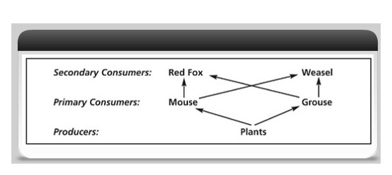
In addition to determining species' trophic levels, community ecologists study specific relationships between species. Such relationships include predation, parasitism, competition, mutualism, and commensalism. Some of these relationships may vary in intensity. For example, there may be a predator who depends entirely on one prey species (an Everglades Kite on apple snails) or a predator who feeds on multiple prey (a Red-tailed Hawk on mice, rats, rabbits, snakes, and so on). Similarly, in a mutualistic relationship, one of the species may depend on the other to a greater degree (e.g., an alga species that can survive with or without a coral animal, whereas the coral animal cannot long survive without the alga). When relationships are very dependent, a change in one of the species' populations may quickly and dramatically affect the other's. For example, when wolves were exterminated in the Olympic National Park, elk populations climbed. In turn, this affected the producers in the area, leading to a steep decline in important tree and shrub species along riverbanks and in the forest due to elk overgrazing.
Prelab Questions:
- An invasive plant species has been introduced and is establishing itself within a community. Explain how this species may affect the established interactions, distribution, and abundance of native species.
- Primary productivity is the rate at which producers store organic materials. Because aquatic producers release oxygen during photosynthesis, dissolved oxygen levels can be used to measure primary productivity in aquatic communities. On the graph below, use the toolbar tools to draw a solid line that predicts a general pattern of dissolved oxygen concentration over a 24-hour period for a pond with only producers present. Using a dashed line, predict the dissolved oxygen level of the same ecosystem if a primary consumer is introduced. Explain your reasoning. (Keep in mind the processes of photosynthesis and cellular respiration, along with the influence of natural light and dark cycles.)
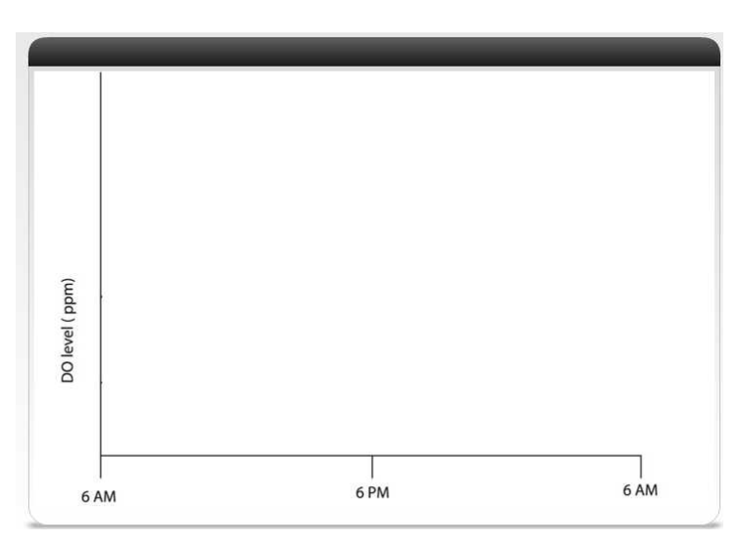

Day 1: Setting Up
Materials:
plastic cups, 24 oz
springwater
Chlorella culture
100-mL and 500-mL graduated cylinders
permanent marker
Parafilm or plastic wrap
light bank sharpened pencil

Procedure
1. Gather the two plastic cups at your desk. Label one cup “control (water).” Label the other cup “algae.” Label both with the initials of your group members.
2. Pour 500 mL of springwater into the control cup.
3. Pour 400 mL of springwater and 100 mL of suspended Chlorella into the “algae” cup.
4. Cover both of your cups with a piece of Parafilm or plastic wrap and seal it tightly.
5. Using the tip of a sharpened pencil, poke four holes in the Parafilm or plastic wrap. This allows gas exchange.
6. Place the cups beneath a light bank and allow them to sit undisturbed for 72 hours.

Day 4: Measuring Dissolved Oxygen
Materials:
DO bottles with caps, Winkler solutions (manganese sulfate, potassium iodide azide solution, sodium thiosulfate solution, starch indicator, sulfamic acid powder), 1-g spoon for sulfamic acid,
titration sampling vials, titration syringes, gloves, goggles OR use DataLogger Oxygen Probe

Procedure
- Label two DO bottles, one of them “C,” for control and the other, “A,” for algae.
- At the light bank, fill bottle C with water from your control cup. It is important that you not trap air in the bottle and that you not introduce any turbulence. Improper filling will mix air into the sample and increase the dissolved oxygen level.
Use the following method to fill the DO bottles (unless using Oxygen Probe)
a. Tilt the DO bottle to a 45° angle.
b. Slowly submerge the DO bottle into the solution in your C (control) cup. Water should slowly flow into the DO bottle.
c. When it is almost full, gently stand the bottle on the bottom of the cup.
d. Cap the bottle while it is still submerged, making sure not to trap any air bubbles. If necessary, uncap and gently tilt the bottle to release any air and then recap.
e. Lift the DO bottle from the solution. Do not shake or jostle the bottle.
- Repeat these steps with bottle A and the cup containing the algae
- Re-cover your cups and return to your desks with your DO bottles, being careful not to jostle them.
- Determine the DO of both samples if you are using Winkler method protocol described as follows:
Winkler Method Protocol:
Step 1: Oxygen fixation:
a. Uncap the DO bottle.
b. Add 8 drops of manganese(II) sulfate solution to the bottle. c. Add 8 drops of alkaline potassium iodide azide to the bottle.
d. Cap the bottle and mix by inverting. A precipitate will form. Allow the precipitate to settle to the shoulder of the bottle before proceeding.
e. Use the spoon provided to add 1 g (1 spoonful) of sulfamic acid powder to the bottle.
f. Cap the bottle and mix until the reagent and precipitate dissolve. The sample is now fixed.
During step 1 of the Winkler method, the dissolved oxygen in the solution becomes incorporated into a compound called manganese(III) sulfamate. After this, introduction of additional oxygen will not affect the results of the titration. Through chemical reactions, manganese(III) sulfamate releases free iodine in the solution. In step 2, titration of the free iodine with sodium thiosulfate occurs. The amount of free iodine is proportional to the initial dissolved oxygen concentration.

Step 2: Titration
a. Uncap a DO bottle and use the previously fixed solution to fill the titration sampling vial to the 20-mL line. Be accurate. Variations in filling volume from group to group and from bottle to bottle will result in inconsistent data. Cap the vial.
b. Fill the titration syringe with 1.0 mL of sodium thiosulfate. Read the volume across the bottom of the meniscus. Insert the titration syringe into the hole on the sampling vial lid.
c. Add 1 drop of sodium thiosulfate at a time to the sample, swirling between each drop until the sample becomes light yellow.
d. Remove the titration syringe and the cap together, without disturbing the syringe.
e. Add 8 drops of starch indicator solution.
f. Replace the lid of the titration vial (with syringe) and swirl the sample. The solution should turn blue.
g. Note: If the solution does not turn blue, either there is not a measurable amount of oxygen present, or too much sodium thiosulfate was added in step 2c. Pour out the sample, rinse the titration vial with deionized water, refill the vial from the BOD bottle, and start the Winkler method protocol again.
h. Continue the titration with the sodium thiosulfate already in the syringe. Add 1 drop at a time, swirling the sample after the addition of each drop, until the blue color disappears. If the blue color remains after the addition of the entire syringe of sodium thiosulfate, refill the syringe and continue. Keep track of how much sodium thiosulfate you add. If you refilled the syringe, remember to add the volume of both syringes together to get the total amount of sodium thiosulfate used.

6. Record your data in Table 1 in the Data Analysis section. Each 0.1 mL of sodium thiosulfate used in the titration indicates 1 ppm DO, or 1 mg DO per L of water.
7. Collect class data and calculate averages in Table 2 in the Data Analysis section (Tab 3).
8. Follow cleanup procedures and complete all Laboratory Questions.

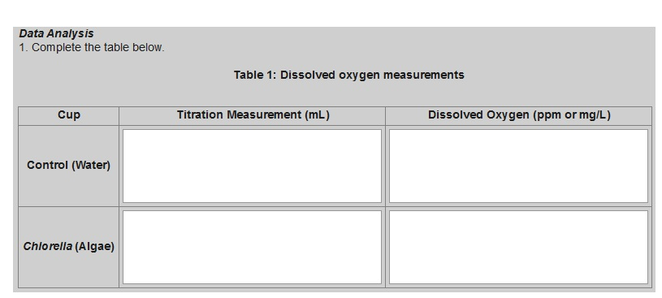

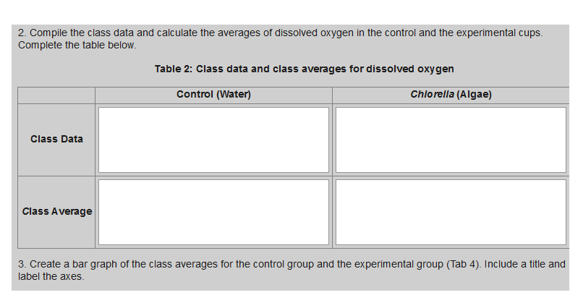

Calculation Formulas:
Use the following formulas to calculate the primary productivity-carbon fixation in your algae bottle.
Primary Productivity Calculation
mg O2/L x 0.698 = mL O2 /L
mL O2/L x 0.536 = mg carbon fixed/L

Laboratory Questions (although there are pronouns in the questions, please do not use pronouns in your answers).
1. How would the dissolved oxygen concentration in the cup with Chlorella have been different if it had been placed on a windowsill for 3 days rather than under continuous light?
2a. Would the dissolved oxygen concentration increase or decrease in the cup with Chlorella if a primary consumer were introduced? Defend your answer.
2b.What if sediment with decomposers were introduced? Defend your answer.
3. Why is it necessary to calculate class averages of the data before drawing conclusions?
4. Form a hypothesis regarding the effect of community interactions on dissolved oxygen concentration. The hypothesis should predict the change in DO level when secondary consumers are added to a mixed culture of producers and primary consumers.

Inquiry Activities
In the previous activity you measured dissolved oxygen concentration in water samples with and without an aquatic producer present. Based on what you learned in the Guided Activity, develop a question to test about interactions in an aquatic food chain, using some or all of the following: Chlorella (producer), Daphnia (primary consumer), and Hydra (secondary consumer). In developing an experimental question, consider the materials and equipment available to you. Consult your instructor for the availability of additional supplies.
Materials:
Winkler method materials
24-oz plastic cups
springwater
Chlorella culture
Daphnia cultures
Hydra cultures
pipets 100-mL and 500-mL graduated cylinders
permanent markers
Parafilm or plastic wrap
light bank
other items as needed and as available

Procedure:
1. In your group, collaborate to come up with a testable question about interactions in an aquatic food chain, using dissolved oxygen as your quantitative measurement. If you have trouble, ask your teacher for guidance.
2. Design an experiment to test your question. Consider the following as you frame your experiment:
• Question - What are you testing in your experiment? What are you trying to find out?
• Hypothesis - What do you think will happen? Why do you think so? What do you already know that helps support your hypothesis?
• Materials - What materials, tools, or instruments are you going to use to find out the answer to the question?
• Procedure - What are you going to do? How are you going to do it? What are you measuring? How can you make sure the data you collect are accurate? What are the independent and dependent variables in this experiment? What is your control? What safe practices do you need to use? (see last page for helping to plan your calendar)
• Data Collection - What data will you record, and how will you collect and present it? Show and explain any data tables and graphs that you plan to use.
3. Have your teacher approve the experimental procedure before you begin the exercise.
4. After you perform the experiment, analyze your data:
• Data Analysis - What happened? Did you observe anything that surprised you? Show and explain any tables and graphs that support your data.
• Conclusion - What conclusions can you draw from the results of your experiment? How does this compare with your initial hypothesis? Identify some possible sources of error in your experiment. If given the opportunity, how might you conduct the experiment differently?
- Be prepared to present the findings of your experiment to the class format TBD
Part A: To be completed and approved before beginning the investigation
What question will you explore?
On the basis of your previous laboratory exercise, background knowledge, and research, what is the hypothesis that you will test?
What will be the independent and dependent variables?
What will be the control group(s)?
What equipment and materials will you need (list items and quantity)?

Big Idea Assessments:
- The graph below depicts an abundance curve for two species in a community. One species is a primary consumer and the other is a secondary consumer.
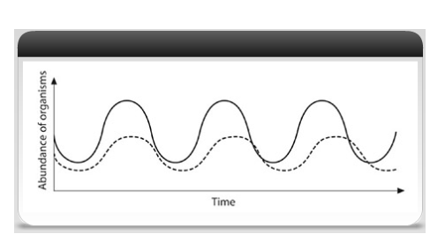

After examining the graph:
- State the trophic level of each species.
Solid, curved line:
Dashed, curved line:
- Explain the cause of the pattern found on the graph.
- Explain how and why the curves would change if producer concentration decreased dramatically in this community
- Using some toolbar tools, create a community food web. Discuss the interactions of organisms in your food web, incorporating at least two of the following topics into the discussion:
a. predation b. competition c. mutualism d. commensalism
- Calculate the primary productivity of your experimental bottles/cups.
