Cell Respiration
Cellular respiration refers to the process of converting the chemical energy of organic molecules into a form immediately usable by organisms. Glucose may be oxidized completely if sufficient oxygen is available by the following equation:
C₆H₁₂O₆ + 6O₂(g) → 6 H₂O + 6 CO₂(g) + energy
All organisms, including plants and animals, oxidize glucose for energy. Often, this energy is used to convert ADP and phosphate into ATP. It is known that peas undergo cellular respiration during germination. Do peas undergo cellular respiration before germination? The results of this experiment will verify that germinating peas do respire. Using your collected data, you will be able to answer the question concerning respiration and non-germinating peas.
Using the CO₂ Gas Sensor, you will monitor the carbon dioxide produced by peas during cellular respiration. Both germinating and non-germinating peas will be tested. Additionally, cellular respiration of germinating peas at two different temperatures will be tested.

OBJECTIVES
In this experiment, you will
- use a CO₂ Gas Sensor to measure concentrations of carbon dioxide.
- study the effect of temperature on cellular respiration.
- determine whether germinated and non- germinated peas respire.
- compare the rates of cellular respiration in germinated and non- germinated peas.

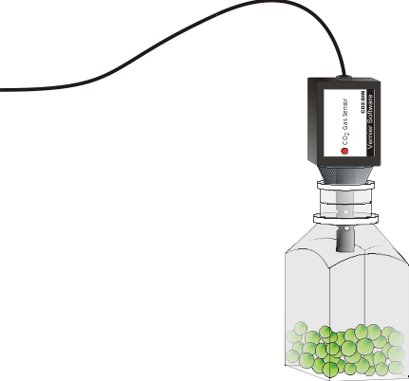
Figure 1
MATERIALS
Power Macintosh or Windows PC | 250-mL respiration chamber
Vernier computer interface | ice cubes
Logger Pro | 1-L beaker
Vernier CO₂ Gas Sensor | thermometer
25 germinating peas | two 100-mL beakers
25 non-germinating peas | Graphical Analysis (optional)

PROCEDURE
1. Prepare the computer for data collection by opening the file in the Experiment 11B folder of Biology with Computers. The vertical axis has carbon dioxide concentration scaled from 0 to 5000 ppm. The horizontal axis has time scaled from 0 to 5 minutes. The data rate is set to 6 samples/minute.
2. Plug the CO₂ Gas Sensor into Port 1 of the Vernier computer interface.
3. Obtain 25 germinating peas and blot them dry between two pieces of paper towel. Use the thermometer to measure the room temperature. Record the temperature in Table 1.
4. Place the germinating peas into the respiration chamber.
5. Place the shaft of the CO₂ Gas Sensor in the opening of the respiration chamber. Gently twist the stopper on the shaft of the CO₂ Gas Sensor into the chamber opening. Do not twist the shaft of the CO₂ Gas Sensor or you may damage it.
6. Wait one minute, then begin measuring carbon dioxide concentration by clicking . Data will be collected for 5 minutes.
7. Remove the CO₂ Gas Sensor from the respiration chamber. Place the peas in a 100-mL beaker filled with cold water and an ice cube. The cold water will prepare the peas for part II of the experiment.
8. Use a notebook or notepad to fan air across the openings in the probe shaft of the CO₂ Gas Sensor for 1 minute.
9. Fill the respiration chamber with water and then empty it. Thoroughly dry the inside of the respiration chamber with a paper towel.
10. Determine the rate of respiration:
- Move the mouse pointer to the point where the data values begin to increase. Hold down the left mouse button. Drag the mouse pointer to the end of the data and release the mouse button.
- Click the Regression button, , to perform a linear regression. A floating box will appear with the formula for a best fit line.
- Record the slope of the line, m, as the rate of respiration for germinating peas at room temperature in Table 2.
- Close the linear regression floating box.

11. Move your data to a stored run. To do this, choose Store Latest Run from the Data menu.
12. Obtain 25 non-germinating peas and place them in the respiration chamber
13. Repeat Steps 5 – 11 for the non-germinating peas.

Part II Germinating peas, cool temperatures
14. Place the respiration chamber in a 1-L beaker. Cover the outside of the chamber with ice.
15. Use the thermometer to measure the water temperature of the 100-mL beaker containing the germinating peas. Record the water temperature in Table 1.
16. Remove the peas from the cold water and blot them dry between two paper towels.
17. Repeat Steps 5 – 11 to collect data with the germinating peas at a cold temperature.
18. To print a graph showing all three data runs:
- Label all three curves by choosing Make Annotation from the Analyze menu, and typing “Room Temp Germinated” (or “Room Temp Non-germinated”, or “Cold Germinated”) in the edit box. Then drag each box to a position near its respective curve.
- Print a copy of the Graph window, with all three data sets and the regression lines displayed. Enter your name(s) and the number of copies of the graph you want.

DATA
Table 1
Condition | Temperature (°C)
room
cold water

Table 2
Peas | Rate of Respiration (ppm/min)
Germinating, room temperature
Non-germinating, room temperature
Germinating, cool temperature

Questions
1. Do you have evidence that cellular respiration occurred in peas? Explain.
2. What is the effect of germination on the rate of cellular respiration in peas?
3. What is the effect of temperature on the rate of cellular respiration in peas?
4. Why do germinating peas undergo cellular respiration?

extensionS
1. Compare the respiration rate among various types of seeds.
2. Compare the respiration rate among seeds that have germinated for different time periods, such as 1, 3, and 5 days.
3. Compare the respiration rates of various small animal types, such as insects or earthworms.

