Cell Respiration
Cellular respiration refers to the process of converting the chemical energy of organic molecules into a form immediately usable by organisms. Glucose may be oxidized completely if sufficient oxygen is available, by the following equation:
C₆H₁₂O₆ + 6O₂(g) → 6 H₂O + 6 CO₂(g) + energy
All organisms, including plants and animals, oxidize glucose for energy. Often, this energy is used to convert ADP and phosphate into ATP.
To measure the rate of cellular respiration, the pressure change due to the consumption of oxygen by peas will be measured. It is not possible to directly measure pressure changes due to oxygen, since the pressure sensor measures the total pressure change. Carbon dioxide is produced as oxygen is consumed. The pressure due to CO₂ might cancel out any change due to the consumption of oxygen. To eliminate this problem, a chemical will be added that will selectively remove CO₂. Potassium hydroxide, KOH, will chemically react with CO₂ by the following equation:
2 KOH + CO₂ → K₂CO₃ + H₂O
This will allow you to monitor pressure changes exclusively due to the consumption of oxygen.
A respirometer is the system used to measure cellular respiration. Pressure changes in the respirometer are directly proportional to a change in the amount of gas in the respirometer, providing the volume and the temperature of the respirometer do not change. If you wish to compare the consumption of oxygen in two different respirometers, as we will in this experiment, you must keep the volume and temperature of the air equal in each respirometer.
Both germinating and non-germinating peas will be tested. Additionally, cellular respiration of germinating peas at two different temperatures will be tested.

OBJECTIVES
In this experiment, you will
- use a computer and Gas Pressure Sensors to measure pressure changes.
- study the effect of temperature on cellular respiration.
- determine whether germinated and non- germinated peas respire.
- compare the rates of cellular respiration in germinated and non- germinated peas.
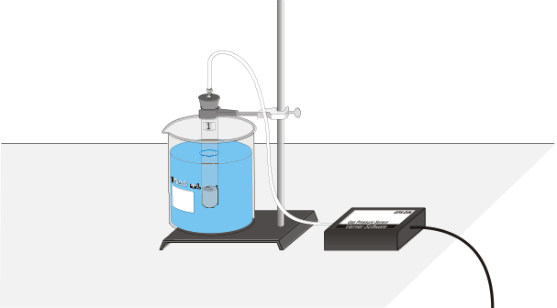
Figure 1
MATERIALS
Power Macintosh or Windows PC | glass beads
Vernier computer interface | ice
Logger Pro | non-absorbent cotton
2 Vernier Gas Pressure Sensors | thermometer
15% KOH in a dropper bottle | test tube rack
25 germinating peas | timer with a second hand
25 non-germinating peas | three 18 X 150 mm test tubes
100-mL graduated cylinder | two 1-hole rubber stopper assemblies
absorbent cotton | two 1-L beakers
forceps | ring stand
2 utility clamps

PROCEDURE
1. Connect the plastic tubing to the valve on the Gas Pressure Sensor. If your sensors have blue plastic valves on them, place the valve in the position shown in Figure 2.
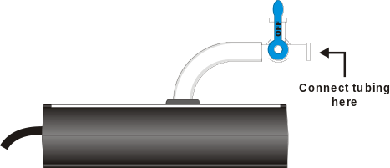
Figure 2
2. Prepare the computer for data collection by opening the Experiment 11C folder from the Biology with Computers folder of Logger Pro. Then open the experiment file that matches the probe you are using. Three graphs are displayed: the experimental pressure measurements, the control’s pressure measurements, and the pressure change. The horizontal axis has time scaled from 0 to 20 minutes in all three graphs. The vertical axes for the experimental and control graphs are scaled from 95 to 100 kPa, while the vertical axis for the pressure change graph is scaled from 0 to 10 kPa.
To test whether germinating peas undergo cellular respiration, you will need to
- set up two water baths.
- prepare a respirometer for the germinating peas.
- prepare a second, control respirometer containing glass beads.

3. Set up two water baths, one at about 25°C and one at about 10°C. Obtain two 1-liter beakers and place about 800 mL of water in each. Add ice to attain the 10°C water bath.
4. To be sure the volumes of air in all respirometers are equal, you will need to measure the volume of the twenty-five peas that will be in the experimental respirometer. The control respirometer must have an equal volume of glass beads (or other non-oxygen consuming material) to make the air volume equal to the respirometer with germinating peas. Similarly, glass beads will be used to account for any volume difference between the germinating and non-germinating peas.
5. Obtain three test tubes and label them “T1”, T2”, and “T3”.
6. Place a 3-cm wad of absorbent cotton in the bottom of each test tube. Using a dropper pipette, carefully add a sufficient amount of KOH to the cotton to completely saturate it. Do not put so much that liquid can easily run out of the tube. Note: Do not allow any of the KOH to touch the sides of the test tube. The sides should be completely dry, or the KOH may damage the peas. CAUTION: Potassium hydroxide solution is caustic. Avoid spilling it on your clothes or skin.
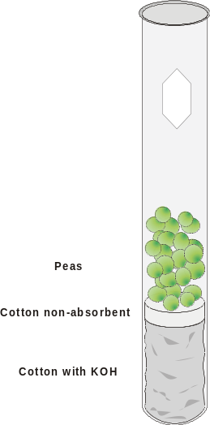
Figure 3
7. Prepare the test tube containing germinating peas (T1):
- Add 50 mL of water to a 100-mL graduated cylinder.
- Place 25 germinating peas into the water.
- Measure the volume of the peas by water displacement. Record that volume in Table 1.
- Gently remove the peas from the graduated cylinder and blot them dry with a paper towel.
- Add a small wad of non-absorbent dry cotton to the bottom of the test tube to prevent the peas from touching the KOH saturated cotton.
- Add these germinating peas to the respirometer labeled “T1”.

8. Prepare the test tube containing non-germinating peas (T2):
- Refill the graduated cylinder with 50 mL of water.
- Place 25 non-germinating peas into the water.
- Measure the volume of the peas by water displacement. Record the volume in Table 1.
- Add a sufficient number of glass beads to the non-germinating peas and water until they displace exactly the same volume of water as the germinating peas.
- Gently remove the peas and glass beads from the graduated cylinder and dry them with a paper towel.
- Add a small wad of dry non-absorbent cotton to the bottom of the test tube to prevent the peas from touching the KOH saturated cotton.
- Add the non-germinating peas and glass beads to the respirometer labeled “T2”.

9. Prepare the test tube containing glass beads (T3):
- Refill the graduated cylinder with 50 mL of water.
- Add a sufficient number of glass beads to the water until they displace exactly the same volume of water as the germinating peas.
- Remove the glass beads from the graduated cylinder and dry them.
- Add a small wad of dry non-absorbent cotton to the bottom of the test tube to prevent the peas from touching the KOH saturated cotton.
- Add the glass beads to the respirometer labeled “T3”.
Part I Germinating peas, room temperature
10. Insert a single-holed rubber-stopper into test tube T1 and T3. Note: Firmly twist the stopper for an airtight fit. Secure each test tube with a utility clamp and ring-stand as shown in Figure 1.
11. Arrange test tubes T1 and T3 in the warm water bath using the apparatus shown in Figure 1. Incubate the test tube for 10 minutes in the water bath. Be sure to keep the temperature of the water bath constant. If you need to add more hot or cold water, first remove about as much water as you will be adding, or the beaker may overflow. Use a basting bulb to remove excess water. Record the resulting temperature of the water bath once incubation has finished in Table 2.
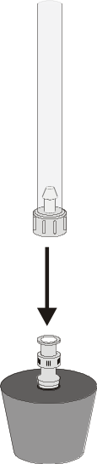
Figure 4
Note: Be sure the tubes are submerged to an equal depth, just up to the rubber stoppers. The temperature of the air in the tube must be constant for this experiment to work well.
12. When incubation has finished, connect the free-end of the plastic tubing to the connector in the rubber stopper as shown in Figure 4.
13. Click to begin data collection. Maintain the temperature of the water bath during the course of the experiment.
14. Data collection will end after 20 minutes. Monitor the pressure readings displayed in the Meter window. If the pressure exceeds 130 kPa, the pressure inside the tube will be too great and the rubber stopper is likely to pop off. Disconnect the plastic tubing from the Gas Pressure Sensor if the pressure exceeds 130 kPa.
15. The rate of respiration can be measured by examining the slope of the pressure change vs. time plot at the right of the screen. Calculate a linear regression for the pressure change vs. time graph:
- Click on the Pressure Change vs. Time graph to select it.
- Click the Regression button, , to perform a linear regression. A floating box will appear with the formula for a best fit line.
- Record the slope of the line, m, in Table 3 as the rate of oxygen consumption by germinating peas.
- Close the linear regression floating box.

16. Move your data to a stored data run. To do this, choose Store Latest Run from the Data menu.
Part II Non-germinating peas, room temperature
17. Disconnect the plastic tubing connectors from the rubber stoppers. Remove the rubber stopper from each test tube.
18. Repeat Steps 10 – 16, using test tubes T2 and T3.
Part III Germinating peas, cool temperatures
19. Disconnect the plastic tubing connectors from the rubber stoppers. Remove the rubber stopper from each test tube.
20. Repeat Steps 10 – 16, using test tubes T1 and T3 in a cold water bath.
21. If instructed by your teacher, make a printout of the graph with each of the three trials.

DATA
Table 1
Peas | Volume (mL)
Germinating
Non-germinating

Table 2
Water bath | Temperature (°C)
warm
cool

Table 3
Peas | Rate of Respiration (kPa/min)
Germinated, room temperature
Non-germinated, room temperature
Germinated, cool temperature

Questions
1. Do you have evidence that cellular respiration occurred in peas? Explain.
2. What is the effect of germination on the rate of cellular respiration in peas?
3. What is the effect of temperature on the rate of cellular respiration in peas?
4. What was the role of the control respirometer in each series of experiments?
5. Why do germinating peas undergo cellular respiration?

extensionS
1. Compare the respiration rate among various types of seeds.
2. Compare the respiration rate among seeds that have germinated for different time periods, such as 1, 3, and 5 days.
3. Compare the respiration rate among various types of small animals, such as insects or earthworms.

