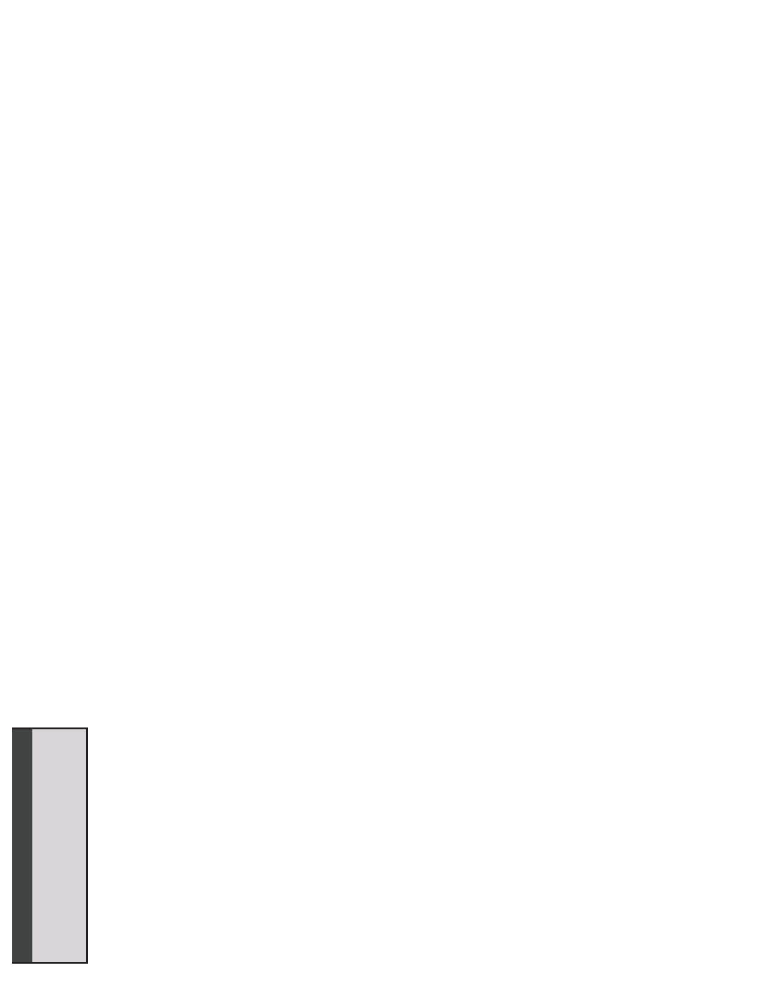
Crime Scene: DNA Profiling Lab Name:
STUDENT MANUAL
POST-LAB ACTIVITY
Period:

Quantitative Analysis of DNA Fragment Sizes

If you were on trial or were trying to identify an endangered species, would you want to rely on a technician's eyeball estimate of a match, or would you want some more accurate
measurement?
In order to make the most accurate comparison between the crime scene DNA and the
suspect DNA, other than just a visual match, a quantitative measurement of the fragment
sizes needs to be completed. This is described below:

1. Using a ruler, measure the distance (in mm) that each of your DNA fragments or bands
traveled from the well. Measure the distance from the bottom of the well to the center of each DNA band and record your numbers in the table on the next page. The data in the
table will be used to construct a standard curve and to estimate the sizes of the crime scene and suspect restriction fragments.

2. To make an accurate estimate of the fragment sizes for either the crime scene or
suspect DNA samples, a standard curve is created using the distance (x-axis) and
fragment size (y-axis) data from the known HindIII lambda digest (DNA marker). Using both linear and semilog graph paper, plot distance versus size for bands 2-6. On each graph, draw a line of best fit through the points. Extend the line all the way to the right- hand edge of the graph.
Which graph provides the straightest line that you could use to estimate the crime
scene or the suspects' fragment sizes? Why do you think one graph is straighter than
the other?

3. Decide which graph, linear or semilog, should be used to estimate the DNA fragment
sizes of the crime scene and suspects. Justify your selection.

4. To estimate the size of an unknown crime scene or suspect fragment, find the distance
that fragment traveled. Locate that distance on the x-axis of your standard graph. From that position on the x-axis, read up to the standard line, and then follow the graph line to
over to the y-axis. You might want to draw a light pencil mark from the x-axis up to the standard curve and over to the y-axis showing what you've done. Where the graph line
meets the y-axis, this is the approximate size of your unknown DNA fragment. Do this for all crime scene and suspect fragments.

5. Compare the fragment sizes of the suspects and the crime scene.
Is there a suspect that matches the crime scene?

How sure are you that this is a match?

42
Student Manual
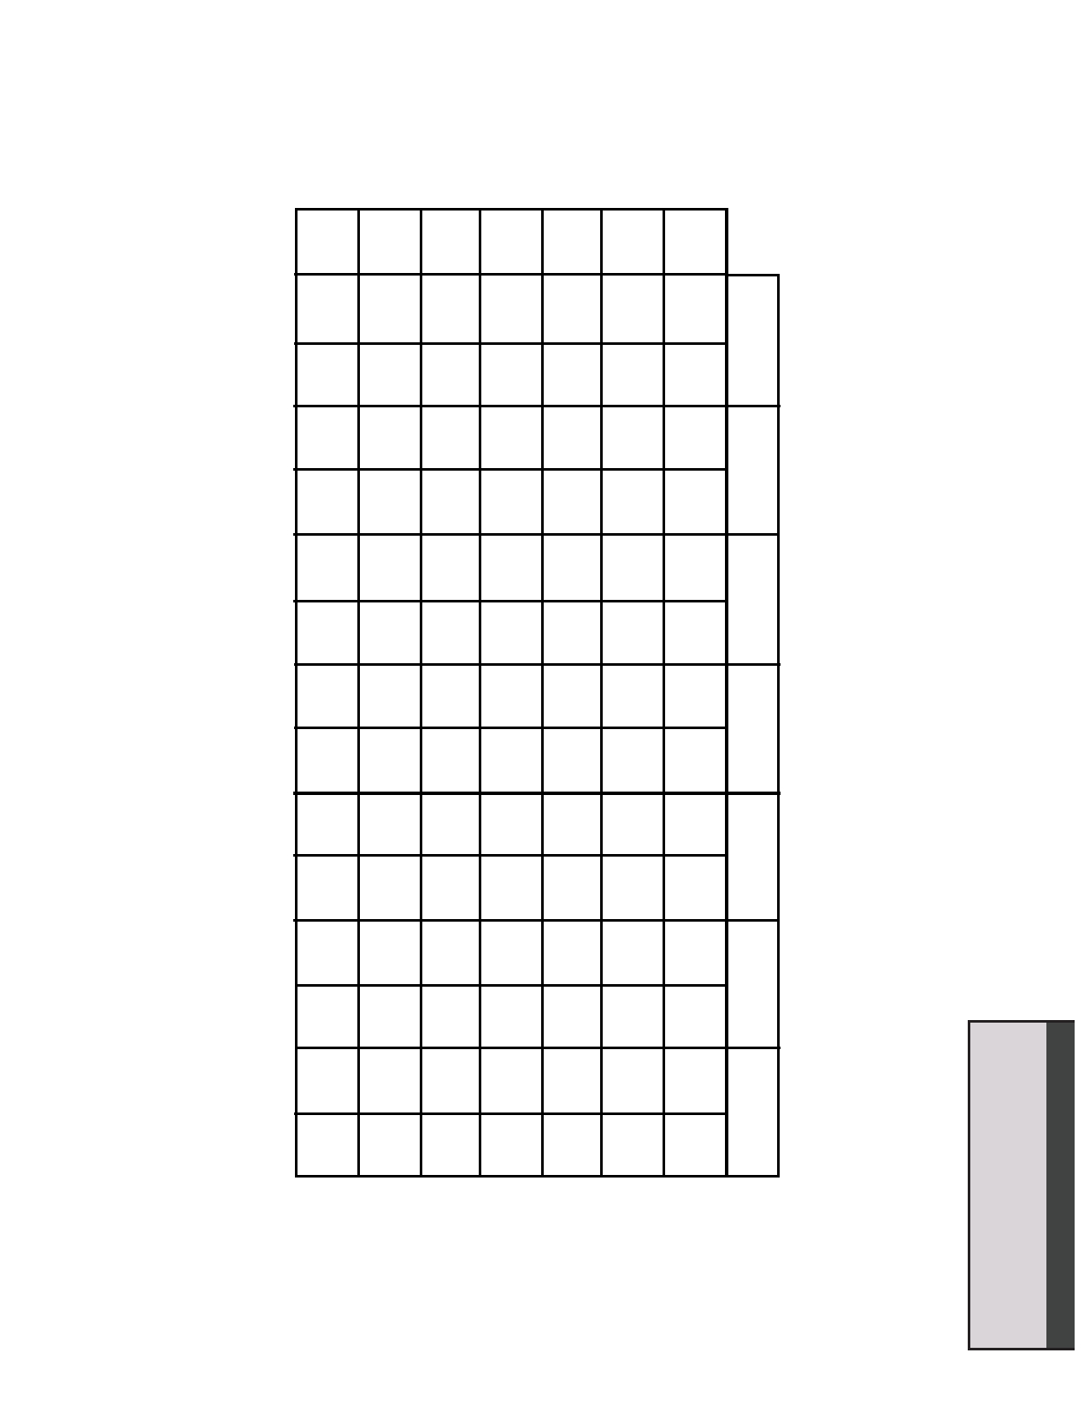
POST-LAB ACTIVITY
STUDENT MANUAL
Electrophoresis data: Measure the distance (in millimeters) that each fragment traveled from the
well and record it in the table. Estimate its size, in base pairs, by comparing its position to the
HindIII lambda DNA markers. Remember: some lanes will have fewer than 6 fragments.
Lambda/HindIII
size marker
Crime Scene
Suspect 1
Suspect 2
Suspect 3
Suspect 4
Suspect 5
Band
Distance
(mm)
Actual
size (bp)
Distance
(mm)
Approx.
size (bp)
Distance
(mm)
Approx.
size (bp)
Distance
(mm)
Approx.
size (bp)
Distance
(mm)
Approx.
size (bp)
Distance
(mm)
Approx.
size (bp)
Distance
(mm)
Approx.
size (bp)
1
23,130
2
9,416
3
6,557
4
4,361
5
2,322
6
2,027

Student Manual
43
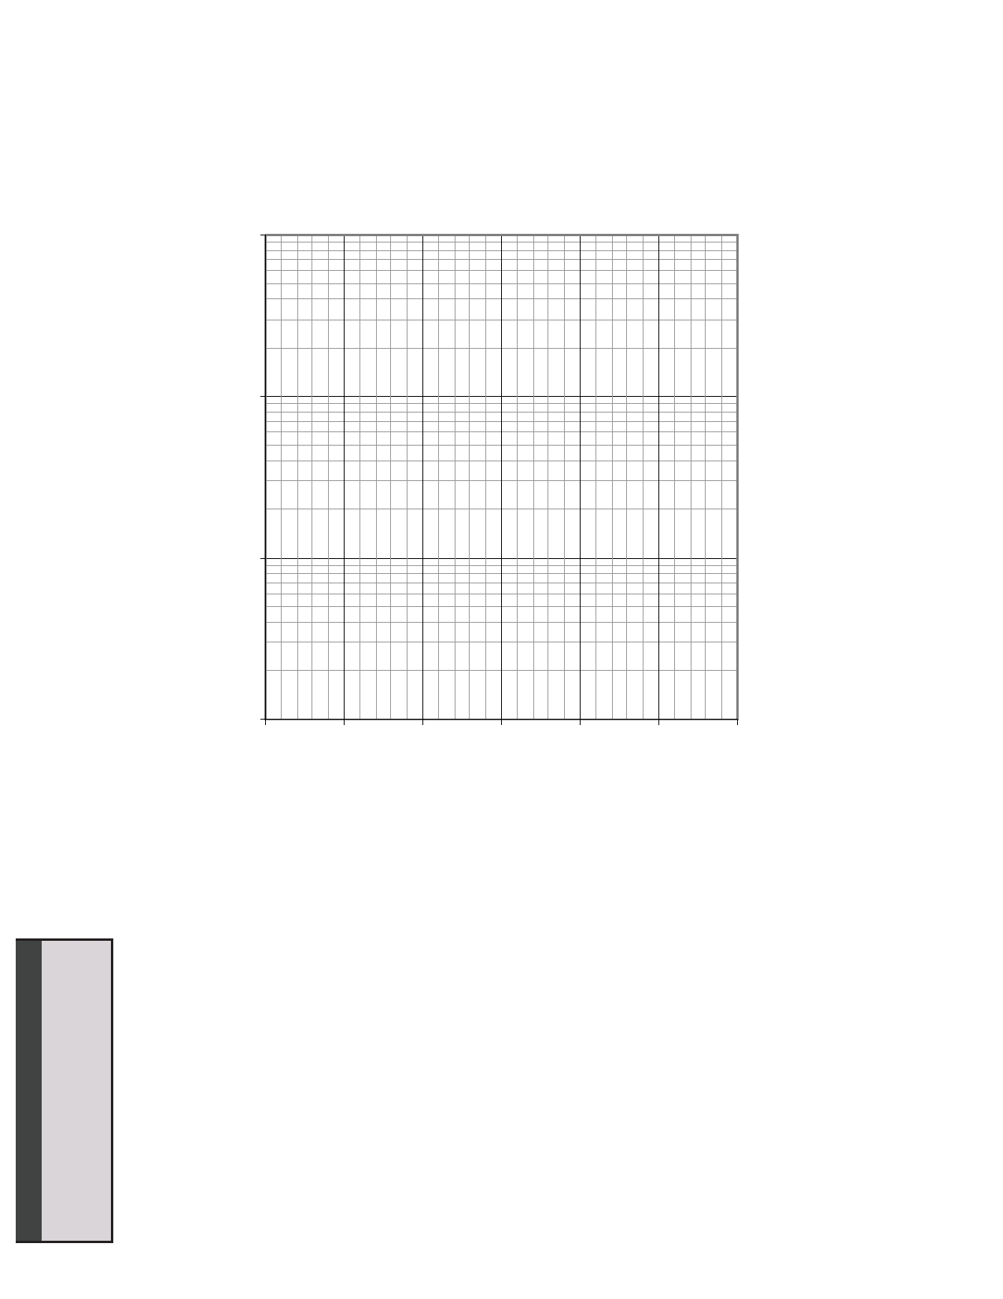
Semilog Graph Paper
Size, base pairs
STUDENT MANUAL
POST-LAB ACTIVITY

100,000

10,000

1,000

100
0 5 10 15 20 25 30
Distance, mm

You must show your work on this graph, to determine the actual base pair sizes of the fragments. Don't forget a full title.

44
Student Manual
Post Lab: Interpretation of Results (remember to write in complete
STUDENT MANUAL
POST-LAB ACTIVITY
sentences).
1. What are we trying to determine? Restate the central question.

2. Which of your DNA samples were fragmented? What would your gel look like if the
DNA were not fragmented?

3. What caused the DNA to become fragmented?

4. What determines where a restriction endonuclease will "cut" a DNA molecule?

5. A restriction endonuclease "cuts" two DNA molecules at the same location. What can
you assume is identical about the molecules at that location?

6. Do any of your suspect samples appear to have EcoRI or PstI recognition sites at the
same location as the DNA from the crime scene?

7. Based on the above analysis, do any of the suspect samples of DNA seem to be from
the same individual as the DNA from the crime scene? Describe the scientific evidence that supports your conclusion.

8. Find a criminal case (poaching animals, selling endangered species meat, crime scene, the Innocence Project (http://www.innocenceproject.org/) , etc). Briefly summarize the case in your own words (don’t forget a citation at the end of sentences). Describe how DNA evidence either helped the prosecution or the defence. How likely was the suspect (human or animal) correctly identified (what was the probability that it could have been someone else? How important is it to have suspects accused of a felony DNA profiled? Should that DNA always stay in the federal crime database? Are there “good” uses of DNA profiling, what are they? Don’t forget to include any references used in this assignment.

(reminder: don’t forget to include Figure #: and titles for data table and graph, include either a labeled picture of your gel or a drawn to scale of your gel.

46
Student Manual

