Ecology Unit Take-home Quiz Test (you may use your textbook and journal but may not talk to anyone or use other sources… due tomorrow or email if you are absent!!!)

Multiple Choice
Identify the letter of the choice that best completes the statement or answers the question.

1. The branch of biology dealing with interactions among organisms and between organisms and their environment is called
a. | economy.
b. | modeling.
c. | recycling.
d. | ecology.

2. All of the members of a particular species that live in one area are called a(an)
a. | biome.
b. | population.
c. | community.
d. | ecosystem.

3. The simplest grouping of more than one kind of organism in the biosphere is
a. | a population.
b. | a community.
c. | an ecosystem.
d. | a species.

4. What is the original source of almost all the energy in most ecosystems?
a. | carbohydrates
b. | sunlight
c. | water
d. | carbon

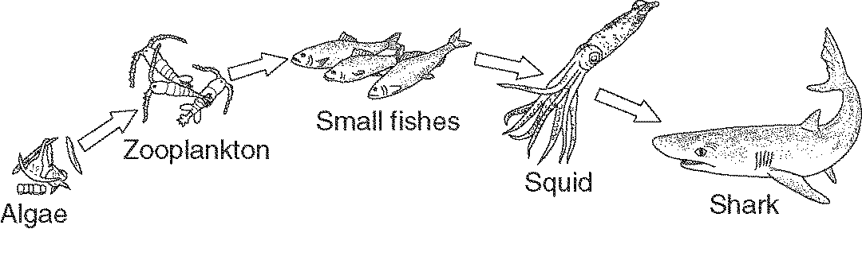

Figure 3-1

5. The algae at the beginning of the food chain in Figure 3-1 are
a. | consumers.
b. | decomposers.
c. | producers.
d. | heterotrophs.

6. An organism that cannot make its own food is called a(an)
a. | heterotroph.
b. | chemotroph.
c. | autotroph.
d. | producer.

7. What is an ecological model of the relationships that form a network of complex interactions among organisms in a community from producers to decomposers?
a. | food web
b. | an ecosystem
c. | food chain
d. | a population

8. What animals eat both producers and consumers?
a. | herbivores
b. | omnivores
c. | chemotrophs
d. | autotrophs

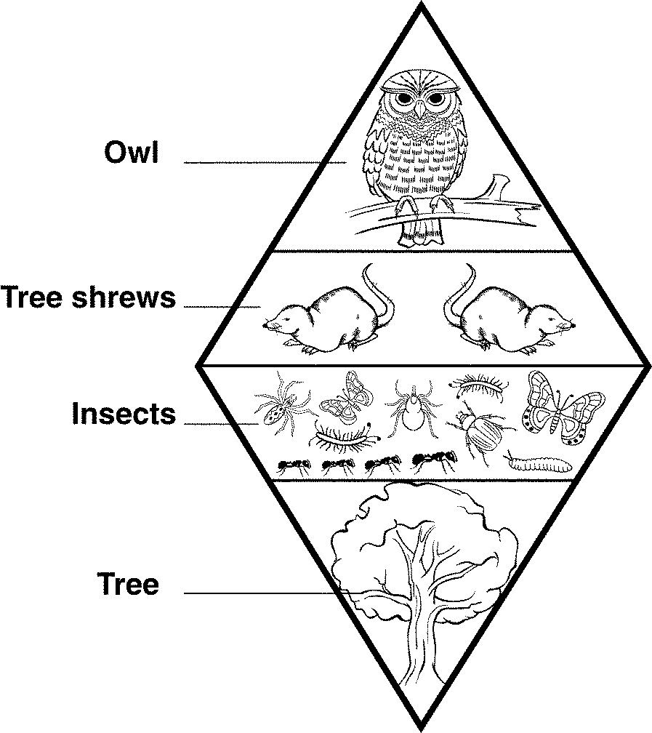

Figure 3-2

9. The trophic levels in Figure 3-2 illustrate
a. | the relative amount of energy at each level.
b. | the amount of living organic matter at each level.
c. | the relative number of individual organisms at each level.
d. | the producers outnumber first-level consumers.

10. Which of the following is NOT recycled in the biosphere?
a. | water
b. | nitrogen
c. | carbon
d. | energy

11. Organisms need nutrients in order to
a. | utilize hydrogen and oxygen.
b. | carry out essential life functions.
c. | recycle chemical compounds.
d. | carry out nitrogen fixation.

12. The average year-after-year conditions of temperature and precipitation in a particular region is the region’s
a. | weather.
b. | latitude.
c. | ecosystem.
d. | climate.

13. Cool air over the poles will
a. | rise.
b. | sink.
c. | absorb heat from the equator.
d. | flow parallel to Earth’s surface.

14. Each of the following is an abiotic factor in the environment EXCEPT
a. | plant life.
b. | soil type.
c. | rainfall.
d. | temperature.

15. Which is a biotic factor that affects the size of a population in a specific ecosystem?
a. | average temperature of the ecosystem
b. | type of soil in the ecosystem
c. | number and kinds of predators in the ecosystem
d. | concentration of oxygen in the ecosystem

16. An organism’s niche is
a. | the way the organism uses the range of physical and biological conditions in which it lives.
b. | all the physical and biological factors in the organism’s environment.
c. | the range of temperatures that the organism needs to survive.
d. | a full description of the place an organism lives.

17. Primary succession can begin after
a. | a forest fire.
b. | a lava flow.
c. | farm land is abandoned.
d. | a severe storm.

18. Which two biomes have the least amount of precipitation?
a. | tropical rain forest and temperate grassland
b. | tropical savanna and tropical dry forest
c. | tundra and desert
d. | boreal forest and temperate woodland and shrubland

19. A biome is identified by its particular set of abiotic factors and its
a. | average precipitation and temperature.
b. | characteristic ecological community.
c. | distance from the equator.
d. | specific geographical location.

20. Which of the following is NOT one of the factors that play a role in population growth rate?
a. | immigration
b. | death rate
c. | emigration
d. | demography

21. There are 150 Saguaro cacti plants per square kilometer in a certain area of Arizona desert. To which population characteristic does this information refer?
a. | growth rate
b. | geographic distribution
c. | age structure
d. | population density

22. The movement of organisms into a given area from another area, is called
a. | immigration.
b. | emigration.
c. | population shift.
d. | carrying capacity.

23. A biotic or an abiotic resource in the environment that causes population size to decrease is a
a. | carrying capacity.
b. | limiting nutrient.
c. | limiting factor.
d. | growth factor.

24. Which of the following is NOT likely to be a limiting factor on the sea otter population?
a. | disease
b. | competition
c. | drought
d. | predation

25. Which would be least likely to be affected by a density-dependent limiting factor?
a. | a small, scattered population
b. | a population with a high birthrate
c. | a large, dense population
d. | a population with a high immigration rate

26. Which of the following is a density-independent limiting factor?
a. | earthquake
b. | disease
c. | emigration
d. | parasitism

