Carolina Biological Student Version: Energy Dynamics: (used in conjugation with AP Lab 10)
Class Set # ___
You have likely encountered caterpillars outside the classroom. If not, take time to examine some leaves. You may find a few holes or ragged edges from caterpillars' chewing. If you see more than one caterpillar near the damage, chances are good that the caterpillars are of the same species. If you examine different types of plants nearby, you may find that they are being eaten by different types of caterpillars. But why would certain caterpillars feed on certain plants; random feeding? preferences? Or the inability to crawl to a different type of plant? In this lab, you will explore foraging behavior in brassica butterfly larvae to determine whether they exhibit a feeding preference among different types of plants.

Background:
Ethology is the scientific study of animal behavior. In their research, ethologists typically address two types of questions, proximate and ultimate. Proximate questions are the “how” questions of animal behavior. These questions focus on how environmental stimuli, genetic, physiological, and anatomical mechanisms cause a behavior to occur. Ultimate questions are the “why” questions of animal behavior. They focus on the evolutionary significance of a behavior. For example, a proximate question might be, “How does salt content affect food choice for a specific organism.” whereas an ultimate question might be, “Why does this preference cause these organisms to be successful?” Two main categories of behaviors are innate and learned. Innate behaviors have a strong genetic influence. Learned behaviors are shaped by individuals' experiences. In many cases, a behavior is not entirely innate or learned but falls somewhere between the two. For example, a bird may sing a somewhat recognizable song even if raised in isolation. If the bird is then placed near others of its kind, it learns to shape the notes of its song more normally and to use the song in ways characteristic of that species. Movement is a frequently studied behavior. Two types of directed movement are typically described—kinesis and taxis. Kinesis is a non-directional response to a stimulus. For example; sowbugs slowdown in wet areas but speed up in dry areas. This behavior tends to keep sowbugs more often in the moist areas where water loss is minimized and their respiration functions better. Taxis are movements directed toward or away from a stimulus. For example, euglenas move toward a light source, increasing their chance of being able to photosynthesize. All animals require adequate nutrition; consequently, foraging behaviors are extremely important. In the field of animal behavior, foraging refers not only to eating but to any behavior involved in seeking, recognizing, and gathering food. Optimal foraging theory addresses foraging behavior as a compromise between benefits and costs. Natural selection should favor those individuals whose behaviors exhibit a high ratio of benefit to cost.

Guided Activity & Laboratory Questions: (note appendix on Procedure: Caterpillar Habitat and Caterpillar Care located at the end of this document).
Materials:
2 petri dishes
4 filter paper disks (2 12-cm, 2 9-cm)
pipet
16-oz cups with caterpillars
material from 6 types of plants, including a variety of brassicas and some non-brassicas
access to a lab balance and weigh boats
water
scissors
masking tape
permanent marker

Procedure
1. To create six equal sections, fold a 12-cm filter paper disk in half. Without unfolding it, fold it again into thirds, forming a cone shape.
2. Unfold the paper and trace the folds with a permanent marker.
3. Place a petri dish lid in the center of the filter paper and trace a circle around its edge.
4. Label each wedge-shaped section in the space at the edge with the name of the food source that will be placed in that section.
5. Repeat the previous steps to make a second labeled filter paper.
6. Moisten two pieces of the smaller (9-cm) filter paper and place one in the bottom of each petri dish. Label the edge of one dish “E” for experimental and the other “C” for control.
7. Cut two similar pieces from one of your plant food sources, each weighing about 0.30 g.
8. Record the exact mass of each sample in Data Table 1 (Tab 4) before placing it on its section in the experimental or control dish
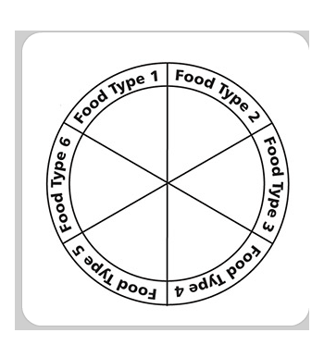
Procedure (continued) (data tables follow the procedure)
9. Repeat this process until all six sections of each dish contain their plant samples.
10. Once both dishes have been set up, place one brassica butterfly larva in the center of the experimental dish.
11. Place lids on both dishes.
12. Formulate a null hypothesis. A null hypothesis is one that typically states that there is no relationship between the independent and dependent variable. Record the null hypothesis on the data sheet (Tab 4). 13. Check the dishes after 24 hours. If any of the food items is practically gone, remove the larva from the dish and return it to the caterpillar habitat. If not, leave the dishes for another 24 hours before removing the larva. Do not run the experiment any longer than 48 hours.
14. As soon as you remove the caterpillar, take the mass of each of the remaining food samples in both the experimental and control dishes. If any sample has been depleted, record a mass of zero for that sample. Record the masses for the both groups in Data Table 1.
15. Calculate the percentage of mass lost for each plant sample during the experiment and record it in Data Table 1.
16. To calculate the percentage of mass loss that was due to herbivory, subtract the control percentage of mass decrease from the experimental percentage of mass decrease. Record these numbers on Data Table 2.
17. To calculate the change in mass that was due to herbivory alone (the mass of each sample that the caterpillar consumed), multiply the percentage calculated in step 16 by the initial mass of the experimental sample. Record these numbers on Data Table 2 (Tab 4).
18. Collect the class data for change in mass due to herbivory. Record the data on Data Table 3 (Tab 5).
19. Find the average change in mass due to herbivory. Record this in Data Table 3 (Tab 5). Answer the questions in the Data Analysis below and Laboratory Questions (Tab 3) sections.

Null hypothesis for this activity:

Table 1: Group Data on Plant Masses
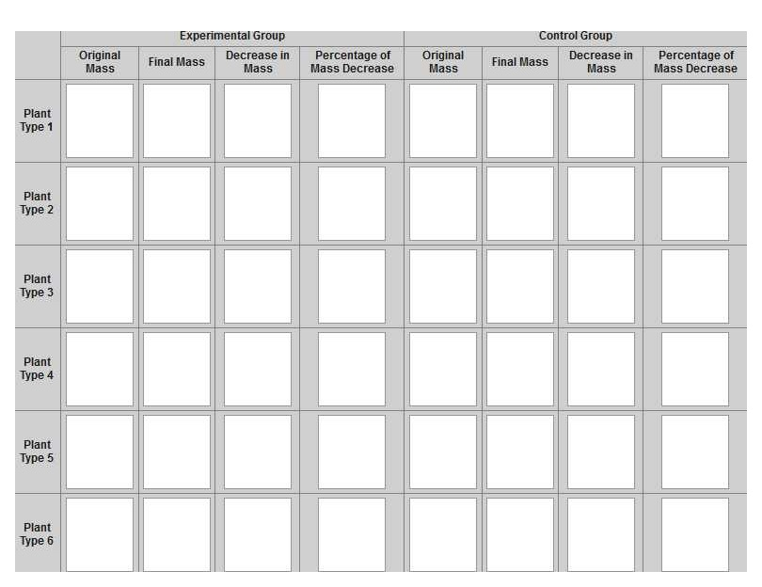
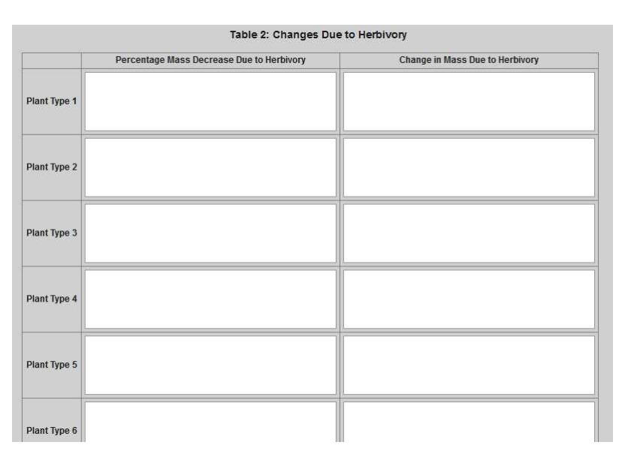
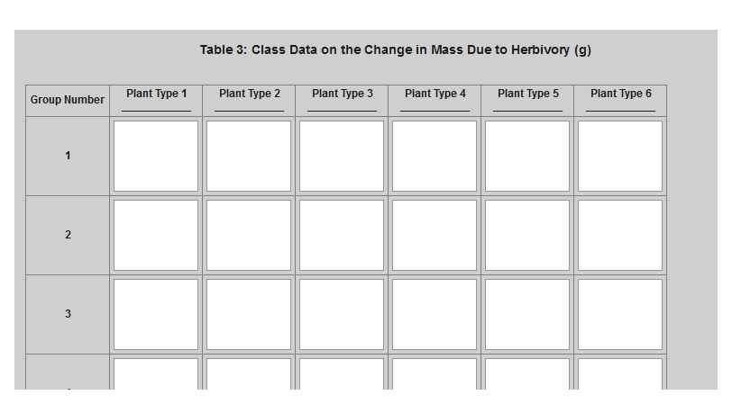
(depends on number of lab groups)
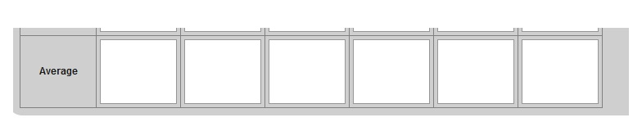

Data Analysis: (in your journal)
- Graph class averages (Tab 6) from Table 3.
Title the graph and supply the following information:
a. The independent variable is:
b. The dependent variable is:
Plot the independent variable on the x-axis, and the dependent variable on the y-axis.

Laboratory Questions: (in your journal)
- Based on the class data that was collected, was your hypothesis accepted or rejected? Explain what this tells you about the feeding preference of brassica butterfly larvae and any results that were not as you anticipated.
- Explain the purpose of the petri dish without a brassica larva.
- Based on the results of this experiment, if you were to search for brassica butterfly larvae outdoors, where would you look?
- Propose an ultimate cause for the feeding preference of the brassica butterfly larva.

Inquiry Activity:
You have just conducted an experiment to determine the feeding preferences of brassica butterfly larvae. During the course of this experiment, perhaps there was something else you wished you knew about brassica butterflies and their behavior. Now it is your turn to formulate a question and a plan for an experiment to find the answer. You may choose to examine behavior during the larva or adult stage.
The following are some of the materials that may be available to you. Due to the requirements of your approved experimental plan, your teacher may supply any number of other materials.
petri dishes
filter paper
pipet
medium cups with lids
variety of brassica and non-brassica plants (e.g., broccoli, mustard greens, red and/or green cabbage, lettuce, spinach, swiss chard)
water
scissors
masking tape
large deli containers
binder clips
small cups with lids
cotton wicks
sugars
honey
food coloring

Procedure
1. As a group, collaborate to come up with a question about butterfly larvae behavior or butterfly behavior. If you have trouble, ask your teacher for guidance.
2. Design an experiment to test your question. Consider the following as you frame your experiment:
• Question - What are you testing in your experiment? What are you trying to find out?
• Hypothesis - What do you think will happen? Why do you think so? What do you already know that helps support your hypothesis?
• Materials - What materials, tools, or instruments are you going to use to find the answer to the question?
• Procedure - What are you going to do? How are you going to do it? What are you measuring? How can you make sure the data you collect are accurate? What are the independent and dependent variables in this experiment? What is/are your control(s)? What safety practices do you need to use?
• Data Collection - What data will you record, and how will you collect and present it? Show and explain any data tables and graphs that you plan to use.
3. Have your teacher approve your experimental plan before you begin the experiment.
4. After you perform the experiment, analyze your data:
• Data Analysis - What happened? Did you observe anything that surprised you? Show and explain any tables and graphs that support your data.
• Conclusion - What conclusions can you draw from the results of your experiment? How does this compare with your initial hypothesis? Identify some possible sources of error in your experiment. If given the opportunity, how might you conduct the experiment differently?
5. Be prepared to present the findings of your experiment to the class according to your instructor's specification.

Part A: To be completed and approved before beginning the investigation
What question will you explore?
On the basis of your previous laboratory exercise, background knowledge, and research, what is the hypothesis that you will test?
What will be the independent and dependent variables?
What will be the control group(s)?
What equipment and materials will you need (list items and quantity)? (let teacher know on chalkboard)

Big Idea Assessments:
1. Living systems store, retrieve, transmit, and respond to information essential to life processes.
a. Explain how researchers could study a behavior to determine whether it is learned or innate. What results would indicate each condition?
b. Explain how optimal foraging theory might account for why many grazing species spend more time foraging in open grassy areas than in or near wooded areas.
2. In a classroom, students studied isopod behavior, attempting to determine whether isopods prefer moist or dry habitats. The students hypothesized that their isopods would prefer moist habitats. To test the hypothesis, the students placed 10 isopods in the center of a petri dish with moist filter paper on one side and dry filter paper on the other side. The students then counted how many isopods were on each side of the chamber every 30 seconds. Their data are shown below.
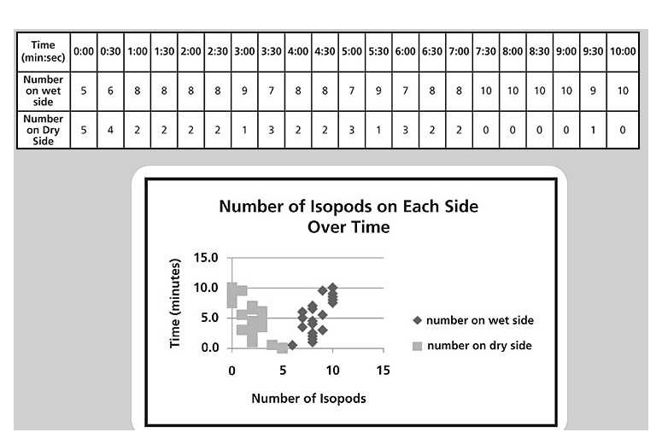
- Examine the graph provided. What mistakes did this researcher make in presenting data? Create a different graph (Tab 2) to present the data better and to determine whether the researcher's hypothesis was accepted or rejected.
- What conclusion(s) can be drawn from the results of the experiment and the data presented?
- Design an experiment to determine which of four sets of conditions isopods prefer: warm and moist, cool and moist, warm and dry, cool and dry.

Appendix: Procedure: Caterpillar Habitat and Caterpillar Care:
1. Using a pushpin, make several holes in the lid of the 16-oz cup.
2. Place a moistened piece of filter paper in the bottom of the cup.
3. Cut a piece of broccoli for the container. Remove the florets.
4. Cut the broccoli stalk into 1-inch pieces.
5. Place three pieces of broccoli in the container.
6. Place four caterpillars in the container.
7. Weekly, replace the filter paper with new moistened filter paper and replace the broccoli. If the broccoli begins to mold, this may need to be done more often.
Procedure: Butterfly Habitat and Transfer of Chrysalises
- To make an access door in the bottom of the butterfly habitat, take one large deli container and make two cuts in one of the long sides as shown below:
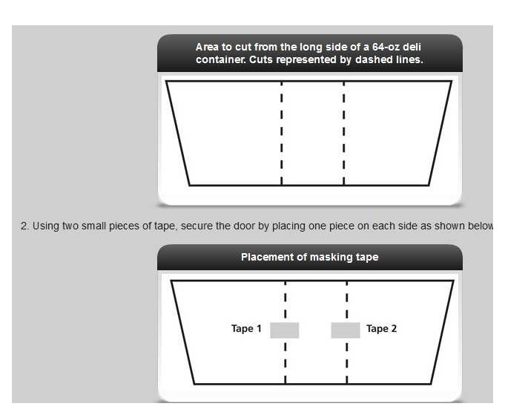
3.Invert an uncut 64-oz deli container on top to form a dome lid. Clamp the rims together with binder clips—one on each side without a door, and one on each side of the door to hold the two containers together.
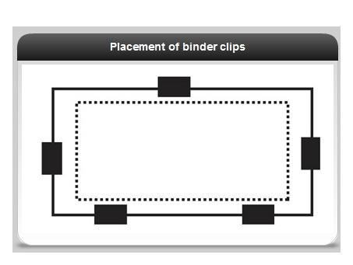
4. After the larvae have transformed into chrysalises, allow them to remain in the caterpillar habitat for 3 additional days.
5. After 3 days, place a strip of double-sided tape on the wall of the butterfly enclosure.
6. Carefully remove the chrysalises from the caterpillar enclosures and stick them on the tape, with the head facing upward and the abdomen down.
7. After the butterflies have emerged, they will require nectar and a nectar source.
Procedure: Nectar and Nectar Feeder:
- In the center of the lid for the 1﷯ -oz plastic cup, cut a small x for the wick. In the cup, place 1 teaspoon sugar, 2 or 3 drops of honey, and 1 or 2 drops of yellow food coloring (optional).
- Add warm water until the nectar feeder is three-quarters full and mix thoroughly.
- Saturate the cotton wicks with the prepared solution.
- Pull the wick through the hole so that about 3 centimeters protrudes from the top of the lid.
- Place the lid on the cup and the cup in the butterfly habitat. Replenish the nectar every 3 days.
Procedure: Egg Depository:
1. Cut a strip of wax paper about 1 inch wide by 4 inches long.
2. Place the plastic vial upside down and tape the strip of wax paper around the side as shown.
3. Using a small piece of double-stick tape, secure a brassica leaf to the top of the container. Trim around the edge to fit.
4. Place the egg depository in the butterfly enclosure. Replace the wax paper and leaf every 2 or 3 days. If you want to raise another generation, move the eggs to a nursery for hatching. If you are finished with them, place them in a freezer for 24 hours before disposal.
