Enzyme Action:
Testing Catalase Activity
Many organisms can decompose hydrogen peroxide (H₂O₂) enzymatically. Enzymes are globular proteins, responsible for most of the chemical activities of living organisms. They act as catalysts, as substances that speed up chemical reactions without being destroyed or altered during the process. Enzymes are extremely efficient and may be used over and over again. One enzyme may catalyze thousands of reactions every second. Both the temperature and the pH at which enzymes function are extremely important. Most organisms have a preferred temperature range in which they survive, and their enzymes most likely function best within that temperature range. If the environment of the enzyme is too acidic or too basic, the enzyme may irreversibly denature, or unravel, until it no longer has the shape necessary for proper functioning.
H₂O₂ is toxic to most living organisms. Many organisms are capable of enzymatically destroying the H₂O₂ before it can do much damage. H₂O₂ can be converted to oxygen and water, as follows:
2 H₂O₂ → 2 H₂O + O₂
Although this reaction occurs spontaneously, enzymes increase the rate considerably. At least two different enzymes are known to catalyze this reaction: catalase, found in animals and protists, and peroxidase, found in plants. A great deal can be learned about enzymes by studying the rates of enzyme-catalyzed reactions. The rate of a chemical reaction may be studied in a number of ways including:
- measuring the pressure of the product as it appears (in this case, O₂)
- measuring the rate of disappearance of substrate (in this case, H₂O₂)
- measuring the rate of appearance of a product (in this case, O₂ which is given off as a gas)
In this experiment, you will measure the rate of enzyme activity under various conditions, such as different enzyme concentrations, pH values, and temperatures. It is possible to measure the pressure of oxygen gas formed as H₂O₂ is destroyed. If a plot is made, it may appear similar to the graph shown.
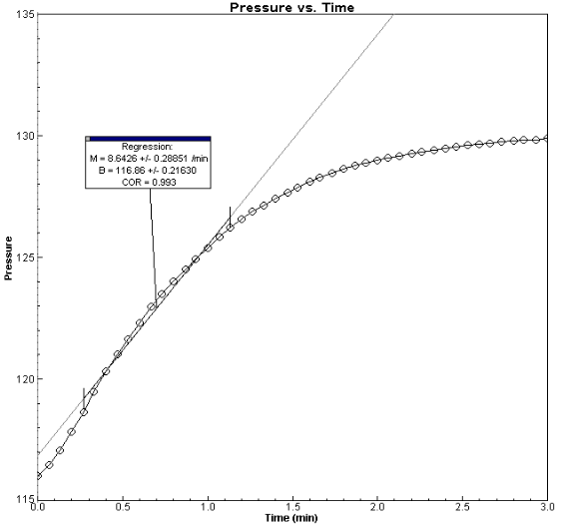
At the start of the reaction, there is no product, and the pressure is the same as the atmospheric pressure. After a short time, oxygen accumulates at a rather constant rate. The slope of the curve at this initial time is constant and is called the initial rate. As the peroxide is destroyed, less of it is available to react and the O₂ is produced at lower rates. When no more peroxide is left, O₂ is no longer produced.

Objectives
In this experiment, you will
- use a computer and Gas Pressure Sensor to measure the production of oxygen gas as hydrogen peroxide is destroyed by the enzyme catalase or peroxidase at various enzyme concentrations.
- measure and compare the initial rates of reaction for this enzyme when different concentrations of enzyme react with H₂O₂.
- measure the production of oxygen gas as hydrogen peroxide is destroyed by the enzyme catalase or peroxidase at various temperatures.
- measure and compare the initial rates of reaction for the enzyme at each temperature.
- measure the production of oxygen gas as hydrogen peroxide is destroyed by the enzyme catalase or peroxidase at various pH values.
- measure and compare the initial rates of reaction for the enzyme at each pH value.

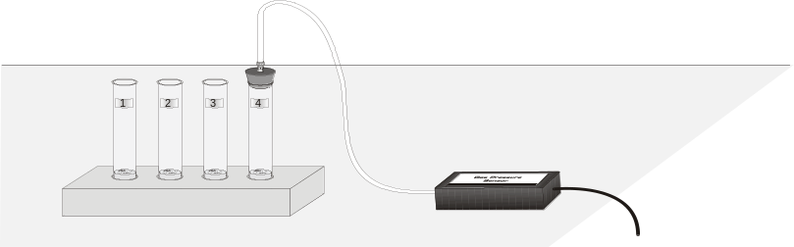

Figure 1

MATERIALS
Power Macintosh or Windows PC | 600-mL beaker
Vernier computer interface | enzyme suspension
Logger Pro | four 18 X 150 mm test tubes
Vernier Gas Pressure Sensor | ice
1-hole rubber stopper assembly | pH buffers
10-mL graduated cylinder | test tube rack
150-mL beaker of water | thermometer
3% H₂O₂ | three dropper pipettes

PROCEDURE
1. Obtain and wear goggles.
2. Prepare the computer for data collection by opening the Experiment 6B folder from the Biology with Computers folder of Logger Pro. Then open the experiment file that matches the probe you are using. The vertical axis has pressure scaled from 90 to 140 kPa. The horizontal axis has time scaled from 0 to 3 minutes. The data rate is set to 12 samples/minute.
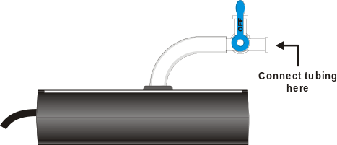
Figure 2
3. Connect the plastic tubing to the valve on the Gas Pressure Sensor. If your sensor has a blue plastic valve on it, place the valve in the position shown in Figure 2.
Part I Testing the Effect of Enzyme Concentration
4. Place four test tubes in a rack and label them 1, 2, 3, and 4. Partially fill a beaker with tap water for use in Step 5.
5. Add 3 mL of water and 3 mL of 3% H₂O₂ to each test tube.
6. Using a clean dropper pipette, add 1 drop of enzyme suspension to Test Tube 1. Note: Be sure not to let the enzyme fall against the side of the test tube.
Table 1
Test tube label | Volume of 3% H₂O₂ (mL) | Volume of water (mL)
1 | 3 | 3
2 | 3 | 3
3 | 3 | 3
4 | 3 | 3

7. Stopper the test tube and gently swirl to thoroughly mix the contents. The reaction should begin. The next step should be completed as rapidly as possible.

Figure 3
8. Connect the free-end of the plastic tubing to the connector in the rubber stopper as shown in Figure 3. Click to begin data collection. Data collection will end after 3 minutes.
9. If the pressure exceeds 130 kPa, the pressure inside the tube will be too great and the rubber stopper is likely to pop off. Disconnect the plastic tubing from the Gas Pressure Sensor if the pressure exceeds 130 kPa.
10. When data collection has finished, disconnect the plastic tubing connector from the rubber stopper. Remove the rubber stopper from the test tube and discard the contents in a waste beaker.
11. Find the rate of enzyme activity:
- Move the mouse pointer to the point where the data values begin to increase. Hold down the mouse button. Drag the mouse pointer to the point where the pressure values no longer increase and release the mouse button.
- Click the Regression button, , to perform a linear regression. A floating box will appear with the formula for a best-fit line.
- Record the slope of the line, m, as the rate of enzyme activity in Table 4.
- Close the linear regression floating box.

12. Find the rate of enzyme activity for test tubes 2 – 4:
- Add 2 drops of the enzyme solution to test tube 2. Repeat Steps 7 – 11.
- Add 3 drops of the enzyme solution to test tube 3. Repeat Steps 7 – 11.
- Add 4 drops of the enzyme solution to test tube 4. Repeat Steps 7 – 11.

Part II Testing the Effect of Temperature
13. Place four clean test tubes in a rack and label them T 0 – 5, T 20 – 25, T 30 – 35, and T 50 – 55.
14. Add 3 mL of 3% H₂O₂ and 3 mL of water to each test tube, as shown in Table 2.
Table 2
Test tube label | Volume of 3% H₂O₂ (mL) | Volume of water
T 0 – 5 | 3 | 3
T 20 – 25 (room temp) | 3 | 3
T 30 – 35 | 3 | 3
T 50 – 55 | 3 | 3

15. Measure the enzyme activity at 0 – 5°C:
- Prepare a water bath at a temperature in the range of 0 – 5°C by placing ice and water in a 600-mL beaker. Check that the temperature remains in this range throughout this test.
- Place Test Tube T 0 – 5 in the cold water bath until the temperature of the mixture reaches a temperature in the 0 – 5°C range. Record the actual temperature of the test-tube contents in the blank in Table 4.
- Add 2 drops of the enzyme solution to Test Tube T 0 – 5. Repeat Steps 7 – 11.

16. Measure the enzyme activity at 30 – 35°C:
- Prepare a water bath at a temperature in the range of 30 – 35°C by placing warm water in a 600-mL beaker. Check that the temperature remains in this range throughout this test.
- Place Test Tube T 30 – 35 in the warm water bath until the temperature of the mixture reaches a temperature in the 30 – 35°C range. Record the actual temperature of the test-tube contents in the blank in Table 4.
- Add 2 drops of the enzyme solution to Test Tube T 30 – 35. Repeat Steps 7 – 11.

17. Measure the enzyme activity at 50 – 55°C:
- Prepare a water bath at a temperature in the range of 50 – 55°C by placing hot water in a 600-mL beaker (hot tap water will probably work fine). Check that the temperature remains in this range throughout this test.
- Place Test Tube T 50 – 55 in the warm water bath until the temperature of the mixture reaches a temperature in the 50 – 55°C range. Record the actual temperature of the test-tube contents in the blank in Table 4.
- Add 2 drops of the enzyme solution to Test Tube T 50 – 55. Repeat Steps 7 – 11.

18. Measure the enzyme activity at 20 – 25°C (room temperature):
- Record the temperature of Test Tube T 20 – 25 in Table 4.
- In the tube labeled T 20 – 25, add 2 drops of the enzyme solution. Repeat Steps 7 – 11.

Part III Testing the Effect of pH
19. Place three clean test tubes in a rack and label them pH 4, pH 7, and pH 10.
20. Add 3 mL of 3% H₂O₂ and 3 mL of each pH buffer to each test tube, as in Table 3.
Table 3
pH of buffer | Volume of 3% H₂O₂ (mL) | Volume of buffer (mL)
pH 4 | 3 | 3
pH 7 | 3 | 3
pH 10 | 3 | 3

21. In the tube labeled pH 4, add 2 drops of the enzyme solution. Repeat Steps 7 – 11.
22. In the tube labeled pH 7, add 2 drops of the enzyme solution. Repeat Steps 7 – 11.
23. In the tube labeled pH 10, add 2 drops of the enzyme solution. Repeat Steps 7 – 11.

DATA
Table 4
Test tube label | Slope, or rate (kPa/min)
1 Drop
2 Drops
3 Drops
4 Drops
0 – 5 °C range: _____ °C
20 – 25 °C range: _____ °C
30 – 35 °C range: _____ °C
50 – 55 °C range: _____ °C
pH 4
pH 7
pH 10

PROCESSING THE DATA
Enzyme concentration plot
1. Open the Manual Entry experiment file from the Biology with Computers folder of Logger Pro. Create a graph of the rate of enzyme activity vs. enzyme concentration. The rate values should be plotted on the y-axis, and the number of drops of enzyme on the x-axis. The rate values are the same as the slope values in Table 4.
Temperature plot
2. Create a graph of the rate of enzyme activity vs. temperature. The rate values should be plotted on the y-axis, and the temperature on the x-axis. The rate values are the same as the slope values in Table 4.
pH plot
3. Create a graph of rate of enzyme activity vs. pH. The rate values should be plotted on the y-axis, and the pH on the x-axis. The rate values are the same as the slope values in Table 4.

QUESTIONS
Part I Effect of Enzyme Concentration
1. How does changing the concentration of enzyme affect the rate of decomposition of H2O2?
- What do you think will happen to the rate of reaction if the concentration of enzyme is increased to five drops? Predict what the rate would be for 5 drops.
Part II Effect of Temperature
3. At what temperature is the rate of enzyme activity the highest? Lowest? Explain.
4. How does changing the temperature affect the rate of enzyme activity? Does this follow a pattern you anticipated?
5. Why might the enzyme activity decrease at very high temperatures?
Part III Effect of pH
6. At what pH is the rate of enzyme activity the highest? Lowest?
7. How does changing the pH affect the rate of enzyme activity? Does this follow a pattern you anticipated?

extensions
1. Different organisms often live in very different habitats. Design a series of experiments to investigate how different types of organisms might affect the rate of enzyme activity. Consider testing a plant, an animal, and a protist.
- Presumably, at higher concentrations of H₂O₂, there is a greater chance that an enzyme molecule might collide with H₂O₂. If so, the concentration of H₂O₂ might alter the rate of oxygen production. Design a series of experiments to investigate how differing concentrations of the substrate hydrogen peroxide might affect the rate of enzyme activity.
- Design an experiment to determine the effect of boiling the catalase on the reaction rate.
- Explain how environmental factors affect the rate of enzyme-catalyzed reactions.

