Evolution Unit Study Guide

1. According to Darwin’s theory of natural selection, individuals who survive are the ones best adapted for their environment. Their survival is due to the

2. The fossil record shows that

3. What best defines evolution by natural selection?

4. A change in a sequence of DNA is called a

5. In organisms that reproduce sexually, inheritable variation is due mostly to

6. In a particular population, sexual reproduction can produce

7. Natural selection acts directly on

8. In genetic drift, allele frequencies change because of

9. What factors are necessary for the formation of a new species?

10. Lethal alleles remain within a population gene pool because

11. On the Galápagos Islands, Charles Darwin observed…

12. James Hutton’s and Charles Lyell’s work was important to Darwin because these scientists…

13. In an experiment, suppose that the wings of fruit flies were clipped short for fifty generations. The fifty-first generation emerged with normal-length wings. This observation would tend to disprove which idea?

14. When a farmer breeds only his or her best livestock, the process involved is called?

15. Members of a population that live long enough to reproduce is consistent with which part of the theory of natural selection?

16. An adaptation is an inherited characteristic that can be….

17. In humans, the pelvis and femur, or thigh bone, are involved in walking. In whales, the pelvis and femur are features that are considered….

18. Modern sea star larvae resemble some primitive vertebrate larvae. This similarity may suggest that primitive vertebrates are…

19. Darwin’s theory of evolution is based on the idea(s) of

20. What all members of a population share in common?

21. What are gene pools?

22. In a population, the sum of the relative frequencies of all alleles for a particular trait is

23. The two main sources of genetic variation are

24. A single-gene trait that has two alleles and that shows a simple dominant-recessive pattern will result in

25. The number of phenotypes produced for a given trait depends upon

26. The phenotypes for a typical polygenic trait can often be expressed as

27. When individuals at only one end of a bell curve of phenotype frequencies have high fitness, the result is

28. In a population of finches in which one group of birds has a short, parrotlike beak and another group has a long, narrow beak, what process has probably occurred?

29. The type of genetic drift that follows the colonization of a new habitat by a small group of individuals is called

30. The situation in which allele frequencies of a population remain constant is called

31. Which factor would most likely disrupt genetic equilibrium in a large population?

32. The separation of populations by barriers such as rivers, mountains, or bodies of water is called

33. What situation might develop in a population having some plants whose flowers open at midday and other plants whose flowers open late in the day?

34. How did the Galápagos finches evolve?

35. Sedimentary rock is formed from

36. What must be true about an index fossil whose absolute age is used as a reference for other fossils?

37. Hominids differ from other primates on the basis of all of the following EXCEPT

38. Bipedal locomotion consists of

39. Two hominids whose fossils you would NOT expect to find in rocks of the same age are

Other

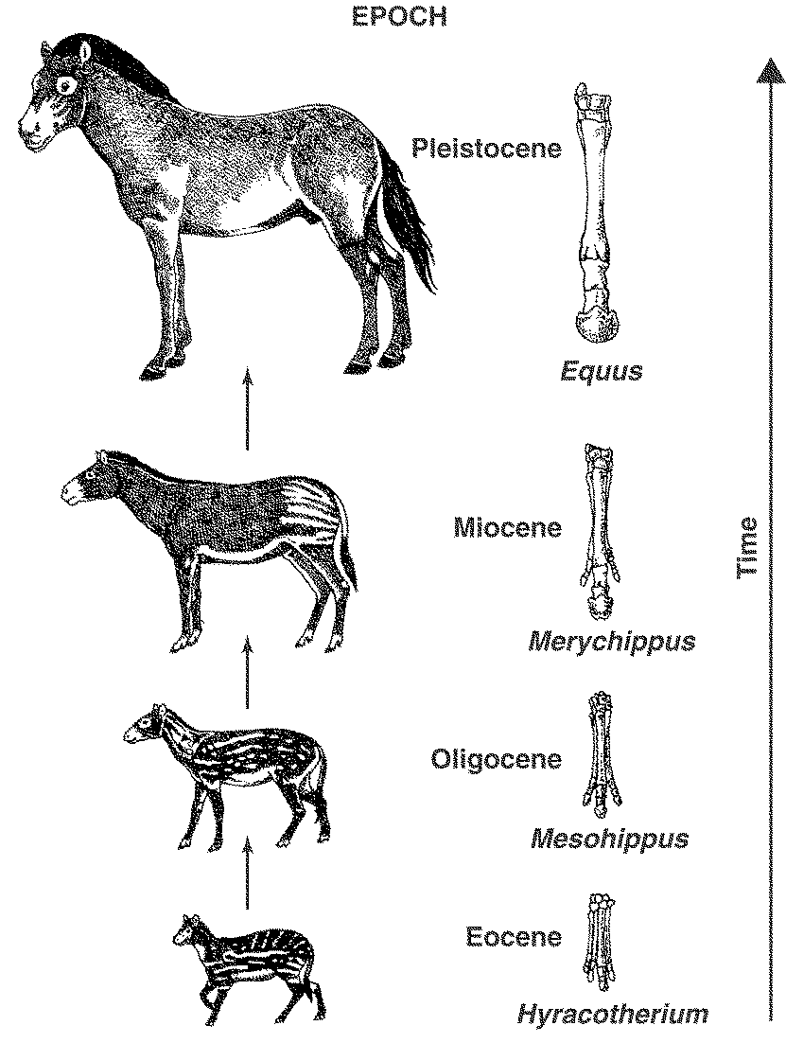

Figure 15–2

40. According to Figure 15-2, how did overall body size of the horse change during its evolution?

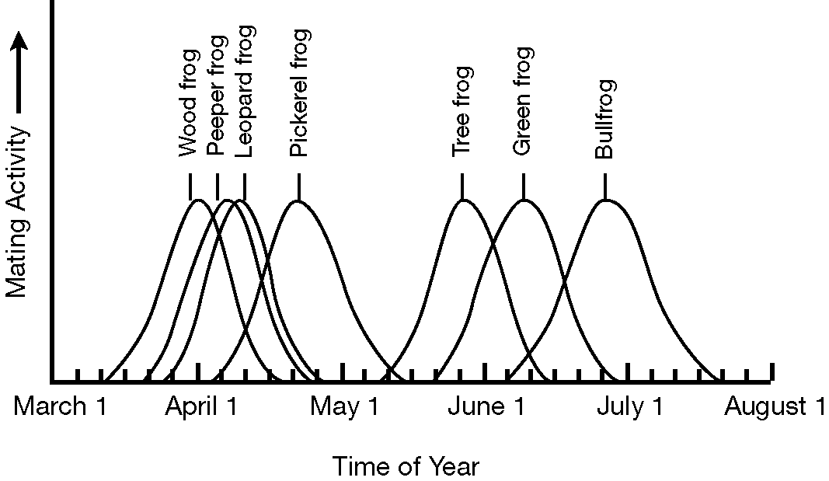

Figure 16–2

41. The information about frog species in Figure 16-2 reveals…

42. Suppose selective breeding has produced a population of very similar chickens. Would that population survive if it were released into the wild? Explain.

43. Describe the founder effect, and describe the conditions in which it arises.

44. Assume that a geographic barrier that results in two very different ecosystems splits a single population. What would likely happen to the two separate populations? Would this process occur more quickly, less quickly, or at the same rate as it would if the two populations lived in similar ecosystems?

45. Identify two features of the primate skeleton that are associated with bipedal locomotion, and contrast these features with their counterparts in a primate that is not bipedal.

