Sugar Fermentation in Yeast
Yeast are able to metabolize some foods, but not others. In order for an organism to make use of a potential source of food, it must be capable of transporting the food into its cells. It must also have the proper enzymes capable of breaking the food’s chemical bonds in a useful way. Sugars are vital to all living organisms. Yeast are capable of using some, but not all sugars as a food source. Yeast can metabolize sugar in two ways, aerobically, with the aid of oxygen, or anaerobically, without oxygen.
In this lab, you will try to determine whether yeast are capable of metabolizing a variety of sugars. Although the aerobic fermentation of sugars is much more efficient, in this experiment we will have yeast ferment the sugars anaerobically. When the yeast respire aerobically, oxygen gas is consumed at the same rate that CO₂ is produced—there would be no change in the gas pressure in the test tube. When yeast ferment the sugars anaerobically, however, CO₂ production will cause a change in the pressure of a closed test tube, since no oxygen is being consumed. We can use this pressure change to monitor the fermentation rate and metabolic activity of the organism.
The fermentation of glucose can be described by the following equation:
C₆H₁₂O₆ → 2 CH₃CH₂OH + 2 CO₂ + energy
glucose ethanol carbon dioxide

Note that alcohol is a byproduct of this fermentation.

OBJECTIVES
In this experiment, you will
- use a Gas Pressure Sensor to measure the pressure change caused by carbon dioxide released during fermentation.
- determine the rate of fermentation.
- determine which sugars yeast can metabolize.

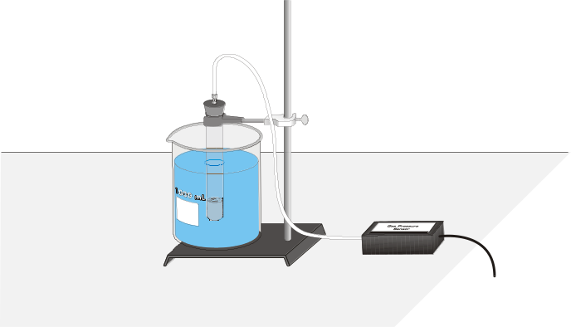
Figure 1

MATERIALS
Power Macintosh or Windows PC | 18 X 150 mm test tube
Vernier computer interface | 1-L beaker (for water bath)
Logger Pro | basting bulb or Beral pipette
Vernier Gas Pressure Sensor | hot and cold water
l-hole rubber stopper assembly | test tube rack
plastic tubing with Luer-lock fitting | thermometer
5% glucose, sucrose, lactose, and one other sugar solution | yeast suspension  vegetable oil in dropper bottle
ring stand | utility clamp

PROCEDURE
1. Prepare the computer for data collection by opening the Experiment 12B folder from the Biology with Computers folder of Logger Pro. Then open the experiment file that matches the probe you are using. The vertical axis has pressure scaled from 90 to 130 kPa. The horizontal axis has time scaled from 0 to 15 minutes. The data rate is set to 6 samples/minute.
2. Connect the plastic tubing to the valve on the Gas Pressure Sensor. If your sensors have blue plastic valves on them, place the valve in the position shown in Figure 2.
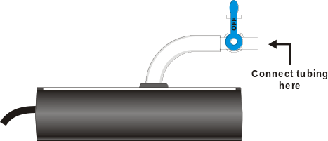
Figure 2
3. Prepare a water bath for the yeast. A water bath is simply a large beaker of water at a certain temperature. This ensures that the yeast will remain at a constant and controlled temperature. To prepare the water bath, obtain some warm and cool water from your teacher. Combine the warm and cool water into the 1-liter beaker until it reaches 38 – 40°C. The beaker should be filled with about 600 – 700 mL water. Place the thermometer in the water bath to monitor the temperature during the experiment.
4. Obtain two test tubes and label them 1 and 2.
5. Your team will test two of the four sugar solutions. Obtain two of the four sugar solutions: glucose, sucrose, lactose, and one other sugar solution, as directed by your instructor. Place 2.5 mL of the first sugar solution into test tube 1 and 2.5 mL of the second sugar solution into test tube 2. Record which solutions you tested in Table 1.
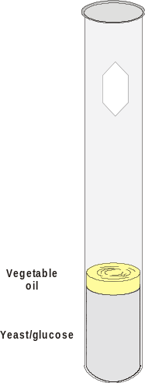
Figure 3
6. Set the test tubes into the water bath.
7. Obtain the yeast suspension. Gently swirl the yeast suspension to mix the yeast that settles to the bottom. Using a 10-mL pipette or graduated cylinder, transfer 2.5 mL of yeast into test tube 1. Gently mix the yeast into the sugar solution. Be gentle with the yeast—they are living organisms!
8. In the test tube, place enough vegetable oil to completely cover the surface of the yeast/glucose mixture as shown in Figure 3. Be careful to not get oil on the inside wall of the test tube. Set the test tube in the water bath.
9. Insert the single-holed rubber-stopper into the test tube. Note: Firmly twist the stopper for an airtight fit. Secure the test tube with a utility clamp and ring-stand as shown in Figure 1.
10. Incubate the test tube for 10 minutes in the water bath. Be sure to keep the temperature of the water bath constant. If you need to add more hot or cold water, first remove about as much water as you will be adding, or the beaker may overflow. Use a basting bulb to remove excess water.
Note: Be sure that most of the test tube is completely covered by the water in the water bath. The temperature of the air in the tube must be constant for this experiment to work well.
11. When incubation has finished, connect the free-end of the plastic tubing to the connector in the rubber stopper as shown in Figure 4.
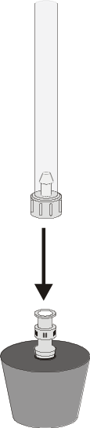
Figure 4
12. Click to begin data collection. Maintain the temperature of the water bath during the course of the experiment. Data will be collected for 15 minutes.
13. Monitor the pressure readings displayed in the Meter window. If the pressure exceeds 130 kilopascals, the pressure inside the tube will be too great and the rubber stopper is likely to pop off. Disconnect the plastic tubing from the Gas Pressure Sensor if the pressure exceeds 130 kilopascals.
14. When data collection has finished, disconnect the plastic tubing connector from the rubber stopper. Remove the rubber stopper from the test tube and discard the contents in a waste beaker.
15. From the Data menu, choose Store Latest Run. This stores the data so it can be used later, but it will still be displayed while you collect data for the second test tube.
16. Repeat Steps 7 – 14 using test tube 2.
17. Click on the Linear Regression button, . Be sure both data runs are checked, then click . A best-fit linear regression line will be shown for each of your runs. In Table 1, record the value of the slope, m, for each of the test tubes. (The linear regression statistics are displayed in a floating box for each of the data sets.)
18. To print a graph of pressure vs. time showing both data runs:
- Label both curves by choosing Make Annotation from the Analyze menu, and typing the sugar you tested in the edit box. Repeat for the second sugar tested. Then drag each box to a position near its respective curve.
- Print a copy of the Graph window, with both data sets and the regression lines displayed. Enter your name(s) and the number of copies of the graph you want.

DATA
Table 1
 | Type of Sugar | Rate of Fermentation (kPa/min)
Test tube 1
Test tube 2

Table 2: Class Averages
Sugar Tested | Fermentation Rate (kPa/min)
Control

PROCESSING THE DATA
1. Share your data with the rest of the class by recording the sugar type you tested and the rate of fermentation on the board.
2. Using the class data, calculate the average rates of fermentation for each of the sugar types tested. Record the average rates in Table 2, along with the names of the 4 sugars tested.
3. Using the class data in Table 2, make a bar graph of rate of fermentation vs. sugar type. The rate values should be plotted on the y-axis, and the sugar type on the x-axis.

QUESTIONS
1. Considering the results of this experiment, can yeast utilize all of the sugars equally well? Explain.
2. Hypothesize why some sugars were not metabolized while other sugars were.
3. Why do you need to incubate the yeast before you start monitoring air pressure?
4. Yeast live in many different environments. Make a list of some locations where yeast might naturally grow. Estimate the food sources of each of these locations.

