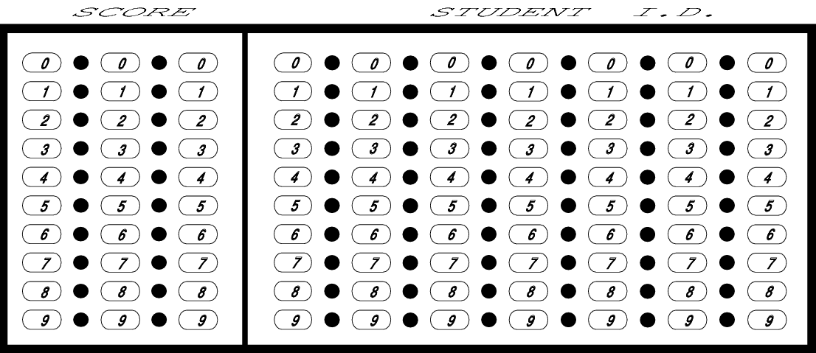
NAME ___________________________________
DATE _____________ PER ___

MAPPING ESSENTIAL KNOWLEDGES ACTIVITY

Big Idea >Enduring Understandings (EU)>Essential Knowledges (EK) > Learning Objectives (LO)

Procedures:
- Read the EU statement at the top of the page.
- Convert the EK statement at the bottom of the page into a question. Place the question in the center of your paper as your title.
- Read each statement found within the EK. Take the statements and condense them into shorter statements/questions/flowchart a regular biology student could understand! Place these outside the center circle. Remember: the statements/questions/flowcharts must ANSWER YOUR CENTRAL QUESTION!
- Associate each of these statements/questions/flowchart with the name/image of an example OR experiment OR activity. DO include data tables, graphs, and/or charts in your map. DO NOT include any explanations. Place these outside the second circle and within the box.
- During the group presentation, your group will explain how all the components on your graphic organizer (EU, EK, statements, questions, examples, experiments, activity) are related and ultimately answers the title question.

Examples, Experiments, Activities

Regular bio statements

Title
Question

Enduring Understanding 1A
Change in the genetic makeup of a population over time is evolution.

Essential knowledge 1.A.1: Natural Selection is a major mechanism of evolution.
Enduring Understanding 1A
Change in the genetic makeup of a population over time is evolution.

Essential knowledge 1.A.2: Natural selection acts on phenotypic variations in populations.
Enduring Understanding 1A
Change in the genetic makeup of a population over time is evolution.

Essential knowledge 1.A.3: Evolutionary change is also driven by random processes.
Enduring Understanding 1A
Change in the genetic makeup of a population over time is evolution.

Essential knowledge 1.A.4: Biological evolution is supported by scientific evidence from many disciplines, including mathematics.

Enduring Understanding 1B
Organisms are linked by lines of descent from common ancestry.

Essential knowledge 1.B.1: Organisms share many conserved core processes and features that evolved and are widely distributed among organisms today.

Enduring Understanding 1B
Organisms are linked by lines of descent from common ancestry.

Essential knowledge 1.B.2: Phylogenetic trees and cladograms are graphical representations (models) of evolutionary history that can be tested.
Enduring Understanding 1C
Life continues to evolve within a changing environment.

Essential knowledge 1.C.1: Speciation and extinction have occurred throughout the Earth’s history.
Enduring Understanding 1C
Life continues to evolve within a changing environment.

Essential knowledge 1.C.2: Speciation may occur when two populations become reproductively isolated from each other.
Enduring Understanding 1C
Life continues to evolve within a changing environment.

Essential knowledge 1.C.3: Populations of organisms continue to evolve.
Enduring Understanding 1D
The origin of living systems is explained by natural processes.

Essential knowledge 1.D.1: There are several hypotheses about the natural origin of life on Earth, each with supporting scientific evidence.
Enduring Understanding 1D
The origin of living systems is explained by natural processes.

Essential knowledge 1.D.2: Scientific evidence from many different disciplines supports models of the origin of life.
Enduring Understanding 2A
Growth, reproduction and maintaining the organization of living systems require energy and matter.

Essential knowledge 2.A.1: All living systems require constant input of free energy.

Enduring Understanding 2A
Growth, reproduction and maintaining the organization of living systems require energy and matter.

Essential knowledge 2.A.2: Organisms capture and store free energy for use in biological processes.
Enduring Understanding 2A
Growth, reproduction and maintaining the organization of living systems require energy and matter.

Essential knowledge 2.A.3: Organisms must exchange matter with the environment to grow, reproduce, and maintain organization.
Enduring Understanding 2B
Growth, reproduction and homeostasis require that cells create and maintain internal environments that are different from their external environments.

Essential knowledge 2.B.1: Cell membranes are selectively permeable due to their structure.
Enduring Understanding 2B
Growth, reproduction and homeostasis require that cells create and maintain internal environments that are different from their external environments.

Essential knowledge 2.B.2: Growth and dynamic homeostasis are maintained by the constant movement of molecules across membranes.
Enduring Understanding 2B
Growth, reproduction and homeostasis require that cells create and maintain internal environments that are different from their external environments.

Essential knowledge 2.B.3: Eukaryotic cells maintain internal membranes that partition the cell into specialized regions.
Enduring Understanding 2C
Organisms use feedback mechanisms to regulate growth and maintain homeostasis.

Essential knowledge 2.C.1: Organisms use feedback mechanisms to regulate growth and reproduction, and to maintain dynamic homeostasis.
Enduring Understanding 2C
Organisms use feedback mechanisms to regulate growth and maintain homeostasis.

Essential knowledge 2.C.2: Organisms respond to changes in their external environments.

Enduring Understanding 2D
Growth and homeostasis of a biological system are influenced by changes in the system’s environment.

Essential knowledge 2.D.1: All biological systems from cells and organisms to populations, communities, and ecosystems are affected by complex biotic and abiotic interactions involving exchange of matter and free energy.
Enduring Understanding 2D
Growth and homeostasis of a biological system are influenced by changes in the system’s environment.

Essential knowledge 2.D.2: homeostatic mechanisms reflect both common ancestry and divergence due to adaption in different environments.
Enduring Understanding 2D
Growth and homeostasis of a biological system are influenced by changes in the system’s environment.

Essential knowledge 2.D.3: Biological systems are affected by disruptions in their dynamic homeostasis.

Enduring Understanding 2D
Growth and homeostasis of a biological system are influenced by changes in the system’s environment.

Essential knowledge 2.D.4: Plants and animals have a variety of chemical defenses against infections that affect dynamic homeostasis.
Enduring Understanding 2E
Many biological processes involved in growth, reproduction and homeostasis include temporal aspects.

Essential knowledge 2.E.1: Timing coordination of specific events is necessary for the normal development of an organism, and these events are regulated by a variety of mechanisms.
Enduring Understanding 2E
Many biological processes involved in growth, reproduction and homeostasis include temporal aspects.

Essential knowledge 2.E.2: Timing and coordination of physiological events are regulated by multiple mechanisms.
Enduring Understanding 2E
Many biological processes involved in growth, reproduction and homeostasis include temporal aspects.

Essential knowledge 2.E.3: Timing and coordination of behavior are regulated by various mechanisms and are important in natural selection.
Enduring Understanding 3A: Heritable information provides for continuity of life.

Essential knowledge 3.A.1: DNA, and in some cases RNA, is the primary source of heritable information.
Enduring Understanding 3A: Heritable information provides for continuity of life.

Essential knowledge 3.A.2: In eukaryotes, heritable information is passed to the next generation via processes that include the cell cycle and mitosis or meiosis plus fertilization.
Enduring Understanding 3A: Heritable information provides for continuity of life.

Essential knowledge 3.A.3: The chromosomal basis of inheritance provides an understanding of the pattern of passage of genes from parent to offspring.
Enduring Understanding 3A: Heritable information provides for continuity of life.

Essential knowledge 3.A.4: The inheritance pattern of many traits cannot be explained by simple Mendelian genetics.
Enduring Understanding 3B
Expression of genetic information involves cellular and molecular mechanisms.

Essential knowledge 3.B.1: gene regulation, results in differential gene expression, leading to cell specialization.
Enduring Understanding 3B
Expression of genetic information involves cellular and molecular mechanisms.

Essential knowledge 3.B.2: A variety of intercellular and intracellular signal transmissions mediate gene expression.
Enduring Understanding 3C
Transfer of genetic information may produce variation.

Essential knowledge 3.C.1: Changes in genotype can result in changes in phenotype.

Enduring Understanding 3C
Transfer of genetic information may produce variation.

Essential knowledge 3.C.2: Biological systems have multiple processes that increase genetic variation.
Enduring Understanding 3C
Transfer of genetic information may produce variation.

Essential knowledge 3.C.3: Viral replication results in genetic variation, and viral infection genetic variation into the hosts.
Enduring Understanding 3D
Cells communicate by generating, transmitting and receiving chemical signals.

Essential knowledge 3.D.1: Cell communication processes share three common features that reflect a shared evolutionary history.
Enduring Understanding 3D
Cells communicate by generating, transmitting and receiving chemical signals.

Essential knowledge 3.D.2: Cells communicate with each other through direct contact with other cells or from a distance via chemical signaling.
Enduring Understanding 3D
Cells communicate by generating, transmitting and receiving chemical signals.

Essential knowledge 3.D.3: Signal transduction pathways link reception with cellular response.
Enduring Understanding 3D
Cells communicate by generating, transmitting and receiving chemical signals.

Essential knowledge 3.D.4: Changes in signal transduction pathways can alter cellular response.
Enduring Understanding 3E
Transmission of nonheritable information results in changes within and between biological systems.

Essential knowledge 3.E.1: Individuals can act on information and communicate it with others.
Enduring Understanding 3E
Transmission of non-heritable information results in changes within and between biological systems.

Essential knowledge 3.E.2: Animals have nervous systems that detect external and internal signals, transmit and integrate information, and produce responses.
Enduring Understanding 4A
Interactions within biological systems lead to complex properties.

Essential knowledge 4.A.1: The subcomponents of biological molecules and their sequence determine the properties of that molecule.
Enduring Understanding 4A
Interactions within biological systems lead to complex properties.

Essential knowledge 4.A.2: The structure and function of subcellular components, and their interactions, provide essential cellular processes.
Enduring Understanding 4A
Interactions within biological systems lead to complex properties.

Essential knowledge 4.A.3: Interactions between external stimuli and regulated gene expression result in specialization of cells, tissues and organs.
Enduring Understanding 4A
Interactions within biological systems lead to complex properties.

Essential knowledge 4.A.4: Organisms exhibit complex properties due to interactions between their constituent parts.
Enduring Understanding 4A
Interactions within biological systems lead to complex properties.

Essential knowledge 4.A.5: Communities are composed of populations of organisms that interact in complex ways.
Enduring Understanding 4A
Interactions within biological systems lead to complex properties.

Essential knowledge 4.A.6: Interactions among living systems and with their environment result in the movement of matter and energy.
Enduring Understanding 4B
Competition and cooperation are important aspects of biological systems.

Essential knowledge 4.B.1: Interactions between molecules affect their structure and function.
Enduring Understanding 4B
Competition and cooperation are important aspects of biological systems.

Essential knowledge 4.B.2: Cooperative interactions within organisms promote efficiency in the use of energy and matter.
Enduring Understanding 4B
Competition and cooperation are important aspects of biological systems.

Essential knowledge 4.B.3: Interactions between and within populations influence patterns of species distribution and abundance.
Enduring Understanding 4B
Competition and cooperation are important aspects of biological systems.

Essential knowledge 4.B.4: Distribution of local and global ecosystems changes over time.

Enduring Understanding 4C
Variation within biological systems affects interactions with the environment.

Essential knowledge 4.C.1: Variation in molecular units provides cells with a wider range of functions.
Enduring Understanding 4C
Variation within biological systems affects interactions with the environment.

Essential knowledge 4.C.2: Environmental factors influence the expression of the genotype in an organism.
Enduring Understanding 4C
Variation within biological systems affects interactions with the environment.

Essential knowledge 4.C.3: The level of variation in a population affects population dynamics.
Enduring Understanding 4C
Variation within biological systems affects interactions with the environment.

Essential knowledge 4.C.4: The diversity of species within an ecosystem may influence the stability of the ecosystem.
Science Practice 1
The student can use representations and models to communicate scientific phenomena and solve scientific problems.

Science Practice 2
The student can use mathematics appropriately.

Science Practice 3
The student can engage in scientific questioning to extend thinking or to guide investigations within the context of the AP course.

Science Practice 4
The student can plan and implement data collection strategies appropriate to a particular scientific question.

Science Practice 5
The student can perform data analysis and evaluation of evidence.

Science Practice 6
The student can work with scientific explanations and theories.

Science Practice 7
The student is able to connect and relate knowledge across various scales, concepts and representations in and across domains.

