Medical Problem Solving Case Study: Pretzel Syndrome

1) Case summary

A Mennonite woman had a pregnancy complicated by excessive amniotic fluid (polyhydramnios) and preterm labor. Her baby boy was born in breech position at the premature age of 30 weeks. The doctor in the delivery room noted his unusual appearance. He had macrocephaly (head circumference >90th percentile for age), prominent forehead, widely spaced eyes (hypertelorism), peaked eyebrows, a small pointed chin, and a small mouth (see Figure 1). At three weeks of age he had a seizure—a sudden stiffening followed by large-scale (clonic) jerking of both arms that lasted for one minute. Two anticonvulsants were required to control seizures. By age 3 months, his pediatrician noticed that he had low muscle tone, abnormal eye alignment (strabismus), and a low-pitched heart murmur. An echocardiogram revealed a large defect in the septum that divides the chambers of the heart (atrial septal defect).
The boy made no developmental progress. By 10 years of age, he had profound psychomotor retardation, was confined to a wheelchair, could not speak, and made limited social contact. A brain MRI showed enlarged cerebral ventricles (ventriculomegaly) and an area of abnormal brain formation (focal transmantle dysplasia), indicating an abnormality of neuron migration during development. Around this time, he became increasingly thirsty as his urine output increased. By 12 years of age, he was putting out up to 5 liters of dilute urine per day. A serum sodium value was elevated at 155 mEq/L (normal 135-145 mEq/L) when urine osmolarity was inappropriately low at 250 mOsm/L. He was diagnosed with diabetes insipidus and treated with oral arginine vasopressin. An ultrasound showed calcium deposition within the kidneys (nephrocalcinosis).

Spend five minutes using the OMIM database (Online Mendelian Inheritance and Man: http://www.ncbi.nlm.nih.gov/sites/entrez?db=omim) to see if you can diagnose this child’s condition.

- Fill in the chart below with some of the possible genes that could be related to the condition described above.

Candidate Gene | Genetic Location | Physical Location

2) Genetic investigations

The mother of the boy decided to identify other children in the community with the same disorder. Over the course of several years, she was able to locate 11 additional children from Mennonite communities in Pennsylvania, Ohio, New York, Iowa, and Ontario. The families named the disorder “Pretzel syndrome” after the characteristic position the children assume when at rest; due to hyperextensibility, and they tend to sit with crossed legs pulled up close to the torso. The pediatricians caring for the initial boy arranged a family meeting and 7 of the twelve suspected children attended with their parents. It was obvious from examination of these children that they all have the same disorder (see Figure 1).

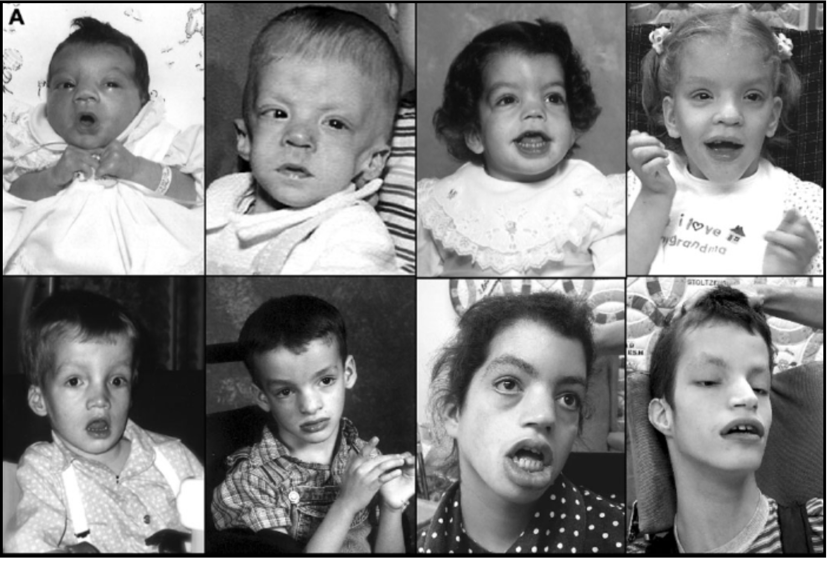
Figure 1. Pictures of children with the “Pretzel syndrome” disorder

Although few families can document relationships to each other, the fact that all cases arise from Weaverland or Groffdale Mennonites suggests a founder effect for the mutation. These two groups of Mennonites originate in southeastern Pennsylvania and share common genetic and social heritage. The researchers at the Clinic collected blood samples for DNA isolation in order to perform a genetic mapping study. Once again, 10K SNP microarrays were utilized to generate SNP genotypes for each patient. Subsequently, the 5 children absent from the meeting also submitted blood samples for inclusion in the mapping study. Figure 2 is an autozygosity plot for the 12 Pretzel syndrome patients.
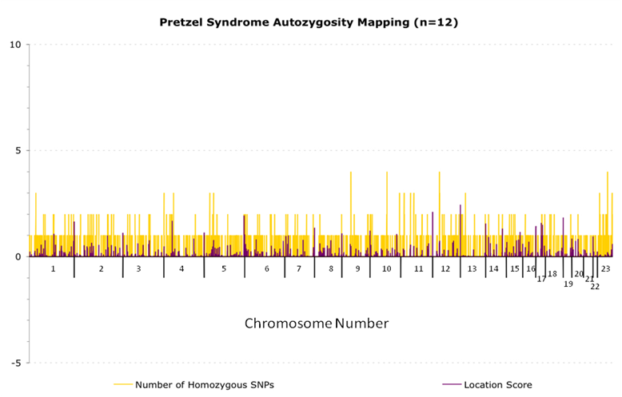
Figure 2. Homozygous regions of the genome shared by 12 Mennonite children with the Pretzel syndrome.

- What pieces of the children’s genomes would you focus on in the 10K microarray results?

- If there are not any large areas of homozygosity common to all of the children, what could you do next to try to find the target gene? Hint: You have many patients with the same symptoms.
- How and where would you look more closely at their genotypes?

Figure 3 presents a more detailed analysis of the genotype data. It is not feasible to scan 10,000 SNPS visually for 12 children. Instead, this method uses a X² analysis to screen for allele frequency differences between the affected children and normal, population-matched controls. This method detects regions of the genome where patients are more genotypically similar than would be expected by chance.

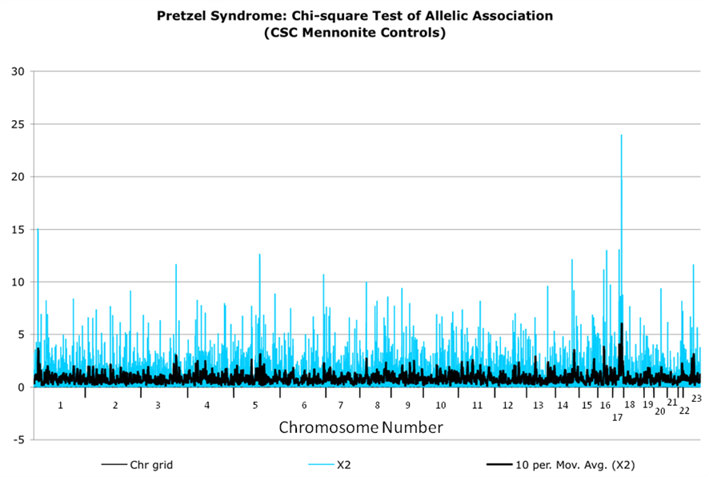
Figure 3. X² analysis of allelic frequencies for the genomes of the 12 children with the Pretzel syndrome

- Where does this analysis suggest that the gene responsible for the disease might be found?

Figure 4 contains the genotype data for the chromosome 17 region. While the patients are not all homozygous for a block of SNPs in the region, significant X² allele frequency differences exist between patients and controls (these values are in the far-right column of data).

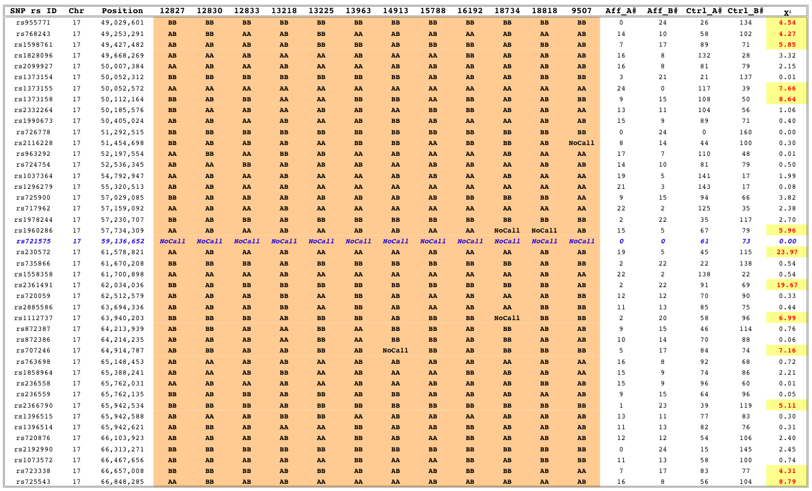
Figure 4. Table of SNP data for distal chromosome 17 for the 12 children with the Pretzel syndrome

Look at the data in Figure 4.

- Which SNP is likely involved in the disorder? Why? (Hint: You explanation should involve the probability of something occurring by chance alone.)

Use the SNP name that you identified above to search for information about the SNP in OMIM (http://www.ncbi.nlm.nih.gov/sites/entrez?db=omim). You can also search the position (Ex. chr15:158745) using the Genome browser again at http://genome.ucsc.edu.

- What is the identity of the mutated gene?
- What type of mutation appears to be present?
- What is the normal function of the mutated gene?

Once you are completely finished with the activity, you may want to refer to the article about the disorder published in Brain at http://www.clinicforspecialchildren.org/CSC/Research_files/PMSE_2007.pdf.

Teacher answers:

- Various candidate genes will be listed.
- The SNP data does not show any large areas of homozygosity.
- Look for places where the affected are more genetically identical than expected.
- Use Chi-square tests to identify places where affected are more genetically identical than expected.
- Chromosome 17.
- SNP rs721575 has a no-call for all affected people… in other words the SNP is missing.
- The gene is STRADA (also know as LYK5).
- The mutation involves a deletion of that SNP, which ends up being representative of a large deletion (involving exons 9-13).
- The gene codes for a protein that is a pseudokinase responsible for localization and function of threonine/serine kinase II.

