Study Guide Meiosis & Genetics Unit

- Suppose a female organism has a genotype of AABbCc in each of her somatic cells. Figure out the genotype of each of the cells produced after mitosis.
- Two chromosomes in a nucleus that carry loci (position) for the same traits in the same positions on the chromosome but specify different versions of some traits constitute a pair of
- What kinds of cells are involved in mitosis? Meiosis?
- During which stage of meiosis do synapsis and the formation of tetrads occur?
- What best describes the behavior of a tetrad during anaphase I of meiosis?
- What aspects of reproduction enhances genetic diversity?
- What are the major differences between oogenesis and spermatogenesis?
- What is the function of a sperm cell's acrosome?
- Androgens stimulate...
- Which are steroid sex hormones?
- The male organ of a flower is the
- In a typical flower such as a magnolia or rose, the flower parts that play the main role in attracting the notice of animal pollinators are the
- Flowers bear seeds in protective chambers called
- In a flowering plant, eggs are produced by meiosis in the
- Which of the following flower parts produces male gametophytes?
- How does the sperm of an angiosperm reach the egg?
- A seed is a mature
- A mature ovary, specialized as a vessel that houses and protects seeds, is a
- Know what a hybrid, P generation, F1 generation, and a cross is...
- A monohybrid cross is
- Alleles of a gene are found at __________ chromosomes.
- What is a testcross?
- A carrier of a genetic disorder who does not show symptoms is most likely to be __________ to transmit it to offspring.
- Dr. Smith's parents have normal hearing. However, Dr. Smith has an inherited form of deafness. Deafness is a recessive trait that is associated with the abnormal allele d. The normal allele at this locus, associated with normal hearing, is D. Dr. Smith's parents could have which of the following genotypes?
- Whiat terms refers to the situation where a single phenotypic characteristic is determined by the additive effects of two or more genes?
- Genes located close together on the same chromosomes are referred to as __________ genes and generally __________.
- In a cross of a purple-flowered, short-stemmed plant with a yellow-flowered, long-stemmed plant, the expected phenotypic ratio is 1 purple-short:1 purple-long:1 yellow-short:1 yellow-long. When you do the actual cross you observe a 5 purple-short:1 purple-long:1 yellow-short:5 yellow-long phenotypic ratio. Which of the following explains these results?
- How many sex chromosomes are in a human gamete?
- Any gene located on a sex chromosome will be
- Recessive sex-linked human conditions include …..
- Why are sex-linked conditions more common in men than in women?
- Varieties of plants in which self-fertilization produces offspring that are identical to the parents are referred to as
- Mendel's principle of independent assortment states that
- Know the differences between genotypes, phenotypes, dominant, recessive homozygous, and heterozygous.
- Labrador retrievers are black, brown, or yellow. In a cross of a black female with a brown male, results can be either all black puppies, 1/2 black to 1/2 brown puppies, or 3/4 black to 1/4 yellow puppies. These results indicate....?
A woman who has blood type A positive has a daughter who is type O positive and a son who is type B negative. Rh positive is a trait that shows simple dominance over Rh negative and is designated by the alleles R and r, respectively.
- What is a possible partial genotype for the son?
- What is a possible genotype for the mother?
- What is the probable genotype for the mother?
- A woman has six sons. The chance that her next child will be a daughter is
The following questions refer to the pedigree chart for a family, some of whose members exhibit the dominant trait, wooly hair. Affected individuals are indicated by an open square or circle.
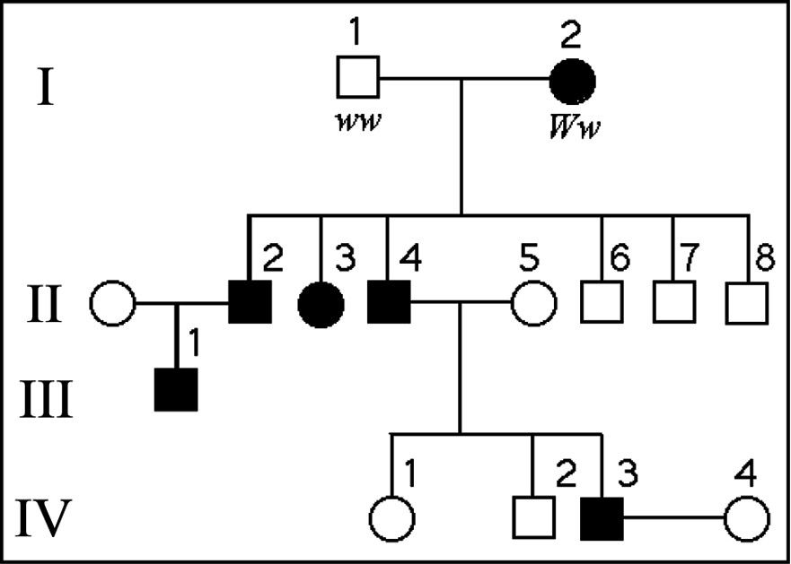
- What is the likelihood that the progeny of IV-3 and IV-4 will have wooly hair?
- A pedigree analysis for a given disorder's occurrence in a family shows that, although both parents of an affected child are normal, each of the parents has had affected relatives with the same condition. The disorder is then ...
- Imagine that you are a genetic counselor, and a couple planning to start a family comes to you for information. Charles was married once before, and he and his first wife had a child with cystic fibrosis. The brother of his current wife, Elaine, died of cystic fibrosis. What is the probability that Charles and Elaine will have a baby with cystic fibrosis? (Neither Charles nor Elaine has cystic fibrosis.)
- A man with hemophilia (a recessive, sex-linked condition) has a daughter of normal phenotype. She marries a man who is normal for the trait. What is the probability that a daughter of this mating will be a hemophiliac? That a son will be a hemophiliac? If the couple has four sons, what is the probability that all four will be born with hemophilia?

