Osmosis
In order to survive, all organisms need to move molecules in and out of their cells. Molecules such as gases (e.g., O₂, CO₂), water, food, and wastes pass across the cell membrane. There are two ways that the molecules move through the membrane: passive transport and active transport. While active transport requires that the cell uses chemical energy to move substances through the cell membrane, passive transport does not require such energy expenditures. Passive transport occurs spontaneously, using heat energy from the cell’s environment.
Diffusion is the movement of molecules by passive transport from a region in which they are highly concentrated to a region in which they are less concentrated. Diffusion continues until the molecules are randomly distributed throughout the system. Osmosis, the movement of water across a membrane, is a special case of diffusion. Water molecules are small and can easily pass through the membrane. Other molecules, such as proteins, DNA, RNA, and sugars are too large to pass through the cell membrane, so they cannot diffuse from one side of the membrane to the other. The membrane is said to be semipermeable, since it allows some molecules to pass through but not others.
If the concentration of water on one side of the membrane is different than on the other side, water will attempt to move through the membrane until the concentration of water is the same on both sides. If the concentration of water outside of a cell is greater, the water moves into the cell faster than it leaves, and the cell swells. The cell membrane acts somewhat like a balloon. If too much water enters the cell, the cell can burst, killing the cell. Cells usually have some mechanism for preventing too much water from entering, such as pumping excess water out of the cell or making a tough outer coat that will not rupture. If the concentration of water inside of a cell is greater, the water moves out of the cell faster than it enters, and the cell shrinks. If a cell becomes too dehydrated, it may not be able to survive.
In this experiment, you will use a Gas Pressure Sensor to measure the rate of pressure change as water moves in or out of potato wells filled with various concentrations of sugar solution.
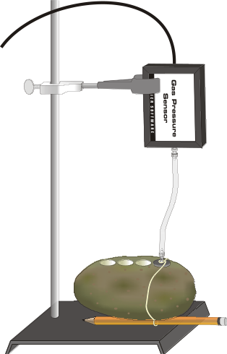
Figure 1

OBJECTIVES
In this experiment, you will
- use a Gas Pressure Sensor to investigate the relationship between water movement and solute concentration.
- determine the molar concentration of potato cells.
- determine the water potential of potato cells.

MATERIALS
Power Macintosh or Windows PC | waste beaker
Vernier computer interface | utility clamp
Logger Pro | ring stand
Vernier Gas Pressure Sensor | paper towels
1-hole rubber stopper assembly | potato with four wells
0 M, 0.33 M, 0.67 M, and 1.0 M sugar solution | pencil  string

PROCEDURE
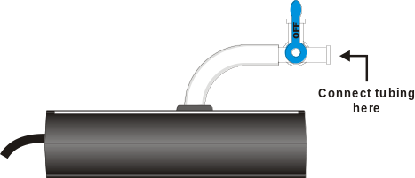
Figure 2
1. If your sensor has a blue plastic valve on it, place the valve in the position shown in Figure 2. Connect the plastic tubing to the valve on the Gas Pressure Sensor.
2. Prepare the computer for data collection by opening the Experiment 22 folder from the Biology with Computers folder of Logger Pro. Then open the experiment file that matches the probe you are using. The vertical axis has pressure scaled from 85 to 115 kPa. The horizontal axis has time scaled from 0 to 5 minutes. The data rate is set to 12 samples per minute.
3. Obtain four sugar solutions. They should be labeled 0 M, 0.33 M, 0.67 M, and 1.0 M.
4. Obtain a tray, if available, and a potato with four wells bored into it. Rinse the wells out with tap water and blot the well dry.
5. Using a ring stand and clamp, mount the pressure sensor above the potato, as in Figure 1. Note: Be careful not to get any solution on the sensor.
6. Fill the first well with the sugar solution labeled “0 M Sugar.” The zero indicates that the solution has no sugar in it, only distilled water. Allow the solution to remain in the well for five minutes. At the end of five minutes, proceed to Step 7.
7. Empty the 0 M Sugar solution from the well and refill the well with fresh 0 M Sugar solution.
8. Place the stopper assembly firmly into the well. You will need to tie the stopper down with a small piece of string, as it may pop out of the well unless it is held in place.
- Loop the string around the plastic stem that is inserted into the one-hole stopper.
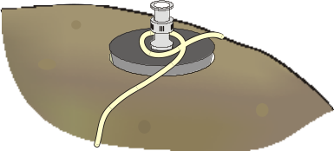
- Loosely wrap the string around the potato.
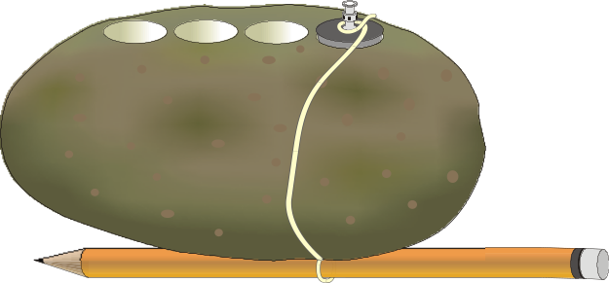
- Tie the string securely around the potato so that the knot will not slip. Leave enough slack to insert a pencil as shown above.
- To cinch the string tightly, place a pencil between the string and the potato. Twist the pencil until the stopper is firmly held in place.
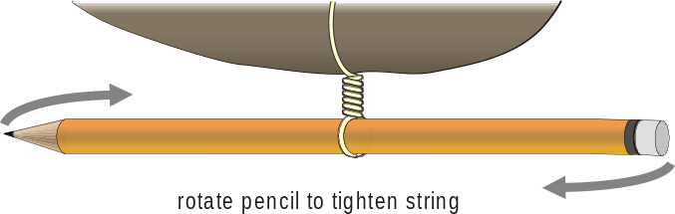

9. Allow the potato to rest for three minutes, making sure the string stays tight and that the pencil does not unwind.
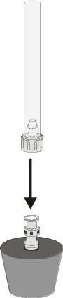
Figure 3
10. After three minutes, connect the free-end of the plastic tubing to the connector in the rubber stopper as shown in Figure 3. Click to begin data collection.
11. Fill the next well with the next higher concentration of sugar, 0.33 M. Allow it to sit in the well during the five minutes that data is being collected.
12. When data collection has finished, disconnect the plastic tubing connector from the rubber stopper. Remove the pencil, string, and rubber stopper, and empty the sugar solution from the potato into a waste beaker.
13. Determine the rate of pressure change for the curve of pressure vs. time. Perform a linear regression to calculate the rate of change.
- Move the mouse pointer to the point where the pressure values begin to change. Hold down the mouse button. Drag the mouse pointer to the end of the data and release the mouse button.
- Click the Regression button, , to perform a linear regression. A floating box will appear with the formula for a best fit line.
- Record the slope of the line, m, as the rate of pressure change in Table 1.
- Close the linear regression floating box.

14. Fill the second well with fresh 0.33 M sugar solution and repeat Steps 8 – 13.
15. Fill the third well with fresh 0.67 M sugar solution and repeat Steps 8 – 13.
16. Fill the last well with fresh 1.0 M sugar solution and repeat Steps 8 – 13. Skip Step 11 since this is the final sugar solution to be tested.

DATA
Table 1
Concentration | Rate of pressure change (kPa/min)
0.00 M
0.33 M
0.67 M
1.0 M

PROCESSING THE DATA
1. Open the Manual Entry experiment file from the Biology with Computers folder of Logger Pro. Create a graph with the rate of pressure change (slope) on the y-axis and the concentration of sugar on the x-axis.

QUESTIONS
1. Which solutions, if any, produced a positive slope? Was water moving in or out of the potato cells under these circumstances? Explain.
2. Which solutions, if any, produced a negative slope? Was water moving in or out of the potato cells under these circumstances? Explain.
3. Does sugar move in or out of the cells? Explain.
4. Examine the plot of the rate of pressure change vs. the sugar concentration. Describe any pattern you discern from the data.
5. Using the plot, estimate the concentration of sugar that would yield no change in pressure. Why is this biologically significant?
6. When wilted plants are watered, they tend to become rigid. Explain how this might happen.

extension – Water Potential
Water potential is a term used when predicting the movement of water into or out of plant cells. Water always moves from an area of higher water potential to an area of lower water potential. The symbol for water potential is the Greek letter Psi, Ψ. Water potential consists of a physical pressure component called pressure potential Ψ_{p}, and the effects of solutes called solute potential, Ψ_{s}.
Ψ | = | Ψ_{p} | + | Ψ_{S}
Water  potential | = | Pressure  potential | + | Solute  potential

Distilled water in an open beaker has a water potential of zero. The addition of solute decreases water potential while the addition of pressure increases water potential. A water potential value can be positive, negative, or zero. Water potential is usually measured in bars, a metric measure of pressure. (1 kPa = .1 bar)
In this experiment, you will measure the percent change in mass of potato cores after they have soaked in various concentrations of sugar solutions for a 24-hour period. You will use this data to calculate the water potential of the potato cells.

Materials
Power Macintosh or Windows PC  Logger Pro | 250-mL beaker  plastic wrap
four potato cores | balance
0 M, 0.33 M, 0.67 M, or 1.0 M sugar solution | paper towels

Procedure
You will be assigned one or more of the sugar solutions in which to soak your potato cores.
1. Pour 100 mL of the assigned sugar solution into a 250-mL beaker.
2. Measure and record the mass of the four potato cores together.
3. Put the four cores into the beaker of sugar solution.
4. Cover the beaker with plastic wrap and allow it to stand for a 24-hour period.
5. Remove the cores from the beaker, blot with a paper towel, and determine the mass of the four cores together after soaking.
6. Calculate the percent change in mass and record your data for the sugar concentration tested in Table 2 as well as on the class data sheet.
7. Repeat Steps 1 – 6 for any additional assigned sugar solutions.
Data
Table 2
Sugar solution concentration | Initial mass  (g) | Final mass  (g) | Percent change in mass
0.00 M
0.33 M
0.67 M
1.0 M

Table 3
Class data of percent change in mass
Sugar solution concentration | Group 1 | Group 2 | Group 3 | Group 4 | Group 5 | Group 6 | Group 7 | Group 8 | Total | Class average
0.00 M
0.33 M
0.67 M
1.00 M

Table 4
Sugar molar concentration | =
Solute potential | =
Water potential | =

Processing the Data
- Open the Manual Entry experiment file from the Biology with Computers folder of Logger Pro. Create a graph with the percent change in mass on the y-axis and concentration of sugar on the x-axis.
- Perform a linear regression to determine the molar concentration of sugar solution at which the mass of the potato cores does not change.
- Move the mouse pointer to the first data point. Press the left mouse button. Drag the pointer to the last data point.
- Click the Regression button, , to perform a linear regression. A floating box will appear with the formula for a best fit line.
- Choose Interpolate from the Analyze menu. Move the mouse pointer along the regression line to the point where the line crosses the x axis. This point represents the molar concentration of sugar with a water potential equal to the potato core water potential. Record this concentration in Table 4.

- Use the sugar molar concentration from the previous step to calculate the solute potential of the sugar solution.
- Calculate the solute potential of the sugar solution using the equation
Ψ_{s} = - iCRT
where i = ionization constant ( 1.0 for sugar since it doesn’t ionize in water)
C = sugar molar concentration (determined from the graph)
R = pressure constant (R = 0.0831 liter bars/mol-K)
T = temperature (K)

- Record this value with units in Table 4.

4. Calculate the water potential of the solution using the equation
Ψ = Ψ_{p} + Ψ_{s}
The pressure potential of the solution in this case is zero because the solution is at equilibrium. Record the water potential value with units in Table 4.

Questions
1. What may happen to an animal cell if water moves into it? How does this differ from what would happen in a plant cell?
2. What factors affect water potential?
3. If a plant cell has a higher water potential than its surrounding environment and the pressure is equal to zero, will water move in or out of the cell? Explain why.

