Photosynthesis and Respiration
Plants make sugar, storing the energy of the sun into chemical energy, by the process of photosynthesis. When they require energy, they can tap the stored energy in sugar by a process called cellular respiration.
The process of photosynthesis involves the use of light energy to convert carbon dioxide and water into sugar, oxygen, and other organic compounds. This process is often summarized by the following reaction:
6 H₂O + 6 CO₂ + light energy → C₆H₁₂O₆ + 6 O₂

Cellular respiration refers to the process of converting the chemical energy of organic molecules into a form immediately usable by organisms. Glucose may be oxidized completely if sufficient oxygen is available by the following equation:
C₆H₁₂O₆ + 6 O₂ → 6 H₂O + 6 CO₂ + energy

All organisms, including plants and animals, oxidize glucose for energy. Often, this energy is used to convert ADP and phosphate into ATP.

Objectives
In this experiment, you will
- use an O₂ Gas Sensor to measure the amount of oxygen gas consumed or produced by a plant during respiration and photosynthesis.
- use a CO₂ Gas Sensor to measure the amount of carbon dioxide consumed or produced by a plant during respiration and photosynthesis.
- determine the rate of respiration and photosynthesis of a plant.

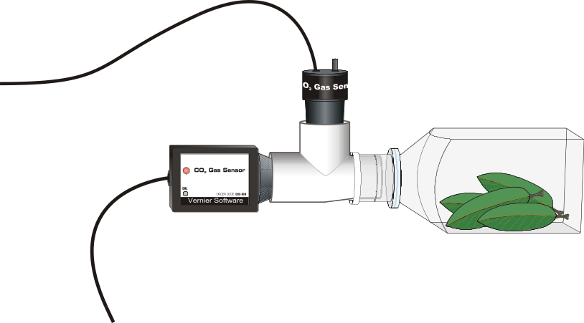
Figure 1

MATERIALS
Power Macintosh or Windows PC | 250-mL respiration chamber
Vernier computer interface | plant leaves
Logger Pro | 500-mL tissue culture flask
Vernier O₂ Gas Sensor | lamp
Vernier CO₂ Gas Sensor | aluminum foil
CO₂–O₂ Tee | forceps

PROCEDURE
1. Prepare the computer for data collection by opening the CO₂ & O₂ file in the CO₂ Gas Sensor folder of Probes & Sensors. The top graph has carbon dioxide concentration scaled from 0 to 5000 ppm on the vertical axis. The horizontal axis has time scaled from 0 to 30 minutes. The bottom graph has oxygen concentration scaled from 16 to 24% on the vertical axis. The horizontal axis has time scaled from 0 to 30 minutes. A meter window for each sensor is on the right of the screen. The data rate is set to 12 samples/minute.
2. Connect the CO₂ Gas Sensor to Channel 1 and the O₂ Gas to Channel 2 of the Vernier computer interface.
3. Obtain several leaves from the resource table and blot them dry, if damp, between two pieces of paper towel.
4. Place the leaves into the respiration chamber, using forceps if necessary. Wrap the respiration chamber in aluminum foil so that no light reaches the leaves.
5. Insert the CO₂–O₂ Tee into the neck of the respiration chamber. Place the O₂ Gas Sensor into the CO₂–O₂ Tee as shown in Figure 1. Gently push the sensor down into the Tee until it fits snugly. The sensor is designed to seal the Tee without the need for unnecessary force. The O₂ Gas Sensor should remain vertical throughout the experiment. Place the CO₂ Gas Sensor into the Tee directly across from the respiration chamber as shown in Figure 1. Gently twist the stopper on the shaft of the CO₂ Gas Sensor into the chamber opening. Do not twist the shaft of the CO₂ Gas Sensor or you may damage it. Wait 3 minutes before proceeding to Step 6.
6. Click to begin data collection. Collect data for fifteen minutes and click .
7. When data collection has finished, determine the rate of respiration:
- Click anywhere on the CO₂ graph. Move the mouse pointer to the point where the data values begin to increase. Hold down the left mouse button. Drag the pointer to the point where the data ceases to increase and release the mouse button.
- Click on the Regression button, , to perform a linear regression. A floating box will appear with the formula for a best fit line.
- Record the slope of the line, m, as the rate of respiration in Table 1.
- Close the linear regression floating box.
- Repeat Steps 7a – d for the O₂ graph. However, you will need to move the mouse pointer to the point where the data values begin to decrease. Hold down the mouse button and drag to the point where the data ceases to decrease.

8. Move your data to a stored run. To do this, choose Store Latest Run from the Data menu.
9. Remove the aluminum foil from around the respiration chamber.
10. Fill the tissue culture flask with water (not the respiration chamber) and place it between the lamp and the respiration chamber. The flask will act as a heat shield to protect the plant leaves.
11. Turn the lamp on. Place the lamp as close to the leaves as reasonable. Do not let the lamp touch the tissue culture flask. Note the time. The lamp should be on for 3 minutes prior to beginning data collection.
12. After the three-minute time period is up, click to begin data collection. Collect data for 15 minutes and click .
13. When data collection has finished, determine the rate of photosynthesis:
- Click anywhere on the CO₂ graph. Move the mouse pointer to the point where the data values begin to decrease. Hold down the left mouse button. Drag the pointer to the point where the data ceases to decrease and release the mouse button.
- Click on the Regression button, , to perform a linear regression. A floating box will appear with the formula for a best-fit line.
- Record the slope of the line, m, as the rate of photosynthesis in Table 1.
- Close the linear regression floating box.
- Repeat steps 13a-d for the O₂ graph. However, you will need to move the mouse pointer to the point where the data values begin to increase, hold down the mouse button and drag to the point where the data ceases to increase.

14. Print a graph showing your photosynthesis and respiration data.
- Label each curve by choosing Make Annotation from the Analyze menu. Enter “Photosynthesis” in the edit box. Repeat to create an annotation for the “Respiration” data. Drag each box to a position near its respective curve.
- Print a copy of the Graph window, with both data sets displayed. Enter your name(s) and the number of copies of the graph you want.

15. Remove the plant leaves from the respiration chamber, using forceps if necessary. Clean and dry the respiration chamber.

DATA
Table 1
Leaves | CO₂ rate of production/consumption  (ppm/min) | O₂ rate of production/consumption  (%/min)
In the dark
In the light

Questions
1. Were either of the rate values for CO₂ a positive number? If so, what is the biological significance of this?
2. Were either of the rate values for O₂ a negative number? If so, what is the biological significance of this?
3. Do you have evidence that cellular respiration occurred in leaves? Explain.
4. Do you have evidence that photosynthesis occurred in leaves? Explain.
5. List five factors that might influence the rate of oxygen production or consumption in leaves. Explain how you think each will affect the rate?

extensionS
1. Design and perform an experiment to test one of the factors that might influence the rate of oxygen production or consumption in Question 5.
2. Compare the rates of photosynthesis and respiration among various types of plants.

