Photosynthesis
The process of photosynthesis involves the use of light energy to convert carbon dioxide and water into sugar, oxygen, and other organic compounds. This process is often summarized by the following reaction:
6 H₂O + 6 CO₂ + light energy → C₆H₁₂O₆ + 6 O₂
This process is an extremely complex one, occurring in two stages. The first stage, called the light reactions of photosynthesis, requires light energy. The products of the light reactions are then used to produce glucose from carbon dioxide and water. Because the reactions in the second stage do not require the direct use of light energy, they are called the dark reactions of photosynthesis.
In the light reactions, electrons derived from water are “excited” (raised to higher energy levels) in several steps, called photosystems I and II. In both steps, chlorophyll absorbs light energy that is used to excite the electrons. Normally, these electrons are passed to a cytochrome containing an electron transport chain. In the first photosystem, these electrons are used to generate ATP. In the second photosystem, excited electrons are used to produce the reduced coenzyme nicotinamide adenine dinucleotide phosphate (NADPH). Both ATP and NADPH are then used in the dark reactions to produce glucose.
In this experiment, a blue dye (2,6-dichlorophenol-indophenol, or DPIP) will be used to replace NADPH in the light reactions. When the dye is oxidized, it is blue. When reduced, however, it turns colorless. Since DPIP replaces NADPH in the light reactions, it will turn from blue to colorless when reduced during photosynthesis.

OBJECTIVES
In this experiment, you will
- use a Colorimeter to measure color changes due to photosynthesis.
- study the effect of light on photosynthesis.
- study the effect that the boiling of plant cells has on photosynthesis.
- compare the rates of photosynthesis for plants in different light conditions.

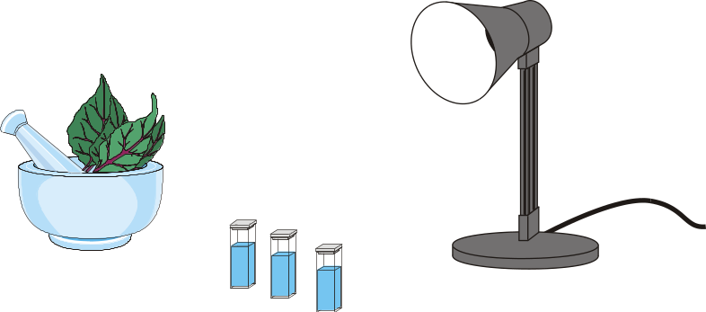
Figure 1

MATERIALS
Power Macintosh or Windows PC | 250-mL beaker
Vernier computer interface | two small test tubes
Logger Pro | 5-mL pipet
Vernier Colorimeter | two eyedroppers or Beral pipets
two cuvettes with lids | 10-mL DPIP/phosphate buffer solution
aluminum foil covered cuvette with lid | unboiled chloroplast suspension
100-watt floodlight | boiled chloroplast suspension
watch or clock with second hand | ice
600-mL beaker filled with water

PROCEDURE
1. Obtain and wear goggles.
2. Obtain two plastic Beral pipets, two cuvettes with lids, and one aluminum foil covered cuvette with a lid. Mark one Beral pipet with a U (unboiled) and one with a B (boiled). Mark the lid for the cuvette with aluminum foil with a D (dark). For the remaining two cuvettes, mark one lid with a U (unboiled) and one with a B (boiled).
3. Prepare the computer for data collection by opening the file “Exp 07 Colorimeter” in the Experiment 7 folder of Biology with Computers. A meter window will display the absorbance readings from the colorimeter.
4. You are now ready to calibrate the Colorimeter. Prepare a blank by filling a cuvette 3/4 full with distilled water. To correctly use a Colorimeter cuvette, remember:
- All cuvettes should be wiped clean and dry on the outside with a tissue.
- Handle cuvettes only by the top edge of the ribbed sides.
- All solutions should be free of bubbles.
- Always position the cuvette with its reference mark facing toward the white reference mark at the right of the cuvette slot on the Colorimeter.

5. Calibrate the Colorimeter.
- Holding the cuvette by the upper edges, place it in the cuvette slot of the Colorimeter.
- If your Colorimeter has an AUTO CAL button, set the wavelength on the Colorimeter to 635 nm (Red), press the AUTO CAL button, and proceed directly to Step 6. If your Colorimeter does not have an AUTO CAL button, continue with this step to calibrate your Colorimeter.

First Calibration Point
- Choose Calibrate from the Experiment menu and then click .
- Turn the wavelength knob on the Colorimeter to the “0% T” position.
- Type “0” in the edit box.
- When the displayed voltage reading for Input 1 stabilizes, click .

Second Calibration Point
- Turn the knob of the Colorimeter to the Red LED position (635 nm).
- Type “100” in the edit box.
- When the displayed voltage reading for Input 1 stabilizes, click , then click .
6. Obtain a 600-mL beaker filled with water and a flood lamp. Arrange the lamp and beaker as shown in Figure 2. The beaker will act as a heat shield, protecting the chloroplasts from warming by the flood lamp. Do not turn the lamp on until Step 10.
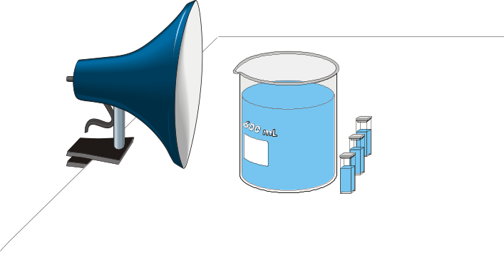
Figure 2

7. Locate the unboiled and boiled chloroplast suspension prepared by your instructor. Before removing any of the chloroplast suspension, gently swirl to resuspend any chloroplast which may have settled out. Using the pipet marked U, draw up ~1 mL of unboiled chloroplast suspension. Using the pipet marked B, draw up ~1 mL of boiled chloroplast suspension. Set both pipettes in the small beaker filled with ice at your lab station to keep the chloroplasts cooled.
8. Add 2.5 mL of DPIP/phosphate buffer solution to each of the cuvettes. Important: perform the following steps as quickly as possible and proceed directly to Step 9.
- Cuvette U: Add 3 drops of unboiled chloroplasts. Place the lid on the cuvette and gently mix; try not to introduce bubbles in the solution. Place the cuvette in front of the lamp as shown in Figure 2. Mark the cuvette's position so that it can always be placed back in the same spot.
- Cuvette D: Add 3 drops of unboiled chloroplasts. Place the lid on the cuvette and gently mix; try not to introduce bubbles in the solution. Place the foil-covered cuvette in front of the lamp as shown in Figure 2 and mark its position. Make sure that no light can penetrate the cuvette.
- Cuvette B: Add 3 drops of boiled chloroplasts. Place the lid on the cuvette and gently mix; try not to introduce bubbles in the solution. Place the cuvette in front of the lamp as shown in Figure 2. Mark the cuvette's position so that it can always be placed back in the same spot.

9. Take absorbance readings for each cuvette. Invert each cuvette two times to resuspend the chloroplast before taking a reading. If any air bubbles form, gently tap on the cuvette lid to knock them loose.
- Cuvette U: Place the cuvette in the cuvette slot of the Colorimeter and close the lid. Allow 10 seconds for the readings displayed in the Meter window to stabilize, then record the absorbance value in Table 1. Remove the cuvette and place it in its original position in front of the lamp.
- Cuvette D: Remove the cuvette from the foil sleeve and place it in the cuvette slot of the Colorimeter. Close the Colorimeter lid and wait 10 seconds. Record the absorbance value displayed in the Meter window in Table 1. Remove the cuvette and place it back into the foil sleeve. Place the cuvette in its original position in front of the lamp.
- Cuvette B: Place the cuvette in the cuvette slot of the Colorimeter and close the lid. Allow 10 seconds for the readings displayed in the Meter window to stabilize, then record the absorbance value in Table 1. Remove the cuvette and place it in its original position in front of the lamp.

10. Turn on the lamp.
11. Repeat Step 9 when 5 minutes have elapsed.
12. Repeat Step 9 when 10 minutes have elapsed.
13. Repeat Step 9 when 15 minutes have elapsed.
14. Repeat Step 9 when 20 minutes have elapsed.

PROCESSING THE DATA
1. Prepare the computer for data entry by opening the file “Exp 07B Data File” in the Experiment 7 folder of Biology with Computers.
2. Enter the data recorded in Table 1 into the appropriate column in the Table window. To type click on the table cell with the mouse pointer. The table cell will enlarge and you will see a blinking cursor in the cell. Type your data point and press ENTER. The cursor will move down to the next cell. The graph will update after each data point is entered.
3. Calculate the rate of photosynthesis for each of the three cuvettes tested.
- Click the Regression button, 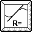,to perform a linear regression. A dialog box will appear. Select the three data sets you wish to perform a linear regression on and click . A floating box will appear with the formula for a best fit line for each data set selected.
- In Table 2, record the slope of the line, m, as the rate of photosynthesis for each data set.
- Close the linear regression floating boxes.

DATA
Table 1 |  |  |  |  | Table 2
Time  (min) | Absorbance  unboiled | Absorbance  in dark | Absorbance  boiled |  | Chloroplast | Rate of photosynthesis
0 |  |  |  |  | Unboiled
5 |  |  |  |  | Dark
10 |  |  |  |  | Boiled
15
20

Questions
1. Is there evidence that chloroplasts were able to reduce DPIP in this experiment? Explain.
2. Were chloroplasts able to reduce DPIP when kept in the dark? Explain.
3. Were boiled chloroplasts able to reduce DPIP ? Explain.
4. What conclusions can you make about the photosynthetic activity of spinach?

extension - Plant Pigment Chromatography
Paper chromatography is a technique used to separate substances in a mixture based on the movement of the different substances up a piece of paper by capillary action. Pigments extracted from plant cells contain a variety of molecules, such as chlorophylls, beta carotene, and xanthophyll, that can be separated using paper chromatography. A small sample of plant pigment placed on chromatography paper travels up the paper due to capillary action. Beta carotene is carried the furthest because it is highly soluble in the solvent and because it forms no hydrogen bonds with the chromatography paper fibers. Xanthophyll contains oxygen and does not travel quite as far with the solvent because it is less soluble than beta carotene and forms some hydrogen bonds with the paper. Chlorophylls are bound more tightly to the paper than the other two, so they travel the shortest distance.
The ratio of the distance moved by a pigment to the distance moved by the solvent is a constant, R_{f}. Each type of molecule has its own R_{f} value.
R_{f} = distance traveled by pigment
distance traveled by solvent

OBJECTIVES
In this experiment, you will
- separate plant pigments
- calculate the R_{f} values of the pigments.

MATERIALS
50-mL graduated cylinder | cork stopper
filter paper | pencil
spinach leaves | scissors
coin | solvent
goggles | ruler

PROCEDURE
Obtain and wear goggles! Caution: The solvent in this experiment is flammable and poisonous. Be sure there are no open flames in the lab during this experiment. Avoid inhaling fumes. Wear goggles at all times. Notify your teacher immediately if an accident occurs.
- Obtain a 50-mL graduated cylinder with 5 mL of solvent in the bottom.
- Cut the filter paper so that it is long enough to reach the solvent. Cut one end of the paper into a point.
- Draw a pencil line 2.0 cm above the pointed end of the paper.
- Use the coin to extract the pigments from the spinach leaf. Place a small section of the leaf on top of the pencil line. Use the ribbed edge of the coin to push the plant cells into the chromatography paper. Repeat the procedure 10 times making sure to use a different part of the leaf each time.
- Place the chromatography paper in the cylinder so the pointed end just touches the solvent. Make sure the pigment is not in the solvent.
- Stopper the cylinder and wait until the solvent is approximately 1 cm from the top of the paper. Remove the chromatography paper and mark the solvent front before it evaporates.
- Allow the paper to dry. Mark the bottom of each pigment band. Measure the distance each pigment moved from the starting line to the bottom of the pigment band. Record the distance that each of the pigments and the solvent moved, in millimeters.
- Identify each of the bands and label them on the chromatography paper.
- beta carotene: yellow to yellow orange
- xanthophyll: yellow
- chlorophyll a: bright green to blue green
- chlorophyll b: yellow green to olive green

9. Staple the chromatogram to the front of your lab sheet.
10. Discard the solvent as directed by your teacher.

DATA
Table 1
Band number | Distance traveled  (mm) | Band color | Identity
1
2
3
4
5*
Distance solvent front moved = mm

* The fifth band may not appear.

Processing the DATA
Calculate the R_{f} values and record in Table 2.

Table 2
Molecule | R_{f}
beta carotene
xanthophyll
chlorophyll a
chlorophyll b

questions
- What factors are involved in the separation of the pigments?
- Would you expect the R_{f} value to be different with a different solvent?
3. Why do the pigments become separated during the development of the chromatogram?

Additional Extensions
- Repeat the paper chromatography with various species of plants. What similarities do you see? What differences are there?
- Use colored filters around the cuvettes to test the effect of red, blue, and green light on the photosynthetic activity of spinach.
- Vary the distance of the floodlight source to determine the effect of light intensity on photosynthesis.
- Compare the photosynthetic activity of spinach with that of chloroplasts from other plants.
- Investigate the effect of temperature on the photosynthetic activity of spinach.
- Explain why the rate of photosynthesis varies under different environmental conditions.

