Primary Productivity
Oxygen is vital to life. In the atmosphere, oxygen comprises over 20% of the available gases. In aquatic ecosystems, however, oxygen is scarce. To be useful to aquatic organisms, oxygen must be in the form of molecular oxygen, O₂. The concentration of oxygen in water can be affected by many physical and biological factors. Respiration by plants and animals reduces oxygen concentrations, while the photosynthetic activity of plants increases it. In photosynthesis, carbon is assimilated into the biosphere and oxygen is made available, as follows:
6 H₂O + 6 CO₂(g) + energy → C₆H₁₂O₆ + 6O₂(g)
The rate of assimilation of carbon in water depends on the type and quantity of plants within the water. Primary productivity is the measure of this rate of carbon assimilation. As the above equation indicates, the production of oxygen can be used to monitor the primary productivity of an aquatic ecosystem. A measure of oxygen production over time provides a means of calculating the amount of carbon that has been bound in organic compounds during that period of time. Primary productivity can also be measured by determining the rate of carbon dioxide utilization or the rate of formation of organic compounds.
One method of measuring the production of oxygen is the light and dark bottle method. In this method, a sample of water is placed into two bottles. One bottle is stored in the dark and the other in a lighted area. Only respiration can occur in the bottle stored in the dark. The decrease in dissolved oxygen (DO) in the dark bottle over time is a measure of the rate of respiration. Both photosynthesis and respiration can occur in the bottle exposed to light, however. The difference between the amount of oxygen produced through photosynthesis and that consumed through aerobic respiration is the net productivity. The difference in dissolved oxygen over time between the bottles stored in the light and in the dark is a measure of the total amount of oxygen produced by photosynthesis. The total amount of oxygen produced is called the gross productivity.
The measurement of the DO concentration of a body of water is often used to determine whether the biological activities requiring oxygen are occurring and is an important indicator of pollution.

OBJECTIVES
In this experiment, you will
- measure the rate of respiration in an aquatic environment using a Dissolved Oxygen Probe.
- determine the net and gross productivity in an aquatic environment.

MATERIALS
Power Macintosh or Windows PC | seven 25 X 150-mm screw top test tubes
Vernier computer interface | shallow pan
Vernier Dissolved Oxygen Probe | scissors
Logger Pro | siphon tube
17 pieces of 12 cm X 12 cm (5″ X 5″) plastic window screen | 500-mL pond, lake, seawater or algal culture
250-mL beaker | distilled water
aluminum foil | rubber bands
PRE-LAB procedure
Important: Prior to each use, the dissolved oxygen probe must warm up for a period of 10 minutes as described below. If the probe is not warmed up properly, inaccurate readings will result. Perform the following steps to prepare the Dissolved Oxygen Probe.
1. Prepare the Dissolved Oxygen Probe for use.
- Remove the protective cap.
- Unscrew the membrane cap from the tip of the probe.
- Using a pipet, fill the membrane cap with 1 mL of DO Electrode Filling Solution.
- Carefully thread the membrane cap back onto the electrode.
- Place the probe into a 250-mL beaker containing distilled water.
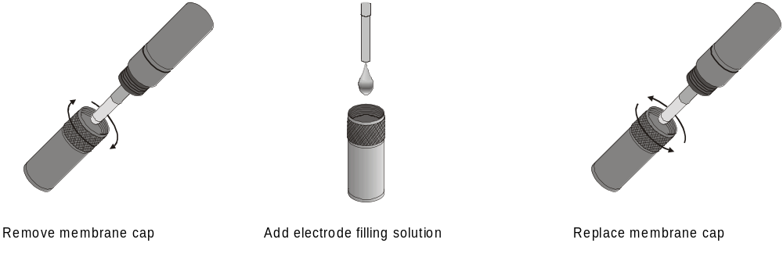
Figure 1
2. Plug the Dissolved Oxygen Probe into Channel 1 of the Vernier interface.
3. Prepare the computer for data collection by opening the file in the Experiment 25 folder of Biology with Computers. The Meter window will display live dissolved oxygen readings.
4. It is necessary to warm up the Dissolved Oxygen Probe for 10 minutes before taking readings. To warm up the probe, leave it connected to the interface, with Logger Pro running, for 10 minutes. The probe must stay connected at all times to keep it warmed up. If disconnected for a few minutes, it will be necessary to warm up the probe again.
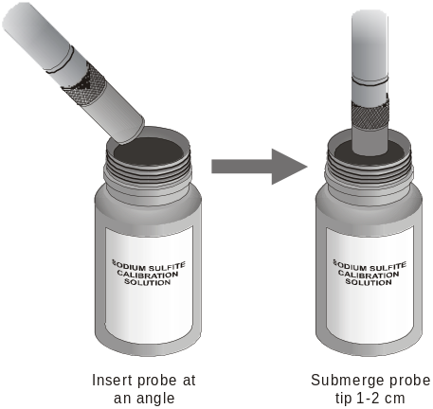
Figure 2
5. You are now ready to calibrate the Dissolved Oxygen Probe.
- If your instructor directs you to use the calibration stored in the experiment file, then proceed to Step 6.
- If your instructor directs you to perform a new calibration for the Dissolved Oxygen Probe, follow this procedure.
Zero-Oxygen Calibration Point
- Choose Calibrate from the Experiment menu and then click .
- Remove the probe from the water and place the tip of the probe into the Sodium Sulfite Calibration Solution. Important: No air bubbles can be trapped below the tip of the probe or the probe will sense an inaccurate dissolved oxygen level. If the voltage does not rapidly decrease, tap the side of the bottle with the probe to dislodge any bubbles. The readings should be in the 0.2- to 0.5-V range.
- Type “0” (the known value in mg/L) in the edit box.
- When the displayed voltage reading for Input 1 stabilizes, click .
Saturated DO Calibration Point
- Rinse the probe with distilled water and gently blot dry.
- Unscrew the lid of the calibration bottle provided with the probe. Slide the lid and the grommet about 2 cm onto the probe body.
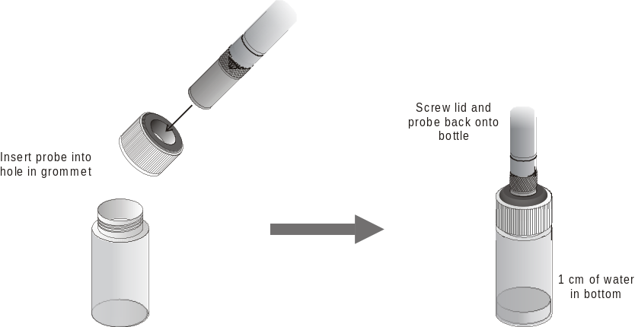
Figure 3
- Add water to the bottle to a depth of about 1 cm and screw the bottle into the cap, as shown. Important: Do not touch the membrane or get it wet during this step. Keep the probe in this position for about a minute.
- Type the correct saturated dissolved-oxygen value (in mg/L) from Table 5 (for example, “8.66”) using the current barometric pressure and air temperature values. If you do not have the current air pressure, use Table 6 to estimate the air pressure at your altitude.
- When the displayed voltage reading for Input 1 stabilizes (readings should be above 2.0 V), click and then click .
- Return the Dissolved Oxygen Probe to the distilled water beaker.
- From the File menu, select Save As and save the current experiment file.

PROCEDURE
Day 1
6. Obtain seven water sampling test tubes.
7. Fill each of the test tubes with the water sample. To fill a test tube:
- Obtain a siphon tube.
- Insert the tube into the water sample and fill the tube completely with water.
- Pinch the tube (or use a tube clamp) to close off the siphon tube.
- Place one end of the tube in the bottom of a test tube. Keep the other end in the water sample, well below the surface. Position the test tube lower than the water sample Place a shallow pan under the test tube to collect any water that spills over.
- Siphon the water into the test tube. Fill the test tube until it overflows approximately 1/3 of the volume of the test tube. Fill the test tube completely to the top of the rim.
- Tighten the cap on the test tube securely. Be sure no air is in the test tube.
8. The percentage of available natural light for each water sample is listed in Table 1 below:
 | Table 1
Test tube | Number of Screens | % Light
1 | 0 | Initial
2 | 0 | 100%
3 | 1 | 65%
4 | 3 | 25%
5 | 5 | 10%
6 | 8 | 2%
7 | Aluminum Foil | Dark

9. Use masking tape to label the cap of each tube. Mark the labels as follows: dark, initial, 2%, 10%, 25%, 65%, and 100%
10. Wrap test tube 7, the dark tube, with aluminum foil so that it is light-proof. This water sample will remain in the dark.
11. Mix the contents of each tube. Be sure that there are no air bubbles present in any of the tubes. Fill a tube with more sample water if necessary.
12. Wrap screen layers around the tubes according to Table 1. Trim the screens so each one only wraps around the tube once. Hold the screens in place with rubber bands or clothes pins. The bottles will stand on end so the bottoms of the tubes need not be covered. The layers of screen will simulate the amount of natural light available for photosynthesis at different depths in a body of water.
13. Remove the Dissolved Oxygen Probe from the beaker. Place the probe into test tube 1, the initial tube, so that it is submerged half the depth of the water. Gently and continuously move the probe up and down a distance of about 1 cm in the tube. This allows water to move past the probe’s tip. Note: Do not agitate the water, or oxygen from the atmosphere will mix into the water and cause erroneous readings.
14. After 60 seconds, or when the dissolved oxygen reading stabilizes, record the reading in Table 2. Discard the contents of the initial tube and clean the test tube. Rinse the Dissolved Oxygen Probe with distilled water and place it back in the distilled water beaker. The probe should remain in the beaker overnight, so that measurements can be made the following day.
15. Place test tubes 2 – 7 near the light source, as directed by your instructor.
Day 2
16. Prepare the computer for data collection by opening the file in the Experiment 25 folder of Biology with Computers. Allow the probe 10 – 15 minutes to warm up. Keep it in the beaker of distilled water during this time. The calibration from the previous day should have been saved with the experiment file, so no calibration is needed for Day 2 measurements.
17. Place the probe into the 100% light tube. Gently and continuously move the probe up and down a distance of about 1 cm in the tube. After 60 seconds, or when the dissolved oxygen reading stabilizes, record the reading in Table 2.
18. Repeat Step 17 for the remaining test tubes.
19. Clean your test tubes as directed by your instructor. Rinse the Dissolved Oxygen Probe with distilled water and place it back in the distilled water beaker.

DATA
Table 2
Test tube | % Light | DO (mg/L)
1 | Initial
2 | 100%
3 | 65%
4 | 25%
5 | 10%
6 | 2%
7 | Dark

Processing the DATA
- Determine the number of hours that have passed since the onset of this experiment. Subtract the DO value in the test tube 1 (the initial DO value) from that of test tube 7 (the dark test tube’s DO value). Divide the DO value by the time in hours. Record the resulting value as the respiration rate in Table 3.
Respiration rate = (dark DO – initial DO) / time
- Determine the gross productivity in each test tube. To do this, subtract the DO in test tube 7 (the dark test tube’s DO value) from that of test tubes 2–6 (the light test tubes’ DO value). Divide each DO value by the length of the experiment in hours. Record each resulting value as the gross productivity in Table 4.
Gross productivity = (DO of test tube – dark DO) / time
- Determine the net productivity in each test tube. To do this, subtract the DO in test tubes 2–6 (the light test tube’s DO value) from that of test tube 1 (the initial DO value). Divide the result by the length of the experiment in hours. Record each resulting value as the net productivity in Table 4.
Net Productivity = (DO of test tube – initial DO) / time
Table 3
Respiration (mg O₂/L/hr)

Table 4
Test Tube | % Light | Gross productivity  (mg/L/hr) | Net productivity  (mg/L/hr)
2 | 100%
3 | 65%
4 | 25%
5 | 10%
6 | 2%

- Prepare a graph of gross productivity and net productivity as a function of light intensity. Graph both types of productivity on the same piece of graph paper.

questions
1. Is there evidence that photosynthetic activity added oxygen to the water? Explain.
2. Is there evidence that aerobic respiration occurred in the water? If so, what kind of organisms might be responsible for this—autotrophs? Heterotrophs? Explain.
3. What effect did light have on the primary productivity? Explain.
4. Refer to your graph of productivity and light intensity. At what light intensity do you expect there to be no net productivity? no gross productivity?
5. How would turbidity affect the primary productivity of a pond?

Extensions
1. Determine the effects of nitrogen and phosphates on primary productivity. Why would the presence of phosphates and nitrogen, in the form of nitrates and ammonium ions, be important to an aquatic ecosystem during the spring season? How do they accumulate in the watershed? What is eutrophication?
2. Measure the dissolved oxygen of a pond at different temperatures. What is the effect of temperature on the primary productivity of a pond?
3. Calculate the amount of carbon that was fixed in each of the tubes. Use the following conversion factors to do the calculations.
mg O₂/L X 0.698 = mL O₂/L
mL O₂/L X .536 = mg carbon fixed/L

CALIBRATION TABLES
Table 5: 100% Dissolved Oxygen Capacity (mg/L)
 | 770 mm | 760 mm | 750 mm | 740 mm | 730 mm | 720 mm | 710 mm | 700 mm | 690 mm | 680 mm | 670 mm | 660 mm
0°C | 14.76 | 14.57 | 14.38 | 14.19 | 13.99 | 13.80 | 13.61 | 13.42 | 13.23 | 13.04 | 12.84 | 12.65
1°C | 14.38 | 14.19 | 14.00 | 13.82 | 13.63 | 13.44 | 13.26 | 13.07 | 12.88 | 12.70 | 12.51 | 12.32
2°C | 14.01 | 13.82 | 13.64 | 13.46 | 13.28 | 13.10 | 12.92 | 12.73 | 12.55 | 12.37 | 12.19 | 12.01
3°C | 13.65 | 13.47 | 13.29 | 13.12 | 12.94 | 12.76 | 12.59 | 12.41 | 12.23 | 12.05 | 11.88 | 11.70
4°C | 13.31 | 13.13 | 12.96 | 12.79 | 12.61 | 12.44 | 12.27 | 12.10 | 11.92 | 11.75 | 11.58 | 11.40
5°C | 12.97 | 12.81 | 12.64 | 12.47 | 12.30 | 12.13 | 11.96 | 11.80 | 11.63 | 11.46 | 11.29 | 11.12
6°C | 12.66 | 12.49 | 12.33 | 12.16 | 12.00 | 11.83 | 11.67 | 11.51 | 11.34 | 11.18 | 11.01 | 10.85
7°C | 12.35 | 12.19 | 12.03 | 11.87 | 11.71 | 11.55 | 11.39 | 11.23 | 11.07 | 10.91 | 10.75 | 10.59
8°C | 12.05 | 11.90 | 11.74 | 11.58 | 11.43 | 11.27 | 11.11 | 10.96 | 10.80 | 10.65 | 10.49 | 10.33
9°C | 11.77 | 11.62 | 11.46 | 11.31 | 11.16 | 11.01 | 10.85 | 10.70 | 10.55 | 10.39 | 10.24 | 10.09
10°C | 11.50 | 11.35 | 11.20 | 11.05 | 10.90 | 10.75 | 10.60 | 10.45 | 10.30 | 10.15 | 10.00 | 9.86
11°C | 11.24 | 11.09 | 10.94 | 10.80 | 10.65 | 10.51 | 10.36 | 10.21 | 10.07 | 9.92 | 9.78 | 9.63
12°C | 10.98 | 10.84 | 10.70 | 10.56 | 10.41 | 10.27 | 10.13 | 9.99 | 9.84 | 9.70 | 9.56 | 9.41
13°C | 10.74 | 10.60 | 10.46 | 10.32 | 10.18 | 10.04 | 9.90 | 9.77 | 9.63 | 9.49 | 9.35 | 9.21
14°C | 10.51 | 10.37 | 10.24 | 10.10 | 9.96 | 9.83 | 9.69 | 9.55 | 9.42 | 9.28 | 9.14 | 9.01
15°C | 10.29 | 10.15 | 10.02 | 9.88 | 9.75 | 9.62 | 9.48 | 9.35 | 9.22 | 9.08 | 8.95 | 8.82
16°C | 10.07 | 9.94 | 9.81 | 9.68 | 9.55 | 9.42 | 9.29 | 9.15 | 9.02 | 8.89 | 8.76 | 8.63
17°C | 9.86 | 9.74 | 9.61 | 9.48 | 9.35 | 9.22 | 9.10 | 8.97 | 8.84 | 8.71 | 8.58 | 8.45
18°C | 9.67 | 9.54 | 9.41 | 9.29 | 9.16 | 9.04 | 8.91 | 8.79 | 8.66 | 8.54 | 8.41 | 8.28
19°C | 9.47 | 9.35 | 9.23 | 9.11 | 8.98 | 8.86 | 8.74 | 8.61 | 8.49 | 8.37 | 8.24 | 8.12
20°C | 9.29 | 9.17 | 9.05 | 8.93 | 8.81 | 8.69 | 8.57 | 8.45 | 8.33 | 8.20 | 8.08 | 7.96
21°C | 9.11 | 9.00 | 8.88 | 8.76 | 8.64 | 8.52 | 8.40 | 8.28 | 8.17 | 8.05 | 7.93 | 7.81
22°C | 8.94 | 8.83 | 8.71 | 8.59 | 8.48 | 8.36 | 8.25 | 8.13 | 8.01 | 7.90 | 7.78 | 7.67
23°C | 8.78 | 8.66 | 8.55 | 8.44 | 8.32 | 8.21 | 8.09 | 7.98 | 7.87 | 7.75 | 7.64 | 7.52
24°C | 8.62 | 8.51 | 8.40 | 8.28 | 8.17 | 8.06 | 7.95 | 7.84 | 7.72 | 7.61 | 7.50 | 7.39
25°C | 8.47 | 8.36 | 8.25 | 8.14 | 8.03 | 7.92 | 7.81 | 7.70 | 7.59 | 7.48 | 7.37 | 7.26
26°C | 8.32 | 8.21 | 8.10 | 7.99 | 7.89 | 7.78 | 7.67 | 7.56 | 7.45 | 7.35 | 7.24 | 7.13
27°C | 8.17 | 8.07 | 7.96 | 7.86 | 7.75 | 7.64 | 7.54 | 7.43 | 7.33 | 7.22 | 7.11 | 7.01
28°C | 8.04 | 7.93 | 7.83 | 7.72 | 7.62 | 7.51 | 7.41 | 7.30 | 7.20 | 7.10 | 6.99 | 6.89
29°C | 7.90 | 7.80 | 7.69 | 7.59 | 7.49 | 7.39 | 7.28 | 7.18 | 7.08 | 6.98 | 6.87 | 6.77
30°C | 7.77 | 7.67 | 7.57 | 7.47 | 7.36 | 7.26 | 7.16 | 7.06 | 6.96 | 6.86 | 6.76 | 6.66

Table 6: Approximate Barometric Pressure at Different Elevations
Elevation  (m) | Pressure  (mm Hg) | Elevation  (m) | Pressure  (mm Hg) | Elevation  (m) | Pressure  (mm Hg)
0 | 760 | 800 | 693 | 1600 | 628
100 | 748 | 900 | 685 | 1700 | 620
200 | 741 | 1000 | 676 | 1800 | 612
300 | 733 | 1100 | 669 | 1900 | 604
400 | 725 | 1200 | 661 | 2000 | 596
500 | 717 | 1300 | 652 | 2100 | 588
600 | 709 | 1400 | 643 | 2200 | 580
700 | 701 | 1500 | 636 | 2300 | 571
Danville, CA Elevation: 368 feet

