Name:
Period:
Date:
The Effect of Moisture on Terrestrial Isopod Behavior
Hypothesis: If pillbugs and sowbugs are ________________, then the isopods will _____________ because the isopods are_________________.¹ (NOTE: if your reason for your “because statement” is a fact that was found during your research you must add a reference. You can use a superscript as shown or use this format. (1)
(NOTE: your data tables and graphs must have figure numbers as shown below, make sure you only use horizontal lines between different types of information. Do not use vertical lines at all, for more information go to: http://www.grochbiology.org/ExampleDataTables.htm)
Figure 1: The Effect of Moisture on Terrestrial Isopod Behavior
Time (min) | Wet (# isopods) | Dry (# isopods)
1 | 2 | 2
2 | 3 | 1
3 | 4 | 0
4 | 4 | 0
5 | 4 | 0
6 | 4 | 0
7 | 4 | 0
Mean | 3.6 | 0.4

Figure 2: The Effect of Moisture on Isopod Behavior (NOTE: you may use a different type of graph if your data does not lend itself to using a scatter graph, please explain below your graph in a NOTE why you chose the different type of graph).
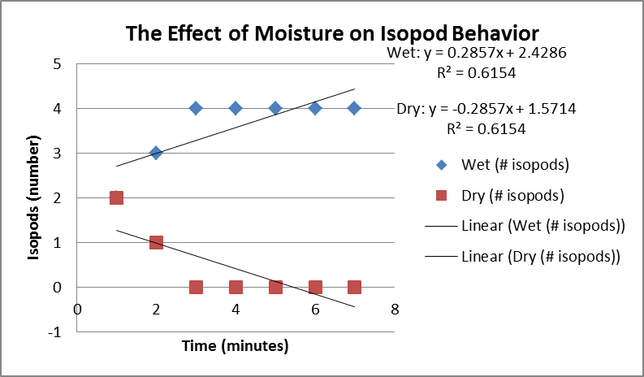

Power Conclusion: (NOTE: see https://docs.google.com/document/pub?id=1L3bwXf5AYMMPSzjdauLLx45haI06295I1000plllG8E) Please do not number your sentences and avoid all pronouns.
Example Conclusion:
The hypothesis proposed that ________________________. (Paraphrase your hypothesis, no pronouns). The data revealed that there was great support for the hypothesis. The ________ preferred the moist side 9 times more than the dry side of the choice chamber. (always include your statistics in this statement). The results are supported by (discussion of specific scientific knowledge/concepts) the fact that sowbugs and pillbugs are found on land living in moist environments.¹The following confounding factor of not using a dry towel for the dry conditions in the choice chamber could have affected the outcome due to the isopods disliking the slick plastic surface rather than dry conditions. Additional research questions such as ….. may (add/clarify/substantiate/...) . (you’ll need to come up with the next logical testable question to answer in an experiment).

References: (go to: http://www.bibme.org/ make sure you use/select APA style from the drop down menu, also make sure you cite the lab activity. Also Wikipedia is a great starting point but should not be your first or second reference).
- Wägele, A. L. (n.d.). Suborder Oniscidea - Woodlice - BugGuide.Net . Welcome to BugGuide.Net! - BugGuide.Net . Retrieved September 6, 2012, from http://bugguide.net/node/view/15976
- Potter, M. F., & Entomologist, E. (n.d.). Sowbugs and Pillbugs | University of Kentucky Entomology. Learning, Discovery, Service | in the College of Agriculture. Retrieved September 5, 2012, from http://www.ca.uky.edu/entomology/entfacts/ef439.asp
- SowbugInquiry. (n.d.). Groch Biology Web Pages. Retrieved September 5, 2012, from http://www.grochbiology.org/SowbugInquiry.html
- Common Woodlouse, Sow Bug, Pillbug. (n.d.). North American Insects and Spiders / Tree Encyclopedia. Retrieved September 6, 2012, from http://www.cirrusimage.com/isopoda_sow_bug.htm

