AP Biology Systematics Activity and Evolution Review (from Heather Essig)

Use your textbook and the following websites to answer these questions.
1. Complete the entire tutorial on evolution and the origin of life (sections 1 and 2) found at the following link: http://evolution.berkeley.edu/evolibrary/article/0_0_0/evo_toc_01

2. Quickly define the following terms: using the website or your book notes.
Convergent Evoution

Derived Characteristic

Outgroup

Cladistics

Cladogram

Clade

Principle of Parsimony

Homoplasy

Molecular Clock

Monophyletic

Paraphyletic

Polyphyletic

3. Using the following diagram differentiate label the following: monphyletic group, paraphyletic group, polyphyltetic group, derived characteristic, and first outgroup.
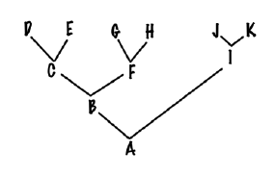

4. Using the following data create (without looking at the text) a cladogram for the following organism.
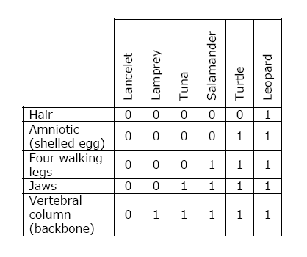
5. Create a cladogram labeling the outgroups, derived characteristics, original ancestor, and at least one example of convergent evolution using of the evolution of the snowman.

6. Go the following website and see if you can use this dichotomous key to identify the smallest group containing the following organisms:
http://faculty.fmcc.suny.edu/mcdarby/Pages/ClassificationKey/ClassificationIntro.htm#4a
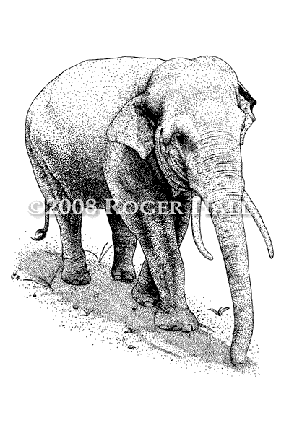Be sure to follow each question to end up at the right point.

8. Make a dichotomous key for the following organisms:
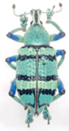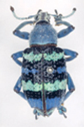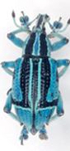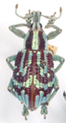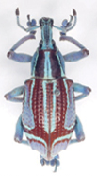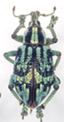
A B C D E F
Alma Berta Celine Daisy Elsa Fiona

If you would prefer, you may make a dichotomous key of the frog species found in the bag on your lab bench.

9. Find out what a T-rex might have tasted like using your newly acquired cladogram skills go the following link:
http://www.ucmp.berkeley.edu/education/explorations/tours/Trex/navigation.html

