Transpiration
Water is transported in plants, from the roots to the leaves, following a decreasing water potential gradient. Transpiration, or loss of water from the leaves, helps to create a lower osmotic potential in the leaf. The resulting transpirational pull is responsible for the movement of water from the xylem to the mesophyll cells into the air spaces in the leaves. The rate of evaporation of water from the air spaces of the leaf to the outside air depends on the water potential gradient between the leaf and the outside air.
Various environmental factors, including those conditions which directly influence the opening and closing of the stomata, will affect a plant’s transpiration rate. This experiment will measure transpiration rates under different conditions of light, humidity, temperature, and air movement. The data will be collected by measuring pressure changes as the plant takes up water into the stem.

Objectives
In this experiment, you will
- observe how transpiration relates to the overall process of water transport in plants.
- use a computer interface and a Gas Pressure Sensor to measure the rate of transpiration.
- determine the effect of light intensity, humidity, wind, and temperature on the rate of transpiration of a plant cutting.

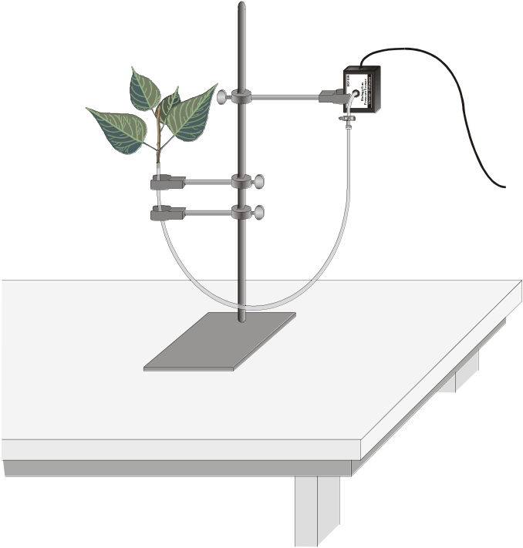
Figure 1
MATERIALS
Power Macintosh or Windows PC | metric ruler
Vernier computer interface | masking tape
Logger Pro | 100-watt light source
Vernier Gas Pressure Sensor | plastic gallon size bag with twist tie
utility clamps | heater, small electric
ring stand | fan with slow speed
plant cuttings | aerosol spray container or plant mister
plastic tubing clamps | plastic syringe
dropper or Beral pipette  razor blade or scalpel | graph paper or Graphical Analysis program

Procedure
1. Position the ring stand, utility clamps, and Gas Pressure Sensor as shown in Figure 1.
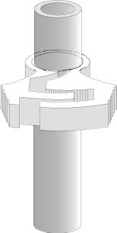
Figure 2
2. Prepare the plastic tubing.
- Connect the plastic syringe to one end of a 36-42 cm piece of plastic tubing.
- Place the other end of the tubing into water and use the syringe to draw water up into the tubing until it is full. Tap the tubing to expel any air bubbles that form inside the tube.
- Slip a plastic tubing clamp onto the tubing as shown in Figure 2.
- Bend the tubing into a U shape with both ends up. Remove the syringe, leaving the tubing full of water.

3. Select a plant which has a stem roughly the same diameter as the opening of the plastic tubing. Using a scalpel or razor blade, carefully cut the plant one inch above the soil. Place the plant under water against a hard surface and make a new cut at a 45° angle near the base of the stem.
4. Connect the plant to the tubing.
- The plastic tubing has a white plastic connector at one end that allows you to connect it to the valve on the Gas Pressure Sensor. Raise the end of the tubing with the connector until you see water beginning to drip out of the other end.
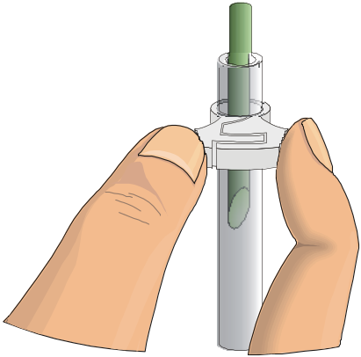
Figure 3
- Carefully push the cut stem of the plant down into the end of the tubing where the water is dripping out. Be careful not to allow any air bubbles to form between the cut portion of the stem and the water in the tube.
- Push the plant down as far as it will go without damaging the plant. At least one centimeter of the plant stem should fit into the tubing. If the stem is too large for the tubing, cut the stem at a higher point where it is smaller.
- Squeeze the tubing clamp shut as tight as possible as shown in Figure 3.

5. When the tubing clamp is shut tight, invert your plant cutting to check for any leaks. If water does leak out, turn the plant right-side up and try tightening the clamp further.
Important: Be sure the tubing is filled completely with water. The water column must be flush with the stem. There should be no air visible at the base of the stem. If water moves down the tube away from the stem after it has been inserted, check for a leak in the system.
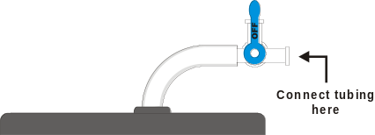
Figure 4
6. Connect the plastic tubing to the sensor valve. If your sensor has a blue plastic valve on it, place the valve in the position shown in Figure 4. Caution: Do not allow water to enter the valve of the Gas Pressure Sensor.
7. Secure the plant in an upright position with the utility clamps as shown in Figure 1. It should be positioned so that the cut stem is about 8 cm below the water level at the other end of the tubing, as shown in Figure 1.
8. Place a mark on the tube at the starting water level to allow you to refill the tube to the proper level in Step 17.
9. Place your plant setup in an area where the wind, humidity, and temperature are reasonably constant. This will be your control setup.
10. Allow the system 5 minutes to adjust to the environment. While the system is adjusting, set up the computer.
11. Prepare the computer for data collection by opening the Experiment 10 folder from the Biology with Computers folder of Logger Pro. Then open the experiment file that matches the probe you are using. The vertical axis has pressure scaled from 80 - 110 kPa. The horizontal axis has time scaled from 0 to 15 minutes. The data rate is set to 4 samples/minute.
12. Check the base of the plant stem in the water tube to make sure that no air bubbles or air pockets have formed that will prevent the plant from taking up water. If an air pocket has formed, refit the plant in the tubing before initiating data collection in Step 13.
13. After the plant has equilibrated for 5 minutes, click to begin data collection. Data will be collected for 15 minutes.
14. When data collection has finished, find the rate of transpiration for your plant. To do this,
- Move the mouse pointer to the point where the pressure values begin to decrease. Click the mouse button and drag the pointer to the end of the data, then release the mouse button.
- Click the Regression button, 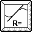, to perform a linear regression. A floating box will appear with the formula for a best fit line.
- Record the slope of the line, m, in Table 1 as the rate of transpiration for the control. Close the floating box.

15. (Optional) Double click on the graph title and enter “Transpiration: Control. Print a copy of your graph. Enter your name(s) and the number of copies of the graph.
16. Design an experiment to simulate one of the following environmental factors, as assigned by your teacher:
- the effect of light intensity
- the effect of the wind blowing on the plant
- the effect of humidity
- the effect of temperature
- the effect of another self-identified environmental variable

Be sure to address the following questions in your design:
- What is the essential question being addressed?
- What assumptions are made about the system being measured?
- Can those assumptions be easily verified?
- Will the measurements provide the necessary data to answer the question under study?

17. After checking your procedure with your teacher, obtain the materials needed for the experiment and perform the tests. Record your values in Table 1.

PROCESSING THE DATA
1. Determine the surface area of all the leaves on your plant cutting by the following method:
- Cut all the leaves (not stems) off your plant and determine their mass using a balance.
- Estimate the total leaf surface area in cm² for your plant by cutting out a section of leaf 5 cm X 5 cm.
- Determine the mass for this leaf section and divide by 25 cm² to find the mass of l cm² of leaf.
- Divide the total mass of the leaves by the mass of l cm² to find the total leaf surface area.
- Record the calculated surface area in Table 1.

2. Calculate the rate of transpiration/surface area. To do this, divide the rate of transpiration by the surface area for each plant. These rate values can be expressed as kPa/min/cm2. Record the rate/area in Table 1.
3. Subtract the control (rate/area) value from the experimental value. Record this adjusted rate in the last column of Table 1.
4. Record the adjusted rate for your experimental test on the board to share with the class. Record the class results in Table 2 for each of the environmental conditions tested. If a condition was tested by more than one group, take the average of the values and record in Table 2.
5. Make a bar graph that shows the effect of different environmental conditions on the transpiration of water in plant cuttings. Using the data in Table 2 plot the adjusted rate for each test on the y-axis and the test label on the x-axis.

Data
Table 1
Test | Slope (kPa/min) | Surface area (cm²) | Rate/area (kPa/min/cm²) | Adjusted rate (kPa/min/cm²)
Experimental ______________
Control

Table 2
Class Data
Test | Adjusted rate (kPa/min/cm²)
Light
Humidity
Wind
Temperature

questions
1. How was the rate of transpiration affected in each of the experimental situations as compared to the control?
2. Which variable resulted in the greatest rate of water loss? Explain why this factor might increase water loss when compared to the others.
3. What adaptations enable plants to increase or decrease water loss? How might each affect transpiration?

Extensions
1. Using a compound microscope, identify the vascular tissues of a plant stem. Describe the function of each tissue type identified.
- Obtain a section of stem from the plant you used during the transpiration experiment.
- Using a nut-and-bolt microtome, carefully cut 6 cross sections of the plant stem. The cross sections should be cut as thin as possible.
- Place each of the cross sections in a dish or cup of 50% ethanol solution for 5 minutes.
- Remove the cross sections from the alcohol and place them in a dish containing toludine blue O stain for 5 minutes.
- Rinse the cross sections with distilled water and mount them on a microscope slide with a drop of 50% glycerin. Place a cover slip on the slide and examine the cross sections using a compound microscope.
- On a separate sheet of paper, make a drawing of the cross sections. Identify and label the cell and tissue types described by your teacher.

2. Test cuttings from a variety of different plant species. How does each compare?
3. Count the number of stoma/cm² for each of the plants in Extension 1. How does this relate to the plant’s ability to transpire water?
4. Design an experiment to test for the variables in Question 3.

