Respiration of Sugars by Yeast
Yeast are able to metabolize some foods, but not others. In order for an organism to make use of a potential source of food, it must be capable of transporting the food into its cells. It must also have the proper enzymes capable of breaking the food’s chemical bonds in a useful way. Sugars are vital to all living organisms. Yeast are capable of using some, but not all sugars as a food source. Yeast can metabolize sugar in two ways, aerobically, with the aid of oxygen, or anaerobically, without oxygen.
In this lab, you will try to determine whether yeast are capable of metabolizing a variety of sugars. When yeast respire aerobically, oxygen gas is consumed and carbon dioxide, CO₂, is produced. You will use a CO₂ Gas Sensor to monitor the production of carbon dioxide as yeast respire using different sugars. The four sugars that will be tested are glucose (blood sugar), sucrose (table sugar), fructose (fruit sugar), and lactose (milk sugar).

OBJECTIVES
In this experiment, you will
- use a CO₂ Gas Sensor to measure concentrations of carbon dioxide.
- determine the rate of respiration by yeast while using different sugars.
- determine which sugars can be used as a food source by yeast.
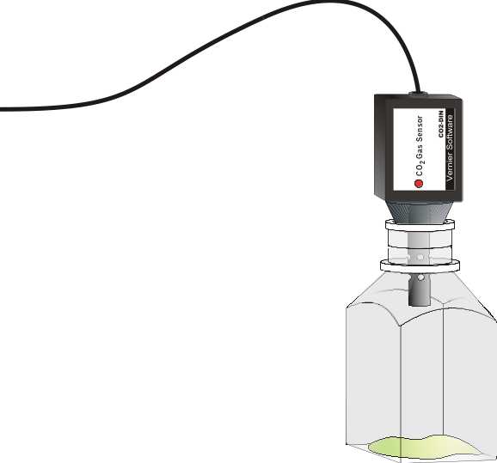
Figure 1
MATERIALS
Power Macintosh or Windows PC | 600-mL beaker (for water bath)
Vernier computer interface | Beral pipettes
Logger Pro | hot and cold water
Vernier CO₂ Gas Sensor | thermometer
250-mL respiration chamber | four 10 X 100 mm test tube
5% glucose, sucrose, lactose, and fructose sugar solution | yeast suspension  Graphical Analysis (optional)
PROCEDURE
1. Prepare a water bath for the yeast. A water bath is simply a large beaker of water at a certain temperature. This ensures that the yeast will remain at a constant and controlled temperature. To prepare the water bath, obtain some warm and cool water from your teacher. Combine the warm and cool water into the 600-mL beaker until it reaches 38 – 40°C. The beaker should be filled with about 300 – 400 mL water. Leave the thermometer in the water bath during the course of the experiment to monitor the temperature of the water bath.
2. Obtain five test tubes and label them G, S, F, L, and W.
3. Obtain the four sugar solutions: glucose, sucrose, fructose, and lactose.
- Place 2 mL of the glucose solution in test tube G.
- Place 2 mL of the sucrose solution in test tube S.
- Place 2 mL of the fructose solution in test tube F.
- Place 2 mL of the lactose solution in test tube L.
- Place 2 mL of distilled water in test tube W.

4. Obtain the yeast suspension. Gently swirl the yeast suspension to mix the yeast that settles to the bottom. Put 2 mL of yeast into each of the five test tubes. Gently swirl each test tube to mix the yeast into the solution.
5. Set the five test tubes into the water bath.
6. Incubate the test tubes for 10 minutes in the water bath. Keep the temperature of the water bath constant. If you need to add more hot or cold water, first remove as much water as you will add, or the beaker may overflow. Use a beral pipet to remove excess water. While the test tubes are incubating, proceed to Step 7.
7. Prepare the computer for data collection by opening the file in the Experiment 12A folder of Biology with Computers. The vertical axis has Carbon Dioxide concentration scaled from 0 to 5000 ppm. The horizontal axis has time scaled from 0 to 4 minutes. The data rate is set to 4 samples/minute.
8. When incubation is finished, use a beral pipet to place 1 mL of the solution in test tube G into the 250-mL respiration chamber. Note the temperature of the water bath and record as the actual temperature in Table 1.
9. Quickly place the shaft of the CO₂ Gas Sensor in the opening of the respiration chamber. Gently twist the stopper on the shaft of the CO₂ Gas Sensor into the chamber opening. Do not twist the shaft of the CO₂ Gas Sensor or you may damage it.
10. Begin measuring carbon dioxide concentration by clicking . Data will be collected for 4 minutes.
11. When data collection has finished, remove the CO₂ Gas Sensor from the respiration chamber. Fill the respiration chamber with water and then empty it. Make sure that all yeast have been removed. Thoroughly dry the inside of the chamber with a paper towel.
12. Determine the rate of respiration:
- Move the mouse pointer to the point where the data values begin to increase. Hold down the left mouse button. Drag the pointer to the end of the data and release the mouse button.
- Click on the Regression button, ,to perform a linear regression. A floating box will appear with the formula for a best fit line.
- Record the slope of the line, m, as the rate of respiration in Table 1.
- Close the linear regression floating box.
- Share your data with the class by recording the sugar type and respiration rate on the board.

13. Move your data to a stored run. To do this, choose Store Latest Run from the Data menu.
14. Use a notebook or notepad to fan air across the openings in the probe shaft of the CO₂ Gas Sensor for 1 minute.
15. Repeat Steps 8 – 14 for the other four test tubes.

DATA
Table 1
Sugar Tested | Actual Temperature (°C) | Respiration Rate (ppm/min)
Glucose
Sucrose
Fructose
Lactose
Water (control)

Table 2: Class Averages
Sugar Tested | Respiration Rate (ppm/min)
Glucose
Sucrose
Fructose
Lactose
Water

PROCESSING THE DATA
1. When all other groups have posted their results on the board, calculate the average rate of respiration for each solution tested. Record the average rate values in Table 2.
2. Using graph paper, make a bar graph of rate of respiration vs. sugar type. The rate values should be plotted on the y-axis, and the sugar type on the x-axis. Use the rate values from Table 2.

QUESTIONS
1. Considering the results of this experiment, do yeast equally utilize all sugars? Explain.
2. Hypothesize why some sugars were not metabolized while other sugars were.
3. Why do you need to incubate the yeast before you start collecting data?
4. Yeast live in many different environments. Make a list of some locations where yeast might naturally grow. Estimate the possible food sources at each of these locations.

