Biology Fall Semester Final Exam Review Part 2

1. A theory is…

2. In science, a hypothesis is useful only if…

3. Which bonds are the strongest types of chemical bonds (strongest attraction)?

4. Amino acid is to protein as….

5. Which organic compound is the main source of energy for living things?

6. Enzymes affect the reactions in living cells by changing the?

7. Prokaryotes lack…

8. A cell or plasma membrane is described as:

9. Which means of particle transport requires input of energy from the cell?

10. DNA is copied during a process called….

11. During protein synthesis ____ is transcribed into ____ and then translated into ____.

12. Photosynthesis uses sunlight to convert water and carbon dioxide into…

13. What is the equation for cellular respiration?

14. During interphase, DNA is copied during a process called…

16. A controlled experiment allows the scientist to isolate and test…

17. How many centimeters are in 15.0 m?

18. What type of electron is available to form bonds?

19. What type of ion forms when an atom loses electrons?

20. Solutions that contain concentrations of H⁺ ions higher than pure water are…

21. What are the various functions of proteins?

22. If a reaction in one direction releases energy, the reaction in the opposite direction does….

23. Why the nucleus is important to cells?

24. What is a function of the cytoskeleton?

25. The cell membrane contains channels and pumps that help move materials from one side to the other. What are these channels and pumps made of?

26. What are the levels of organization in a multicellular organism from the simplest level to the most complex level?

27. What are some examples of autotrophs?

28. What is ATP? What is it used for?

29. Plants gather the sun’s energy with light-absorbing molecules called…

30. Most plants appear green because chlorophyll…

31. What is the main product of the Calvin cycle?

32. What is correct sequence of events in cellular respiration?

33. What is the correct equation for photosynthesis?

34. What processes of cellular respiration take place in the cytoplasm of a cell?

35. Glycolysis provides a cell with a maximum NET gain of ____ ATP

36. Lactic acid fermentation occurs in which organisms?

37. The starting molecule for the Krebs cycle is the ____

38. In eukaryotes, the electron transport chain is found in the ____

39. Which molecules passes high-energy electrons into the electron transport chain in mitochondria?

40. The products of photosynthesis are the ____

41. What happens when a cell divides?

42. What are the phases of mitosis?

43. What is the role of the spindle during mitosis?

44. One DIFFERENCE between cell division in plant cells and in animal cells is that plant cells have ___

45. During normal mitotic cell division, a parent cell having eight chromosomes will produce two daughter cells, each containing ___ chromosomes

46. In eukaryotic cells, the timing of the cell cycle is regulated by ____

47. Cancer is a disorder in which some cells have lost the ability to control their ____

48. Which of the following is a nucleotide found in DNA?

49. Because of base pairing in DNA, Chargaff’s rules state that the percentage of ___ equals ____

50. Which type(s) of RNA is(are) involved in protein synthesis?

51. Why is it possible for an amino acid to be specified by more than one kind of codon?

52. A mutation that involves a single nucleotide is called a(an) ____

53. A promoter site on a bacterial chromosome is a place where….

54. If a specific kind of protein is not continually used by a cell, the gene for that protein is____

55. A lac repressor turns off the lac genes by ____

56. Hox genes determine an animal’s ____

57. Suppose a bacterial culture were mixed with recombinant plasmids containing a gene for resistance to penicillin. The bacterial culture was then treated with penicillin. What would you expect to happen?

58. Miller and Urey’s experiments attempted to demonstrate ____

59. All organisms in the kingdoms Protista, Plantae, Fungi, and Animalia are ____

60. The two domains composed of only unicellular organisms are _____

61. The instructions for making new copies of a virus are found on….

62. Viruses are considered to be ____

63. Viruses cause infection by ____

65. The process by which organ systems maintain a relatively stable internal environment is called ____

66. A well-tested explanation that unifies a broad range of observations is a(an)

67. The three particles that make up an atom are

68. Isotopes are atoms of the same element with the same number of protons and ____

69. What are the properties or components of a compound?

70. A covalent bond is formed as the result of

71. Water molecules are polar, because…

72. What is the term used to describe the energy needed to get a reaction started?

73. A substance that accelerates the rate of a chemical reaction is called a(an)

74. What are the principles of the cell theory?

75. Which organelles help provide cells with energy?

76. What is the correct sequence the traces the production of a protein in the cell?

77. Diffusion is the movement of molecules from

78. The diffusion of water across a selectively permeable membrane is called

79. Organisms, such as plants, that make their own food are called

80. Which types of organisms do not fully carry out cellular respiration?

81. How are cellular respiration and photosynthesis almost opposite processes?

82. Compared to small cells, large cells have more trouble because

83. Cell cycle is composed of the following phases…

84. The cell cycle is the

85. During DNA replication, a DNA strand that has the bases CTTGGT produces a complementary strand with the bases reading ____

86. RNA contains the sugar ___

87. How many nucleotides are needed to specify four amino acids?

88. What happens during the process of translation?

89. What are four major groups of macromolecules found in living organisms?

Figure 03.01 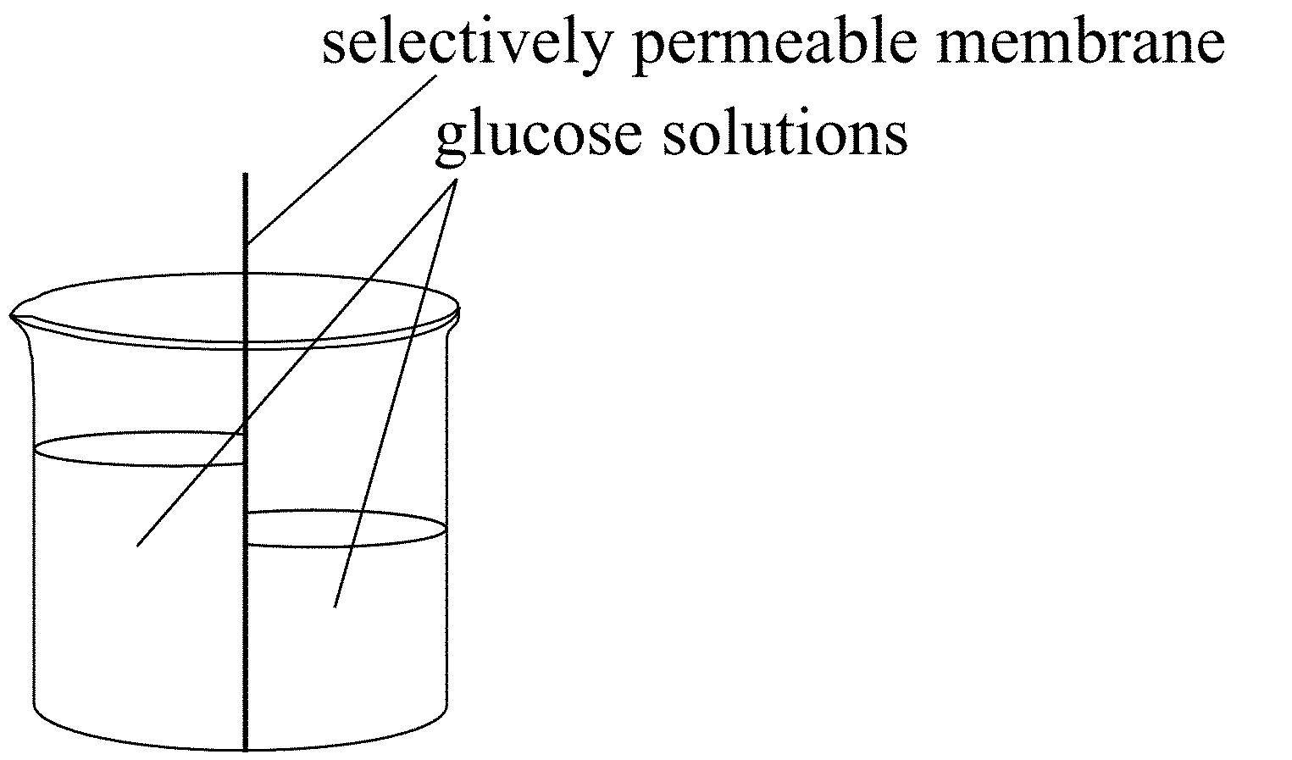

90. Refer to Figure 03.01.
If the original levels of liquid on both sides were the same, the glucose concentration on the left side was originally (where?)

91. Cell membranes are composed of layers of

92. The four nucleotides in a DNA molecule differ from one another only in the

93. Distribution of one of each replicated chromosome to each of two cells following mitosis ensures

94. A group of similar cells that perform a single function is called a(an)

95. What are some examples of a heterotroph?

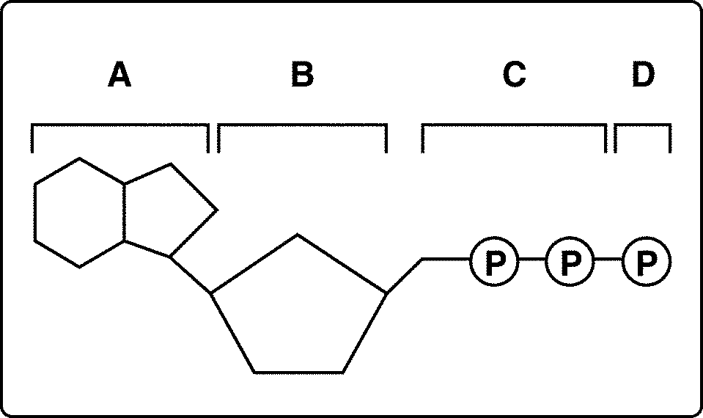

Figure 8–1

96. Look at Figure 8–1. All of the following are parts of an ADP molecule EXCEPT

97. In Figure 8–1, between which parts of the molecule must the bonds be broken to form an ADP molecule?

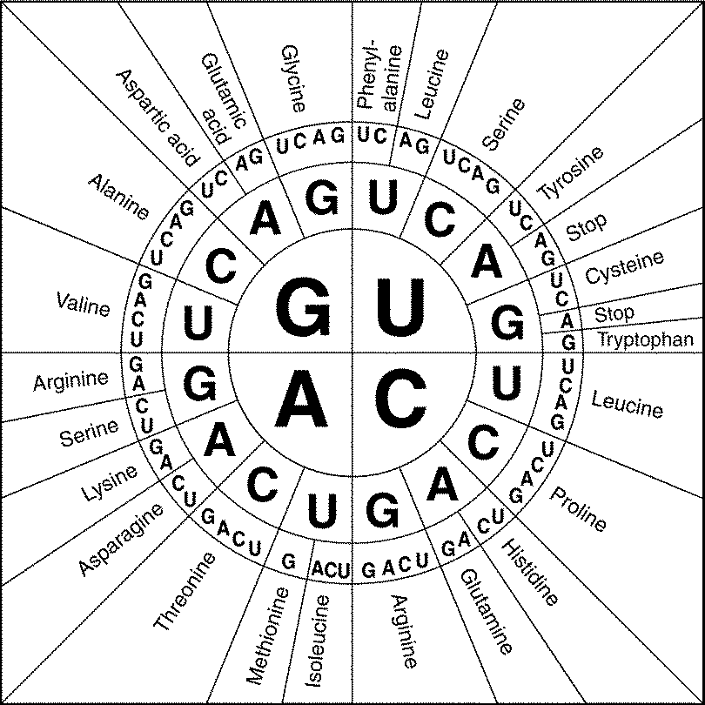

98....According to Figure 12-3, how many different triple codons specify the amino acid arginine?

1. Compare cellular respiration with respiration.

2. Explain how feedback controls regulate the body’s metabolism.

3. Compare and contrast adhesion and cohesion, using capillary action as an example.

4. Describe what happens when sugar solutions with two different concentrations are placed on opposite sides of a semipermeable membrane in a container.

5. How do facilitated diffusion and active transport differ?

6. What happens to the electrons in a chlorophyll molecule when light shines on it? Does the chlorophyll molecule ever run out of electrons? Explain your answer.

7. Explain how high-energy electrons are used by the electron transport chain.

8. Compare photosynthesis with cellular respiration.

9. How does transcription differ from DNA replication? Describe at least four differences.

