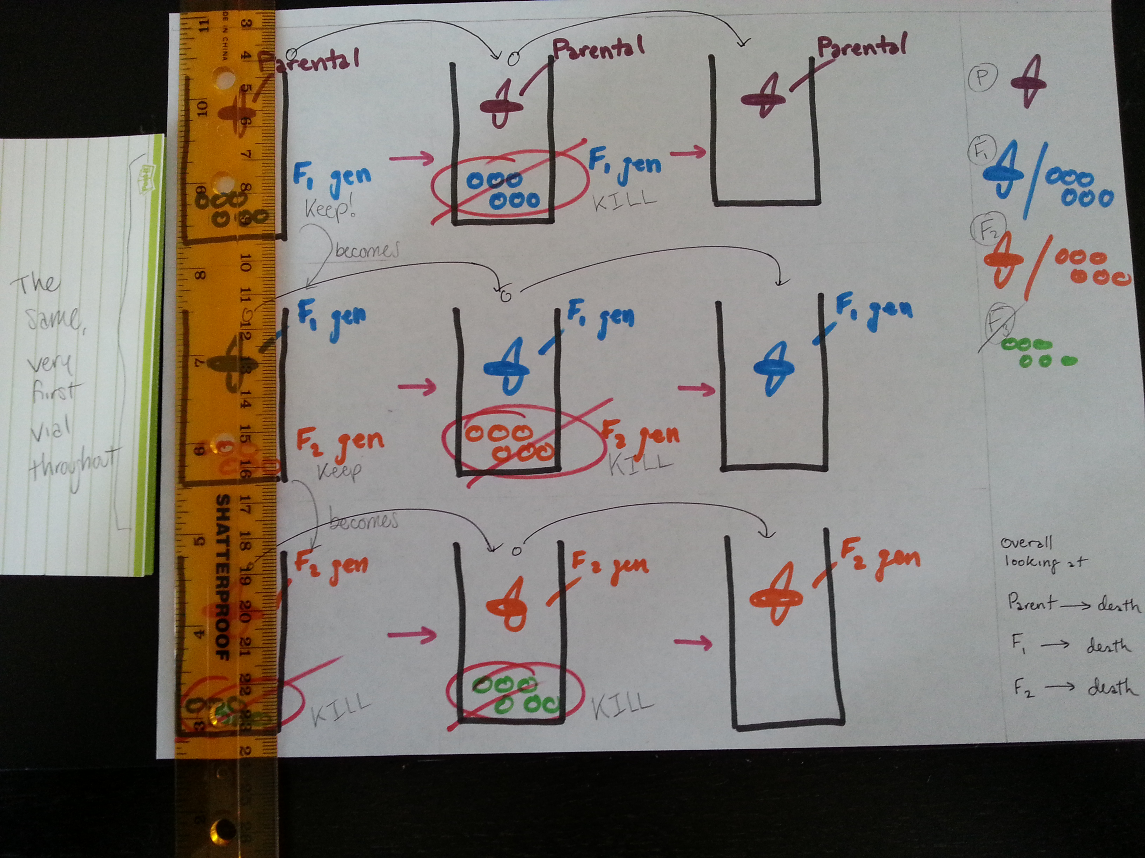
Overview of fly epigenetics scheme ( picture and explanation by Andrew Lau class of 2013)
Starting out with the PARENT generation in vial 1, let the flies make whoopee (mate) and lay eggs still in vial 1. After X time, move PARENT generation into vial 2 and leave F1 eggs in vial 1. Focusing on vial 2, the PARENT generation still makes whoopee and lays eggs, so you must move the PARENT generation into new vial 3 and dispose of the new eggs made in vial 2. Hopefully, the PARENT generation will have died out in vial 3 without any eggs.

Back in vial 1, the eggs containing F1 hatch. Let the F1 generation make whoopee and lay the eggs of the F2 generation; move F1 into new vial 4. F1 generation will lay more eggs of F2 [which you can dispose of] so you need to move F1 into new vial 5 where they hopefully will die without any eggs.

Back in vial 1, the eggs containing F2 hatch. Let the F2 generation live and lay eggs of the F3 generation [we don’t care about the F3 anymore]. Move the F2 generation from vial 1 into new vial 6, where the flies of F2 will continue to lay eggs. You will have to move the F2 generation into new vial 7 in order to maintain focus on ONLY the F2.

Overall, we look at the longevity of the PARENT/F1/F2 generation, whether or not the additive affects the lifespan of the flies.
In all, we will use 14 vials [7 per variable (control or additive)]; the very first vial of the [control or additive] will remain in use. Intermediate vials can be reused once you clean it out and dispose of the nasty things (remaining instars and pupa) inside.
____________________________________
Hopefully this is clear for everyone. As you can see from the sentence structure/grammar, I tried to simplify the process.

