Unit Test: Scientific Method Study Guide

1. Information gathered from observing a plant grow over a time period results in___?

2. What is the purpose (use) of a hypothesis?

3. Science differs from other disciplines, such as history and the arts, because science relies on___

4. A controlled experiment allows the scientist to isolate and test….

5. A theory is….

6. What are the characteristics of all living things? What is not always a characteristic of living things?

7. What are levels of organization includes all of the living things on Earth?

8. The three particles that make up atoms are…

9. What is the term that describes a substance formed by the combination of two or more elements in definite proportions?

10. What is the formula for a molecule of water?

11. A covalent bond is formed as the result of….?

12. What type of electron is available to form bonds?

13. Ice floats on water because….

14. Water molecules are polar because…

15. A map of eastern North America, showing the pH of rainfall in the various states, indicates that the pH of rain in New York State varies from 4.22 to 4.40. The most acidic rainfall in New York State would have a pH of…?

16. Why did oceans not exist on Earth nearly 4 billion years ago?

17. Miller and Urey’s experiments attempted to demonstrate
Modified True/False: Answer the following:
18. “The bird has brown spots on its wings” is an example of an inference.
19. “The plant in Container A has five offshoots” is an example of a ____________________ observation.

Hypothesis: If a certain type of fish food is used, aquarium fish will grow larger and healthy because the fish will have the proper nutrients.

20. The independent variable in the above experiment is__________________________.
21. The dependent variable in the above experiment is ______________________________.
22. One possible standard variable in the above experiment is __________________________.
23. The graph below is missing some information in the title and on an axis, what words would fix this graph?

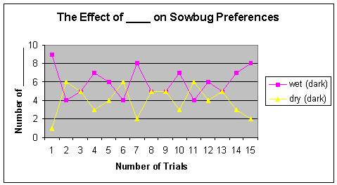

a. The title needs the word?
b. The Y axis needs the word?

24. A mom wanted to know if the amount of sugar her son has in his breakfast makes him happier in the morning. She usually feeds him plain oatmeal. Every day for one week she fed him at 7 a.m. at his normal seat at the table warm oatmeal with his favorite airplane spoon and bowl. Day 1 she added 1 Tablespoon (Tbsp) of sugar. The next day she added 2 Tbsp, the third she added 3 and the fourth day she added 4 Tbsp.
Identify the following:
a. Name an independent variable
b. Name a dependent variable
c. Name ONE standarized variable
d. What is the control in this experiment?
e. Write a hypothesis for this experiment (If...then...because).

Figure 17–3 shows a version of Stanley Miller and Harold Urey’s apparatus used to simulate what was thought to be conditions on early Earth.

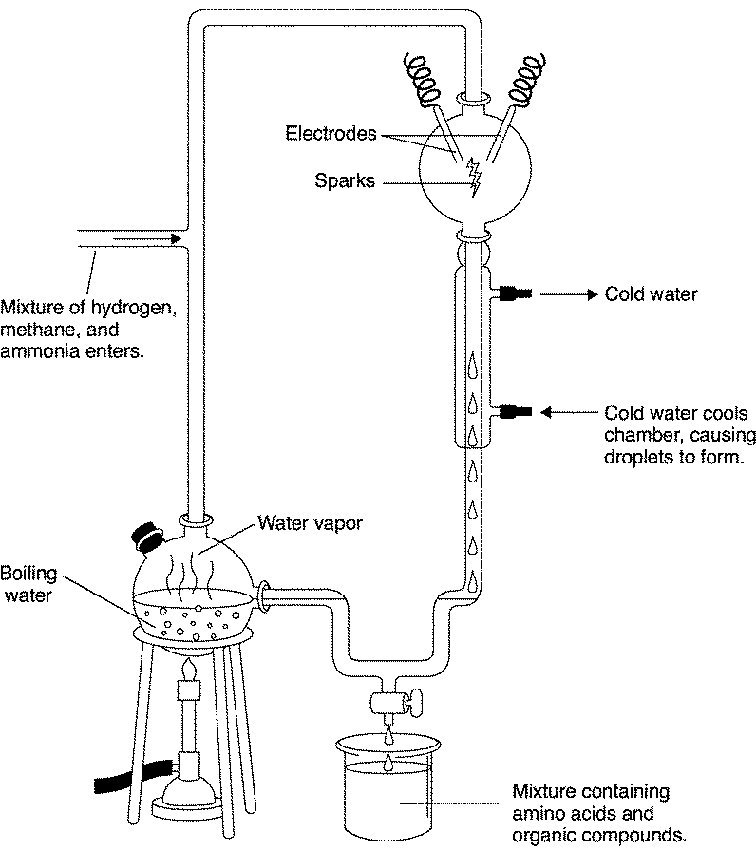

Figure 17–3

25. Looking at the apparatus in Figure 17–3, what do the electrodes produce and what part of abiogenesis are the electrodes simulating (representing)?

