Spring Cumulative Exam Study Guideu

1. A student suggests that a certain species of bacteria grows better in the light than in the dark. The student has 10 culture plates on which to grow the bacteria. What would be the best experiment to test this idea?

2. When enough experimental data support a hypothesis, the hypothesis becomes a(an)...?

3. In which way are plants in a sunny mountain meadow and sulfur bacteria in a deep-sea volcanic vent alike in their ability to feed themselves?

4. What factors contribute to Earth’s climate?

5. Name some biotics factor that affects the size of a population in a specific ecosystem.

6. During a long period when there is no rainfall, a mountain lion may temporarily leave its usual hunting territory to drink from a farm pond. This behavior is probably due to...?

7. Name examples of autotrophs?

8. Energy is released from ATP when...?

9. A student is collecting the gas given off from a plant in bright sunlight at a temperature of 27°C. The gas being collected is probably

10. Most plants appear green because chlorophyll...?
11. What is a product of the Calvin cycle?

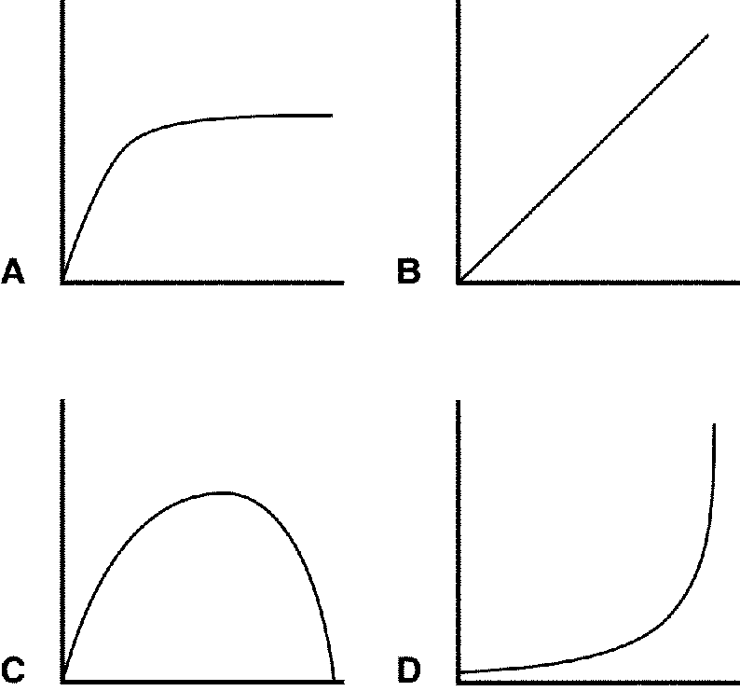

Figure 8–2

12. Which of the graphs in Figure 8–2 represents the effect of temperature on the rate of photosynthesis?

13. Which of the graphs in Figure 8–2 represents the effect of light intensity on the rate of photosynthesis?

14. What are the parts of cell cycle and what happens in each?

15. Gregor Mendel concluded that traits are....?

16. A heterozygous tall pea plant is crossed with a short plant. The probability that an F₁ plant will be tall is...?

 |  |  | Tt
 |  | T |  | t
TT | T | TT |  | Tt
TT | T | TT |  | Tt

T | = | Tall
t | = | Short

Figure 11–1

17. In the Punnett square shown in Figure 11–1, which of the following is true about the offspring resulting from the cross?

18. If a pea plant that is heterozygous for round, yellow peas (RrYy) is crossed with a pea plant that is homozygous for round peas but heterozygous for yellow peas (RRYy), how many different phenotypes are their offspring expected to show?

19. What is the relationship between purines and pyrimidines?

20. During DNA replication, a DNA strand that has the bases CTAGGT produces a strand with the bases

21. What is found in both DNA and RNA?

22. mRNA, tRNA, and rRNA are all copied from ….?

23. What is the difference between what a human female inherits and a human male?

24. If a man with blood type A and a woman with blood type B produce an offspring, what might be the offspring’s blood type?

25. People who are heterozygous for sickle cell disease are generally healthy because....?

26. Colorblindness is more common in males than in females because...?

27. If nondisjunction occurs during meiosis,then... what will happen?

28. What is the relationship between viral diseases, antibiotics, and vaccines?

29. Name some examples of a vector and the disease it spreads?

30. What will the immune system of a person who has received a vaccine against polio do?

31. Hypotheses may arise from...?

32. A controlled experiment allows the scientist to isolate and test...?

33. The process by which organisms keep their internal conditions fairly constant is called...?
34. What is the term for a group of organisms of one type living in the same place?

35. What are considered good safety procedures?

36. Eukaryotes usually contain...?

37. What are some examples of prokaryotes?

38. The main source of energy for producers in an ecosystem is..?

39. Charles Darwin proposed a mechanism for descent with modification that stated that organisms of a particular species are adapted to their environment when they possess....?

40. Where does glycolysis and fermentation take place in an eukaryotic cell?

41. Where does the Calvin cycle take place?
42. The reactions that produce molecular oxygen (O₂) take place in the ____?

43. How many total chromosomes in a cell with a chromosome number of 2n = 16?

44. What is the difference between haploid and diploid, autosomes & sex chromosomes, where are gametes formed?

45. What is a karyotype?

46. What happens at the conclusion of meiosis I?

47. Chromatids are separated from each other.

48. What do we mean when we use the terms monohybrid cross and dihybrid cross?

49. A sexually reproducing animal has two unlinked genes, one for head shape (H) and one for tail length (T). Its genotype is HhTt. Which of the following genotypes is possible in a gamete from this organism?

50. In certain plants, tall is dominant to short. If a heterozygous plant is crossed with a homozygous tall plant, what is the probability that the offspring will be short?

51. Duchenne muscular dystrophy is a serious condition caused by a recessive allele of a gene on the human X chromosome. The patients have muscles that weaken over time because they have absent or decreased dystrophin, a muscle protein. They rarely live past their 20s. How likely is it for a woman to have this condition?

52. Which of the following must exist in a population before natural selection can act upon that population?

53. What is the role that humans play in artificial selection?

54. What is natural selection?

55. There are those who claim that the theory of evolution cannot be true because the apes, which are supposed to be closely related to humans, do not likewise share the same large brains, capacity for complicated speech, and tool-making capability. They reason that if these features are generally beneficial, then the apes should have evolved them as well. What would be the best argument against this misconception?

Use this information to answer the following questions.

You are studying three populations of birds. Population A has 10 birds, of which 1 is brown (a recessive trait) and 9 are red. Population B has 100 birds, of which 10 are brown. Population C has 30 birds, and 3 of them are brown.

56. In which population would it be least likely that an accident would significantly alter the frequency of the brown allele?

57. An example of a properly functioning homeostatic control system is seen when... what are some examples?
58. Positive feedback differs from negative feedback in that...?

59. In a typical nerve cell, the nucleus is found in the...?

60. Histamines trigger dilation of nearby blood vessels as well as an increase in their permeability, producing...what?

61. Antigens are...?

62. The function of antibodies is to...?

63. The operation of the sodium-potassium "pump" moves....what?

64. How do action potentials move along axons?

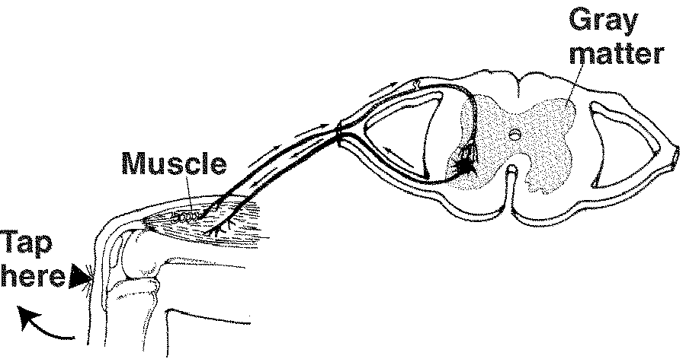

Figure 35–3

65. The pathway illustrated in Figure 35–3 is called a(an) __(do not write here)___.

66. A number of rats are divided into two groups: One group is fed a normal diet, whereas the other group is fed the same diet but with one necessary mineral left out. The animals receiving the normal diet remained healthy; those in the other group grew weaker. Formulate a hypothesis based on this experiment.

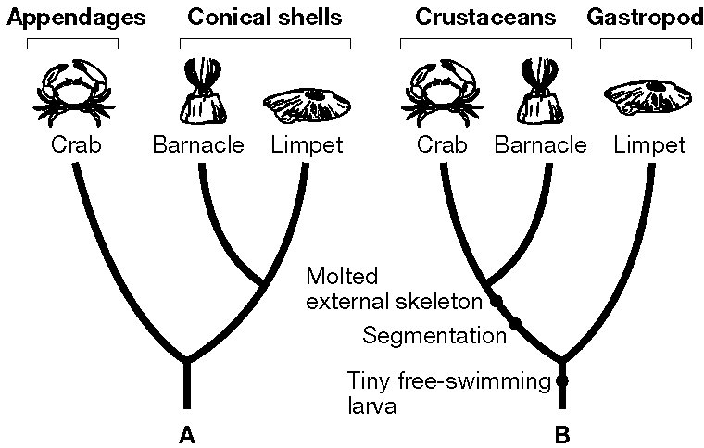

Figure 18–1

67. According to the cladogram in Figure 18–1, what two characteristics do crabs and barnacles share that limpets do not?

A scientist conducted an experiment to determine the effect of environment on the color of fur of a Himalayan rabbit. The Himalayan rabbit typically has a white coat except for its colder nose, feet, tail, and ears, which are black. The scientist shaved an area of hair on the back of each rabbit, then placed an ice pack over the shaved area on one rabbit (A).

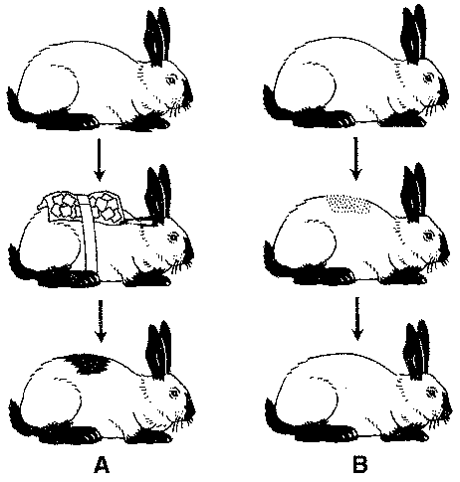

Figure 1–1

68. Interpreting Graphics In Figure 1–1, which rabbit is the control?

69. Before completing the experiment in Figure 1–1, the scientist made a hypothesis. What is the hypothesis she is testing?

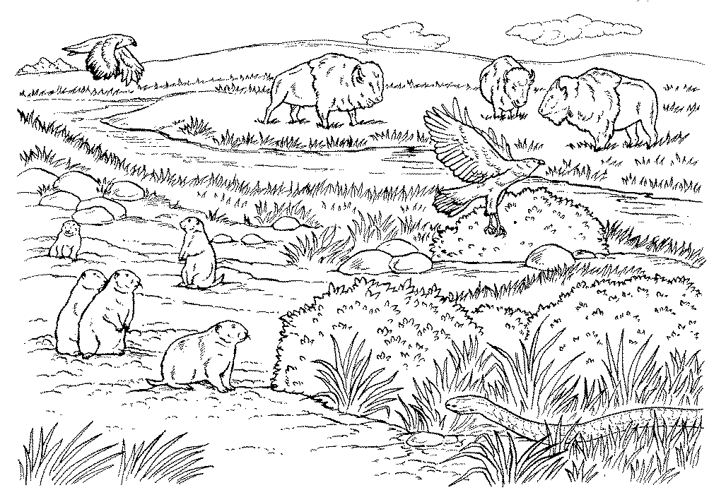

Figure 1-2

70. According to Figure 1–2, what are the abiotic (nonliving) elements in this ecosystem?

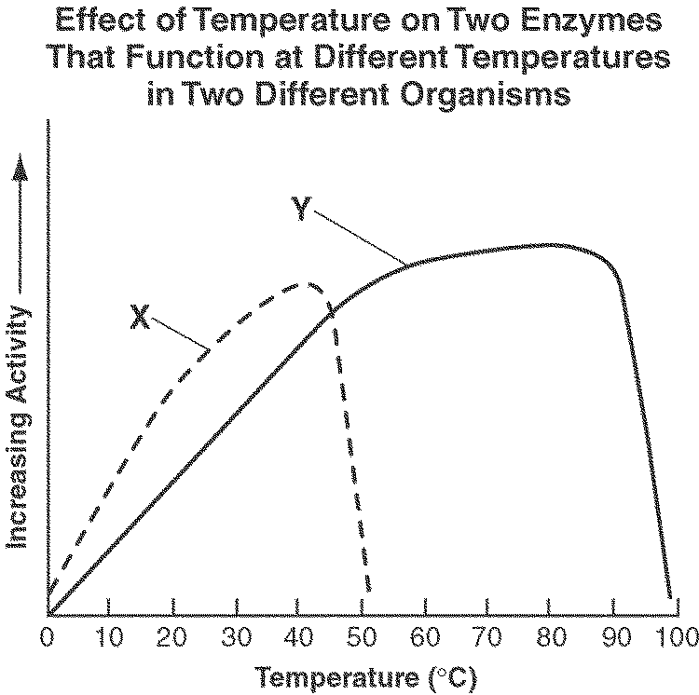

Figure 2–3

71. According to Figure 2–3, at what temperature do the two enzymes have the same amount of activity?

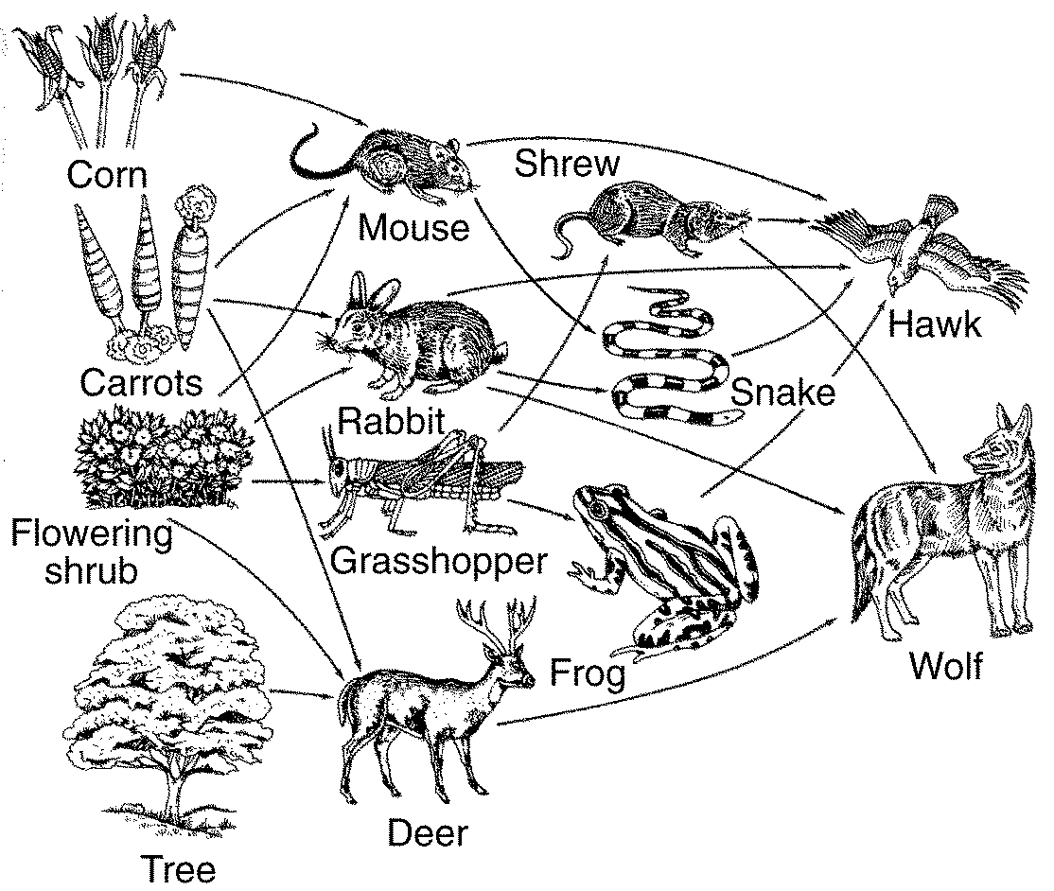

Figure 3–4

72. A food web, such as the one in Figure 3–4, is a model of the feeding relationships in an ecosystem. What makes this model representative of an ecosystem?

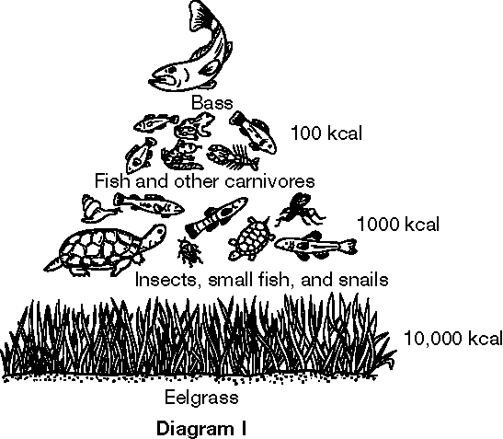

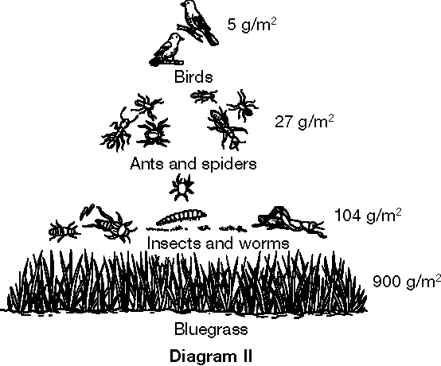

Figure 3–5

73. If a limiting nutrient, such as a fertilizer, is supplied to the producer in Figure 3–5, Diagram II, what effect could it have on the birds?

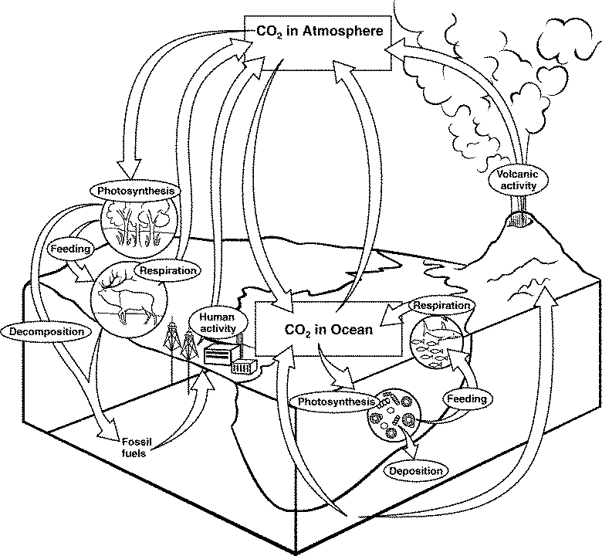Figure 3–6

74. Compare the carbon cycle shown in Figure 3–6 with what you know about photosynthesis and respiration. What simple change could be made to the figure to show how the carbon cycle and the oxygen cycle are related?

A student prepared two beakers with identical sprigs of a water plant as shown below. She placed one beaker in the shade and the other beaker beside a fluorescent lamp. She then systematically changed the distance from the beaker to the lamp. She counted the bubbles given off by each sprig of the water plant. Shown here is the graph of the data for the beaker she placed in the light.
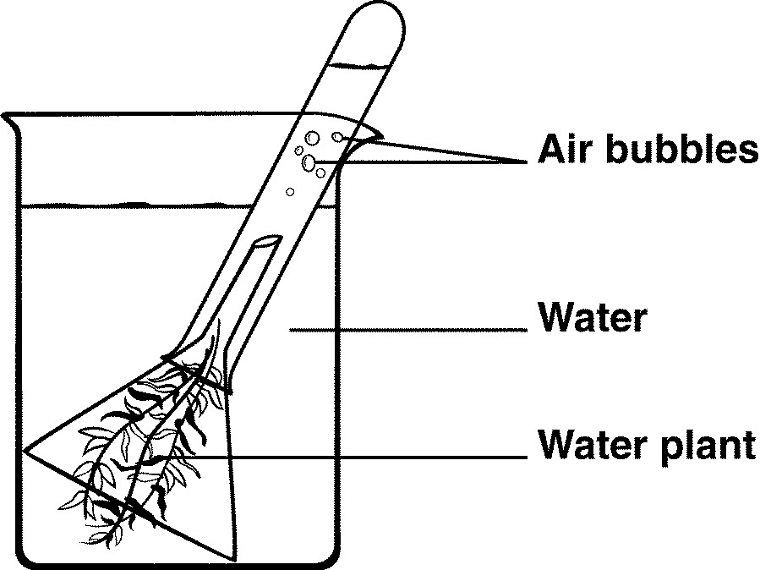 |  | 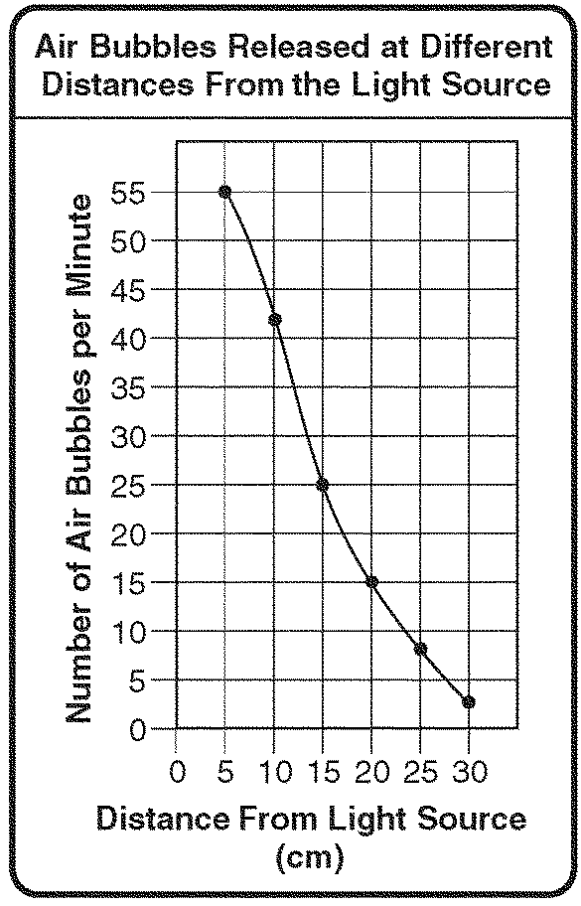

Figure 8–4

75. Look at the graph in Figure 8–4. What do the student’s data show?

A scientist set up a respiration chamber as shown below. She placed a mouse in flask B. Into flasks A, C, and D, she poured distilled water mixed with the acid-base indicator phenolphthalein. In the presence of CO₂, phenolphthalein turns from pink to clear. She allowed the mouse to stay in the chamber for about an hour.

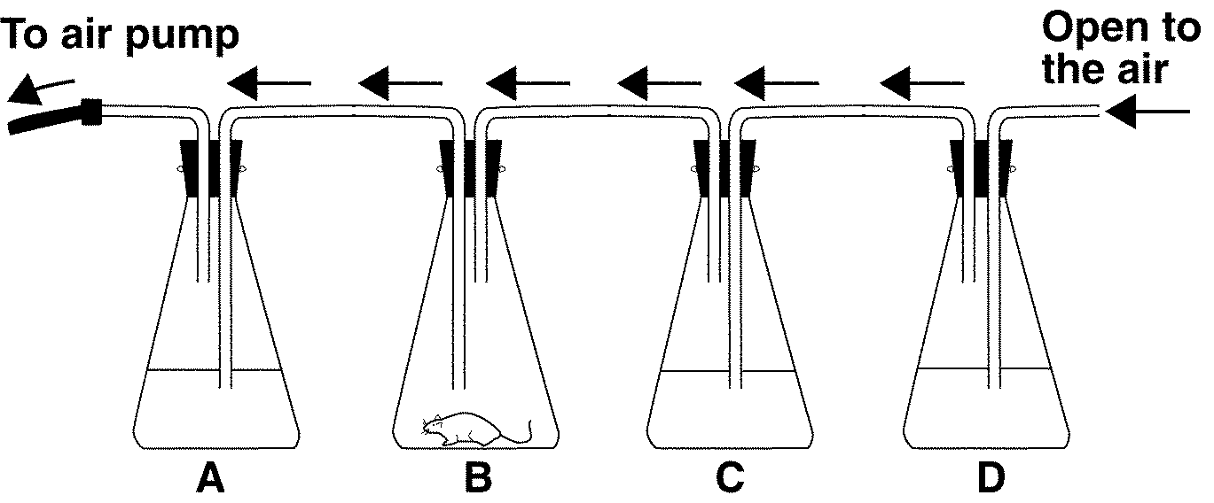

Figure 9–2

76. What is the equation for cellular respiration? Based on this equation and the setup shown in Figure 9–2, what substance(s) would you expect the mouse in flask B to give off?.

77. Assume that the scientist set up an identical respiration chamber, except that in this setup she placed a mouse that had been exercising on a hamster wheel. Then, the scientist measured the amount of CO₂ given off by both mice at the end of 15 minutes. Predict which setup produced the most CO₂.

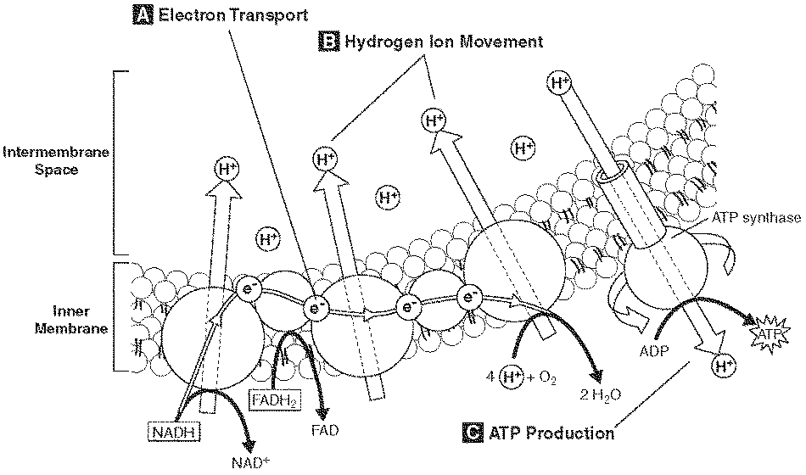

Figure 9–3

78. Where do the electrons moving along the inner membrane in Figure 9–3 end up?

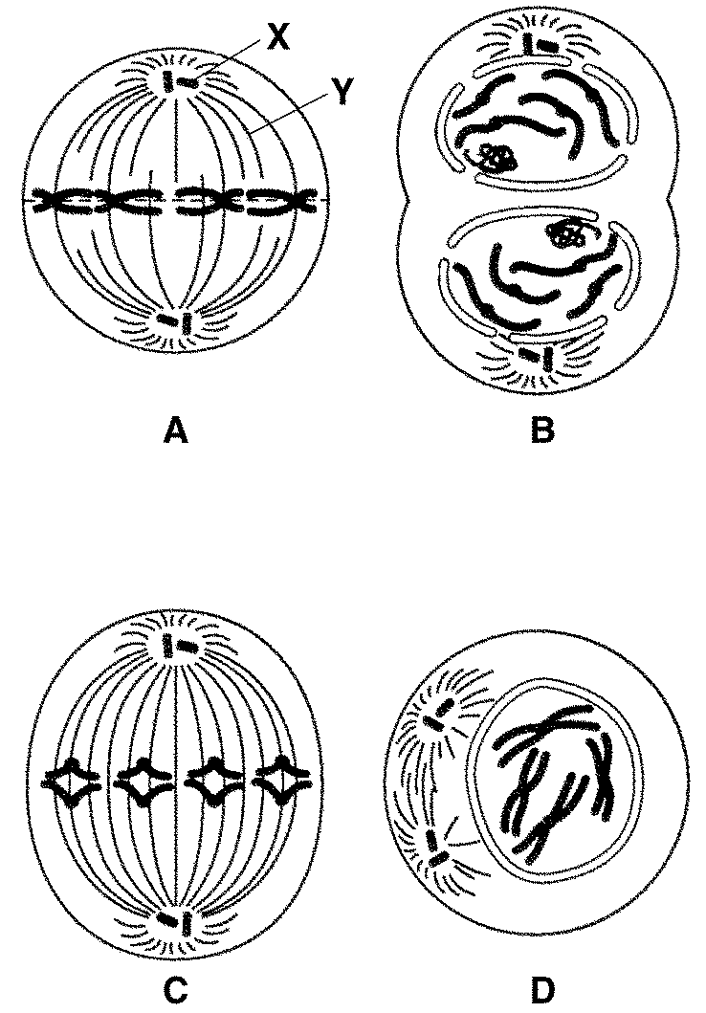

Figure 10–4

79. List the correct order for the diagrams in Figure 10–4.

80. After the steps shown in Figure 10–4 are arranged in the correct order, what would a diagram of the next step show?

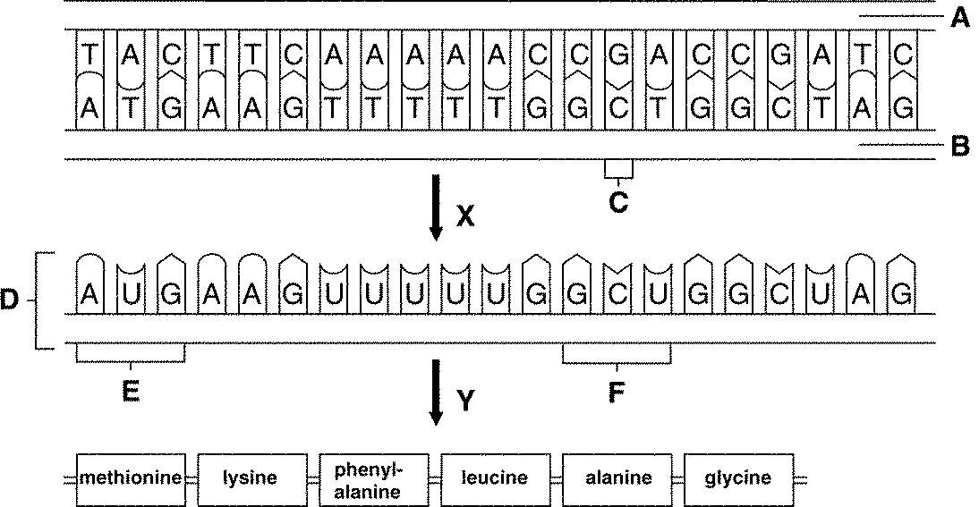

Figure 12–4

81. What would happen to structure F in Figure 12–4 if structure C were deleted?

82. In Figure 12–4, what effect would the deletion of structure C have on the process that occurs during step Y?

The pedigree shows the inheritance of free earlobes and attached earlobes in five generations of a family. Attached earlobes are caused by a recessive allele (f).

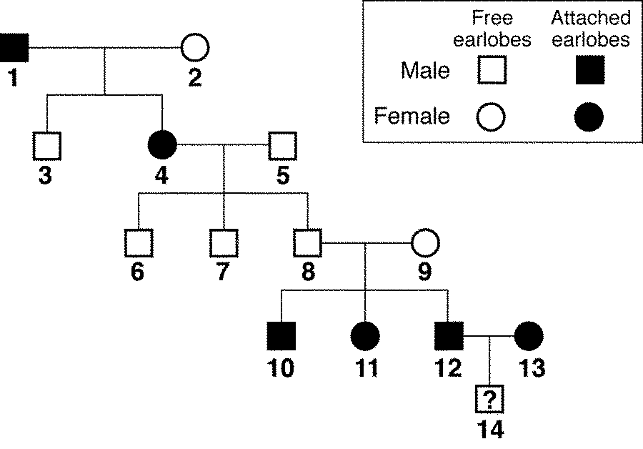

Figure 14–2

83. In Figure 14–2, how many children of individuals 4 and 5 have attached earlobes?

84. Predict the genotype and phenotype of individual 14 in Figure 14–2.

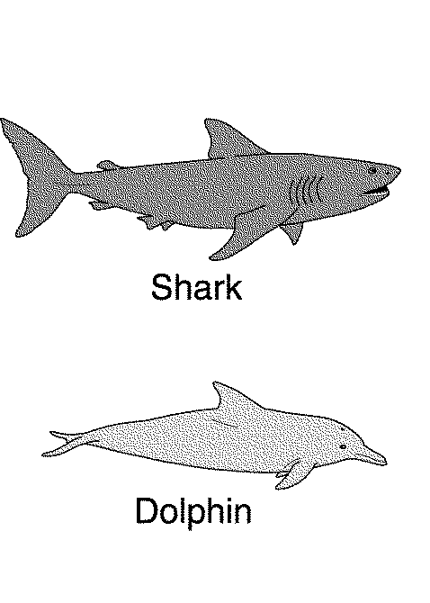 | Comparison of Two Vertebrates
 | Characteristics |  | Shark | Dolphin
 | Habitat |  | Ocean | Ocean
 | Type of  Vertebrate |  | Fish | Mammal
 | Composition  of Skeleton |  | Cartilage | Bone
 | Type of Teeth |  | Large numbers  of sharp teeth | Large numbers  of sharp teeth
 | Respiration |  | Breathes in water | Breathes in air

Figure 15–4

85. If you wanted to find out whether sharks and dolphins share homologous structures, what structures would you examine?

86. Suppose a dolphin population becomes trapped in a harbor that is growing smaller and more shallow because of climate changes. Is it likely that the dolphins would evolve into a land-dwelling species in a few thousand years? What would Darwin say?

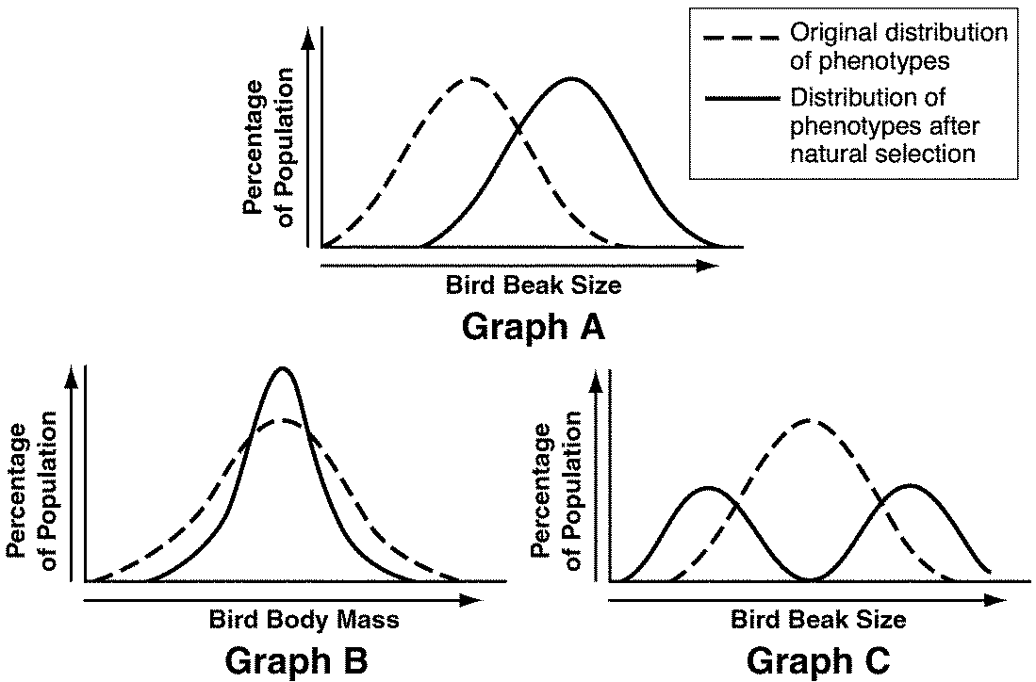

Figure 16–1

87. Which of the three graphs shown in Figure 16–1 might show a population of birds with members that specialize in different types of food?

88. What factors or conditions might have led to the change shown in Graph A of Figure 16–1?

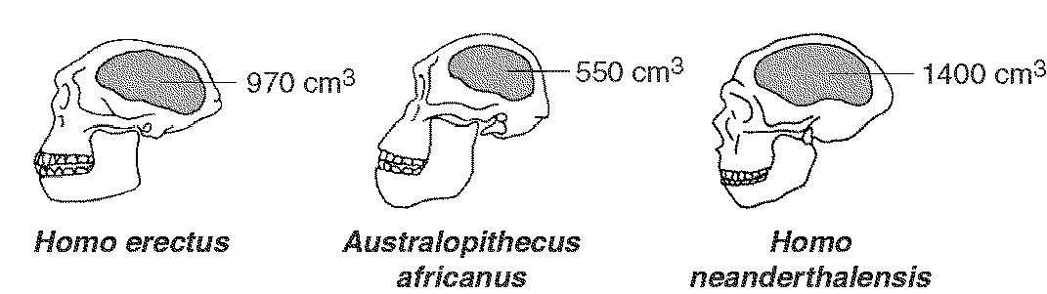
Figure 32–3

89. Rank the species shown in Figure 32–3 in order according to when they first appeared.

This diagram shows the structure of a synapse between the axon of one neuron and the dendrite of a neighboring neuron.
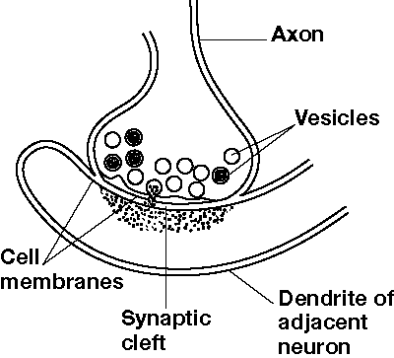Figure 35–4

90. In Figure 35–4, which structures release neurotransmitters?

91. Referring to Figure 35–4, after the neurotransmitters are released from the cell surface, what happens to the neurotransmitters?

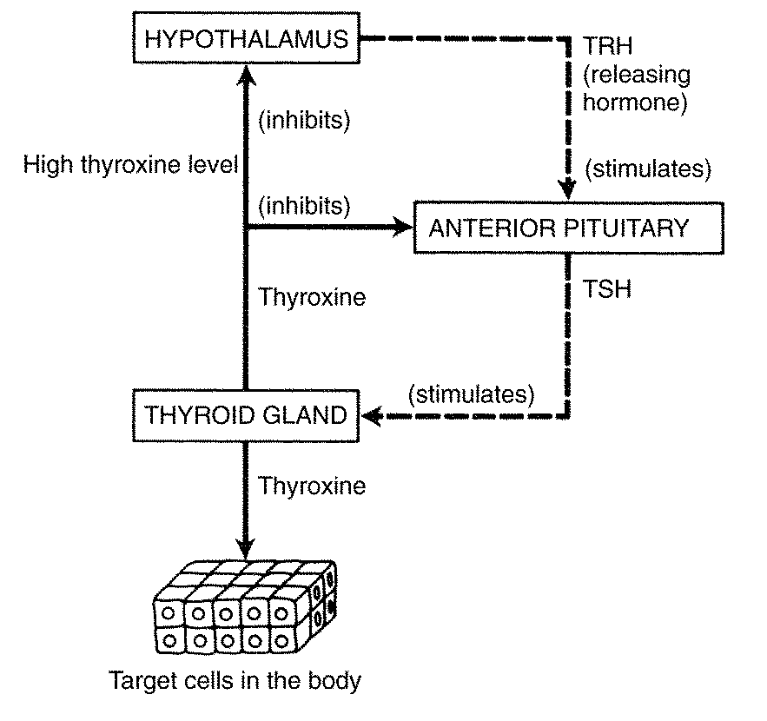Figure 39–2

92. Based on Figure 39–2, which hormone directly stimulates target cells in the body?

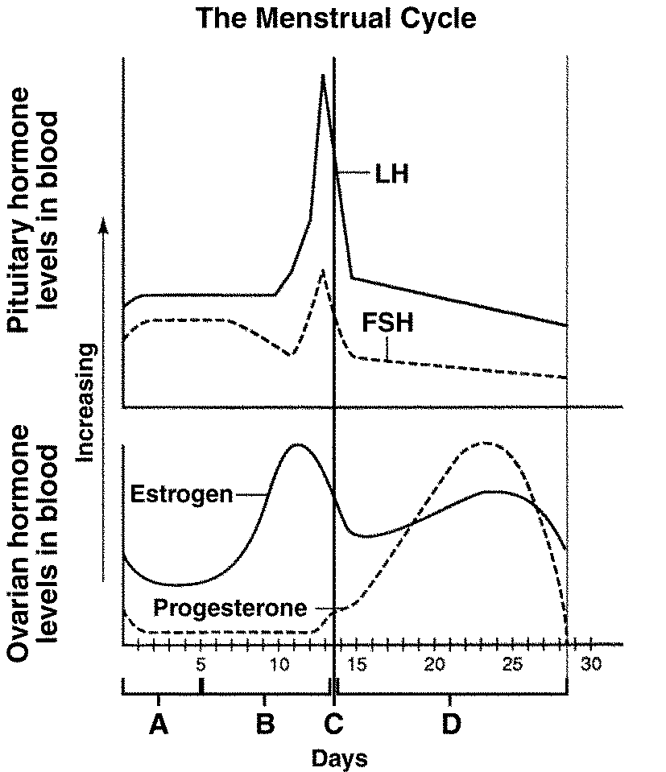
Figure 39–4

93. Compare the peaks of estrogen, LH, and FSH in Figure 39–4. When does estrogen reach its peak compared with the peaks of the pituitary hormones?

Blood alcohol concentration (BAC) is a measure of the amount of alcohol in the bloodstream. The following graphs illustrate how many alcoholic drinks consumed in one hour result in different levels of BAC in individuals of different masses. In some states, an adult driving with a BAC of 0.08% or higher is considered to be legally drunk.

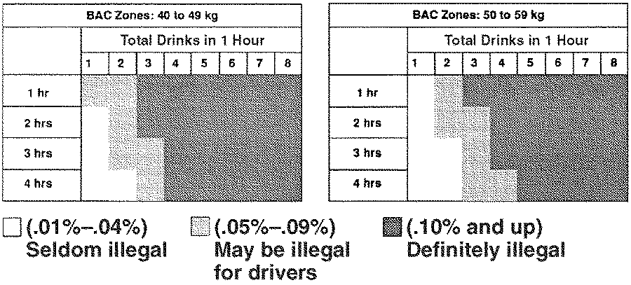

Figure 35–5

94. You have a mass of 45 kg and have had one drink. According to Figure 35–5, how long would it take for your BAC to drop to 0.04% or lower?

95. You are a 48-kg adult and have had four drinks in an hour. According to Figure 35–5, could you drive legally after three hours?

96. Based on Figure 35–5, how is the mass of an individual related to BAC levels?

97. A 58-kg person has two cocktails just before dinner and a glass of wine with dinner 30 minutes later. According to Figure 35–5, how long would the individual be in the “Definitely illegal” category?

98. While walking outside one night, you notice that moths are staying close to a light. Think about this phenomenon and generate a hypothesis to explain why it occurs. Outline the design of a controlled experiment that would test your hypothesis.

99. Describe how solar energy is related to the greenhouse effect, and explain how the greenhouse effect maintains Earth’s temperature range.

100. Identify three factors that affect the rate of photosynthesis and explain the effect of each.

101. Why do some kinds of point mutations cause greater changes in proteins than others?

102. In a rare genetic disorder called Kallman syndrome, the hypothalamus produces reduced levels of the hormone that signals the pituitary to increase its production of LH. How would this disorder affect a person’s development and ability to reproduce? Explain your answer.

103. When a person is first infected with HIV, the body produces many antibodies against HIV and the number of viruses in the blood decreases significantly. Although the antibody level remains high, the number of viruses in the blood increases over time and the number of T cells decreases. Explain these typical lab results based on how HIV affects the immune system.

