## **Milano - Ricordo di Grock; Obbiettivo sulla cronaca**

Reference Link: <https://www.europeana.eu/portal/it/record/2051914/data_euscreenXL_IL5000060098.html?q=grock>

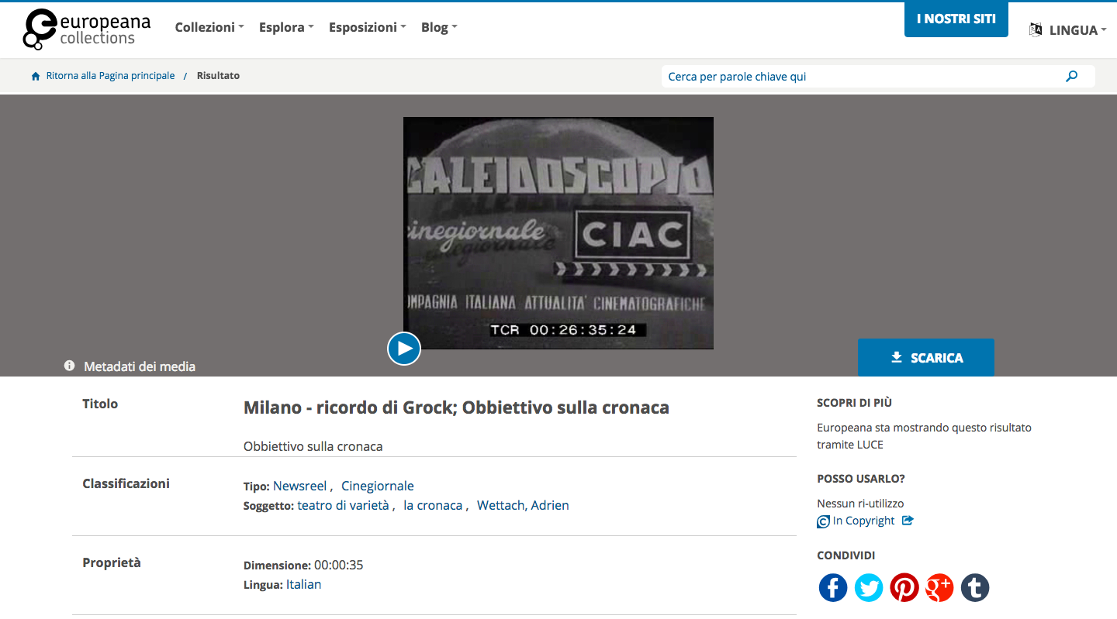

Also in this case, we have an object from Europeana using as metadata Standard Europeana Data Model (EDM).

The item is a Newsreel (a short informative movie about current events, it is usually reported by means of newspapers, websites, radio, television, and other forms of media). *Milano - ricordo di Grock; Obbiettivo sulla cronaca* is the title of the object. In particular it is a short video of presentation of Grock.

It easy to find interesting items in Europeana, because it allow the accessibility to a huge amount of digitised cultural objects from different institutions (libraries, archives and museums). For this reason it needs a standard to manage knowledge of different domain heritages. That is why EDM allow the use of Dublin Core, EAD, LIDO, METS, among many other standards.

We saw that Europeana makes a distinction between the creation submitted and the digital representation of this object. EDM integrates the Dublin Core properties and re-contextualizes each element in the more structured context of EDM.

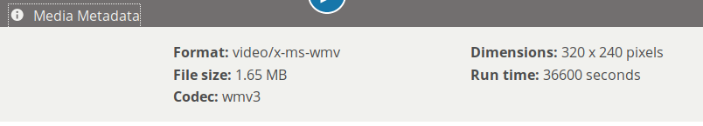

As we know, Europeana deal with the physical object, but also with the media object. In the section of the **Media Metadata** we can find the information about the Newsreel and the Cinegiornale.

We can find the basic Dublin Core property **Format - <dc:format>** with a series of technical metadata properties that are applied to WebResource (**File size - <ebucore:fileByteSize>**, which defines the size of the Media Resource expressed in bytes (in this case: in megabytes), is used for video, image, sound, text, 3D. Than we have the property **Codec - <edm:codecName>**, which defines the name of a device or computer program capable of encoding or decoding a digital data stream or signal, is used for videos. Than the property **Dimensions** apparently represents the aggregation of two different properties into one: **Width - <ebucore:width>** (), which defines the width of a video frame, and **Height - <ebucore:height>**, which defines the height of a video frame, both expressed as numbers of pixels. Both are used for video and image. Finally the **Run time - <ebucore:duration>**, which defines the duration of a track or a signal expressed in milliseconds (in this case: in seconds!), is used for video and sound.

[<http://www.ebu.ch/metadata/ontologies/ebucore/ebucore#fileByteSize>

<http://www.europeana.eu/schemas/edm/codecName>

<http://www.ebu.ch/metadata/ontologies/ebucore/ebucore#width>

<http://www.ebu.ch/metadata/ontologies/ebucore/ebucore#height>

<http://www.ebu.ch/metadata/ontologies/ebucore/ebucore#duration>]

However, what we were more interested in were the metadata about the object, the item that we chose and we chose also to give an interpretation of the labels mostly attributing them to the DCTERMS.

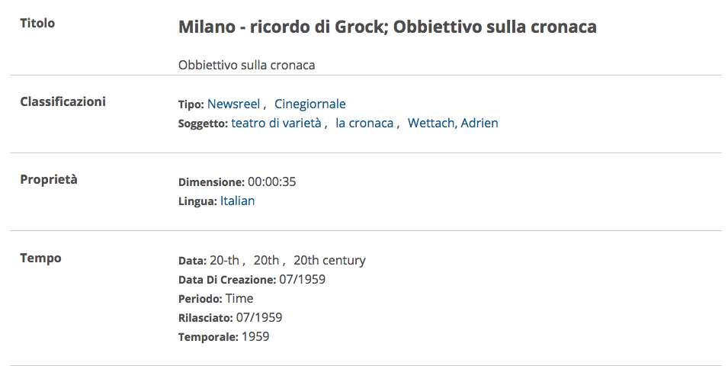

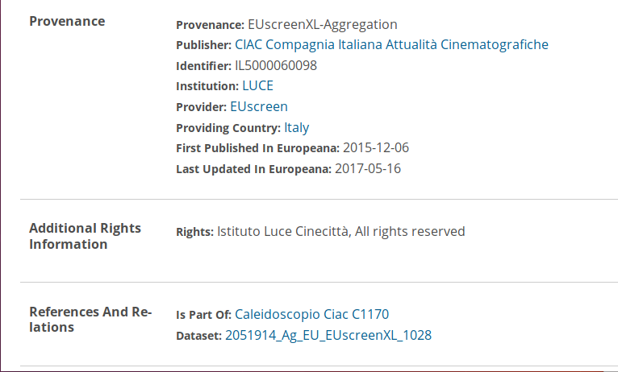

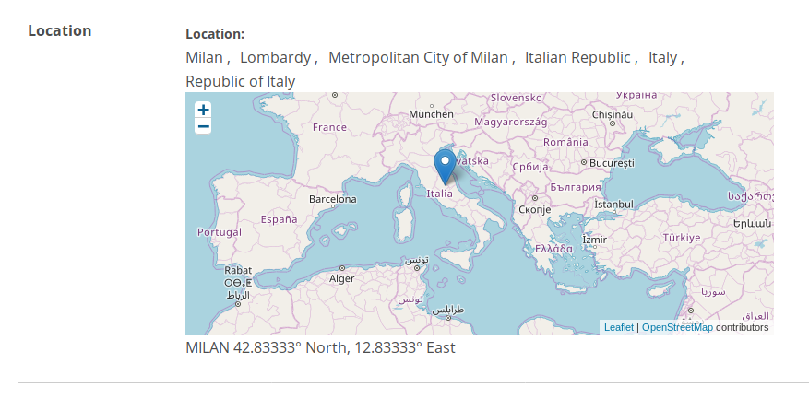

The **<dc:title>** defines the title of the object *Milano - ricordo di Grock; Obbiettivo sulla cronaca*. This Newsreel is, in fact, a memory of the central node of our project “Grock”.

In the classification section we can find the Dublin Core property Type **<dc:type>** which defines the type of the object as a definition (in this case it is identified as “Tipo: Newsreel Cinegiornale”), but we also find the **<dc:subject>** which defines the topic of the resource usually using keywords, key phrases, or classification codes.

**This is one case where Charles Adrien Wettach is actually treated as “Wettach, Adrien” and not as Grock.**

Other keywords that we can find in this category are “teatro di varietà” and “la cronaca”.

Since there are multiple EDM elements that are relevant for expressing dates related to different events occurred in the life of the object (such as **<dc:date>**, <dcterms:temporal>, <dcterms:issued>...), we assume that in this case the property Creation Date is represented by **<dcterms:created>**, which defines the date of creation of the object in the 20th century. Precisely we talk about the July of 1959 and the first Issued probably refers to <dcterms:issued>, which defines the date of formal issuance or publication of the object. While the property Temporal <dcterms:temporal> defines the temporal characteristics of the object, such as what it is about or what it depicts in terms of time, in this case refers to the year of its creation (because the newsreel is about current events).

The Dublin Core property Provenance - **<dc:provenance>** (http://purl.org/dc/terms/provenance) defines the state of **ownership/custody** of the resource. In this case “EUscreenXL-Aggregation”.

The Dublin Core property Publisher **<dc:publisher>**  specify who is responsible for the item distribution and defines the name of the publisher of the object. In this case “CIAC Compagnia Italiana Attualità Cinematografiche”.

The Dublin Core property Identifier - <dc:identifier> defines an unambiguous reference to the resource within a given context. Here is “IL5000060098”.

The property Provider <edm:provider> defines the name of the organization (or aggregator or project) that delivers data into Europeana. [It is mandatory for Europeana.]

First Published in Europeana and Last Updated in Europeana probably are both related to the property Year <edm:year>, which defines a point in time associated with an event in the life of the object in relation with Europeana.

The Dublin Core property **<dc:rights>** or the **<edm:rights>**  are used for information about intellectual property rights. It does not give any URI so it is a <dc:rights> that needs only a string.

In the “Riferimenti E Relazioni” section we can find the property In Part Of <dcterms:isPartOf>, which defines a resource in which the WebResource is physically or logically included, refers to the number of the specific newsreel which this object is part of. While the the property Dataset Name <edm:datasetName>, identify the element into the dataset in Europeana.

The property **Location** probably refers to **<edm:currentLocation>** which defines the geographic location of the object; such location has a position not only indicated by textual tags but also within an established positioning system with coordinates.

(*<edm:currentLocation>* is used only to record the place where the object is currently held while *<dcterms:spatial>* is used to record the place depicted in the object and other locations associated with it.)

Some **missing information** are about the people who create and contribute to the item creation (the creator of the item **<dc:creator>** and the contributors **<dc:contributor>**).

[<http://www.europeana.eu/schemas/edm/provider>

<http://www.dublincore.org/documents/dcmi-terms/>

http://www.europeana.eu/schemas/edm/rights]