Automated Shifter
Sponsored by the Vanderbilt Society of Automotive Engineers

Vanderbilt University
Nashville, TN
Senior Design 2012
Nor Ghazali, Rocky Gray, Deandre Jones, Spencer Price

Table of Contents
Table of Contents
Context Information
Statement of Work
Global Description
Project Structure
References

Final reports for the course are to be both written and oral and will take the form of detailed Project Proposals. This is a contract that you will prepare for your customer that includes the following information:

Context Information
The Vanderbilt Society of Automotive Engineers (SAE) team is a group of students who spend the entire year working on building a small open wheel race car. The students range from incoming freshmen to graduating seniors. They spend the majority of first semester designing and fabricating the chassis of the vehicle. The international competition the team participates in is the Formula SAE competition which is sponsored by the SAE. The Vanderbilt team competes against teams from other schools all across the nation at races at various times throughout second semester. Some of the race sites include competitions in Michigan and California. The faculty advisor for the Vanderbilt team is Phil Davis. Before this year the last race car was built in the 2008-2009 school year. The team is aiming to race in the FSAE race in February. In order to compete in these races FSAE has strict rules on how a team builds the car which can prohibit a team from racing
As of now, the car is manually shifted by moving a lever back and forth. The lever is located in the cockpit of the vehicle. When the driver wants to shift the vehicle up a gear, he or she has to push the lever forward (towards the front of the car). The lever will snap back to its neutral position after the driver releases it. To shift down a gear, the driver pulls the lever towards them and releases the lever. When racing, constantly having to shift the gears up and down can be a hassle and can decrease the performance of the driver. The automated gear shifter we are building will ease the stress of handling the vehicle on the driver.

Statement of Work

Global Description
The main objective we want to get accomplished is the up and down shifting of the gears without the driving having to do it himself. From the engine the ECU will read at what rpm is the engine running. The ECU will then output this value to the Arduino. The Arduino will determine whether the driver is slowing down or speeding up and from this reading will determine whether to send a positive or negative voltage to the solenoid to push or pull the solenoid causing the gears to shift up or down.

Project Structure
There are three phases to making a fully automatic shifter. Phase one is removing the lever and replacing it with two buttons on the steering wheel. The button on the right-hand side of the steering wheel will be used to shift up gears and the button on the left-hand side will shift gears down. Our control unit will send a signal to the ECU to tell the engine to cut the spark for a split second in order to shift gears up and down. Then, our control unit will either push or pull a 12 volt push-pull Pingel solenoid based on the user’s input. The solenoid will replace the lever arm. This will be the longest and most difficult portion of the project because it requires interfacing our control unit with the ECU and assembling the mechanical pieces of our product. The second phase of the project will implement an automatic up-shift control. This will require accessing the rpm rate from the ECU so that the engine will change gears at the optimum time. This phase of the project will require more coding because the up-shift will be fully automatic but the entire vehicle will be semi-automatic because the driver will still be required to downshift when necessary. Also, we will have to be working in depth with the Fine Tuning Team because they will tell us the optimum rpm range to shift up a gear for each of the 5 gears of the engine. Being that we plan on finishing the first phase before the race in February, we will be working on the second phase separately because we want to make sure the care has something working for the race. The final phase of the project will implement an automatic down-shift control. This will essentially make the car fully automatic. This phase will once again require more coding.

Work Breakdown Structure
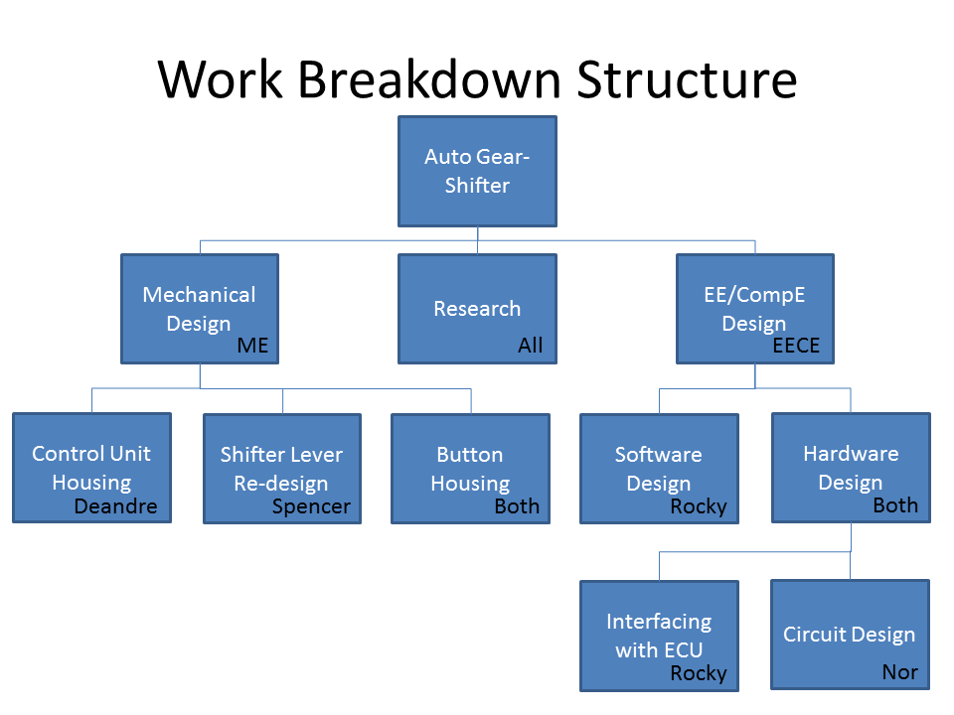
Figure 1 - WBS
The Work Breakdown Structure (WBS) found in Figure 1 displays the work necessary to complete the Automated-Shifter project.

Control Unit Housing
SOW
Design and assemble an acrylic box that will house the main control unit, i.e. the Arduino board and power supply. The box must have strategically placed holes that will allow wires to pass through the box’s walls to easily connect to the ECU.
Resource Requirements
Pro/E
Laser cutter
Acrylic sheets
Olin Lab
Time
2 days
Responsibility
Deandre Jones
Spencer Price
Outcomes
An acrylic box that will sufficiently hold the control unit and powersupply.
Inputs
None
Risk
Low

Shift Lever Re-design
SOW
Design a shorter shift lever that will allow for quicker gears shifts through the solenoid
Resource Requirements
Pro/E
Mechanical Engineering Machine Shop
Time
10 days
Responsibility
Spencer Price
Deandre Jones
Outcomes
A shift lever that works well with the supplied vehicle and allows for faster shift times.
Inputs
None
Risk
Medium

Button Housing Manufacturing
SOW
Design and manufacture button housing to be placed on the steering wheel of the vehicle. The housing must allow for 2 push buttons and one tri-state switch and protect the wires extending from the buttons.
Resource Requirements
Pro/E
Aluminum
Steel
Time
10 days
Responsibility
Spencer Price
Deandre Jones
Outcomes
A housing for the user interface contained within the steering wheel.
Inputs
None
Risk
Low

Software Design
SOW
Design software modules that will fetch data from the ECU and also give commands to it. Also, modules should be designed that will receive user input via the buttons and switches. Lastly, a module should be designed to activate the solenoid based on the current input state.
Resource Requirements
ECU technical documentation
Microcontroller
AVR Studio
Hapsim
Time
30 days
Responsibility
Rocky Gray
Outcomes
The software should be incrementally developed such that testing and integration with hardware can be troubleshooted relatively easily.
Inputs
Data from the ECU
Button and Switch input.
Risk
Low

Interfacing with the ECU
SOW
The main control unit must be able to access particular data within the ECU and also give commands to the ECU. The necessary hardware to interface with the ECU for input and output must be designed and tested such that that Arduino microcontroller can communicate with the ECU.
Resource Requirements
ECU technical documentation
Phil Davis
Engine Tuning team
Time
3 days
Responsibility
Rocky Gray
Outcomes
The necessary physical connectors must be constructed.
Inputs
None
Risk
Low

Circuit Design
SOW
The solenoid needs 15V to drive it. A circuit is necessary in order to convert the 5V output of the Arduino to the required 15V.
Resource Requirements
Dr. Tim Holman
Circuit Design texts
Time
9 days
Responsibility
Nor Ghazali
Outcomes
The necessary circuits and power supplies to drive the solenoid.
Inputs
Output of Arduino
Risk
Medium

Spencer - 3. Detailed diagram of project components/modules, with properties of each module defined.
Rocky & Spencer - 6. For projects involving hardware, schematic or mechanical diagrams of the design. For projects involving software, program structure diagrams.

Nor- 7. Network diagram showing the schedule of execution of the project components.

Nor -8. Gantt chart summarizing the project's expected schedule.

Spencer - 9. For projects that will require purchase of supplies, detailed list of required parts. Include source, catalog number and price.

References
http://studentorgs.vanderbilt.edu/vumotorsports/index.html (Dre)

