Fund Raising Calculator

Scenario
You wish to raise funds for your favourite charity and have decided to create a product that will then be sold, with all the profits being passed on to the charity.
You want to be able to easily calculate the cost of creating the product and then work out how much you will need to charge to reach the fundraising goal.

Required Features
Your calculator needs to…
- Allow users to specify the amount to be raised either as a percentage or as a dollar amount
- Have a way for users to enter the costs associated with creating their product.
- Output a cost breakdown showing both the fixed and variable costs. Both lists (fixed and variable) should be displayed showing components from the most to the least expensive
- Suggest a reasonable price for the final product based on the production cost, projected sales and fundraising goal

Task
- Decompose the problem.
- Plan how you will tackle the problem (using a Kanban board for this is one option)
- Write a test plan for your first component. Then create the code and test it using your plan.
- Where necessary, refine your component and retest.
- Explain which implications are relevant to your component and discuss how your component addresses the relevant implications
- Repeat the above steps until you have a series of working components
- Combine your components to create a working program
- Test and debug your program to ensure that it works for expected, boundary and unexpected values
- Ask a friend / parent to use your recipe moderniser. Watch them as they do this and make note of any changes that could be made to make the program easier to use
- Make the changes identified in the previous step
- Retest your program to ensure that it still works correctly

Resources
Here is a screenshot of possible input.
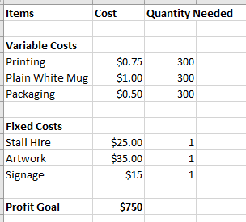
Below is a spreadsheet showing the possible output. Note that setting up a spreadsheet would mean that users need to be quite confident using Spreadsheet Software. Hopefully your program will make it quick and easy for them to enter the information and get sorted lists and a selling price recommendation at the end.
