 ­­­

02.17.2016 • Version: 1.0 • Prepared by: Lightwellinc

31 Gifts – Trigger Manual Process

*Prepared for:*

31 Gifts Project Team



Table of Contents

Overview: 3

UI Look & Feel: 3

JSP Screens: 3

Java Code: 3

Configuration: 3

Crontabs/Scripts: 8

Assumptions/One-Time Setup Tasks: 8

# Overview:

This is for recording any/all parts of the TOG Trigger Manual Process and setup.

# UI Look & Feel:

* The following UI screen allows the user to select 1 of 3 Agent Processed to trigger manually.
  + Browse to: System – Manual Processes.
  + Select the process you wish to run, and click “Run Manual Process”.

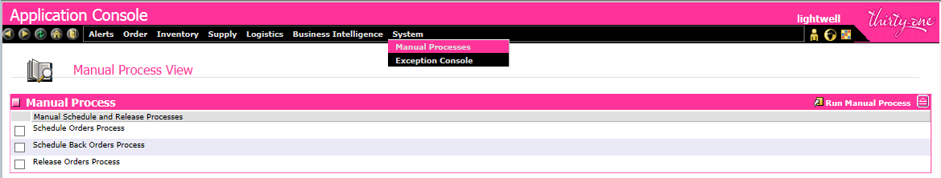

* Only 1 process can be selected at a time, and not more than 1.
* An email will be sent once the process has been triggered.

# JSP Screens:

* /extn/system/tog_agenttrigger_anchor.jsp
* /extn/system/tog_agenttrigger_detail.jsp

# Java Code:

* com.tog.agent.tools.TOGTriggerAgent.java
* com.tog.agent.tools.TOGTriggerAgentQueueReader.java

# Configuration:

* Application – Application Platform – Presentation – Resources – Sterling_Supply_Chain_Applications_Console – Entities – TOG AgentTrigger (TOGAgentTrigger)

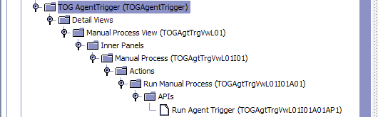

* TOG AgentTrigger (TOGAgentTrigger)

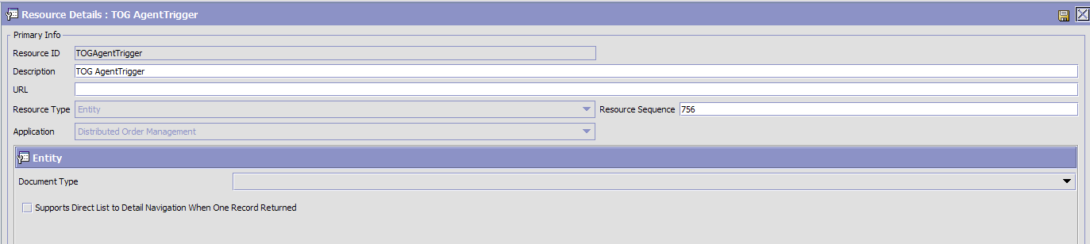

* Manual Process View (TOGAgtTrgVwL01)

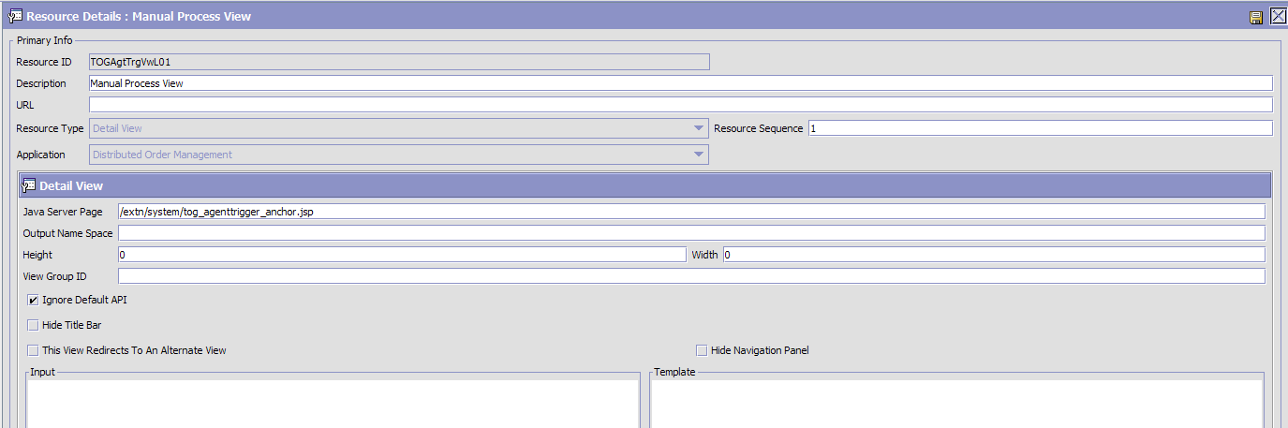

* Manual Process (TOGAgtTrgVwL01I01)

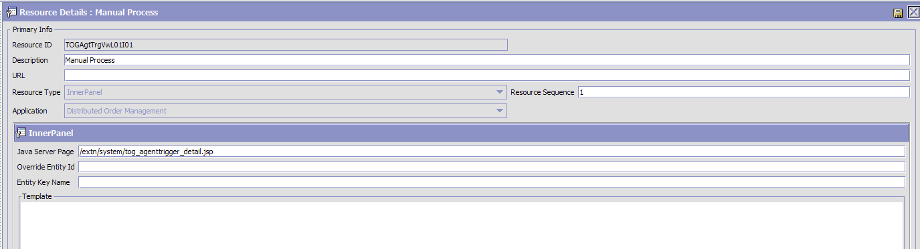

* Run Manual Process (TOGAgtTrgVwL01I01A01)

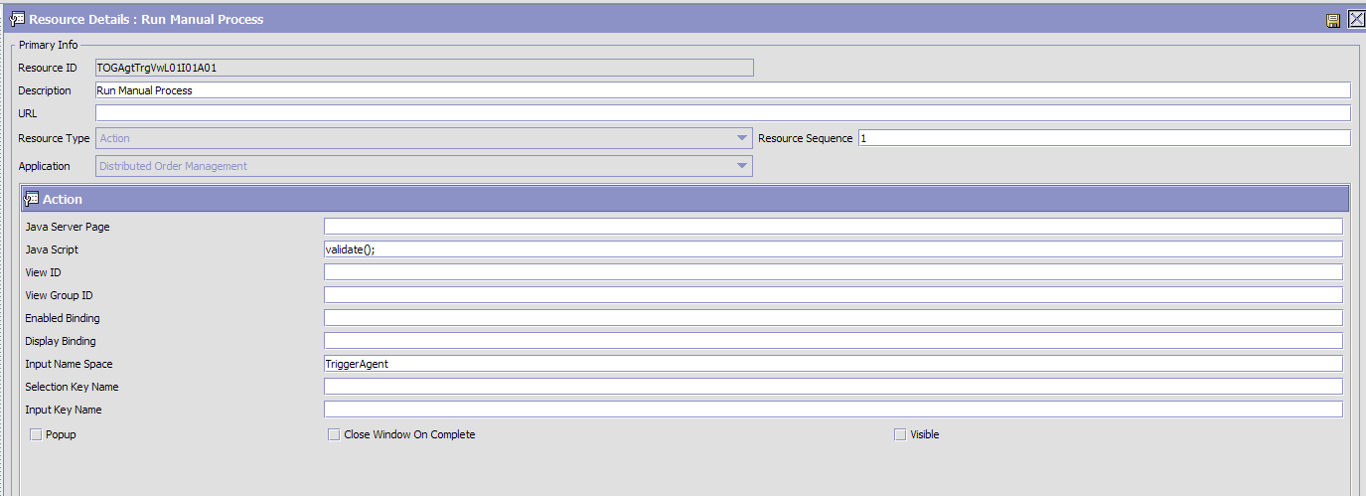

* Run Agent Trigger (TOGAgtTrgVwL01I01A01AP1)

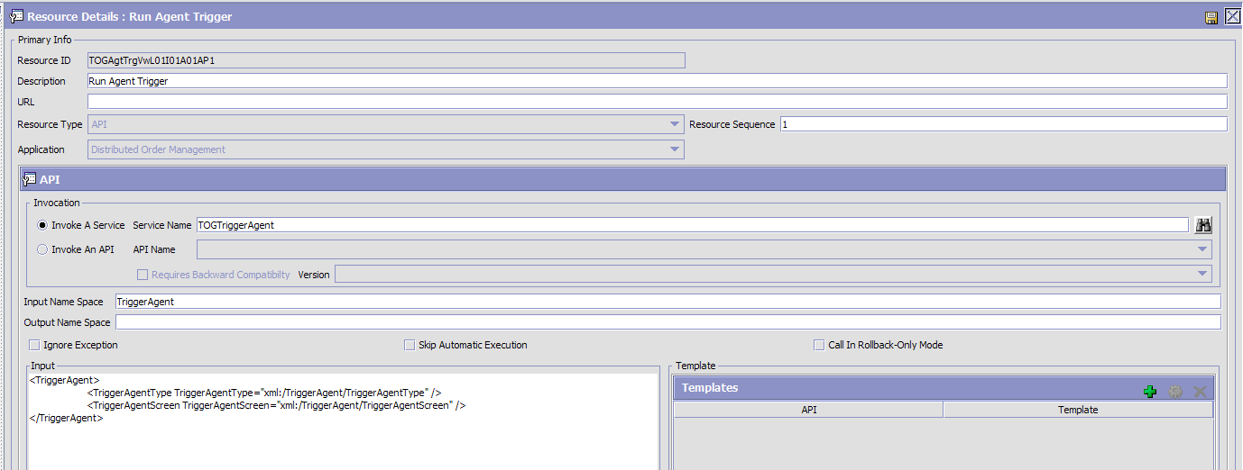

* Application – Application Platform – Process Modeling – General Services – ThirtyOne – TOGTriggerAgent
  + API Name: TOGTriggerAgent
  + Class Name: com.tog.agent.tools.TOGTriggerAgent
  + Method Name: triggerForManualProcess

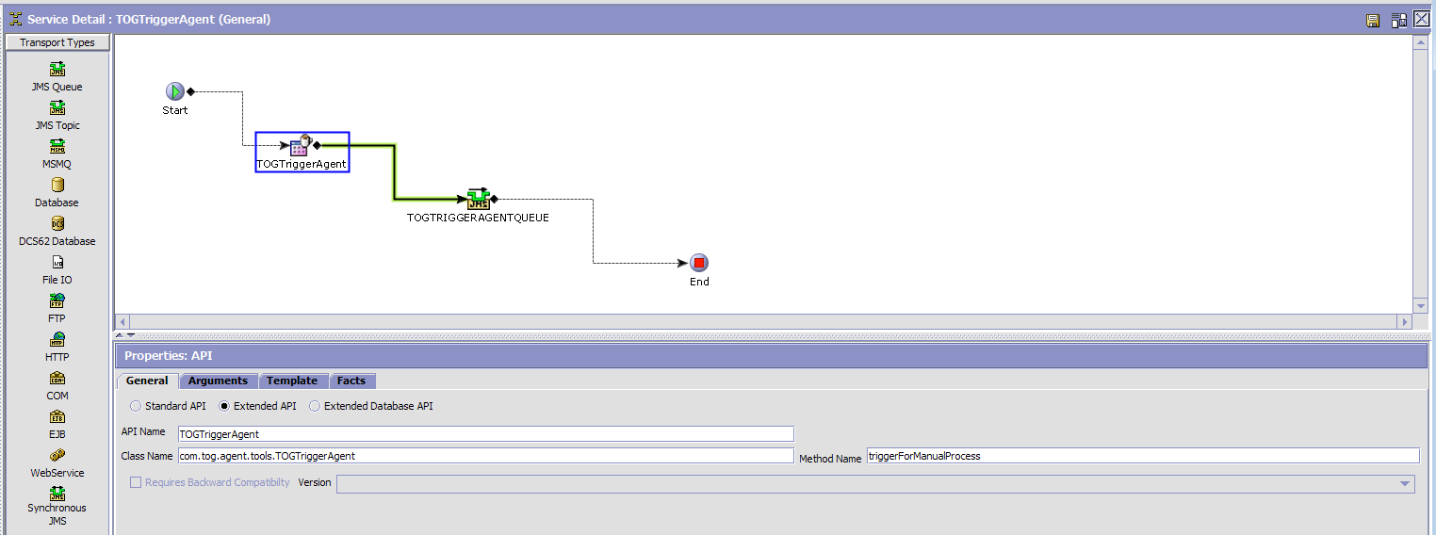

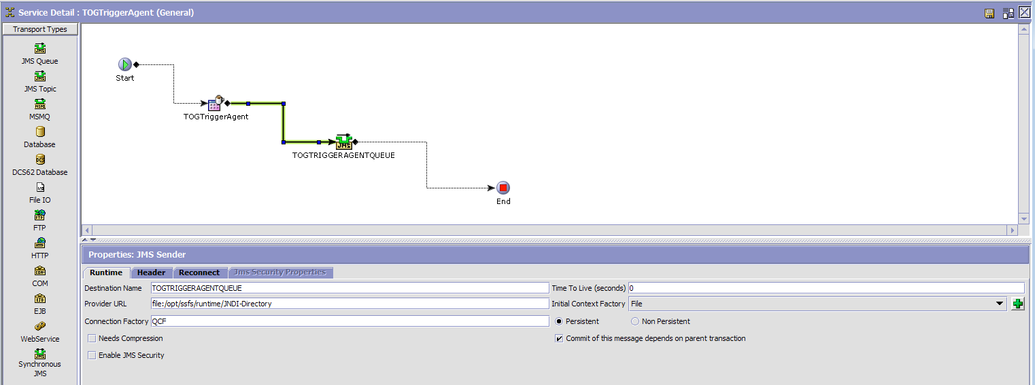

* Application – Application Platform – Process Modeling – General Services – ThirtyOne – TOGTriggerAgentQueueReader

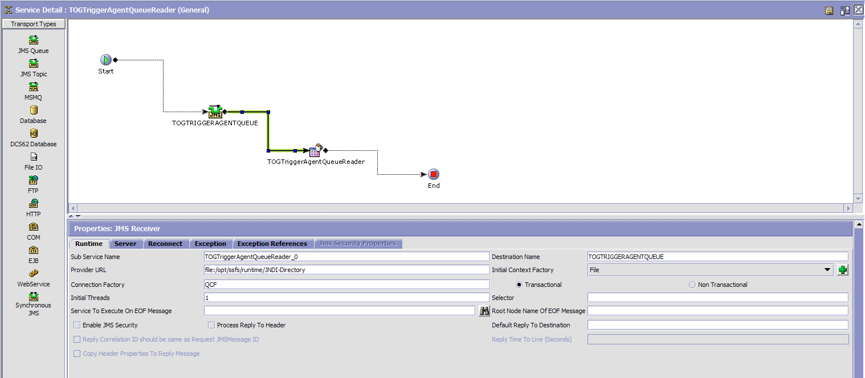

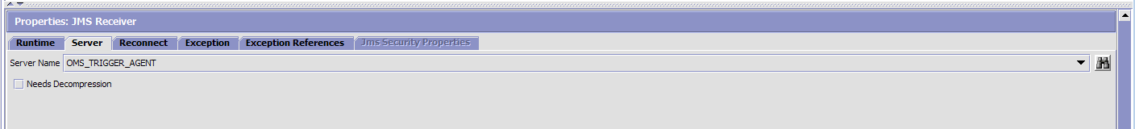

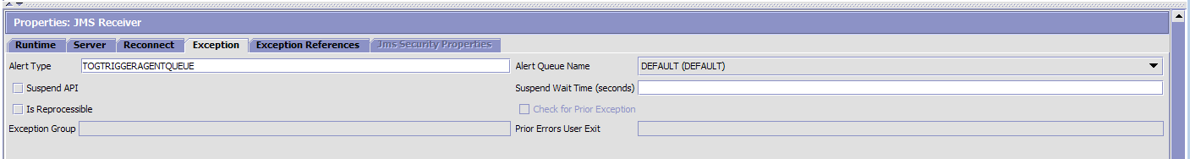

* + API Name: TOGTriggerAgentQueueReader
  + Class Name: com.tog.agent.tools.TOGTriggerAgentQueueReader
  + Method Name: triggerAgentForManualProcess

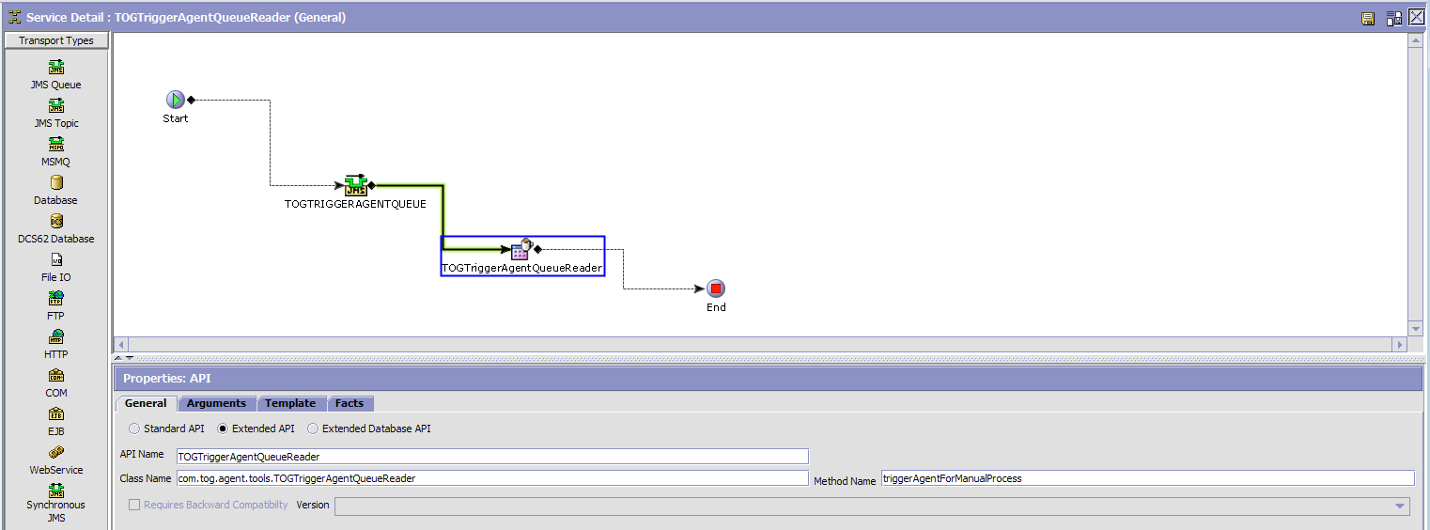

* Application – Application Platform – Presentation – Menu

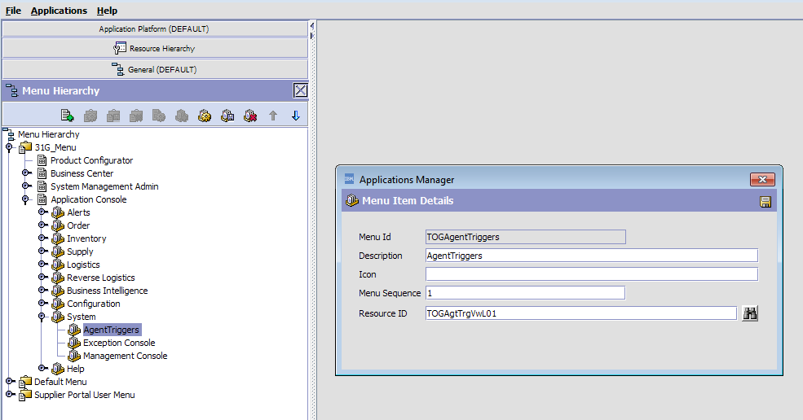

* Application – Application Platform – Security – Groups – AgentTriggerGroup
  + (it is a new group for Thirty-One Enterprise)

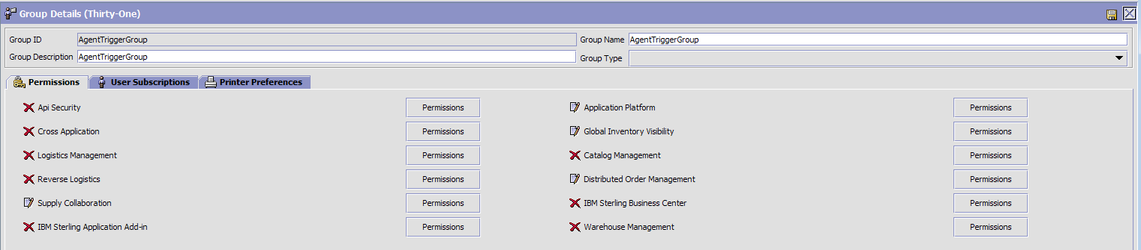

* Application – Application Platform – Security – Groups – AgentTriggerGroup – Distributed Order Management

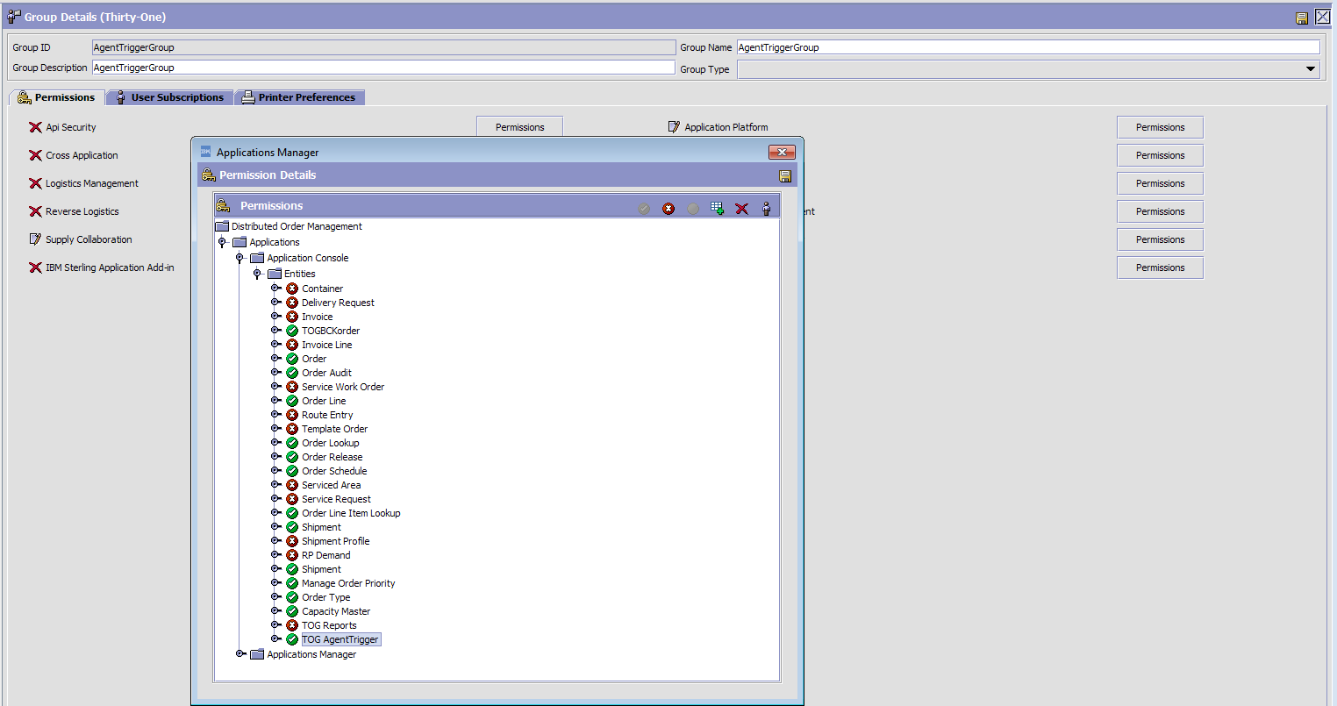

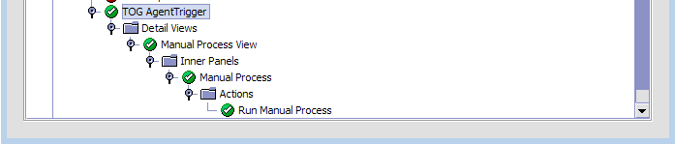

# Crontabs/Scripts:

* This represents the flow:
  + From App 1 or 2 Box. User selects a process on the UI and clicks “Run Manual Process”.
  + From App 1 or 2 Box. Service is triggered that will place a message in a MQ queue. The message is based on 2 things:
    - UI Screen Name.
    - Option you want to run.
  + From Agent 1 or 2 Box. A new agent will read the message from the MQ queue and determine the type and location of the trigger file to be placed.
  + From Agent 1 or 2 Box. Cron job sees the placed trigger file and runs the script for the specified agent.

# Assumptions/One-Time Setup Tasks:

* Validate that the Scripts can successfully send email via unix “mail” command.
  + Raise IBM ticket if this is not working.
* Validate that crontabs can trigger jobs successfully.
  + Raise IBM ticket if this is not working.
* You have created the directory structure for the reports:

(all 775, and owned by ‘wasuser’ id)

(Note: Easiest way is to zip the TriggerAgent folder on Preprod or QA and copy it over to Prod or future environments, just make sure you clean out all folders as the build will populate them fresh)

* + /opt/ssfs/runtime/TriggerAgent
  + /opt/ssfs/runtime/TriggerAgent/logs