RESULTS
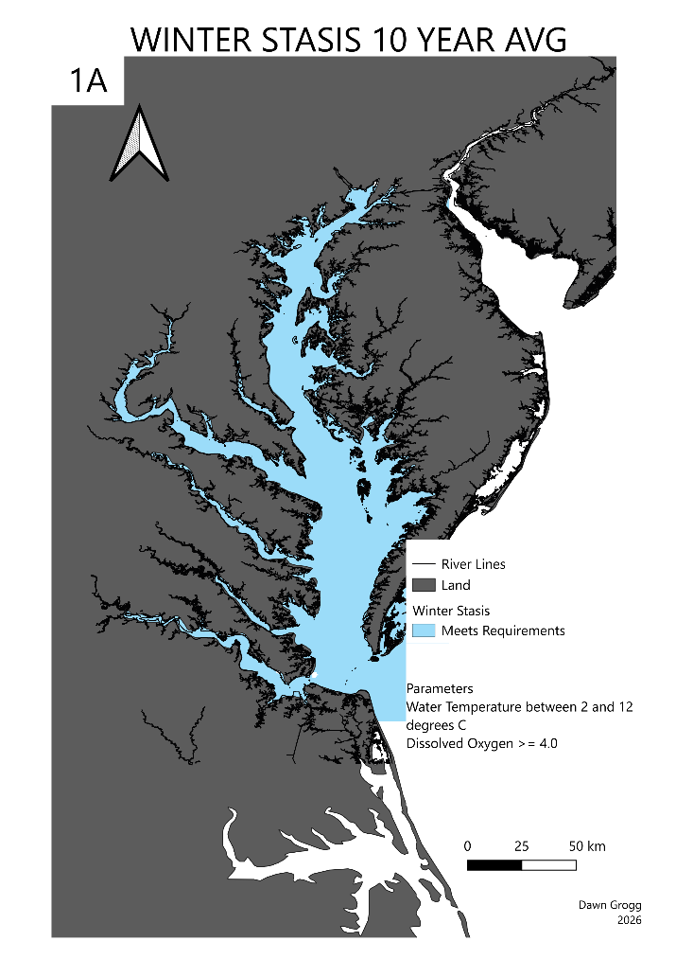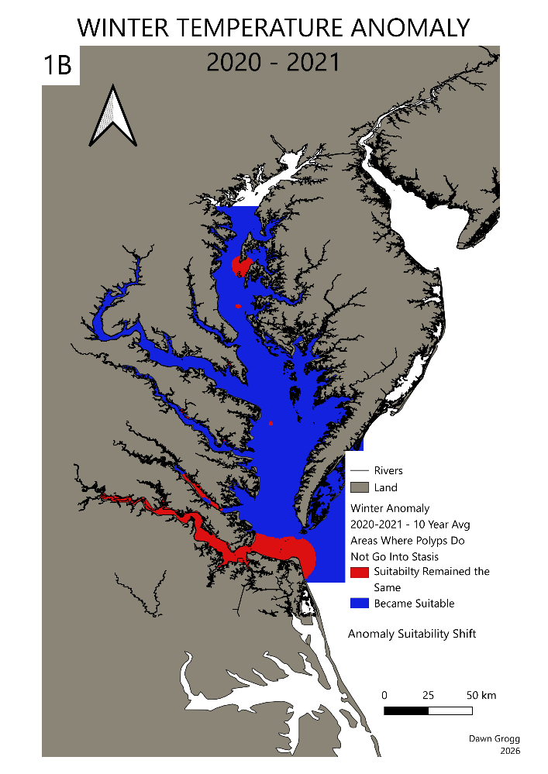
3.1 Winter Thermal Anomalies and Population Surge Dynamics

The continuous geographic footprint of the primary estuarine nurseries during a standard winter baseline is illustrated in Map 1A. Under historical ten-year winter averages, water temperatures across most of the Chesapeake Bay mainstem and its lower tributaries consistently drop below the critical 7.0°C threshold required to induce benthic polyp stasis. Crucially, all secondary biochemical and physical metrics—including salinity, dissolved oxygen (DO), and chlorophyll a (CHLA)—remain completely fixed at their standardized 10-year baseline values. Under these controlled historical conditions, only the James River nursery grounds maintain water temperatures warm enough to allow polyps to continuously divide, maintaining a baseline status of "Suitability Remained the Same" for active reproduction. The remaining primary nursery mouths—including the Potomac, Rappahannock, and York Rivers—historically remain locked in defensive winter stasis.

In contrast, Map 1B isolates the extensive spatial breakdown of this thermal regulation gate during the extreme winter anomaly of 2021, with all secondary background parameters strictly held at their identical baseline levels to isolate the independent temperature impact. The spatial analysis reveals that winter sea surface temperatures failed to drop below the 7.0°C stasis threshold across vast, unprecedented stretches of the estuarine system. Consequently, while the James River maintained its active baseline status of "Suitability Remained the Same," the entire remainder of the Chesapeake Bay mainstem and its major lower river nurseries transitioned completely into the "Became Suitable" category. This continuous thermal footprint explicitly maps the environmental boundaries where the 2021 anomaly allowed the overwintering benthic population to completely bypass winter stasis across almost the entire system, unlocking the premature, accelerated strobilation loops that fuel the subsequent summer population surge.
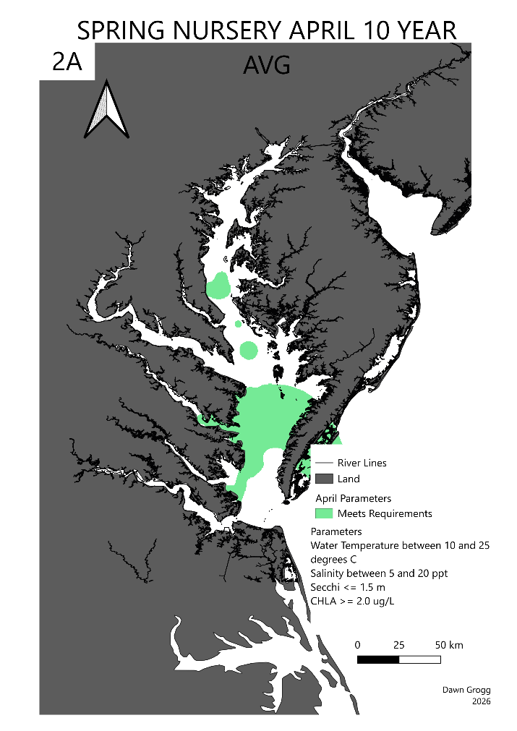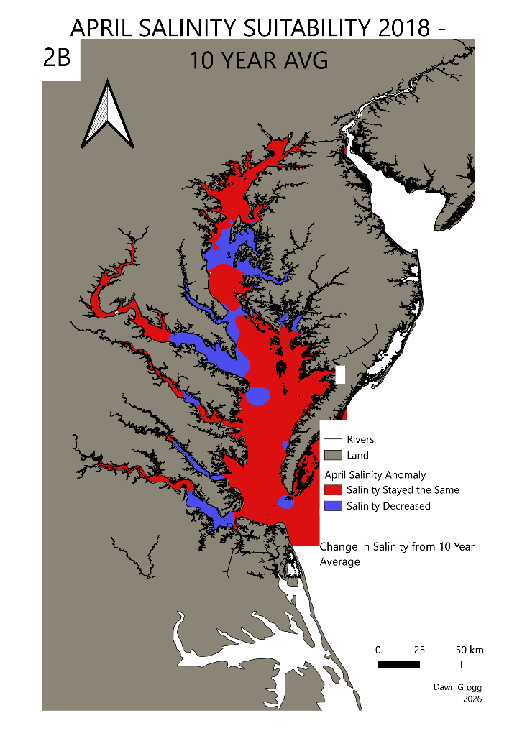
3.2 Spring Hydrologic Anomalies and Nursery Scarcity Dynamics

The spatial distribution and baseline environmental capacity of primary estuarine nurseries during a standard spring climatic regime are illustrated in Map 2a. Under normal 10-year historical April averages, ambient salinity values across the primary lower river nursery mouths—specifically the Potomac, Rappahannock, York, and James Rivers—remain consistently above the critical 7.0–10.0 ppt threshold required to sustain active benthic polyp development. Crucially, all secondary background variables, including water temperature, dissolved oxygen (DO), and chlorophyll a (CHLA), are held strictly fixed at their standardized 10-year control values. Under these stable historical baseline conditions, the core geographic zones of the lower tributaries maintain a constant habitat rating, establishing that standard spring river discharge profiles do not restrict polyp survival or impede the seasonal transition to adult medusae populations.

In contrast, Map 2b isolates the massive geographical contraction of suitable nursery habitats during the extreme spring hydrologic anomaly event, with all secondary background parameters held completely fixed at baseline levels to isolate the independent velocity of the salinity drop. Intense freshwater plumes and heavy upland discharge forced ambient salinity levels well below the 7.0 ppt survival boundary across extensive shallow-water matrices. Consequently, vast stretches of the lower river nurseries transitioned entirely into the "Suitability Decreased" category. This spatial footprint explicitly maps the localized geographic boundaries where extreme freshwater inundation independently drove overwintering polyps into permanent podocyst dormancy or direct mortality. This independent salinity bottleneck mathematically accounts for the subsequent localized scarcity collapses observed in adult medusae populations during anomaly years.

