Matt Grogan

Midterm Exam I

PREDICT 401: Introduction to Statistical Analysis

1. Joanne sells silk-screened t-shirts at a community festival. Her marginal cost to produce one t-shirt is $3.50. Her total cost to produce 60 t-shirts is $300, and she sells them for $7 each. Use Python to graph this information and determine the number of t-shirts Joanne must produce and sell to break even.

import numpy as np

import matplotlib.pyplot as plt

x = np.arange(0,60,1)

marginal_cost = 3.5

# total cost to produce 60 shirts is $300. 300/3.5 = 210. 300-210= 90. Fixed cost

fixed_cost = 90

# total_cost = marginal_cost*x + fixed_cost

# marginal_rev = 7*x

marginal_rev = 7

break_even = 90//(7.0 - 3.5)

# you can't sell fractions of a shirt.

# You have to round up if there is a remainder.

remainder = 90%3.5

if remainder > 0: break_even += 1

def cost(x):

return marginal_cost*x + fixed_cost

def revenue(x):

return marginal_rev*x

plt.xlim(0,60)

plt.ylim(0,300)

plt.xlabel('Sales')

plt.ylabel('$ Amount')

plt.plot(x,cost(x))

plt.plot(x,revenue(x))

plt.scatter(break_even, 7*break_even)

plt.legend(['Total Cost: 3.5x + 90','Marginal Reveune: 7x=y'],loc='best')

plt.show()

print 'They must sell {} to break even'.format(break_even)

OUTPUT:

***They must sell 26 to break even***

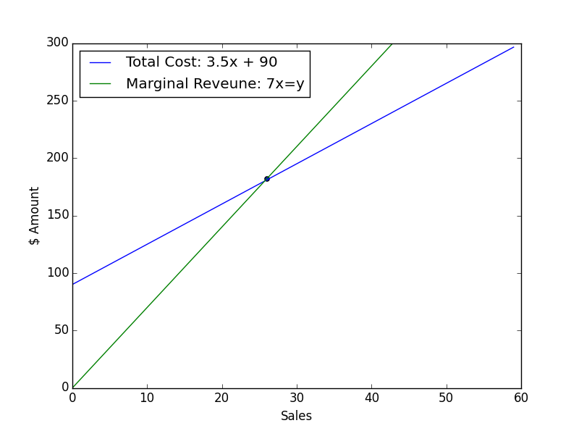

1. An electronics company produces transistors, resistors, and computer chips. Each transistor requires 3 units of copper, 1 unit of zinc and 2 units of glass. Each resistor requires 3, 2 and 1 units of the three materials, and each computer chip requires 2, 1, and 2 units of these materials respectively. How many of each product can be made with the following amount of material? 900 units of copper, 500 units of zinc, and 610 units of glass?

3. A pharmacist mixes together three types of vitamin tablets. Each tablet A contains, among other things, 13 mg of niacin and 11 IU of vitamin E. The amounts for a tablet B are 18 mg and 14 IU, and for a tablet C are 23 mg and 36 IU. Use Python to determine how many of each tablet there are if there are 225 total tablets, 4300 mg of niacin, and 5200 IU of vitamin E.

4. Jayla is raising money for the homeless and discovers each church group requires 2 hours of letter writing and 1 hour of follow-up calls, while each labor union needs 2 hours of letter writing and 3 hours of follow-up. She can raise $100 from each church group and $175 from each union. She has a maximum of 20 hours of letter writing and 14 hours of follow-up available each month. Determine the most profitable mixture of groups she should contact and the most money she can raise in a month.

5. To be at his best as a teacher, Phil needs at least 10 units of vitamin A, 12 units of vitamin B, and 20 units of vitamin C per day. Pill #1 contains 4 units of A and 3 of B. Pill #2 contains 1 unit of A, 2 of B, and 4 of C. Pill #3 contains 10 units of A, 1 of B, and 5 of C. Pill #1 costs 6 cents, pill #2 costs 8 cents, and pill #3 costs 1 cent. How many of each pill must Phil take to minimize his cost?

6. Recreate the following graph using Python. Be sure to replace ‘Red Line’ and ‘Blue Line with the correct equations.

7. Thor, a fitness trainer, has an exercise regimen that includes running, swimming, and walking. He has no more than 12 hours per week to devote to exercise, including at most 4 hours running. He wants to walk at least three times as many hours as he swims. Thor will burn on average 528 calories per hour running, 492 calories per hour swimming, and 348 calories per hour walking. Calculate how many hours per week Thor should spend on each exercise to maximize the number of calories he burns, as well as the maximum number of calories he will burn. (Hint: Write the constraint involving walking and swimming in the form ≤ 0.)

8. A plant food is made from three chemicals, labeled I, II, and III. In each batch of the plant food, the amounts of chemicals II and III must be in the ratio of 5 to 3. The amount of nitrogen must be at least 29 kg. The percent of nitrogen in the three chemicals is 8%, 4%, and 5%, respectively. If the three chemicals cost $1.03, $0.83, and $0.68 per kilogram, respectively, how much of each should be used to minimize the cost of producing at least 650 kg of the plant food?

9. Among uses of automated teller machines (ATMs), 93% use ATMs to withdraw cash and 32% use them to check their account balance. Suppose that 96% use ATMs to either withdraw cash or check their account balance (or both). Given someone who uses an ATM to check his or her balance, what is the probability that this person also uses an ATM to withdraw cash?

10. A study showed that in 1990, 49% of all those involved in a fatal car crash wore seat belts. Of those in a fatal crash who wore seat belts, 46% were injured and 27% were killed. For those not wearing seat belts, the comparable figures were 41% and 52%, respectively. Find the probability that a randomly selected person who was unharmed in a fatal crash was not wearing a seat belt.