OPUS16

16 BIT CENTRAL PROCESSING UNIT
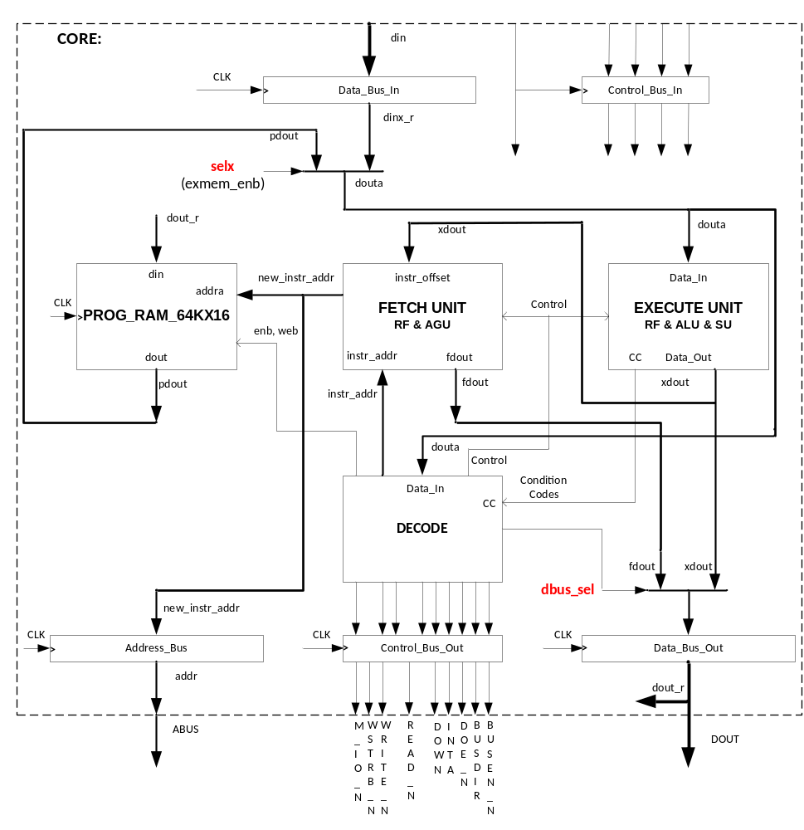

Version 1.0 Rev.1.0
Guillermo H. ROMERO / Copyright 2002..2022
GiLL Romero : Romero@IEEE.org

OPUS1
======

Opus16 16 bits integer processor unit ============================

ISA: ARCHITECTURE DEFINITION
===============================

AUTHOR: Guillermo H. Romero (GiLL)

EMAIL: Romero@ieee.org
PHONE: (617)-905-0508

COPYRIGHT: 2002-2022

FIRST ISSUE: 08/01/2002

HISTORY:
08/01/2002
First version of an 8 bit data/ 12 bit address processor.

08/01/2004
Second version of a 16 bits data/address processor.

08/01/2021
Final version of the Opus16 custom processor.

GENERAL DESCRIPTION

INTRODUCTION

The Opus16 custom processor is a 16 bits integer processor, with about 80 instructions and 4 interrupts, instructions are very simple but very useful.
The main object of this design is to program in Assembler language easy, fast and it does not require a software environment but some careful process that I’ll explain later.

- ISA: Instruction Set Architecture
- Opus16 pin out
- Opus16 architecture
- Hardware interrupt control
- Opus16 Internal Structure
- Examples

The following documentation provides an architectural definition of this custom processor. It should be noted that this is not a fully 100% tested CPU, as much as I simulated with different standar simulators and also thoroughly tested in hardware, there is a possibility that one particular instruction sequence can cause undesirable results. Said that, it is not complicated to fix the problem if exists.

Instruction structure:
rd is the destination register-------------------------- rd
rs is the source register-------------------------------- rs
rg is either source or destination -------------------- rg
pd is the destination pointer-------------------------- pd
ps is the source pointer-------------------------------- ps
Semicolon is the line terminator---------------------- ;
Double forward slash is a comment------------------ //
Preceding ‘h means an hexadecimal number------- ‘h1234
A parenthesis means content of --------------------- (p1)
P1 = address 1000 hex, content of address 1000 is 55
(p1) = 55 hex

For example :

Add r1,r2; // r1 = r1+r2
Addv r3,’h0234; // r3 = r3 + 0234 (hexadecimal)
Addv r4,123; // r4 = r4 + 0123 (decimal)
Addrp r5,p2; // r5 = r5 + p2
1) ISA: Instruction Set Architecture

Mnemonic opcode words order example; // comment

General Group
NOP 00 1 0 nop; // no operation

Arithmeticgroup
ADD 01 1 1 add rd,rs; // rd = rd + rs
ADC 02 1 1 adc rd,rs; // rd = rd + rs + cy
ADDV 03 2 1 addv rd,val; // rd = rd + val affects R0
ADDRP 04 1 1 addrp rd,ps; // rd = rd + ps affects R0
SUB 05 1 1 sub rd,rs; // rd = rd - rs
SBB 06 1 1 sbb rd,rs; // rd = rd - rs - ~cy
SUBV 07 2 1 subv rd,val; // rd = rd – val affects R0
SUBRP 08 1 1 subrp rd,ps; // rd = rd – ps affects R0

Logic group
NOT 09 1 2 not [rs,]rd; // rd = ~rs
AND 0a 1 1 and rd,rs; // rd = rd & rs
ANDV 0b 2 1 andv rd,val; // rd = rd & val affects R0
OR 0c 1 1 or rd,rs; // rd = rd | rs
ORV 0d 2 1 orv rd,val; // rd = rd | val affects R0
XOR 0e 1 1 xor rd,rs; // rd = rd ^ rs
XORV 0f 2 1 xorv rd,val; // rd = rd ^ val affects R0
INC 10 1 1 inc rd; // rd = rd + 1
DEC 11 1 1 dec rd; // rd = rd - 1
CMPR 12 1 1 cmpr rd,rs; // rd - rs
CMPRV 13 2 2 cmprv rg,val; // rg – val affects R0
CMPRP 14 1 1 cmprp rg,pt; // rg – pt affects R0
SHL 15 1 1 shl type,rg; // rd = rd << 1
SHR 16 1 1 shr type,rg; // rd = rd >> 1
SHL4 17 1 1 shl4 rg; // rd = rd << 4
SHR4 18 1 1 shr4 rg; // rd = rd >> 4

Move Group
MVRR 19 1 0 mvrr rs,rd; // rd = rs
MVRP 1a 1 0 mvrp rs,pd; // pd = rs
MVPR 1b 1 0 mvpr ps,rd; // rd = ps
MVPP 1c 1 0 mvpp ps,pd; // pd = ps
SWAP 1d 1 0 swap rg,rg; // rg <--> rg affects R0
SWAPP 1e 1 0 swap rg,pt; // rg <--> pt

Load Group
LDCV 1f 2 1 ldcv cn,val; // c[0/1/2/3] = val
LDC 43 2 1 ldc cn,rs; // c[0/1/2/3] = reg
LDR 20 2 1 ldr rd,addr ; // rd = (addr)
LDRV 21 2 1 ldrv rd,val; // rd = val
LDRP 22 1 1 ldrp rd,ps; // rd = (ps)
LDRX 23 2 1 ldrx rd,ps,val; // rd = (ps + val)
LDRPI 24 1 1 ldrpi rd,ps; // rd = (ps) => ps++
LDRPD 25 1 1 ldrpd rd,ps; // --ps, rd = (ps)
PULL 25 1 1 ldrpd rd,ps; // --ps, rd = (ps)
POP 25 1 1 ldrpd rd,ps; // --ps, rd = (ps)
LDMAM 26 1 0 ldmam mn; // m[0/1/2/3] access mode
LDPAGV 27 2 1 ldpagv val; // page address = value
LDPAG 42 1 0 ldpag rs; // page address = reg

Store Group
STR 28 2 0 str rs,addr; // (addr) = rs
STRP 29 1 0 strp rs,pd; // (pd) = rs
STRX 2a 2 0 strx rs,pd,val; // (pd + val) = rs
STRPI 2b 1 0 strpi rs,pd; // (pd) = rs => pd++
PUSH 2b 1 0 strpi rs,pd; // (pd) = rs => pd++
STRPD 2c 1 0 strpd rs,pd; // --pd, (pd) = rs

Pointer Group
LDP 2d 2 1 ldp pd,addr; // pd = (addr)
LDPV 2e 2 1 ldpv pd,val; // pd = val
LDPY 44 1 1 ldpy pd,rs; // pd = (pd+rs)
STP 2f 2 0 stp ps,addr; // (addr) = ps
INCP 30 1 1 incp pt; // pd = pd + 1
DECP 31 1 1 decp pt; // pd = pd - 1

I/O Group
INP 32 2 1 inp rd,port; // rd = (port) => i/o
INPP 33 1 1 inpp rd,ps; // rd = (ps) => i/o
OUTP 34 2 0 outp rs,port; // (port) = rs => i/o
OUTPP 35 1 0 outpp rs,pd; // (pd) = rs => i/o
// 36 // see DCJZ

Control Transfer : Branch Group, two's complements -2^15-1 to +2^15
BRA 37 2 0 bra cond,addr; // pc = pc + offset

Jump Group: full address range
DCJZ 36 2 1 dcjz cn,addr; // pc = pc + offset,cn=0
DCJNZ 38 2 1 dcjnz cn,addr; // pc = pc + offset,cn~=0
JMP 39 2 5 jmp [t/f]#,addr // pc = addr
JMPP 3a 1 1 jmpp pt; // pc = pt
JSR 3b 2 0 jsr addr; // pc = addr => --sp
RTS 3c 1 0 rts // pc = (sp) => sp++
RTI 3d 1 0 rti // pc = (sp) => sp++

Bit control
UFLAG 3e 1 5 uflag [t/f]#; // uflag bit n clr/set
UPORT 3f 1 5 uport [t/f]#; // oport bit n clr/set
// Test bits
BIT 40 1 1 bit rd,rs; // rd = rd & rs
BITV 41 2 1 bitv rd,val; // rd = rd & val affects R0
// 42 // see LDPAG
// 43 // see LDC
// 44 // see LDPY
SEI 45 1 1 sei; // set interrupt, enable
CLI 46 1 1 cli; // clear interrupt, disable
SWI 47 2 1 swi addr; // pc = (sp) => sp++

Special Instructions
HWI 5a 1 0 hwi ; // hw interrupt, do not use
STOP ff 1 0 stop; // hw signal,

Notes:
Mnemonic
Lower case instruction

Words:
1 = one 16 bit opcode
2 = one 16 bit opcode and one address/data value, total of two words

Order:
Register order for src and dst fields: used by PERL compiler
0: src,0
1: 0,dst
2: src,src
3: src,src
4: src,src
5: special

Full opcode:
______________________________________________________________________________
| 1 | 1 | 1 | 1 | 1 | 1 | | | | | | | | | | |
| 5 | 4 | 3 | 2 | 1 | 0 | 9 | 8 | 7 | 6 | 5 | 4 | 3 | 2 | 1 | 0 |
|___|___|___|___|___|___|___|___|___|___|___|___|___|___|___|___|
| s r c | d s t | opcode |
|_______________|_______________|_______________________________|
| mode/type | d s t | opcode |
|_______________|_______________|_______________________________|
| e x t e n d e d | opcode |
|_______________________________|_______________________________|

// Conditional and mofifier fields for branchs.
Cond Mode Instruction opcode condition
none 0 bra label; 0037 always
z 1 bra z,label; 1037 zero
nz 9 bra nz,label; 9037 non zero
e 1 bra e,label; 1037 equal
ne 9 bra ne,label; 9037 non equal
c 2 bra c,label; 2037 carry
nc a bra nc,label; a037 no carry
lo 2 bra lo,label; 2037 lower (unsigned)
hs a bra hs,label; a037 higher or same (unsigned)
s 3 bra s,label; 3037 sign (negative)
ns b bra ns,label; b037 no sign (positive)
o 4 bra o,label; 4037 overflow
no c bra no,label; c037 no overflow
ge 5 bra ge,label; 5037 greater than or equal
lt d bra lt,label; d037 less than
gt 6 bra gt,label; 6037 greater than
le e bra le,label; e037 less than or equal
hi 7 bra hi,label; 7037 higher (unsigned)
ls f bra ls,label; f037 lower or same (unsigned)

// type for shifts
l 0 shl l,r2; 0215 shift left, link bit = bit15
k 1 shl k,r3; 1315 shift left, bit0 = link bit
r 3 shl r,r5; 3515 rotate left or right, link bit = msb or lsb
l 0 shr l,ra; 0a16 shift right, link bit = bit0
k 1 shr k,rb; 1b16 shift right, bit15 = link bit
a 2 shr a,r4; 2416 shift right arithmetic
r 3 shr r,rc; 3c16 rotate left or right, link bit = msb or lsb

// types for ldmam : load memory access mode, internal RAM vs external RAM
0 ldmam m0; 0026 internal read, internal write
1 ldmam m1; 1026 external read. internal write
2 ldmam m2; 2026 internal read, external write
3 ldmam m3; 3026 external read, external write

SPECIAL NOTES:
1) Pointer 0 (PC) is read only access.
Valid instructions are:
stp p0,address;
any other store instruction involves p0

2) Register 0 (r0) is modified by the following instructions

Arithmetic Group
ADDV
ADDRP
SUBV
SUBRP

Logic Group
ANDV
ORV
XORV
CMPRV
CMPRP
BITV

Move Group
SWAP

3) LDMAM : load memory access mode
LDMAM m0 internal read, internal write 0 0 IRW
LDMAM m1 external read. internal write 0 1 XRD
LDMAM m2 internal read, external write 1 0 XWR
LDMAM m3 external read, external write 1 1 XRW

affected instructions:
LDR STR
LDRP STRP
LDRX STRX
LDRPI STRPI PUSH
LDRPD STRPD PULL POP
LDP STP
2) Opus16 Pinout

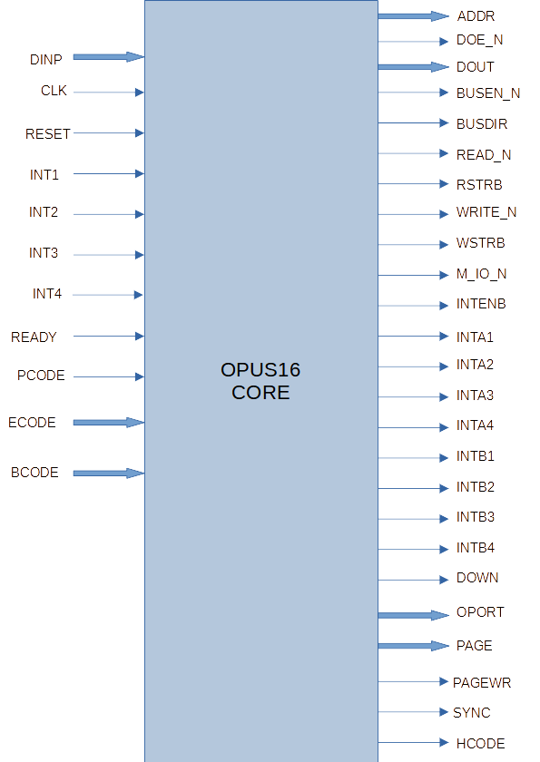
--OUTPUTS
OPUS1_ADDR : out std_logic_vector(ABUS_WIDTH-1 downto 0); -- ADDRESS BUS
OPUS1_BUSEN_N : out std_logic; -- BUS ENABLE, ACTIVE LOW
OPUS1_BUSDIR : out std_logic; -- BUS DIRECTION
OPUS1_READ_N : out std_logic; -- READ CONTROL LINE, ACTIVE LOW
OPUS1_RSTRB : out std_logic; -- READ STROBE
OPUS1_WRITE_N : out std_logic; -- WRITE CONTROL LINE, ACTIVE LOW
OPUS1_WSTRB : out std_logic; -- WRITE STROBE
OPUS1_M_IO_N : out std_logic; -- MEMORY OR IO SELECT
OPUS1_INTENB : out std_logic; -- INTERRUPT ENABLE
OPUS1_INTA1 : out std_logic; -- INTERRUPT ACKNOWLEDGE
OPUS1_INTA2 : out std_logic; -- INTERRUPT ACKNOWLEDGE
OPUS1_INTA3 : out std_logic; -- INTERRUPT ACKNOWLEDGE
OPUS1_INTA4 : out std_logic; -- INTERRUPT ACKNOWLEDGE
OPUS1_INTB1 : out std_logic; -- INTERRUPT BUSY
OPUS1_INTB2 : out std_logic; -- INTERRUPT BUSY
OPUS1_INTB3 : out std_logic; -- INTERRUPT BUSY
OPUS1_INTB4 : out std_logic; -- INTERRUPT BUSY
OPUS1_DOWN : out std_logic; -- POWER DOWN
OPUS1_OPORT : out std_logic_vector(OBUS_WIDTH-1 downto 0); -- USER PORT
OPUS1_PAGE : out std_logic_vector(ABUS_WIDTH-1 downto 0); -- address page.
OPUS1_PAGEWR : out std_logic; -- address page write pulse.
OPUS1_SYNC : out std_logic; -- SYNC
OPUS1_HCODE : out std_logic; -- PROTECTION OVERWRITE HIT

--INPUTS
OPUS1_CLK : in std_logic; -- SYSTEM CLOCK
OPUS1_RESET : in std_logic; -- GLOBAL RESET
OPUS1_INT1 : in std_logic; -- INTERRUPT #1
OPUS1_INT2 : in std_logic; -- INTERRUPT #2
OPUS1_INT3 : in std_logic; -- INTERRUPT #3
OPUS1_INT4 : in std_logic; -- INTERRUPT #4
OPUS1_READY : in std_logic; -- READY, for external slow memories/devices
OPUS1_PCODE : in std_logic; -- PROTECTION OVERWRITE
OPUS1_ECODE : in std_logic_vector(ABUS_WIDTH-1 downto 0);-- CODE PROTECTION
OPUS1_BCODE : in std_logic_vector(ABUS_WIDTH-1 downto 0);-- BOOT CODE

--INOUT
OPUS1_DOUT : out std_logic_vector(DBUS_WIDTH-1 downto 0); -- DATA BUS OUT
OPUS1_DINP : in std_logic_vector(DBUS_WIDTH-1 downto 0); -- DATA BUS INPUT
OPUS1_DOE_N : out std_logic -- DATA BUS OUTPUT ENABLE

Defines:
ABUS_WIDTH : integer := 16; -- address bus width
DBUS_WIDTH : integer := 16; -- data bus width
OBUS_WIDTH : integer := 16; -- ouput port single bit access
PBUS_WIDTH : integer := 12 ;-- internal program bus RAM width

3)Opus16 Architecture

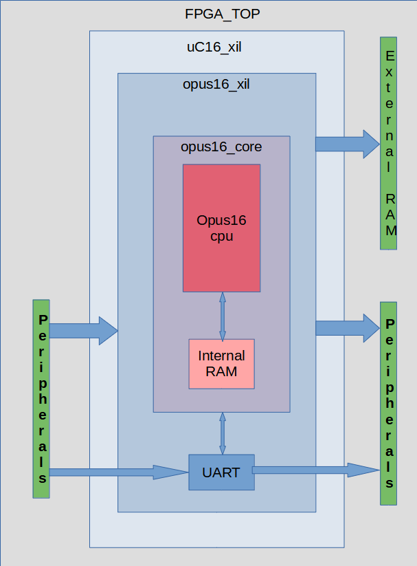
4) Hardware interrupt control

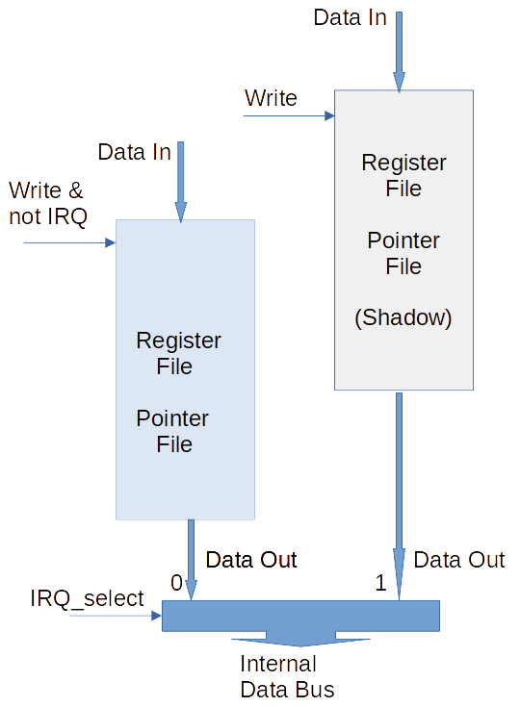

The interrupt logic, in normal operation both the register file and the pointer file are writen at the same time, when one of the 4 Opus16 interrupts occur the logic switch and the shadow file is selected.
This means that in normal mode the File and the Shadow File are writen at the same time, when an interrupt occurs only the shadow register file is writen, so there is no need to save in stack any of the 16 registers or pointers.
Also you can pass arguments through registers to the interrupt routine but not back unless you save into memory. Another way is through the Stack, the normal stack pointer operation is frozen when an interrupt occurred , so the last stack pointer is restored after return from interrupt, you can use this feature to pass values through the stack.
5)Opus16 Internal Structure

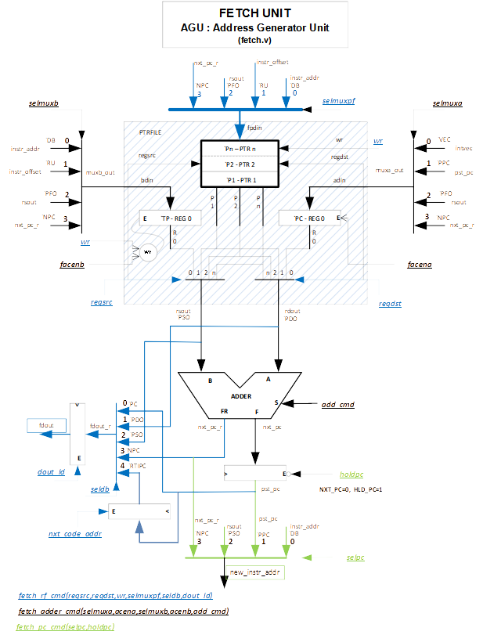
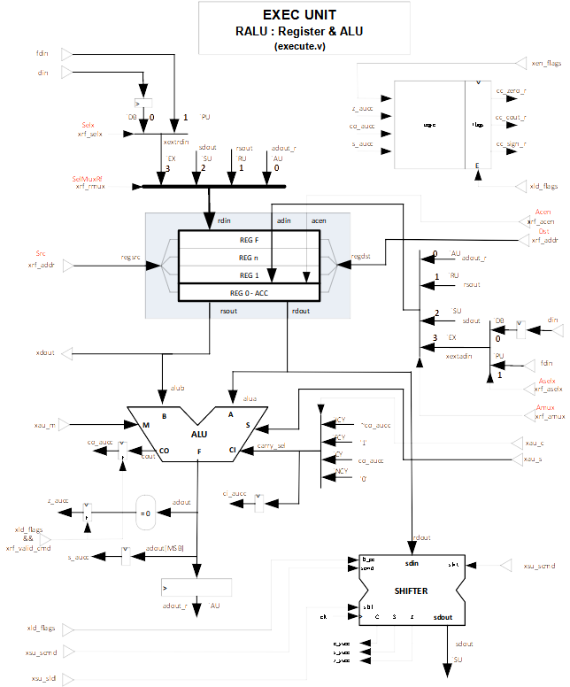

5)Opus16 program example

Assembly Source Code

Whole set of instructions in order, to show the opcodes.

define CR 13 // Return (decimal)
define LF ‘h0a // Line feed (hexadecimal)

@'h0000
main: nop ; // no operation

// ARITHMETIC
lb_arith: add r1,r2 ; // r1 = r1 + r2
adc r3,r4 ; // r3 = r3 + r4 + CY
addv r5,'h1234 ; // r5 = 1234h
addrp r6,p0 ; // r6 = (p0)
sub r7,r8 ; // r7 = r7 - r8
sbb r9,ra ; // r9 = r9 - ra - CY
subv rB,'h0001 ; // rB = rB - 1
subrp rC,p1 ; // rC = rC - p1

// Logic
lb_logic: not rD ; // rD = ~rD
not rD,r1 ; // r1 = ~rD
and rE,rF ; // rE = rE and rF
andv r1,'hffff ; // r1 = r1 and 'hffff
or r2,r1 ; // r2 = r2 or r1
orv r3,'h1010 ; // r3 = r3 or 10
xor r4,r5 ; // r4 = r4 xor r5
xorv r6,'h1010 ; // r6 = r6 xor 10
inc r7 ; // r7++
dec r8 ; // r8--
cmpr r9,rA ; // r9-rA, set status flags
cmprv rb,'h0000 ; // rB-0, set status flags
cmprp rc,p2 ; // rC-p2,set status flags
shl r1 ; // r1<<1
shr r2 ; // r2>>1
shl4 r3 ; // r3<<4
shr4 r3 ; // r3>>4

// MOVE
lb_move: mvrr r3,r4 ; // r4 - r3
mvrp r4,p4 ; // p4 = r4
mvpr p4,r7 ; // r7 = p4
mvpp p4,p5 ; // p5 = p4
swap r3,r4 ; // r4=r3, r3=r4
swapp r4,p3 ; // p3=r4, r4=p3

// LOAD
lb_load: ldcv c0,3 ; // counter #0 = 3
ldc c1,r9 ; // counter #1 = 9
ldr r1,temp0 ; // r1 = (temp0)
ldrv r2,'h0003 ; // r2 = 3
ldrp r3,p1 ; // r3 = (p1)
ldrx r4,p1,2 ; // r4 = (p1+2)
ldrpi r5,p2 ; // r5 = (p2), p2++
ldrpd r6,p3 ; // r6 = (p3),--p3
pull r7,p4 ; // r7 = (p4),--p4
pop r8,p5 ; // r8 = (p5),--p5
ldmam m2 ; // internal
ldpagv 'haba ; // page = 'h0aba
ldpag r9 ; // page = r9

// store group
lb_store: str r6,temp0 ; // (temp0) = r6
strp r1,p4 ; // (p4) = r1
strx r2,p4,2 ; // (p4+2) = r2
strpi r3,p5 ; // (p5) = r3, p5++
push ra,p8 ; // (p8) = ra, p8++
strpd rB,p9 ; // (p9) = rb, --p9

// pointer group
lb_pointer: ldp pa,tempa ; // pa = (tempa)
ldpv pb,temp0 ; // pB = &temp0
ldpy pc,rb ; // pc = (pc+rb)
stp pd,tempa ; // (tempa) = pd
incp pE ; // pE++
decp pf ; // pF--

// I/O group
lb_io: inp r1,port1 ; // r1 = (port1)
inpp r2,pc ; // r2 = (pC)
outp r3,port2 ; // (port2) = r3
outpp r4,pd ; // (pD) = r4

// control transfer
main1: bra main1 ; // branch to main

// Jump Group, full address range
main2: dcjz c0,main2 ; // if c0=0 jump main2
main3: dcjnz c1,main3 ; // if c1<>0 jump main3
jmp main4 ; // always jump main4
main4: jmp f1,main5 ; // if uflag 1 = 0 jump main5
main5: jmp tA,main6 ; // if uflag a = 1 jump main6
main6: jmpp pe ; // jump to (pe)
main7: jsr subr1 ; // jump subr1
subr1: rts ; // return from subr1
rti ; // return from interrupt

// User flags and single bit output port.
lb_bits: uflag tE ; // user flag E = 1
uflag ff ; // user flag F = 0
uport ta ; // oport a (10dec) = 1
uport fB ; // oport b (11dec) = 0

// Bit test
bit r1,r2 ; // r1 and r2, cc affected
bitv r3,'h0011 ; // r3 and 3, cc affected

// Interrupts
lb_irq: cli ; // disable interrupts
sei ; // enable interruts
swia: swi swia ; // software interrupt / trap

// Special intructions
hwi ; // do not use it
stop ; // output stop signal

// temporary data storage
temp0: dw 33 ; // one word and initialize with 33 decimal
tempa: ds 5 ; // reserve 5 words, uninitialized
temp_ascii: dw CR ; // Carry Return ASCII 0d(hex)
port1: dw 'h0100 ; // address port1
port2: dw 'h0108 ; // address port2

Assembly Code List

*****************************************
Assembler and Date : version 6.1: (11-09-21)
Program size : 181
----------
Asm file name : sim_isa_order.asm
List file name : sim_isa_order.lst
----------
Hex file name : sim_isa_order.hex
COE file name : sim_isa_order.coe
MEM file name : sim_isa_order.mem
Altera Mif file name : sim_isa_order_alt.mif
Xilinx Mif file name : sim_isa_order_xil.mif
*****************************************

Labels and Defines:
lb_arith: 0041
lb_bits: 00a0
lb_io: 0089
lb_irq: 00a7
lb_load: 0066
lb_logic: 004b
lb_move: 0060
lb_pointer: 0080
lb_store: 0078
main: 0000
main1: 008f
main2: 0091
main3: 0093
main4: 0097
main5: 0099
main6: 009b
main7: 009c
port1: 00b3
port2: 00b4
subr1: 009e
swia: 00a9
temp0: 00ad
tempa: 00ae
*****************************************
Opcode listing.

0000 0000 main:nop ;
0001 0021 ldrv r0,'h1000 ;
0002 1000
0003 0121 ldrv r1,'h1001 ;
0004 1001
0005 0221 ldrv r2,'h1002 ;
0006 1002
0007 0321 ldrv r3,'h1003 ;
0008 1003
0009 0421 ldrv r4,'h1004 ;
000a 1004
000b 0521 ldrv r5,'h1005 ;
000c 1005
000d 0621 ldrv r6,'h1006 ;
000e 1006
000f 0721 ldrv r7,'h1007 ;
0010 1007
0011 0821 ldrv r8,'h1008 ;
0012 1008
0013 0921 ldrv r9,'h1009 ;
0014 1009
0015 0a21 ldrv ra,'h100a ;
0016 100a
0017 0b21 ldrv rb,'h100b ;
0018 100b
0019 0c21 ldrv rc,'h100c ;
001a 100c
001b 0d21 ldrv rd,'h100d ;
001c 100d
001d 0e21 ldrv re,'h100e ;
001e 100e
001f 0f21 ldrv rf,'h100f ;
0020 100f
0021 002e ldpv r0,'h2000 ;
0022 2000
0023 012e ldpv r1,'h2001 ;
0024 2001
0025 022e ldpv r2,'h2002 ;
0026 2002
0027 032e ldpv r3,'h2003 ;
0028 2003
0029 042e ldpv r4,'h2004 ;
002a 2004
002b 052e ldpv r5,'h2005 ;
002c 2005
002d 062e ldpv r6,'h2006 ;
002e 2006
002f 072e ldpv r7,'h2007 ;
0030 2007
0031 082e ldpv r8,'h2008 ;
0032 2008
0033 092e ldpv r9,'h2009 ;
0034 2009
0035 0a2e ldpv ra,'h200a ;
0036 200a
0037 0b2e ldpv rb,'h200b ;
0038 200b
0039 0c2e ldpv rc,'h200c ;
003a 200c
003b 0d2e ldpv rd,'h200d ;
003c 200d
003d 0e2e ldpv re,'h200e ;
003e 200e
003f 0f2e ldpv rf,'h200f ;
0040 200f
0041 2101 lb_arith: add r1,r2 ;
0042 4302 adc r3,r4 ;
0043 0503 addv r5,'h1234 ;
0044 1234
0045 0604 addrp r6,p0 ;
0046 8705 sub r7,r8 ;
0047 a906 sbb r9,ra ;
0048 0b07 subv rB,'h0001 ;
0049 0001
004a 1c08 subrp rC,p1 ;
004b dd09 lb_logic: not rD ;
004c d109 not rD,r1 ;
004d fe0a and rE,rF ;
004e 010b andv r1,'hffff ;
004f ffff
0050 120c or r2,r1 ;
0051 030d orv r3,'h1010 ;
0052 1010
0053 540e xor r4,r5 ;
0054 060f xorv r6,'h1010 ;
0055 1010
0056 0710 inc r7 ;
0057 0811 dec r8 ;
0058 a912 cmpr r9,rA ;
0059 bb13 cmprv rb,'h0000 ;
005a 0000
005b 2c14 cmprp rc,p2 ;
005c 0115 shl r1 ;
005d 0216 shr r2 ;
005e 0317 shl4 r3 ;
005f 0318 shr4 r3 ;
0060 3419 lb_move: mvrr r3,r4 ;
0061 441a mvrp r4,p4 ;
0062 471b mvpr p4,r7 ;
0063 451c mvpp p4,p5 ;
0064 341d swap r3,r4 ;
0065 431e swapp r4,p3 ;
0066 001f lb_load: ldcv c0,3 ;
0067 0003
0068 9143 ldc c1,r9 ;
0069 0120 ldr r1,temp0 ;
006a 00ad
006b 0221 ldrv r2,'h0003 ;
006c 0003
006d 1322 ldrp r3,p1 ;
006e 1423 ldrx r4,p1,2 ;
006f 0002
0070 2524 ldrpi r5,p2 ;
0071 3625 ldrpd r6,p3 ;
0072 4725 pull r7,p4 ;
0073 5825 pop r8,p5 ;
0074 2026 ldmam m2 ;
0075 0027 ldpagv 'haba ;
0076 0aba
0077 9042 ldpag r9 ;
0078 6028 lb_store: str r6,temp0 ;
0079 00ad
007a 1429 strp r1,p4 ;
007b 242a strx r2,p4,2 ;
007c 0002
007d 352b strpi r3,p5 ;
007e a82b push ra,p8 ;
007f b92c strpd rB,p9 ;
0080 0a2d lb_pointer: ldp pa,tempa ;
0081 00ae
0082 0b2e ldpv pb,temp0 ;
0083 00ad
0084 bc44 ldpy pc,rb ;
0085 d02f stp pd,tempa ;
0086 00ae
0087 0e30 incp pE ;
0088 0f31 decp pf ;
0089 0132 lb_io: inp r1,port1 ;
008a 00b3
008b c233 inpp r2,pc ;
008c 3034 outp r3,port2 ;
008d 00b4
008e 4d35 outpp r4,pd ;
008f 0037 main1: bra main1 ;
0090 ffff
0091 0036 main2: dcjz c0,main2 ;
0092 0091
0093 0138 main3: dcjnz c1,main3 ;
0094 0093
0095 0039 jmp main4 ;
0096 0097
0097 0139 main4: jmp f1,main5 ;
0098 0099
0099 8a39 main5: jmp tA,main6 ;
009a 009b
009b 0e3a main6: jmpp pe ;
009c 003b main7: jsr subr1 ;
009d 009e
009e 003c subr1: rts ;
009f 003d rti ;
00a0 8e3e lb_bits: uflag tE ;
00a1 0f3e uflag ff ;
00a2 8a3f uport ta ;
00a3 0b3f uport fB ;
00a4 2140 bit r1,r2 ;
00a5 0341 bitv r3,'h0011 ;
00a6 0011
00a7 0046 lb_irq: cli ;
00a8 0045 sei ;
00a9 0047 swia: swi swia ;
00aa 00a9
00ab 005a hwi ;
00ac 00ff stop ;
00ad 0021 temp0: dw 33 ;
00b3 0100 port1: dw 'h0100 ;
00b4 0108 port2: dw 'h0108 ;

