- Madrid was far from being the biggest city of Spain when it was set as its capital city in XVI century, nor was it the head of a great archbishopric, so within its barely 128 hectares there were not great buildings comparable to those of Toledo, Seville, or even Lisabon. The footprint of this small village that became the capital of Philippe II Empire is still visible on its messy mediaeval urban fabric in the city centre, known as Madrid of the Austrias. In the following two centuries the city grew in the same chaotic way, gradually covering the 700 hectares surface within the wall built by Philippe IV, with sober civil buildings, together with an increasing number of religious facilities and royal monumental buildings, leaving just the minimum necessary space for narrow and winding streets. This situation lasts until 1860, when, following the hygienists stream, a grid-shaped urban expansion plan was approved, adding 1,500 extra hectares to the city, however, its execution took over 50 years and hence it reached the XXth century. In this analysis 'classical residential' style encloses those civil buildings built before 1920, indeed a broad and diverse period, but in which buildings rose up along XIX century in an eclectic style are the majority above those built before 1800 (currently these sums up only 1,349 buildings in a city with more than 122,000 buildings, 11,138 of them erected before 1920). This expansion area (figure X or Y) has another characteristic that is shown by our analysis: in the new wide and straight streets there is place for trees, forming boulevards, with a reflection on 'loose vegetation' label, and a high density of commercial premises on ground floor. It is interesting to verify how 'classical residential' heatmap shows informal settlements out of the ordered area that afterwards were to be incorporated to the city -such as Tetuán and Vallecas. After 1930's, when the city reached its first million inhabitants, rationalism architectural current derives into a 'contemporary style' -quite homogeneous, of cheap and quick execution (concrete structures and brick façades)- this factor allows a rapid growth that was steadily accelerated until 1970's, when the city reaches its current population (though up to our days new buildings have kept on filling the remaining empty land plots or replacing previous buildings). Nowadays the city is surrounded by heavy traffic highways -M30 and M40- built between 1970's and 1990's, and where many tertiary buildings are located (offices and commercial centres), this is shown in our data through the 'contemporary non residential' (steel and glass architecture) and 'open view' labels. The major transformation experienced by the city in the 2000's, the M30 south-west arch burying and the huge lineal green area so generated along Manzanares river, is not shown in our data -open view and vegetation labels- because the google street view car gathered images inside the resulting underground tunnel.

- Another family of labels have faced the problem of raw data scarcity such as 'graffiti', 'litter', or 'broken glasses', however they may be useful in other geographies, being helpful to draw a map of trendy, unsafe or decaying areas.

- In global terms, the project contributes with interesting insights to the reading of the territory in a quantified way structured upon an available and rich datasource. This innovative generation of urban metrics obtained thanks to a massive and fast method constitutes a broad and transversal approach that encloses multiple potential aims. To quote just some of them, this results open the possibility of correlating urban characteristics such as the architectonical predominant style, or the street average width with commercial or touristic success or decay of an area, if crossed with other data such as economic performance information, or the vegetation density with life quality attributes, such as liveability, healthiness or even other more subjective matters such as safety.

- 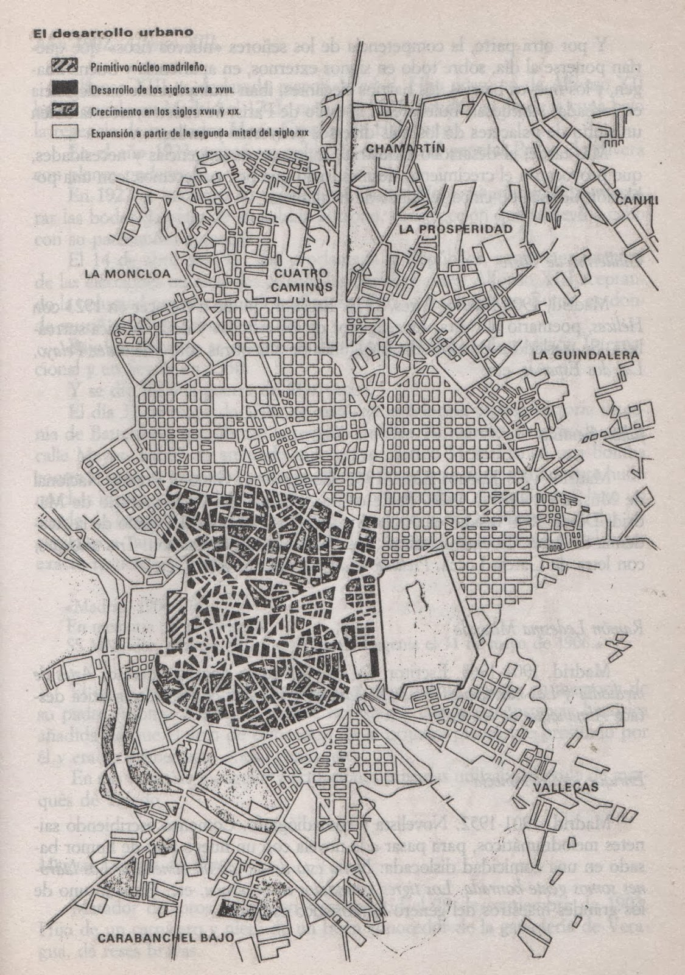
- figure X

- 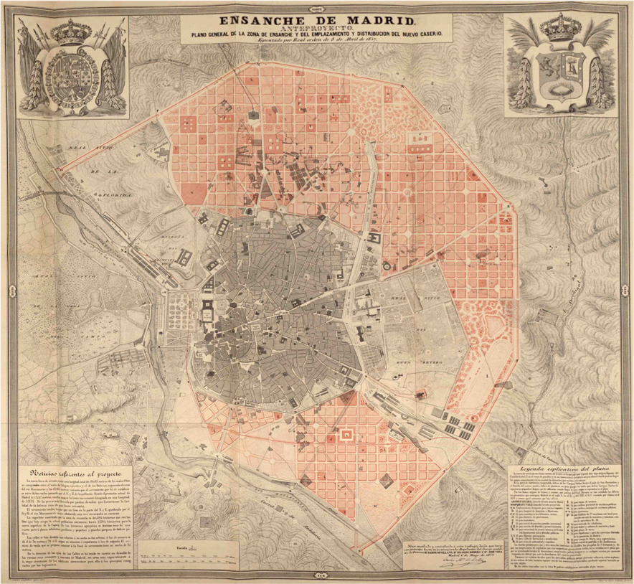
- figure Y

