1. Project.lst:

| 00000000 00000001 1 ListNode <Counter, ($ + Counter * SIZEOF ListNode)>  00000008 R  00000008 00000002 1 ListNode <Counter, ($ + Counter * SIZEOF ListNode)>  00000010 R  00000010 00000003 1 ListNode <Counter, ($ + Counter * SIZEOF ListNode)>  00000018 R  00000018 00000004 1 ListNode <Counter, ($ + Counter * SIZEOF ListNode)>  00000020 R  00000020 00000005 1 ListNode <Counter, ($ + Counter * SIZEOF ListNode)>  00000028 R  00000028 00000006 1 ListNode <Counter, ($ + Counter * SIZEOF ListNode)>  00000030 R  00000030 00000007 1 ListNode <Counter, ($ + Counter * SIZEOF ListNode)>  00000038 R  00000038 00000008 1 ListNode <Counter, ($ + Counter * SIZEOF ListNode)>  00000040 R  00000040 00000009 1 ListNode <Counter, ($ + Counter * SIZEOF ListNode)>  00000048 R  00000048 0000000A 1 ListNode <Counter, ($ + Counter * SIZEOF ListNode)>  00000050 R  00000050 0000000B 1 ListNode <Counter, ($ + Counter * SIZEOF ListNode)>  00000058 R  00000058 0000000C 1 ListNode <Counter, ($ + Counter * SIZEOF ListNode)>  00000060 R  00000060 0000000D 1 ListNode <Counter, ($ + Counter * SIZEOF ListNode)>  00000068 R  00000068 0000000E 1 ListNode <Counter, ($ + Counter * SIZEOF ListNode)>  00000070 R  00000070 0000000F 1 ListNode <Counter, ($ + Counter * SIZEOF ListNode)>  00000078 R  00000078 00000000 ListNode <0,0> ; tail node  00000000 |
| --- |

* 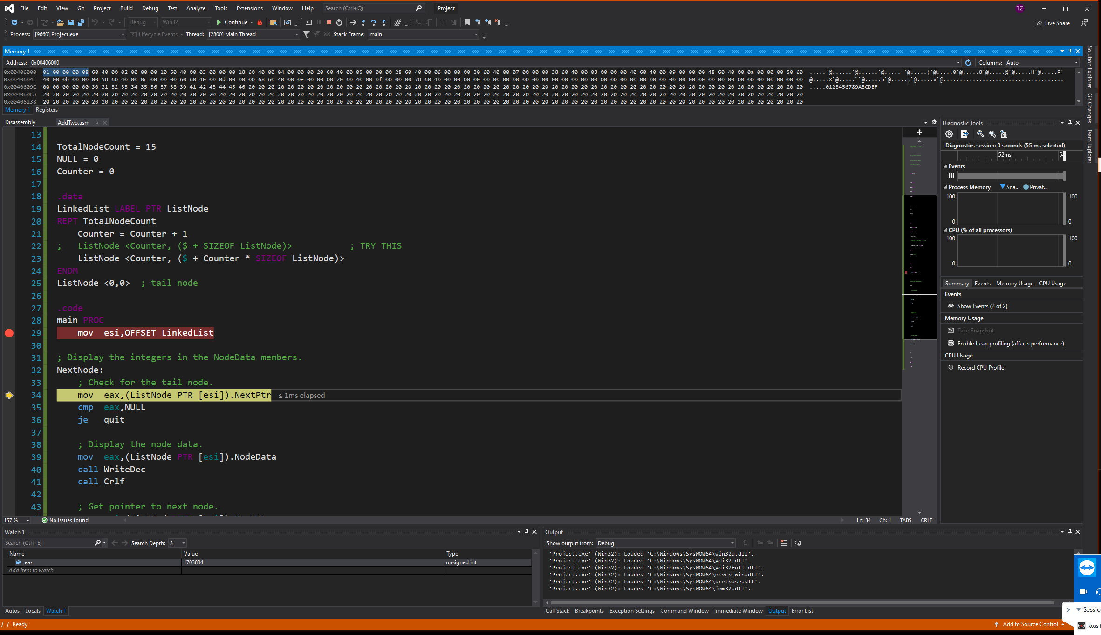*lab-10.2II*

1. Project.lst (looping linked list)

| 00000000 00000001 1 ListNode <Counter, ($ + SIZEOF ListNode)> ; TRY THIS  00000008 R  00000008 00000002 1 ListNode <Counter, ($ + SIZEOF ListNode)> ; TRY THIS  00000008 R  00000010 00000003 1 ListNode <Counter, ($ + SIZEOF ListNode)> ; TRY THIS  00000008 R  00000018 00000004 1 ListNode <Counter, ($ + SIZEOF ListNode)> ; TRY THIS  00000008 R  00000020 00000005 1 ListNode <Counter, ($ + SIZEOF ListNode)> ; TRY THIS  00000008 R  00000028 00000006 1 ListNode <Counter, ($ + SIZEOF ListNode)> ; TRY THIS  00000008 R  00000030 00000007 1 ListNode <Counter, ($ + SIZEOF ListNode)> ; TRY THIS  00000008 R  00000038 00000008 1 ListNode <Counter, ($ + SIZEOF ListNode)> ; TRY THIS  00000008 R  00000040 00000009 1 ListNode <Counter, ($ + SIZEOF ListNode)> ; TRY THIS  00000008 R  00000048 0000000A 1 ListNode <Counter, ($ + SIZEOF ListNode)> ; TRY THIS  00000008 R  00000050 0000000B 1 ListNode <Counter, ($ + SIZEOF ListNode)> ; TRY THIS  00000008 R  00000058 0000000C 1 ListNode <Counter, ($ + SIZEOF ListNode)> ; TRY THIS  00000008 R  00000060 0000000D 1 ListNode <Counter, ($ + SIZEOF ListNode)> ; TRY THIS  00000008 R  00000068 0000000E 1 ListNode <Counter, ($ + SIZEOF ListNode)> ; TRY THIS  00000008 R  00000070 0000000F 1 ListNode <Counter, ($ + SIZEOF ListNode)> ; TRY THIS  00000008 R  00000078 00000000 ListNode <0,0> ; tail node  00000000 |
| --- |

| .model flat  mLocate MACRO xval, yval  IF xval LT 0  EXITM  ENDIF  ;... ; reverse keywords' characters in the next three lines to get it right ;) and comment dots  IF yval LT 0  EXITM  ENDIF  ;.... ; up to here symbols are reversed ;)  mov bx, 0 ; video page 0  mov ah, 2 ; locate cursor  mov dh, yval  mov dl, xval   IF IsDefined (RealMode)  int 10h ; call BIOS  ENDIF ENDM  .data row BYTE 15 col BYTE 60 .code main proc  mLocate -2,20  mLocate 10,20  ; mLocate col,row   mov eax, 0  exit main endp end main |
| --- |

*lab-10.2IV*

* Debugging macros is painful, and compilation errors typically come from macros.
* No the macros are not tested for passed variables or registers. To enable use of registers, you cannot compare with 0. You have to use the test `IF IDENTIFIER I EQUALS`.
* No. It was not executed because the main proc did not contain them.
* To compile and execute without errors, then you have to make sure that
  + int 10h is only available in real mode.
  + something like:

| IF IsDefined (RealMode)  int 0h ; call BIOS ENDIF |
| --- |