lab-10I.s:

| .code32 .text .globl main .type main, @function .globl square_root_proc .type square_root_proc, @function square_root_proc:  push %ebx  push %ecx  push %edx  xor %ecx, %ecx  mov %eax, %ebx   sqloop:  mov %ecx, %eax  mul %eax  cmp %ebx, %eax  je quit  inc %ecx  jmp sqloop  quit:  mov %ecx, %eax  pop %edx  pop %ecx  pop %ebx  ret |
| --- |

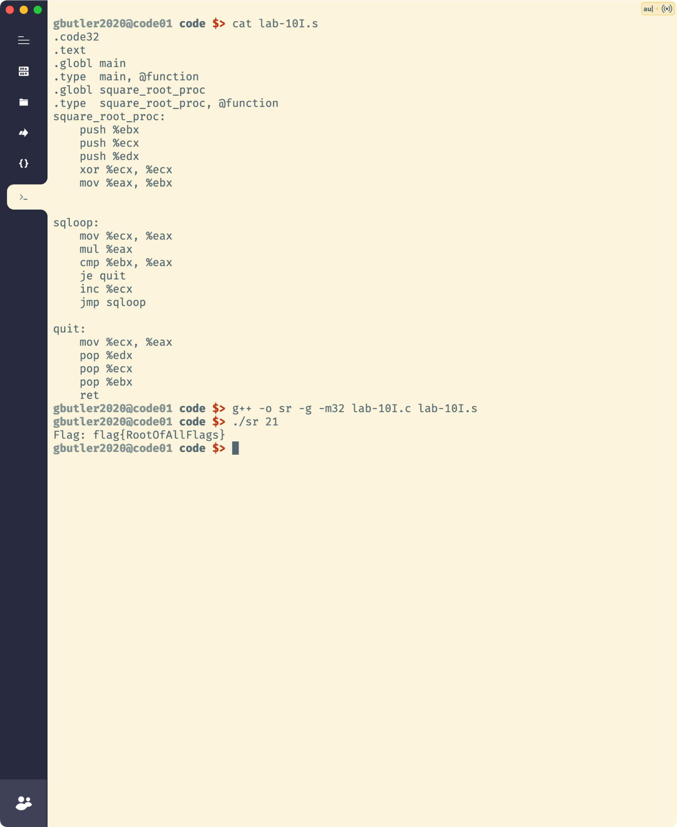

lab-10II.s

| .code32 .globl _start .struct 4 MyStruct: MyStruct.x: .space 2 MyStruct.y: .space 2 MyStruct_size = . - MyStruct  .bss my_obj:  .space MyStruct_size  .text _start:  mov $my_obj, %edi  movw $0, MyStruct.x(%edi)  movw $0, MyStruct.y(%edi)  mov $1, %eax  mov $MyStruct_size, %ebx  int $0x80 |
| --- |

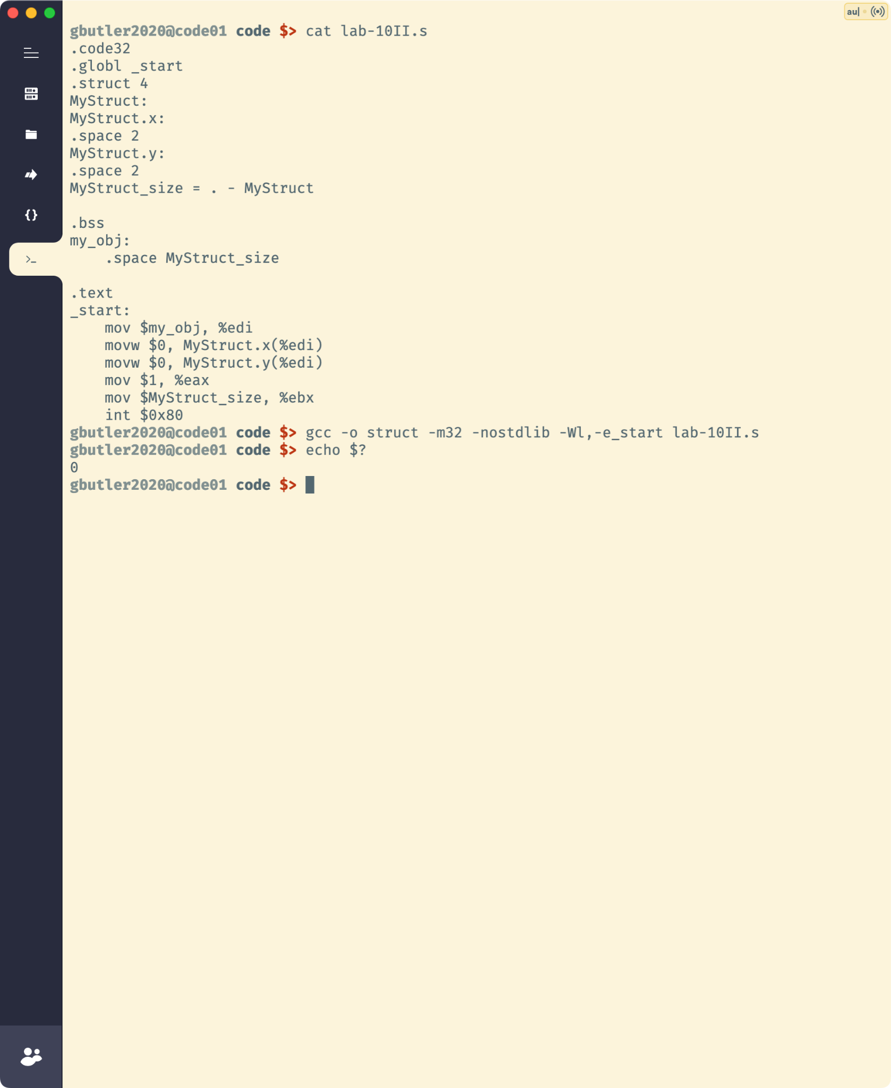

lab-10III.asm:

| INCLUDE Irvine32.inc  .data MyStruct STRUCT  field1 WORD ?  field2 DWORD ? MyStruct ENDS  var MyStruct <>  .code  main PROC  mov eax, SIZEOF MyStruct.field2  mov ebx, SIZEOF var.field2  exit main ENDP END main |
| --- |

