# lab-11.1

##### task 1:

; Demonstrate MessageBoxA (MessageBox.asm)  
  
; Demonstration of the Windows API MessageBox function, using  
; various icons and button configurations.  
  
INCLUDE Irvine32.inc  
  
.data  
captionW BYTE "Warning",0  
warningMsg BYTE "The current operation may take years "  
 BYTE "to complete.",0  
  
captionQ BYTE "Question",0  
questionMsg BYTE "A matching user account was not found."  
 BYTE 0dh,0ah,"Do you wish to continue?",0  
  
captionC BYTE "Information",0  
infoMsg BYTE "Select Yes to save a backup file "  
 BYTE "before continuing,",0dh,0ah  
 BYTE "or click Cancel to stop the operation",0  
  
captionH BYTE "Cannot View User List",0  
haltMsg BYTE "This operation not supported by your "  
 BYTE "user account.",0  
  
.code  
main PROC  
  
; Display Exclamation icon with OK button  
 INVOKE MessageBox, NULL, ADDR warningMsg,  
 ADDR captionW,  
 MB_OK + MB_ICONEXCLAMATION  
  
; Display Question icon with Yes/No buttons  
 INVOKE MessageBox, NULL, ADDR questionMsg,  
 ADDR captionQ, MB_YESNO + MB_ICONQUESTION  
  
 ; interpret the button clicked by the user  
 cmp eax,IDYES ; YES button clicked?  
  
; Display Information icon with Yes/No/Cancel buttons  
 INVOKE MessageBox, NULL, ADDR infoMsg,  
 ADDR captionC, MB_YESNOCANCEL + MB_ICONINFORMATION \  
 + MB_DEFBUTTON2  
  
; Display stop icon with OK button  
 INVOKE MessageBox, NULL, ADDR haltMsg,  
 ADDR captionH,  
 MB_OK + MB_ICONSTOP  
  
 exit  
main ENDP  
  
END main

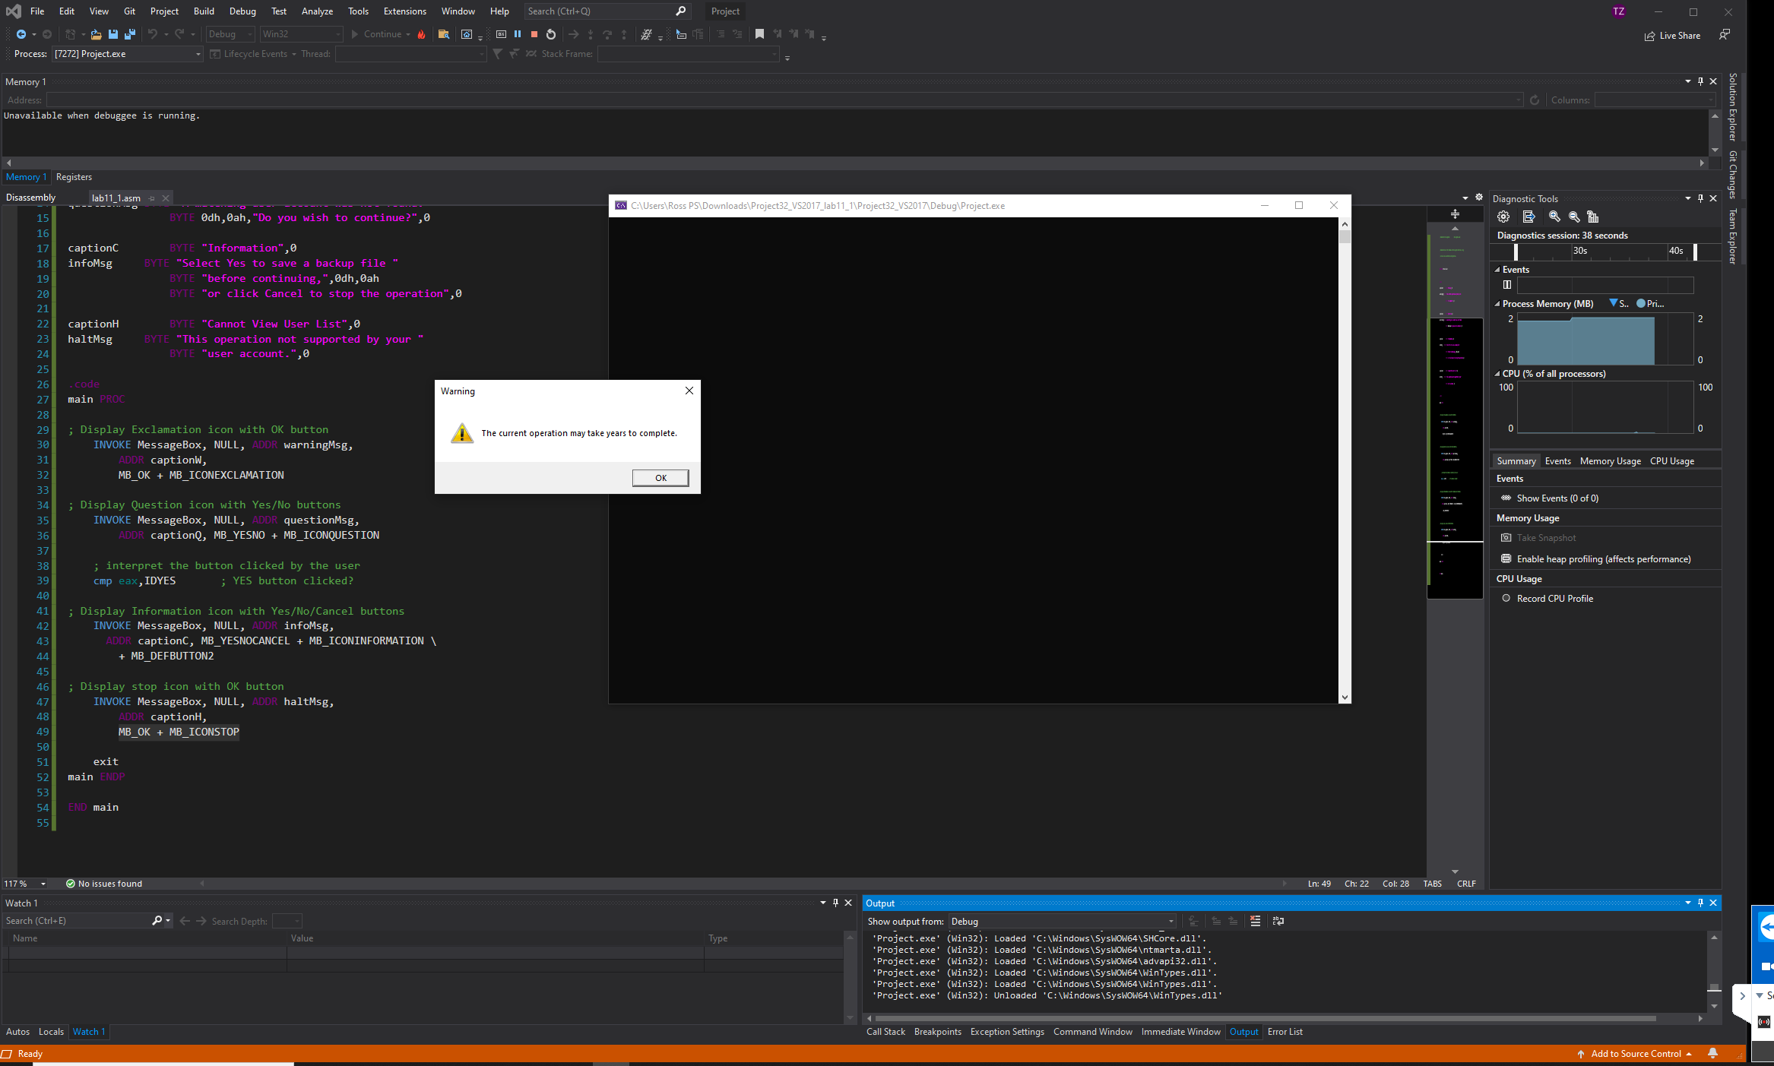

###### task 2:

; Read From the Console (ReadConsole.asm)  
  
; Read a line of input from standard input.  
  
INCLUDE Irvine32.inc  
  
BufSize = 80  
  
.data  
buffer BYTE BufSize DUP(?)  
stdInHandle HANDLE ?  
bytesRead DWORD ?  
  
.code  
main PROC  
 ; Get handle to standard input  
 INVOKE GetStdHandle, STD_INPUT_HANDLE  
 mov stdInHandle,eax  
  
 ; Wait for user input  
 INVOKE ReadConsole, stdInHandle, ADDR buffer,  
 BufSize, ADDR bytesRead, 0  
  
 ; Display the buffer  
 mov esi,OFFSET buffer  
 mov ecx,bytesRead  
 mov ebx,TYPE buffer  
 call DumpMem  
  
 exit  
main ENDP  
END main

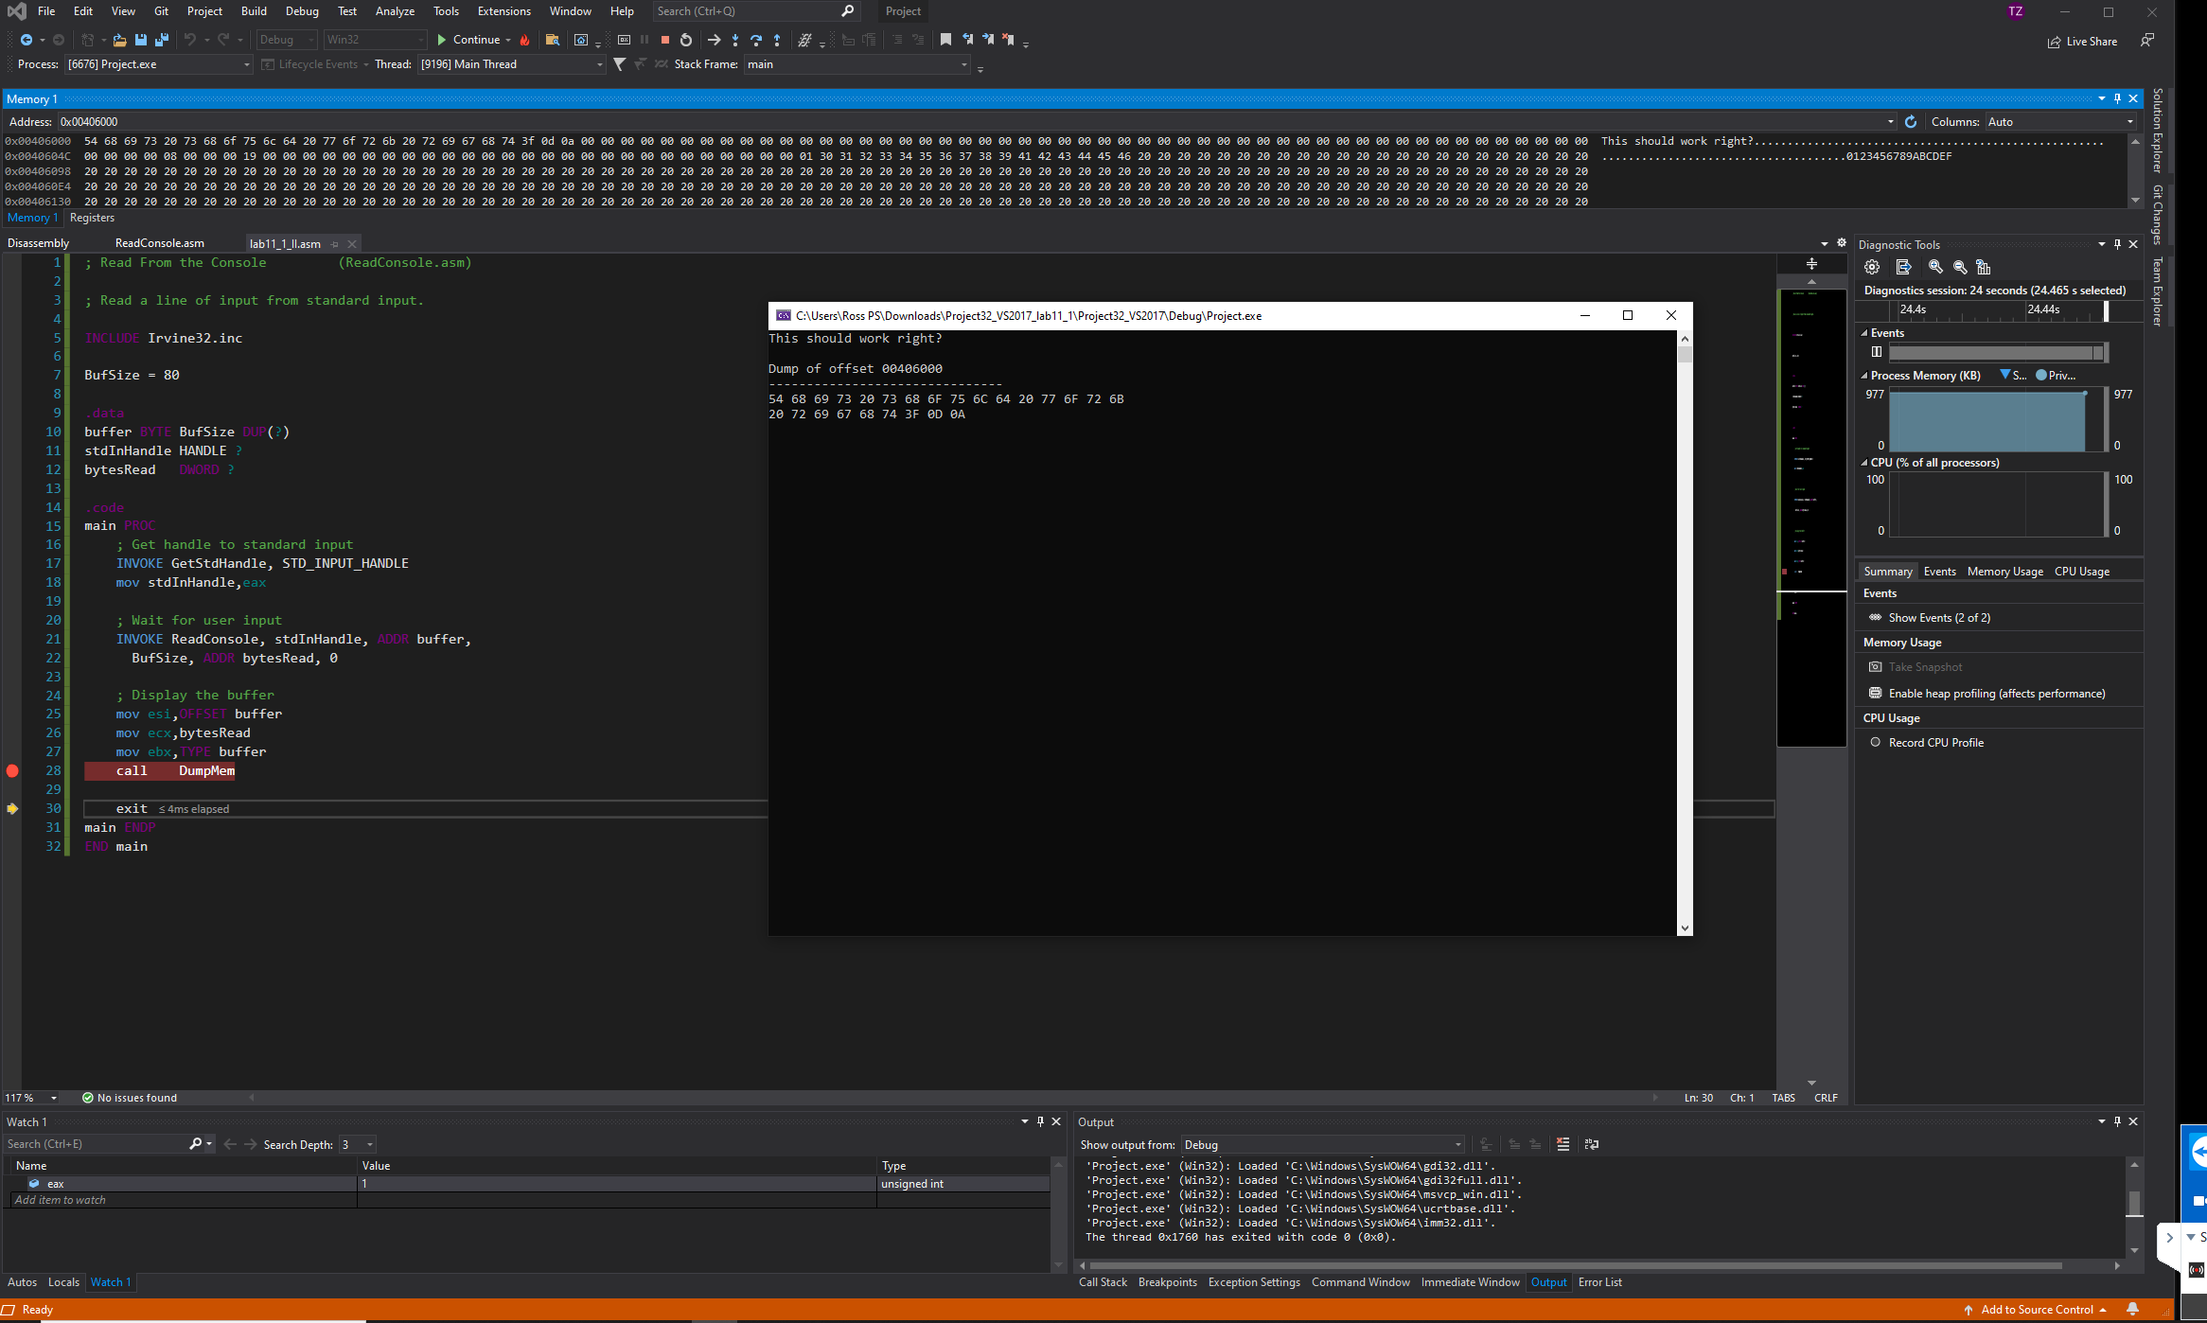

##### task 3:

; Win32 Console Example #1 (Console1.asm)  
  
; This program calls the following Win32 Console functions:  
; GetStdHandle, ExitProcess, WriteConsole  
  
INCLUDE Irvine32.inc  
  
.data  
endl EQU <0dh,0ah> ; end of line sequence  
  
message LABEL BYTE  
 BYTE "This program is a simple demonstration of "  
 BYTE "console mode output, using the GetStdHandle "  
 BYTE "and WriteConsole functions.", endl  
messageSize DWORD ($-message)  
  
consoleHandle HANDLE 0 ; handle to standard output device  
bytesWritten DWORD ? ; number of bytes written  
  
.code  
main PROC  
 ; Get the console output handle:  
 INVOKE GetStdHandle, STD_OUTPUT_HANDLE  
 mov consoleHandle,eax  
  
 ; Write a string to the console:  
 INVOKE WriteConsole,  
 consoleHandle, ; console output handle  
 ADDR message, ; string pointer  
 messageSize, ; string length  
 ADDR bytesWritten, ; returns num bytes written  
 0 ; not used  
  
 INVOKE ExitProcess,0  
main ENDP  
END main

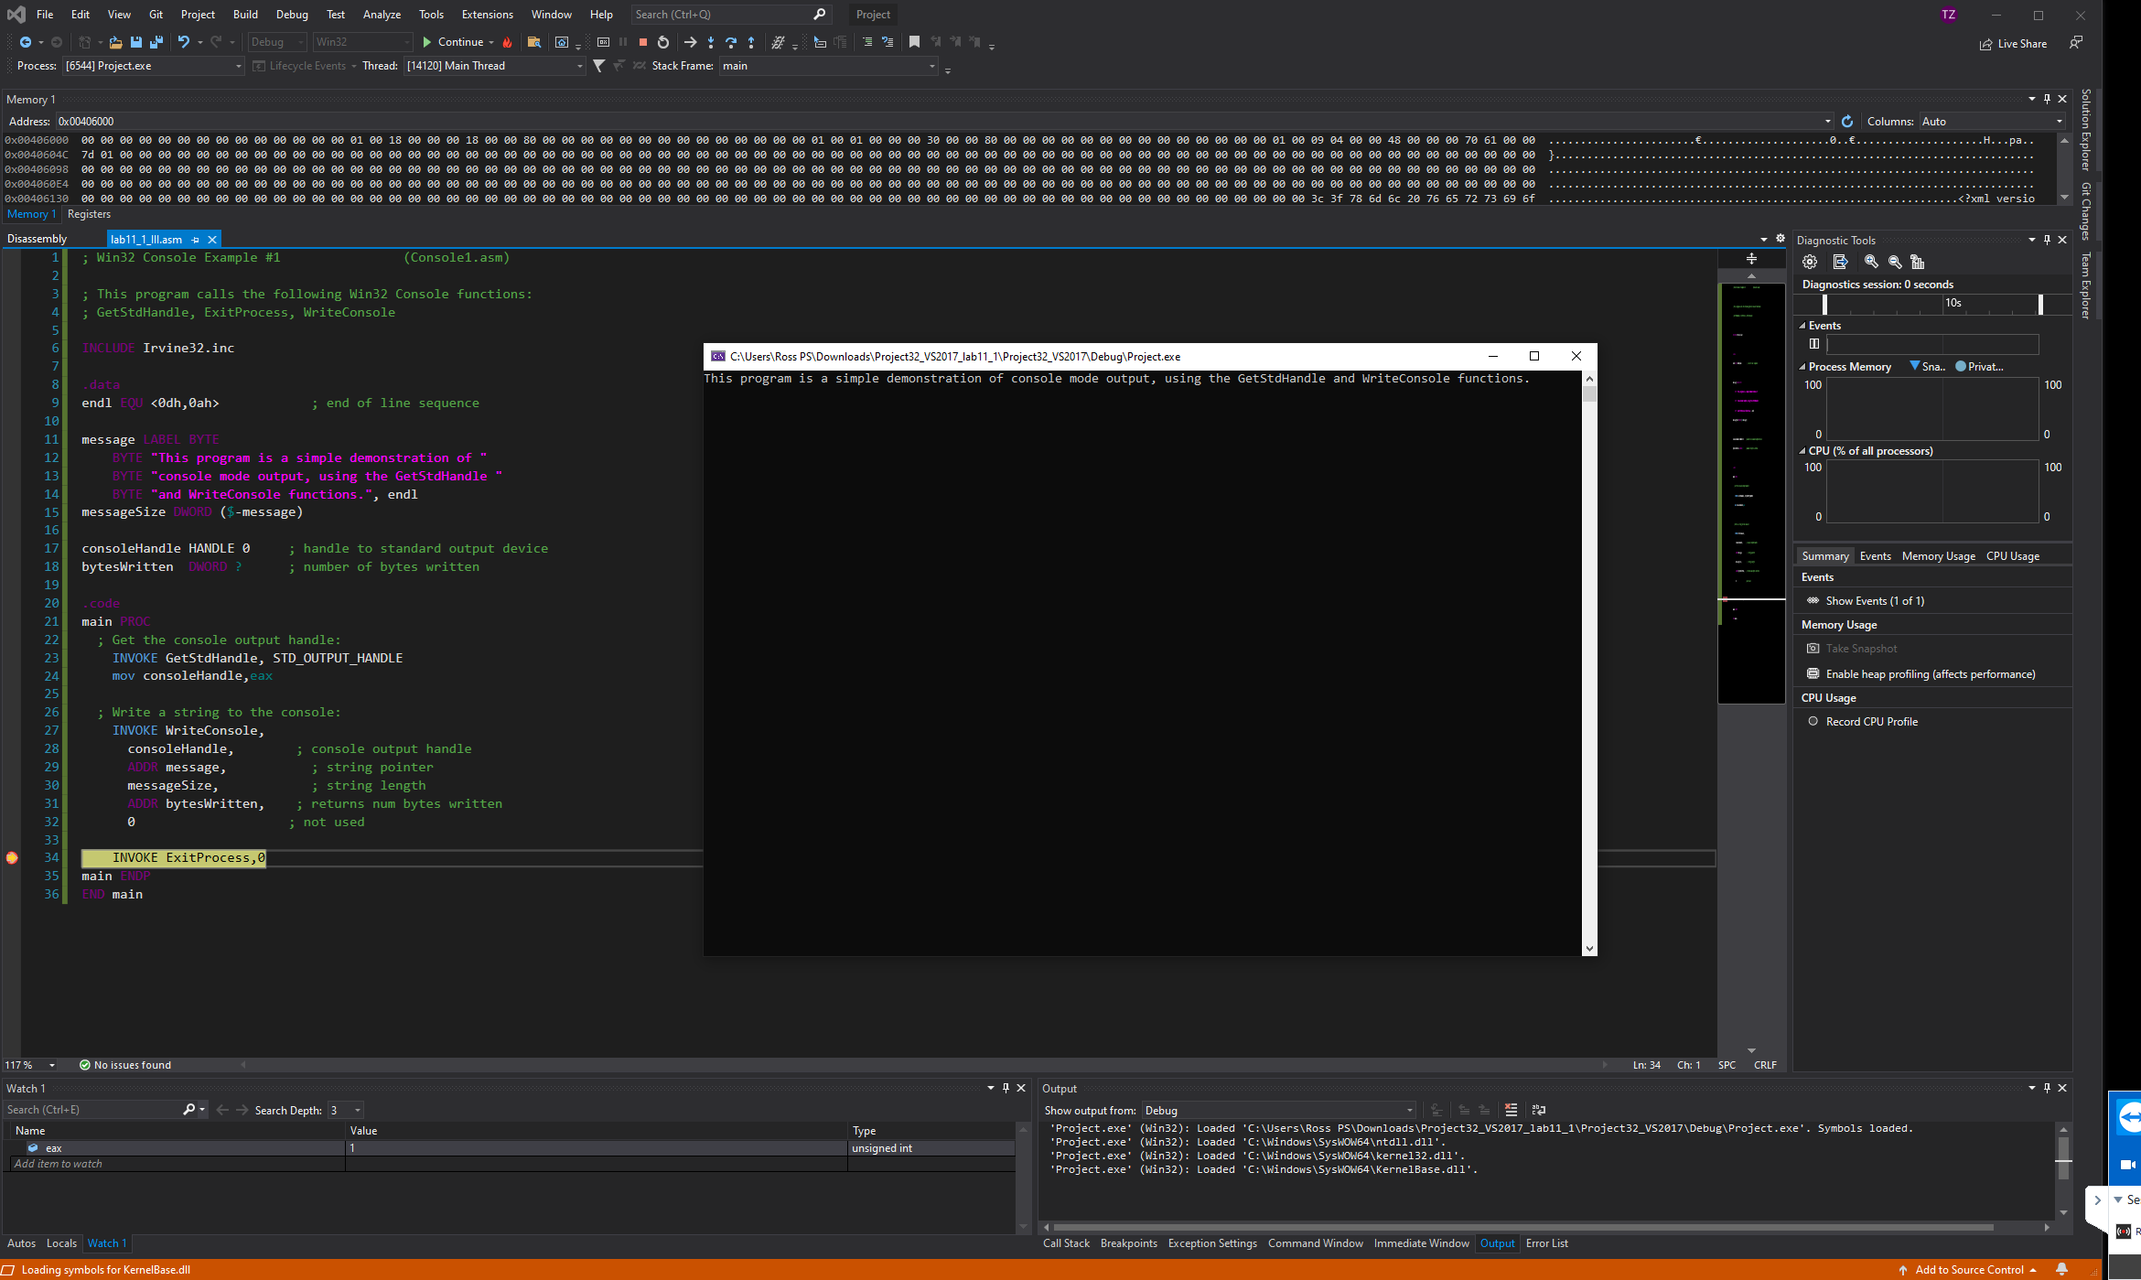

##### task 4:

INCLUDE Irvine32.inc  
  
writeAtXY MACRO position, buffer, lenbuffer  
 INVOKE SetConsoleCursorPosition, outputConsole, position  
 INVOKE WriteConsole, outputConsole, ADDR buffer, lenbuffer, ADDR writtenBytes, 0  
ENDM  
  
readAtXY MACRO position, buffer, lenbuffer, result  
 INVOKE SetConsoleCursorPosition, outputConsole, position  
 INVOKE ReadConsole, inputConsole, ADDR buffer, lenbuffer, ADDR result, 0  
ENDM  
  
LENLABEL = 20  
BUFSIZE = 30  
labelInfo MACRO position, X, Y, nfield, vfield, positionRead, buffer, lReadBytes, positionResult  
 position COORD<X, Y>  
 nfield BYTE vfield  
 positionRead COORD<X+LENLABEL, Y>  
 positionResult COORD<X, Y+10>  
 buffer BYTE BUFSIZE DUP(?)  
 lReadBytes DWORD ?  
ENDM  
  
.data  
inputConsole HANDLE 0  
outputConsole HANDLE 0  
  
writtenBytes DWORD ?  
  
labelInfo p1, 0, 0, n1, <"First Name:", 0>, pr1, b1, rb1, pre1  
labelInfo p2, 0, 1, n2, <"Last Name:", 0>, pr2, b2, rb2, pre2  
labelInfo p3, 0, 2, n3, <"Age:", 0>, pr3, b3, rb3, pre3  
labelInfo p4, 0, 3, n4, <"Phone:", 0>, pr4, b4, rb4, pre4  
  
.code  
main PROC  
 ; get console handles/ptrs  
 INVOKE GetStdHandle, STD_INPUT_HANDLE  
 mov inputConsole, eax  
  
 INVOKE GetStdHandle, STD_OUTPUT_HANDLE  
 mov outputConsole, eax  
  
 ; writing out the messages  
 writeAtXY p1, n1, <sizeof n1>  
 writeAtXY p2, n2, <sizeof n2>  
 writeAtXY p3, n3, <sizeof n3>  
 writeAtXY p4, n4, <sizeof n4>  
  
 ; read in data  
 readAtXY pr1, b1, <sizeof b1>, rb1  
 readAtXY pr2, b2, <sizeof b2>, rb2  
 readAtXY pr3, b3, <sizeof b3>, rb3  
 readAtXY pr4, b4, <sizeof b4>, rb4  
  
 ; write it out  
 writeAtXY pre1, b1, rb1  
 writeAtXY pre2, b2, rb2  
 writeAtXY pre3, b3, rb3  
 writeAtXY pre4, b4, rb4  
  
 exit  
main ENDP  
  
END main

