5.

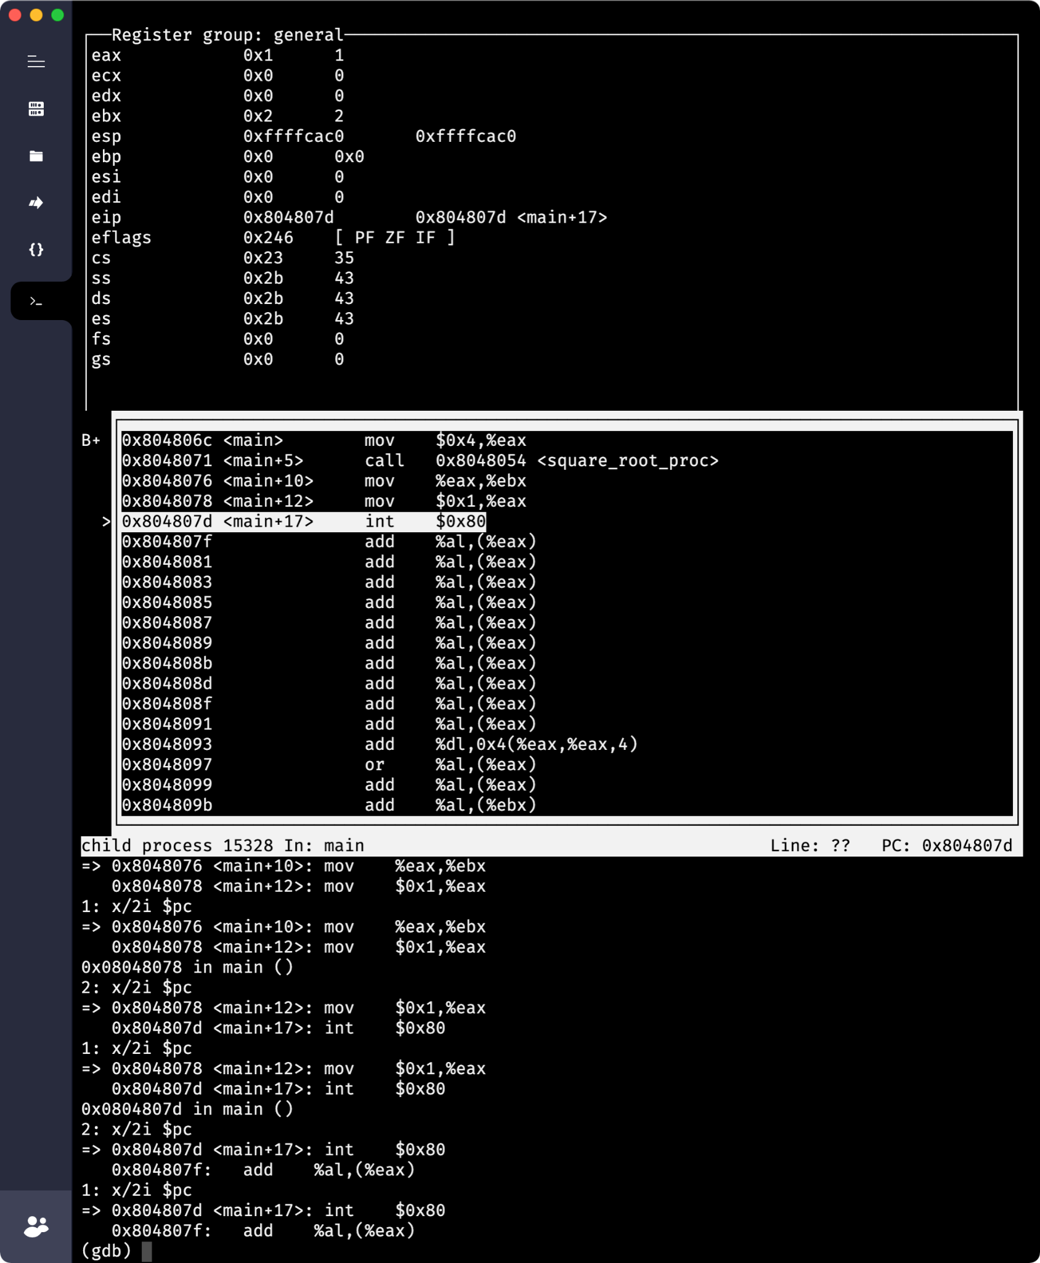

6.

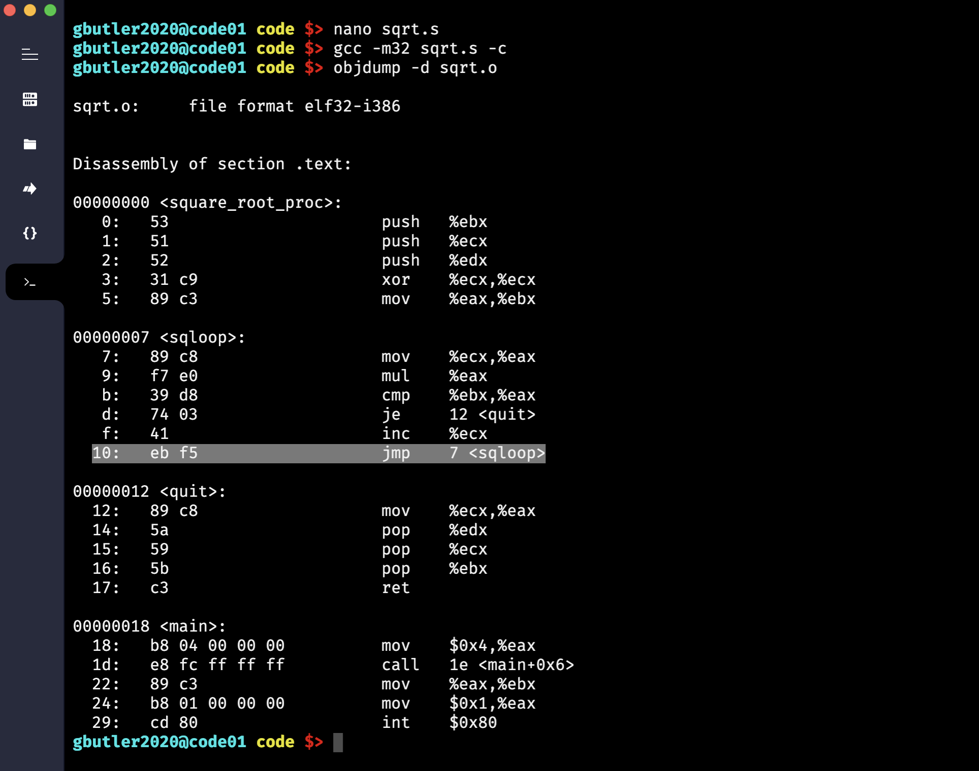

7.

sqrt.txt:

| 0000 53515231 c989c389 c8f7e039 d8740341  0010 ebf589c8 5a595bc3 b8040000 00e8fcff |
| --- |

8.

