7.1-I)

| # file hello_world.S .p2align 4, 0x90 # 16 byte alignment, filled nops  .globl _start _start:  subq $8, %rsp  leaq L_format(%rip), %rdi # rdi = L_format + rip  leaq L_HW(%rip), %rsi # rsi = L_HW + ripz  mov $0, %al  callq printf  add $8, %rsp  # The next three lines are the equivalent of the "exit" # in the 64 bit MASM  mov $60, %rax  xor %edi, %edi  syscall  L_format:  .asciz "%s" L_HW:  .asciz "Hello World!\n" |
| --- |

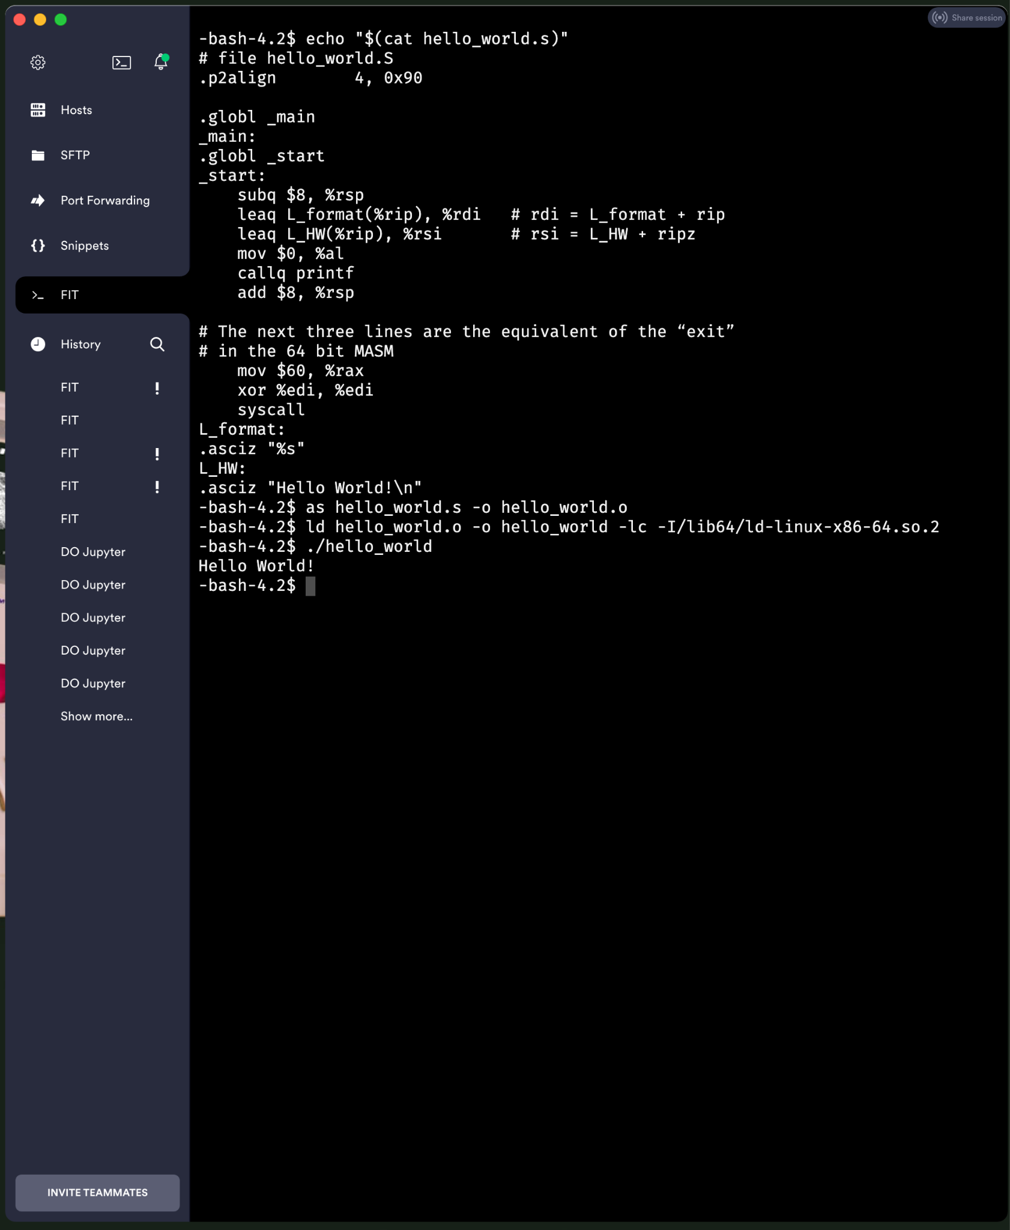

7.1-II)

| INCLUDE Irvine32.inc .code square_root_proc proc ; the value to square root is assumed received in EAX  ; init some register <reg_i> with 0 (xor with itself), to represent variable i  ; note that <reg_i> should not be EAX, or EDX as those are used in multiplication  ; move EAX into yet another register <reg_value>  push ebx  push ecx  push edx  xor ecx, ecx ; our i val for loop (set to 0)  mov ebx, eax   sqloop:  ; move the register <reg_i> into EAX  mov eax, ecx  ; multiply EAX with the register storing <reg_i>  mul eax  cmp eax, ebx  je quit  inc ecx  jmp sqloop  ; if the result is equal with <reg_value> jump out of the loop  ; increment <reg_i> and jump to the EAX preparation with <reg_i>  ; restore original values of registers <reg_i> <reg_value> EDX  ; but first store for return in EAX the result (the value of <reg_i>)  ; return  quit:  mov eax, ecx  pop edx  pop ecx  pop ebx  ret square_root_proc endp  main proc  mov eax, 4  call square_root_proc  exit main endp end main |
| --- |

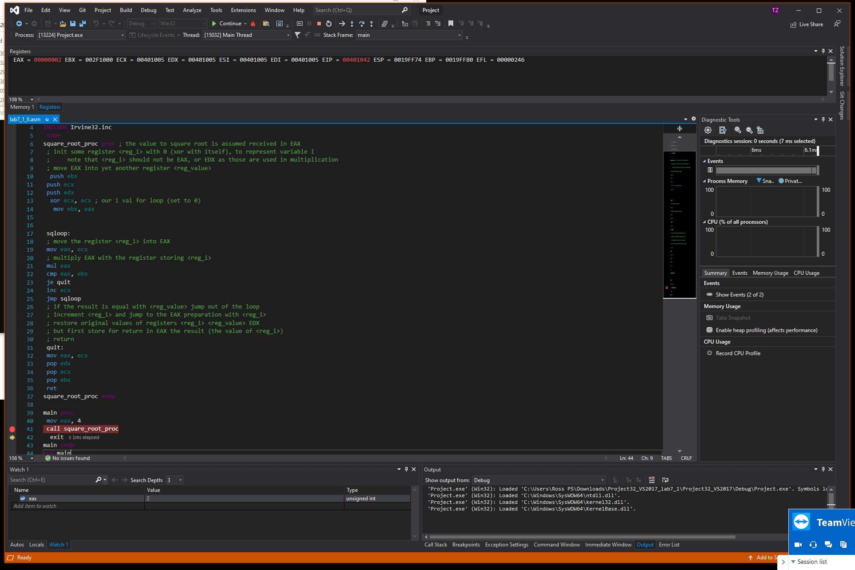

7.1-III)

| .code32 .text .globl main .type main, @function .globl square_root_proc .type square_root_proc, @function square_root_proc:  push %ebx  push %ecx  push %edx  xor %ecx, %ecx  mov %eax, %ebx   sqloop:  mov %ecx, %eax  mul %eax  cmp %ebx, %eax  je quit  inc %ecx  jmp sqloop  quit:  mov %ecx, %eax  pop %edx  pop %ecx  pop %ebx  ret   main:  mov $4, %eax  call square_root_proc  mov %eax, %ebx # exit code  mov $1, %eax # exit syscall  int $0x80 |
| --- |

