I.

| ; (MakeArray.asm)  ; This program creates an array on the local variables ; area of the stack.  INCLUDE Irvine32.inc  .data  count = 100  array WORD count DUP(?)  .code main PROC   call makeArray  mov eax,0   exit  main ENDP   makeArray PROC  push ebp  mov ebp,esp  sub esp,32 ; myString is at EBP-32  mov esi, ebp  add esi,-32  mov ecx,30 ; loop counter L1: mov BYTE PTR [esi],'*' ; fill one position  inc esi ; move to next  loop L1 ; continue until ECX = 0   add esp,32 ; remove the array (restore ESP)  pop ebp  ret makeArray ENDP  END main |
| --- |

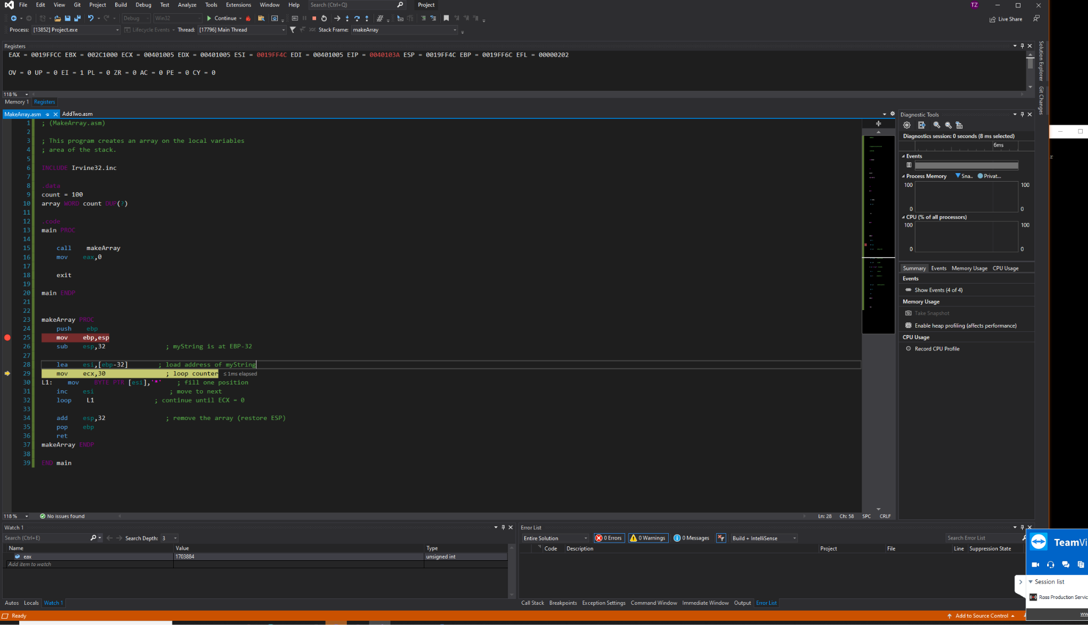

II.

| ; (MakeArray.asm)  ; This program creates an array on the local variables ; area of the stack.  INCLUDE Irvine32.inc  .data count = 100 array WORD count DUP(?)  .code main PROC   call makeArray  mov eax,0   exit  main ENDP   makeArray PROC  push ebp  mov ebp,esp  sub esp,32 ; myString is at EBP-32   mov esi, ebp; load address of myString  add esi,-32  mov ecx,30 ; loop counter L1: mov BYTE PTR [esi],'*' ; fill one position  inc esi ; move to next  loop L1 ; continue until ECX = 0   add esp,32 ; remove the array (restore ESP)  pop ebp  ret makeArray ENDP  END main |
| --- |

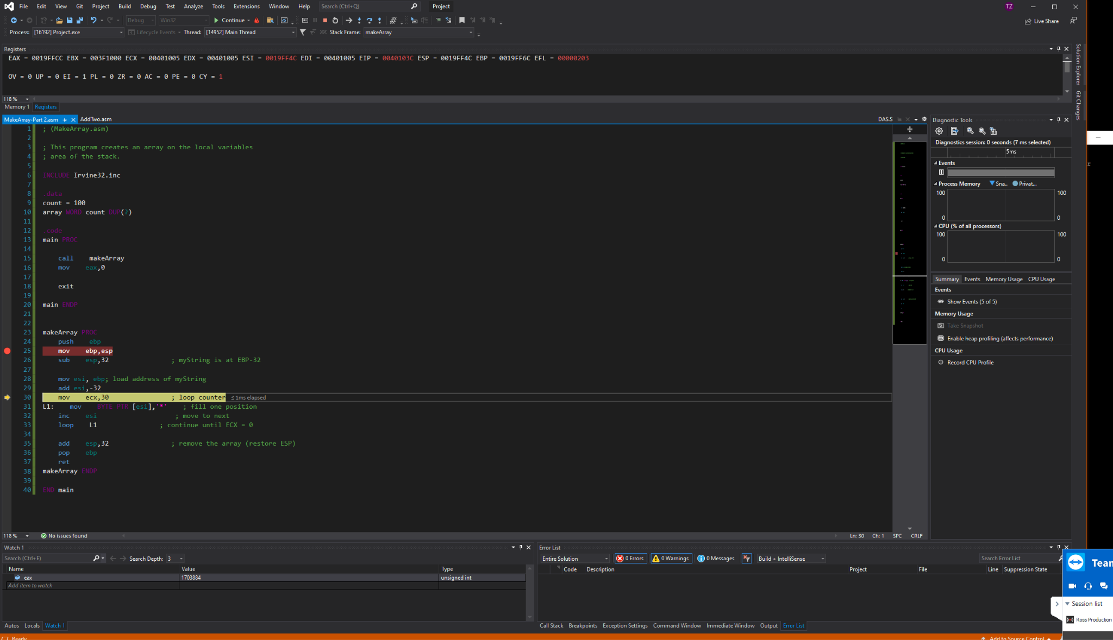

III.

| ; Demonstrate local variables (LocalVars.asm) ; This program demonstrates the use of local variables. INCLUDE Irvine32.inc .data .code main PROC  call MySub  exit main ENDP   ; X_local EQU DWORD PTR [ebp-4] ; Y_local EQU DWORD PTR [ebp-8]  MySub PROC  LOCAL X_local:DWORD, Y_local:DWORD  ; push ebp  ; mov ebp,esp  ; sub esp,8 ; create variables  mov X_local,20 ; X  mov Y_local,10 ; Y   ; replaced with `leave`  ; mov esp,ebp ; remove locals from stack  ; pop ebp  ret MySub ENDP   END main  ; ALTERNATE VERSION:  MySub PROC  push ebp  mov ebp,esp  sub esp,8 ; create variables  mov DWORD PTR [ebp-4],20 ; X  mov DWORD PTR [ebp-8],10 ; Y  mov esp,ebp ; remove locals from stack  pop ebp  ret MySub ENDP |
| --- |

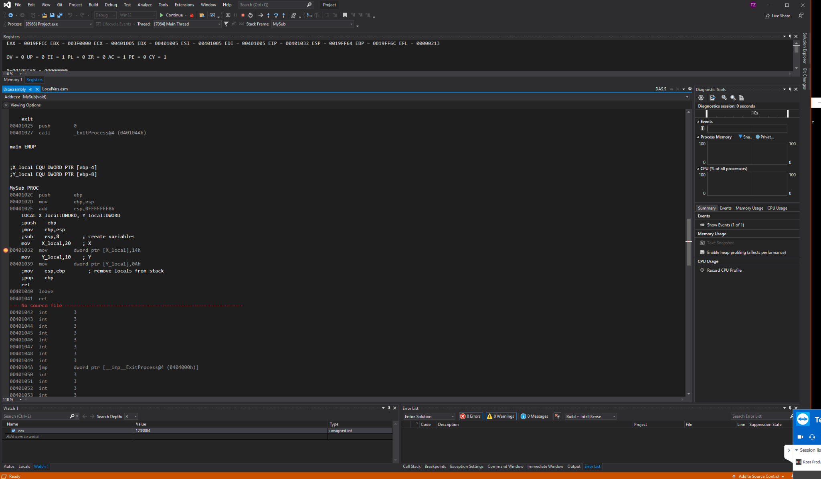

* The changes made replaces the lines:

| ; mov esp,ebp ; remove locals from stack  ; pop ebp |
| --- |

* With just: `leave`.

IV.

| ; Demonstrate local variables (LocalVars.asm) ; This program demonstrates the use of local variables. INCLUDE Irvine32.inc .data .code main PROC  call MySub  exit main ENDP  X_local EQU DWORD PTR [ebp-4] Y_local EQU DWORD PTR [ebp-8]  MySub PROC  ; push ebp  ; mov ebp,esp  ; sub esp,8 ; create variables  enter 8, 0 ; two double words instead of regular prefix  mov X_local,20 ; X  mov Y_local,10 ; Y  ; mov esp,ebp ; remove locals from stack  ; pop ebp  leave  ret MySub ENDP   END main  ; ALTERNATE VERSION:  MySub PROC  push ebp  mov ebp,esp  sub esp,8 ; create variables  mov DWORD PTR [ebp-4],20 ; X  mov DWORD PTR [ebp-8],10 ; Y  mov esp,ebp ; remove locals from stack  pop ebp  ret MySub ENDP |
| --- |

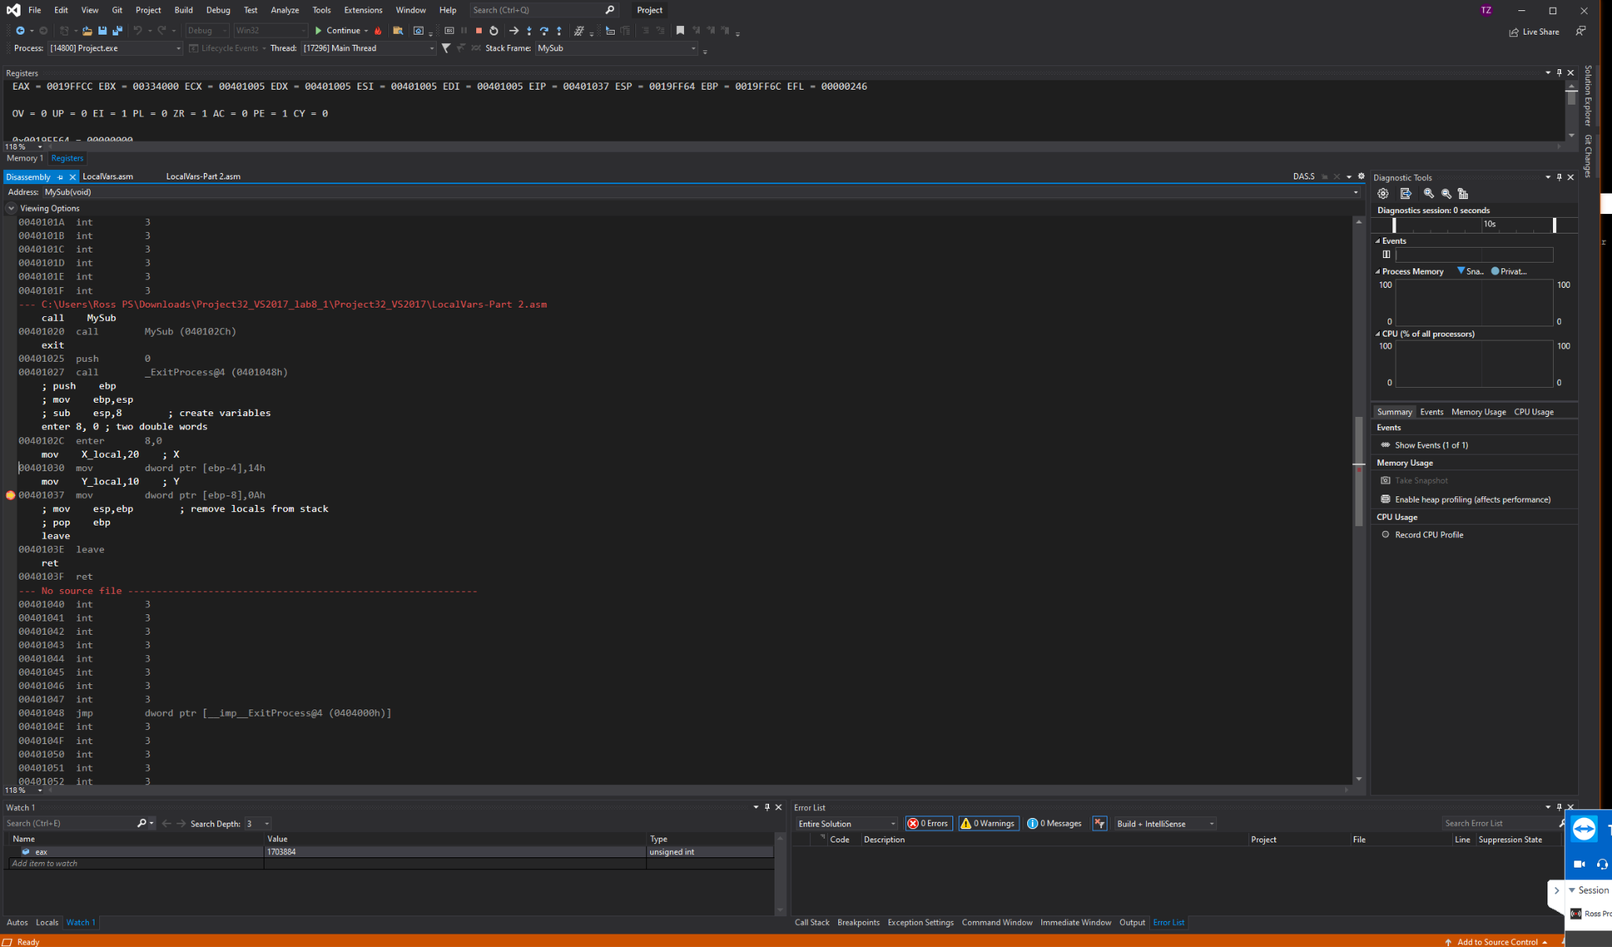

Changes are `leave` at the end and:

| enter 8, 0 ; two double words instead of regular prefix |
| --- |

Which moves the size of two DWORD’s.