I.

HelloWorld.j



| ; --- Copyright Jonathan Meyer 1996. All rights reserved. ----------------- ; File: jasmin/examples/HelloWorld.j ; Author: Jonathan Meyer, 10 July 1996 ; Purpose: Prints out "Hello World!" ; -------------------------------------------------------------------------   .class public NoJad.j .super java/lang/Object  ; ; standard initializer .method public <init>()V  aload_0    invokenonvirtual java/lang/Object/<init>()V  return .end method  .method public static main([Ljava/lang/String;)V  .limit stack 2  .limit locals 2    bipush 2  istore 0  bipush 3  istore 1   iload 0  iload 1  istore 0  istore 1   return .end method |
| --- |

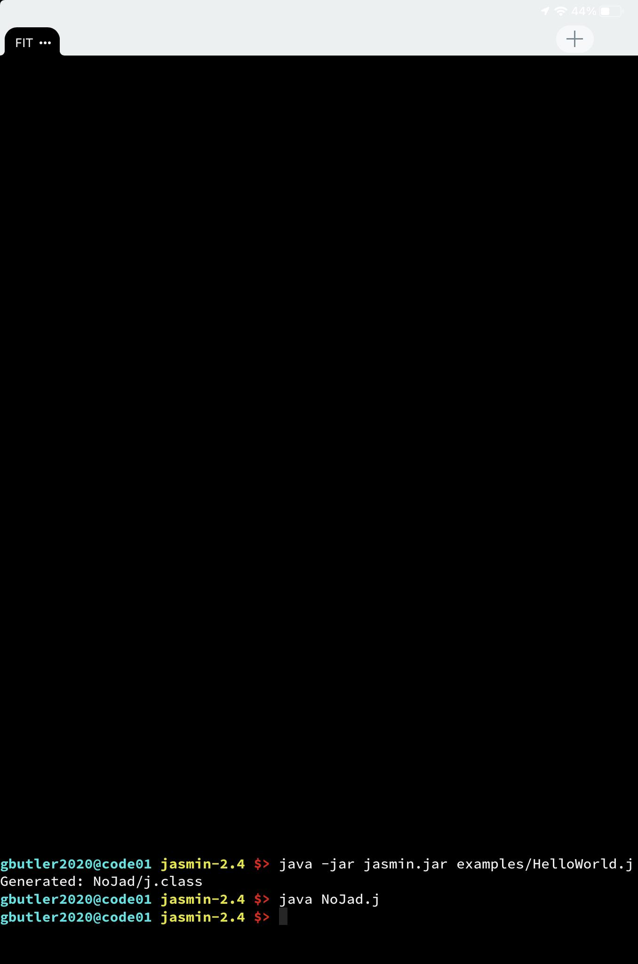

II.

hello.j

| .class public hello .super java/lang/Object  .method public static main([Ljava/lang/String;)V  .limit stack 10  .limit locals 10   getstatic java/lang/System/out Ljava/io/PrintStream;  ldc "Hello World!"  invokevirtual java/io/PrintStream/println(Ljava/lang/Object;)V  return .end method |
| --- |

