|  |  |  |  |
| --- | --- | --- | --- |
| Term | Project Name | Project Sponsor / Professor | Doc. Revision |
| 2021 | Localization of Autonomous Delivery Vehicle via WiFi | Self-Funded | 3 |

Project Description

## Project Background:

This past year there was a rise in interest in autonomous home delivery vehicles to alleviate the strain on human delivery drivers and prevent the spread of COVID-19. However, there are many challenges in the functionality of these vehicles, such as inaccurate location and loss of signal quality indoors. This prevents prompt and accurate delivery to the consumer wherever they are.

## Problem Statement:

To solve the issue of inaccurate location of the vehicle and to alleviate the signal quality issue, we will develop an indoor positioning system that will be able to accurately direct the autonomous vehicle to its intended target location.

## Objectives/Scope:

## Adapters can sample power usage over a period and over power thresh hold indication through signal light emitting diode (LED lights)

## Main controller can gather data about power usage

## Main controller allows for control inputs to outlet systems

## User interface allows for control settings and primarily displays data

## Deliverables:

* What you will deliver exactly (List the 3-5 biggest things)

## Expected Project Benefits:

## Will you be able to sell it? Does it fill a niche in the market that is not currently being filled?

## How much money will you make by designing and producing something like this?

## 

## Core Team Members:

* Erik Floden - Project Lead
* John Thomas - Treasurer

Strategy & Approach

## Assumptions & Constraints:

## What key assumptions are you making or constraints that will impact your project if the assumption fails or the constraint is not removed?

## 

## Issues & Risks:

## These are the biggest challenges the team will face in delivering the project

## List 3-6 of them

## 

## 

## 

## 

|  |  |
| --- | --- |
| Will Deliver | G |
| Will Not Deliver | R |
| At Risk | Y |

Customer Needs:

|  |  |  |
| --- | --- | --- |
| Objective | Description / Measure | Status |
| Positional Accuracy | Vehicle arrives within xx meters of target destination |  |
| Delivery Time | Vehicle arrives within xx minutes from deployment to arrival |  |
| Vehicle Size Limits | Vehicle must |  |
| Vehicle Speed Limits |  |  |
| Cost of Vehicle |  |  |
| Battery Usage |  |  |
| Base Station Cost |  |  |
| Base Station Charging |  |  |
| Obstacle Avoidance |  |  |
| WiFi FCC Spec |  |  |
|  |  |  |
|  |  |  |
| Obstacle Scaling (opportunistic) |  |  |
| Weatherproofing (opportunistic) |  |  |
| GPS Usage (opportunistic) |  |  |

Project Flexibility Matrix: (Remove this line, but note that only one check mark in each column is allowed)

|  |  |  |  |
| --- | --- | --- | --- |
|  | Flexibility | | |
|  | Least | Moderate | Most |
| Scope | 🗸 |  |  |
| Schedule | 🗸 |  |  |
| Resources ($ + People) | 🗸 |  |  |

System Level Design: (Use PowerPoint or similar tool to draw a picture of how your design will look)

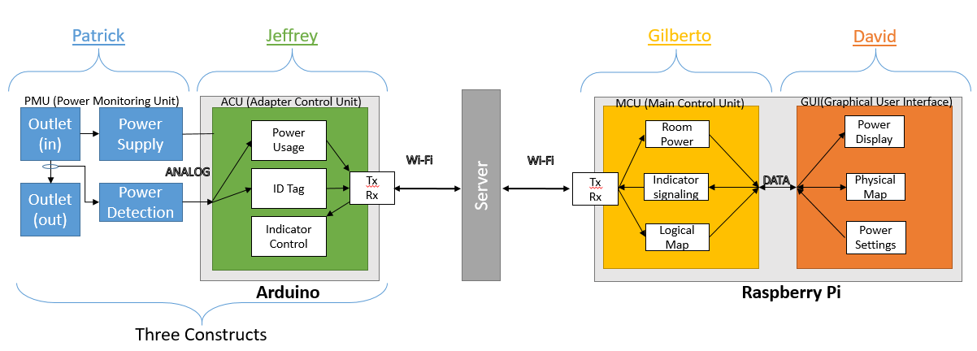

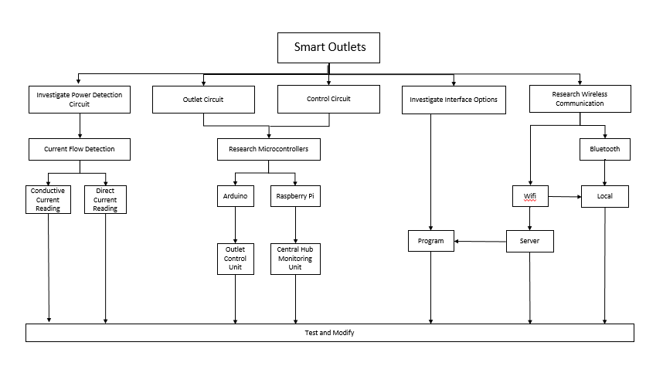Work Breakdown Structure: (Use Visio or similar tool to create a flow diagram that show the tasks that must be complete in your project and the order in which they will be completed)

|  |  |  |  |  |  |
| --- | --- | --- | --- | --- | --- |
| *System Implementation Review (Modify as Required)* | | | | | |
|  |  |  |  |  |  |
| **Subsystem** | **Name** | **Market Solutions** | **Advantages** | **Disadvantages** | **Adopted Solution** |
| **1** | UAV Mechanical | a. DJI Phantom | this quadcopter is capable of automatically takingoff and land.It has Inertial Measurement Unit (IMU) which uses a 6-axis gyroscope plus an accelerometer to keep track the slightest tilt or change in acceleration. Also the Computational fluid dynamics (CFD) have been applied to the prop design, which provids them with increased thrust and better efficiency. The self-tightening design helps ensure they do not loosen in flight and not require a separate prop nut.Intelligent Orientation Control (IOC) is used in this model when the yaw control allow the Quadcopter to rotate continuously which can easily confusing and the use of IOC will locate the front and back of quadcopter. | its expensive model to operate and maintain | the group decision is to build our own frame which we decided on H model the material will be used is Aluminum and wood which will help to eliminate heavy weight if we use other materials. |
| b. Parrot Ar | its great entry level quadcopter that can be operated easily not much information avialable about this model | Only works on IOS and Andriod oparator doesn't work with window oprater, easy to break the frame. doesn't have enough space to place more equpment. |
| c. Anteos L | its small size roter wings driven by 4 collective pitch low noise electric rotors, its about 8LBS with maxima takeoff 35LBS, easy to maneuver | its too small to work in be oprated in unstable weather |
|  |  |  |  |  |  |
| **2** | UAV Software | a. PIXHAWK | Open Source. Waypoint plotting software with good GUI. Whole sensor array/control software in one single integrated circuit. Supports autonomous flight. Easy to change code to fit needs. Will probably use this product if we fail to come up with a robust control scheme. | Expensive. More 'plug and play' than it should be for this project. | We decided to begin this project by building our own flight control software on an Intel Edison board, coupled with a 9 degree of freedom inertial measurement unit and a GPS receiver (hopefully) provided by Garmin. The advantage of the Edison Board is we can probably tunnel into the board over WIFI or Bluetooth to add code or command the drone. We will attempt to learn quadrotor flight dynamics and reverse engineer the open source C++ code provided by the PIXHAWK project to make our own from scratch. This will save us money and provide us with ample experience in digital control systems. |
| b. MULTIWII | Open Source. Not as well tested in autonomous flight and lacking crucial data. | Cheaper than either of the other options but is not as well regarded for autonomous flight. |
| c. ARDUCOPTER | A subset of the PIXHAWK open source controller. Has all of the PIXHAWK materials plus some peripherals. Good GUI interface and well tested autonomous flight capabilities. | Expensive. More 'plug and play' than it should be for this project. |
|  |  |  |  |  |  |

|  |  |  |  |  |  |
| --- | --- | --- | --- | --- | --- |
| **3** | UAV Electrical | a. "High Voltage" LiPo Battery System (22.5 V) | Coupled with a low RPM/Volt motor is capable is longer flight times despite heavier batteries due to substantially less current being drawn. Require less expensive Electronic Speed Controllers (ESCs) and all system wiring will be lighter and less expensive (10 Amp Required). Require lower RPM/Volt motors, which typically generate more torque capable of turning larger propellers, thus increasing efficiency. Calculated Flight Time @ 100% throttle: 20 minutes. | More Expensive batteries. Heavier. Capacity to Weight Ratio Smaller than medium and low voltage options. Require more expensive motors (lower RPM/Volt). | We will be using the "High Voltage" LiPo Battery. Using a motor selection calculation we developed it seems that despite the cost and weight, it will still get us longer flight times due to higher efficiency. High torque and low RPM/Volt motors that can be used at this voltage support larger props with lower pitches. The lower current will benefit our system despite the increase in weight. For our specific mechancal setup, our calculated flight time is 2x that of the 11.2 V system. |
| b. "Medium Voltage" LiPo (14.8 V) | Cheaper than "High Voltage" option. Batteries are typically lighter but have less capacity, 2 parallel batteries may be necessary for useful flight times for a quadrotor of this size. Requires less expensive motors (as RPM/Volt increases, cost typically decreases). Calculated Flight Time @ 100% throttle: 13.6 minutes. | Requires more expensive Electronic Speed Controllers (20 Amp required). Requires more expensive and heavy system wiring with higher current rating. Decreased efficiency due to reduced motor torque. |
| c. "Low Voltage" LiPo (11.2 V) | Cheapest option for just about everything except wiring and Electronic Speed Controllers. Overwhelmingly the most used option by amateur/hobbyist groups, thus most literature online pertains to this system voltage. More variety of available parts. Calculated Flight Time @ 100% throttle: 10 minutes. | In our mechanical setup, this system voltage gives us the least flight time because of the large amounts of current required to generate enough torque to turn the props. Multiple batteries would have to be used to get any decent flight time which will increase weight and physical space used on the copter. Higher amperage ratings will be required for the Electronic Speed Controllers (>20 Amp Required). |
|  |  |  |  |  |  |
| **4** | Charging Pad Mechanical | a. SkySense | Fully assembled charging solution | Very Expensive, contact based solution may be vunerable to electrical shorts. | We have decided to build the mechanical frame of the charging pad ourselves. We will purchase and use electrical components (ie, transformers, resistors, LEDs, etc.) to create the circuit and create the casing for the charging pad ourselves. |
| b. DroneChargingDock.com | Fully assembled charging solution, charges batteries at 5.4- 14.5 V, uses Qi charging technology, and visually appealing (LEDs to indicate charging and full charge) | Very Expensive, limited batteries it can charge, is not compatible with all devices. |
| c. Linear Technology | Fully assembled charging solution, wide input voltage range (12.5 V to 40 V), programmable 5% accurate charge current, and no microprocessor required. Offers a low current sleep mode and then recharges when the battery voltage drops by 2.2%. | Expensive product, only suitablefor Li-Ion/Polymer batteries, offers many features we would not be using (ie, charging in harsh environments such as moving or rotating equipment). |
|  |  |  |  |  |  |

|  |  |  |  |  |  |
| --- | --- | --- | --- | --- | --- |
| **5** | Charging Pad Software | a. Arduino | Basic low power microcontroller. Has a number of Input/Output headers for reading data from sensors and controlling hardware like relays and servos. Programming language is C-like and fairly easy to use. Ideal for solutions that don't require much processing power.  Very Inexpensive. | Doesn't have built in communications, so there is a little more work to expand it's fuctionality to include the wireless communications that we need. | We will be using an Arduino microcontroller for the charging station since it is inexpensive and well suited to the kinds of tasks the station controller will be performing. |
| b. Raspberry pi | Has lots of functionality for a low power micro computer. Supports almost all programming and scripting languages. Easy to use. Built in USB makes it easy to expand connected components. Very Inexpensive. | Does a lot more than we need it to for a reletively simple set of tasks. |
| c. Intel Edison | Small and very powerful linux based micro computer. Built in wireless communications over wi-fi and bluetooth. Easy to log into system through terminal programs like MobaXterm. System is easily expandible. | Overkill for the tasks it will be handling on the charging station. Much more expensive than the other options. |
|  |  |  |  |  |  |
| **6** | Charging Pad Electrical | a. Solar Panel | easy to install in any location, dosn't required wiring to be connected | expansive to maintain espasially in desret ares where the sand stroms are frequent. its effective more in area where the sun is always shinning | We currently already have a solar panel with a charge controller. We are still trying to decide if we are going to use it. |
| b. AC/DC convertor | the AC/DC converter can convert different voltage based on the rectifier, the rectifier can transfer AC to DC even if there is no electric current. | the main disadvantage is the AC/DC converter has limit in power since it uses the battery it can drian which it need to be rechage or replace the battery |
| c. Storage Battery | Inexpensive, prolongs flight time | If connected incorrectly (two batteries in series) it could just recharge each other and not work properly. Batteries have an associated weight to them that may just be more battery draining that what they would provide. |

Estimated Costs

Create a table of the major cost items for your project. Group all “low cost items” into a miscellaneous category (e.g., resistors, capacitors, …)

References: (If Required)

