KuStudio User Guide

Version 1.70 OSX/Windows

**Introduction**

KuStudio is an OSC editor, recorder and player, aimed to create timeline on an audiotrack.

It can be used as core timeline module in interactive audiovisual and dance/vocal performances.

KuStudio lets create, record and OSC tracks, synchronized with given audio track. Audiotrack can be WAV or AIFF file.

KuStudio is inspired by famous Duration OSC editor, but has different philosophy: KuStudio stores all OSC tracks as discrete arrays, not curves, that allows to record and edit them freely. Also, KuStudio performs very stable for 10 min and longer projects.

OSC tracks are float-valued. They can be drawn and edited by mouse, or recorded from external programs such as TouchOSC, Max/MSP.

OSC tracks values can be send up to 4 OSC receivers.

OSC receivers includes: Processing apps, openFrameworks apps, VDMX projects, Resolume projects, Max/MSP patches.

KuStudio is made with openFrameworks.

Binaries: <https://sourceforge.net/projects/kustudio/>

Source codes: <https://github.com/kuflex/KuStudio>

For any questions: write to <perevalovds@gmail.com>

**Installation and Running**

**OSX**

Unzip archive and run KuStudio.

At the first run you can get the security warning:

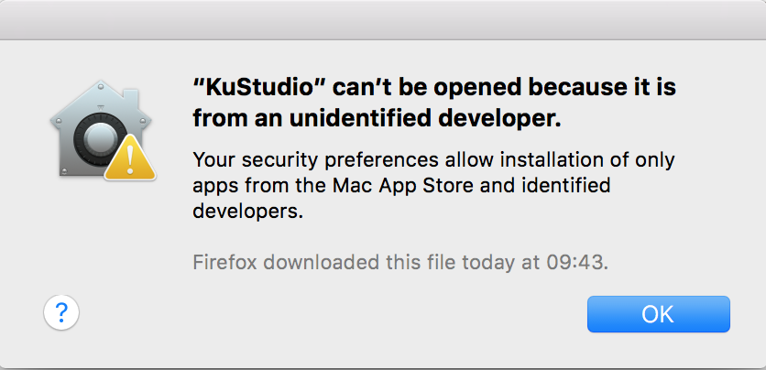

To resolve it, right-click KuStudio to show context menu and click there "Open". You will see security dialog with two buttons, "Open" and "Cancel". Choose "Open" to start KuStudio.

**Windows**

If KuStudio doesn't start, install Microsoft Visual C++ 2015 Redistributable (x86) by running **vc_redist.x86_vs2015.exe**.

Alternatively, you can download it from Microsoft website.

**Starting with demo project**

KuStudio is shipped with a demo project, which is a good starting point for learning KuStudio.

To start this project, do the following:

1. Run KuStudio.

2. Press Project - Open... and select file **DemoProject/DemoProject.kus**

3. The project will be loaded.

4. Press **Space** key to start playing fragment of audio track.

5. Press **Space** key again to stop playing.

Also, KuStudio is shipped with a demo visualizer for this demo project, written on openFrameworks. When playing audiotrack, KuStudio sends OSC data to this project to control its visualization.

To start demo visualizer, do the following (here we continue working with demo project in KuStudio):

6. Run **OSC-Demo-oF/OSC-Demo-oF**.

7. Switch to KuStudio and press **Space**.

8. The audio will play, and in visualizer you will see pulsating geometric figures, such as in the picture below:

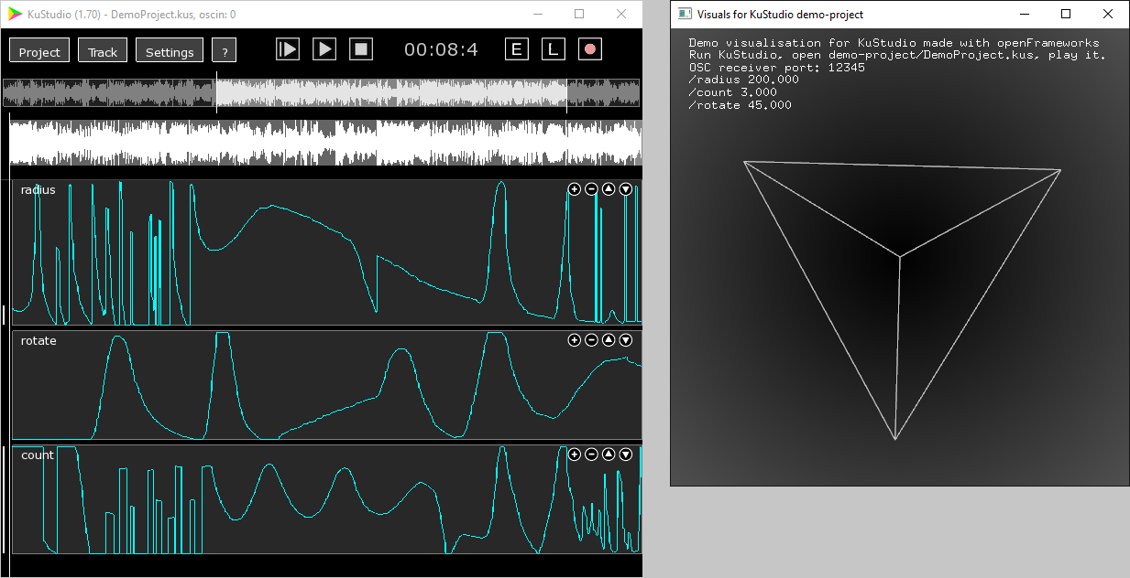

9. To play entire audio track, press **Enter**.

Now, we will learn more details about KuStudio.

**Using KuStudio for your own project**

1. Create a new project using **Project** - **New**.

2. Choose audio track - WAV or AIFF file.

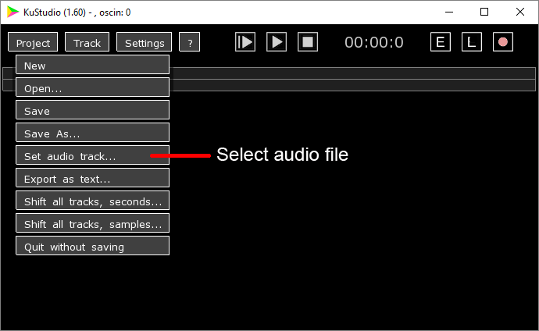

After setting audio track, you will see the track on the screen in two versions. Upper version shows the whole track, and lower version shows fragment of the track.

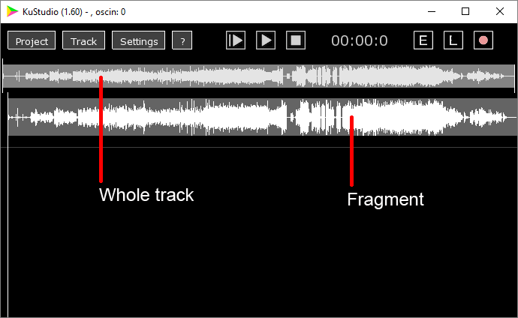

Using mouse, you can drag left and right segment boundaries on the whole track to select desired fragment.

3. Press **Enter** to play the whole track. To stop it, click **Stop** button. You can't stop whole track playing using keyboard to prevent accidental stopping during real performance.

4. Press **Space** to play and stop the fragment.

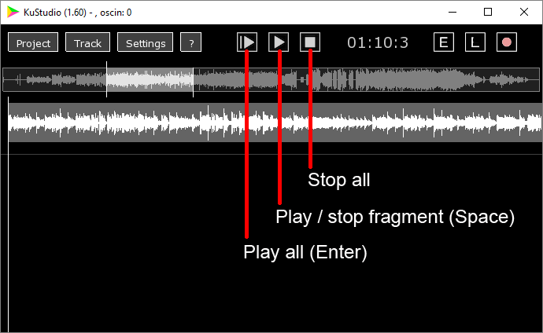

5. Add a new OSC track by clicking **Track** - **New track...**

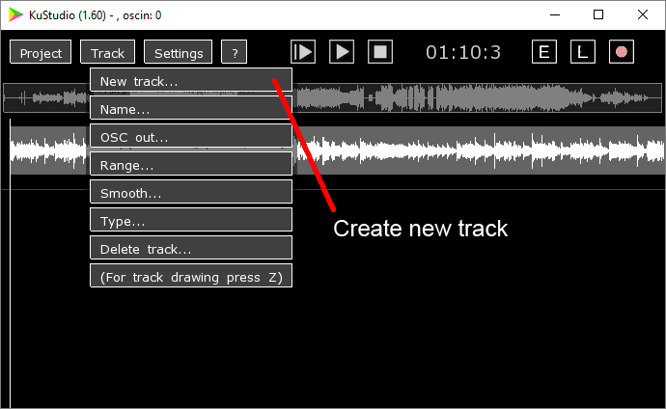

The track name corresponds the OSC address on which will be sent the tracks's values. For example, track named **valueX** will send data to **/valueX** address.

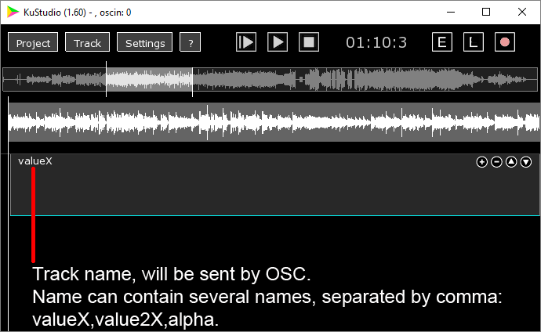

6. Let's edit track using mouse. At first, select track by clicking it.

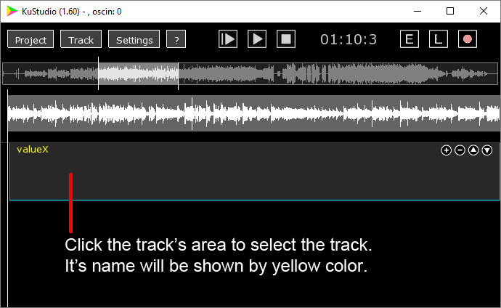

Then click **E** button to enable drawing mode. Or, equivalently, press and hold the key **z** in English keyboard layout (we propose to use this method to prevent accidental track's editing).

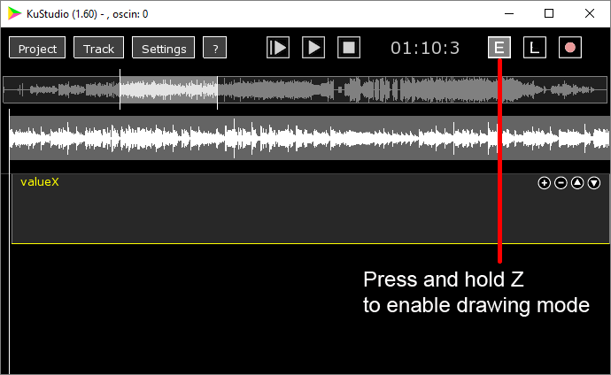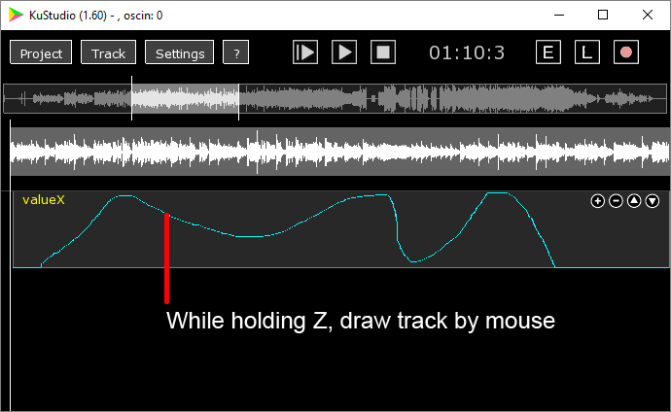

By default, track's range is from 0 to 1. To change it, use "Range" dialog.

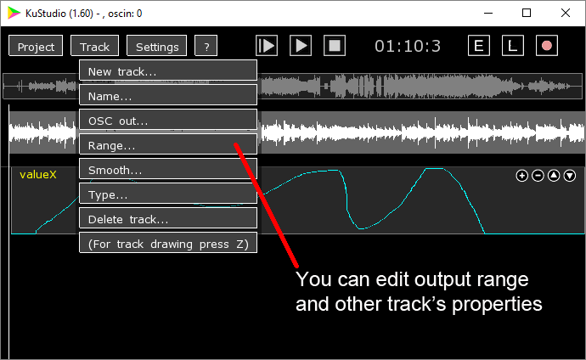

7. Click buttons in the top-right corner of a track to adjust vertical size and order of the tracks.

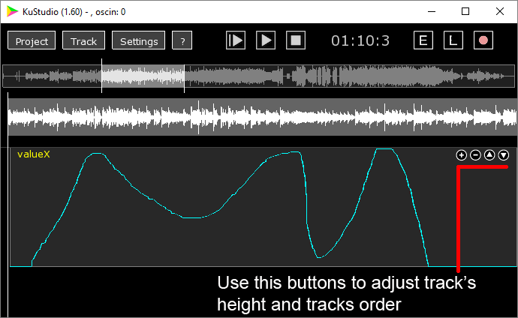

8. Setup OSC receivers by clicking **Settings** - **OSC out 1** (2,3,4) and specifying host address and port.

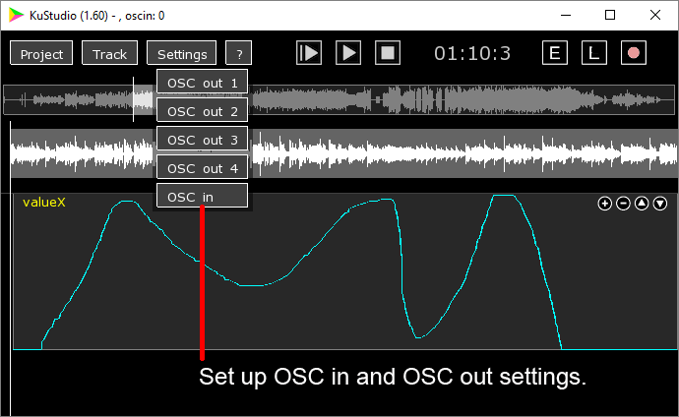

9. Click **Record** button (it's button with circle) to record values from external OSC senders (see *Recording OSC values from external programs* below) or by dragging track's value during playing.

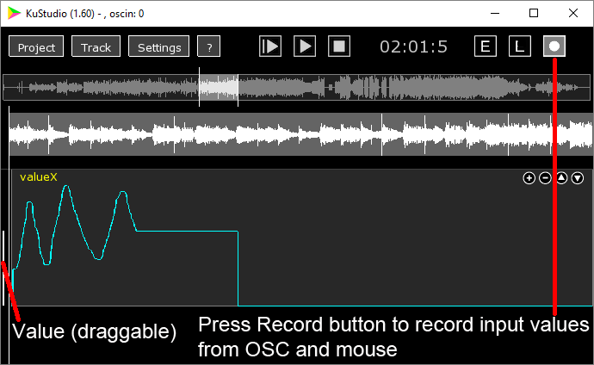

10. Click **Project** - **Save** or **Save as...** to save your KuStudio project.

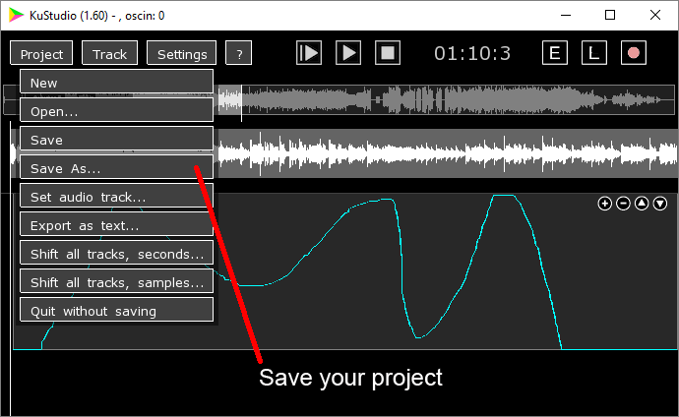

**Additional tricks**

**Drawing a line segment on a track**

Press and hold **x** key (you will see that "L" button will enable), then click mouse to the starting point of the desired line. Drag mouse to the end point of the desired line, and release mouse button. You will see an line drawn on the track.

**Sending track's values to several addresses**

You can include to the track's name several OSC addresses, using comma (without spaces), such as **param1,param2,param3**

Then the track will send it's values to addresses **/param1**, **/param2**, **/param3**.

**Recording OSC values from external programs**

You can record the tracks data from external sources such as Max/MSP, VDMX, TouchOSC. To enable this feature, you need to set its OSC input port to non-zero value using "**Settings - OSC in dialog**".

Also, you need to enable "Recording" button and start playing (by pressing **Space** or **Enter**).

To record data to track named, for example, **valueX**, you need to send to KuStudio OSC messages with address /**valueX** and one float argument.

Another way to write data to some track is to use address

/kusN, where N is track's number.

For example, for sending data to the first track, use address **/kus1**.

**Controlling KuStudio using OSC commands**

KuStudio can receive OSC commands to start playing, stop playing, and load another KuStudio project.

To enable this feature, you need to set its OSC input port to non-zero value using "**Settings - OSC in dialog**".

**List of commands**

(Command is a OSC message without arguments)

/playStopSegment - play/stop fragment

/stopSegment - stop playing fragment

/playAll - play whole track

/stopAll - stop playing whole track or fragment

/openProject FILE_NAME - open project. Here FILE_NAME should be a string argument in OSC message, which is an absolute path to KuStudio project file with **kus** extension.

During it's working, KuStudio sends each second to the first OSC receiver it's status, as an OSC message:

**kustudio:status PROJECT_NAME PLAY_TIME APP_TIME STATUS**

Here:

**PROJECT_NAME** - a name of current KuStudio project,

PLAY_TIME - current position of playing in seconds

**APP_TIME** - time in seconds from starting KuStudio (helpful to see KuStudio is ok)

**STATUS** - current playing status, can be **playAll**, **playSegm**, **stop**.