**Phase 4**

**Naan mudhalvan project submission**

**Air quality analysis in tamilnadu**

**TEAM MEMBERS:**

**MONISH.C 511921104039**

**POOVARSAN.D 511921104045**

**ARUN.D 511921104009**

**DHANDAPANI.S 511921104014**





**Ambient air quality criteria**

**Ambient air quality criteria**, or standards, are concentrations of pollutants in the air, and typically refer to outdoor air. The criteria are specified for a variety of reasons including for the protection of human health, buildings, crops, vegetation, ecosystems, as well as for planning and other purposes. There is no internationally accepted definition but usually "standards" have some legal or enforcement aspect, whereas "guidelines" may not be backed by laws. "Criteria/criterion" can be used as a generic term to cover standards and guidelines.

Various organisations have proposed criteria e.g. WHO, EU, US EPA. These criteria are often similar – but not always, even if they are proposed for the same purpose (e.g. the protection of human health).

The criteria

The [World Health Organization](https://en.wikipedia.org/wiki/World_Health_Organization) guidelines were most recently updated in 2021. The guidelines offer guidance about these air pollutants: particulate matter (PM), ozone (O3), nitrogen dioxide (NO2), sulfur dioxide (SO2) and carbon monoxide (CO) The WHO first released the air quality guidelines in 1987, then updated them in 1997. The reports provide guidelines intending to give guidelines to reduce the health effects of air pollution.

The guidelines stipulate that [PM2.5](https://en.wikipedia.org/wiki/PM2.5) should not exceed 5 μg/m3 annual mean, or 15 μg/m3 24-hour mean; and that [PM10](https://en.wikipedia.org/wiki/PM10) should not exceed 15 μg/m3 annual mean, or 45 μg/m3 24-hour mean. For ozone (O3), the guidelines suggest values no higher than 100 μg/m3 for an 8-hour mean and 60 μg/m3 peak season mean. For nitrogen dioxide (NO2), the guidelines set 10 μg/m3 for the annual mean or 25 μg/m3 for a 24-hours mean. For sulfur dioxide (SO2), the guidelines stipulate concentrations not exceeding 40 μg/m3 24-hour mean. For carbon monoxide concentrations not exceeding 4 mg/m3 24-hour mean.

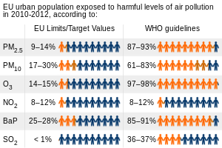

Along with cardiopulmonary and lung cancer deaths, the chances of which an individual increases their risk of being diagnosed with these is highly coordinated to fine particulate matter and sulfur dioxide-related pollution. A 2002 study found that "Each 10 μg/m3 elevation in fine particulate air pollution was associated with approximately a 4%, 6% and 8% increased risk of all-cause, cardiopulmonary, and lung cancer mortality, respectively."[[4]](https://en.wikipedia.org/wiki/Air_quality_guideline#cite_note-4) A 2021 study found that outdoor air pollution is associated with substantially increased mortality "even at low pollution levels below the current European and North American standards and WHO guideline values".[[5]](https://en.wikipedia.org/wiki/Air_quality_guideline#cite_note-5)[[6]](https://en.wikipedia.org/wiki/Air_quality_guideline#cite_note-6) Shortly afterwards, on 22 September 2021, for the first time since 2005,[[7]](https://en.wikipedia.org/wiki/Air_quality_guideline#cite_note-7) the WHO, after a systematic review of the accumulated evidence, adjusted their air quality guidelines whose adherence "could save millions of lives, protect against future diseases and help meet

# **Air quality law**

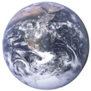**Air quality laws** govern the emission of [air pollutants](https://en.wikipedia.org/wiki/Air_pollution) into the [atmosphere](https://en.wikipedia.org/wiki/Atmosphere). A specialized subset of air quality laws regulate [the quality of air inside buildings](https://en.wikipedia.org/wiki/Indoor_air_quality). Air quality laws are often designed specifically to protect human health by limiting or eliminating airborne pollutant concentrations. Other initiatives are designed to address broader ecological problems, such as limitations on chemicals that affect the [ozone layer](https://en.wikipedia.org/wiki/Ozone_layer), and [emissions trading](https://en.wikipedia.org/wiki/Emissions_trading) programs to address [acid rain](https://en.wikipedia.org/wiki/Acid_rain) or [climate change](https://en.wikipedia.org/wiki/Global_warming). Regulatory efforts include identifying and categorising air pollutants, setting limits on acceptable emissions levels, and dictating necessary or appropriate mitigation technologies.

## Air pollutant classification

Air quality regulation must identify the substances and energies which qualify as "[pollution](https://en.wikipedia.org/wiki/Pollution)" for purposes of further control. While specific labels vary from jurisdiction to jurisdiction, there is broad consensus among many governments regarding what constitutes air pollution. For example, the United States Clean Air Act identifies [ozone](https://en.wikipedia.org/wiki/Ozone), [particulate matter](https://en.wikipedia.org/wiki/Particulate_matter), [carbon monoxide](https://en.wikipedia.org/wiki/Carbon_monoxide), [nitrogen oxides](https://en.wikipedia.org/wiki/Nitrogen_oxides) (NOx), [sulfur dioxide](https://en.wikipedia.org/wiki/Sulfur_dioxide" \o "Sulfur dioxide) (SO2), and [lead](https://en.wikipedia.org/wiki/Lead) (Pb) as "criteria" [pollutants](https://en.wikipedia.org/wiki/Pollutant) requiring nationwide regulation.[[1]](https://en.wikipedia.org/wiki/Air_quality_law#cite_note-1) EPA has also identified over 180 compounds it has classified as "hazardous" pollutants requiring strict control.[[2]](https://en.wikipedia.org/wiki/Air_quality_law#cite_note-2) Other compounds have been identified as air pollutants due to their adverse impact on the environment (e.g., [CFCs](https://en.wikipedia.org/wiki/CFCs) as agents of [ozone depletion](https://en.wikipedia.org/wiki/Ozone_depletion)), and on human health (e.g., [asbestos](https://en.wikipedia.org/wiki/Asbestos) in indoor air).[[3]](https://en.wikipedia.org/wiki/Air_quality_law#cite_note-3) A broader conception of air pollution may also incorporate [noise](https://en.wikipedia.org/wiki/Noise_pollution), [light](https://en.wikipedia.org/wiki/Light_pollution), and [radiation](https://en.wikipedia.org/wiki/Radon). The United States has recently seen controversy over whether [carbon dioxide](https://en.wikipedia.org/wiki/Carbon_dioxide) (CO2) and other [greenhouse gases](https://en.wikipedia.org/wiki/Greenhouse_gases) should be classified as air pollutants

## Air quality standards

Air quality standards are legal standards or requirements governing concentrations of [air pollutants](https://en.wikipedia.org/wiki/Air_pollution) in breathed air, both outdoors and indoors. Such standards generally are expressed as levels of specific air pollutants that are deemed acceptable in ambient air, and are most often designed to reduce or eliminate the human health effects of air pollution, although secondary effects such as crop and building damage may also be considered.[[5]](https://en.wikipedia.org/wiki/Air_quality_law#cite_note-5) Determining appropriate air quality standards generally requires up-to-date scientific data on the health effects of the pollutant under review, with specific information on exposure times and sensitive populations. It also generally requires periodic or continuous monitoring of air quality.

A distinction may be made between mandatory and aspirational air quality standards. For example, U.S. state governments must work toward achieving NAAQS, but are not forced to meet them. On the other hand, employers may be required immediately to rectify any violation of OSHA workplace air quality standards.

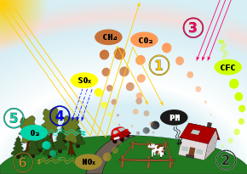

## Emission standards

Emission standards are the legal requirements governing [air pollutants](https://en.wikipedia.org/wiki/Air_pollution) released into the [atmosphere](https://en.wikipedia.org/wiki/Atmosphere). Emission standards set quantitative limits on the permissible amount of specific [air pollutants](https://en.wikipedia.org/wiki/Air_pollution) that may be released from specific sources over specific timeframes. They are generally designed to achieve air quality standards and to protect human life. Different regions and countries have different standards for vehicle emissions.

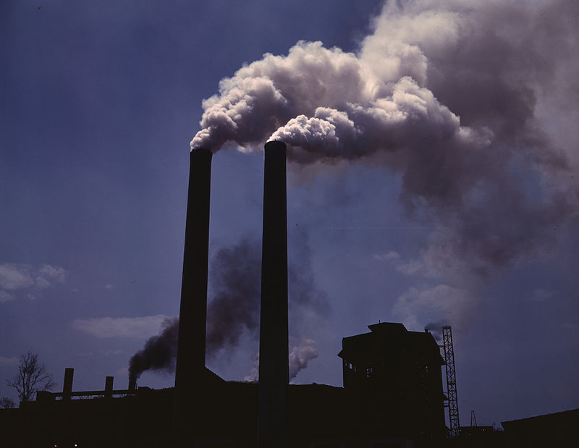

Numerous methods exist for determining appropriate emissions standards, and different regulatory approaches may be taken depending on the source, industry, and [air pollutant](https://en.wikipedia.org/wiki/Air_pollution) under review.[[8]](https://en.wikipedia.org/wiki/Air_quality_law#cite_note-8) Specific limits may be set by reference to and within the confines of more general air quality standards. Specific sources may be regulated by means of performance standards, meaning numerical limits on the emission of a specific pollutant from that source category. Regulators may also mandate the adoption and use of specific control technologies, often with reference to feasibility, availability, and cost. Still other standards may be set using performance as a benchmark – for example, requiring all of a specific type of facility to meet the emissions limits achieved by the best performing facility of the group. All of these methods may be modified by incorporating emissions averaging, market mechanisms such as emissions trading, and other alternatives

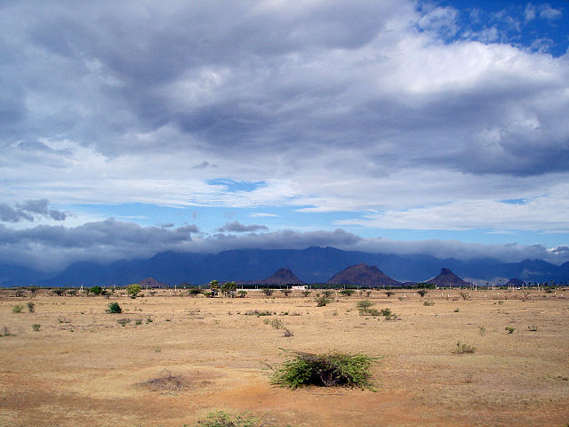

The **Climate of Tamil Nadu**, India is generally [tropical](https://en.wikipedia.org/wiki/Tropical_climate) and features fairly hot temperatures over the year except during the **monsoon** seasons. The city of [Chennai](https://en.wikipedia.org/wiki/Chennai) lies on the [thermal equator](https://en.wikipedia.org/wiki/Thermal_equator),[[1]](https://en.wikipedia.org/wiki/Climate_of_Tamil_Nadu#cite_note-ThermalE-1) which means Chennai and Tamil Nadu does not have that much temperature variation.

Under the [Köppen climate classification](https://en.wikipedia.org/wiki/K%C3%B6ppen_climate_classification" \o "Köppen climate classification) the greater part of Tamil Nadu fills under [Tropical savanna climate](https://en.wikipedia.org/wiki/Tropical_savanna_climate) and smaller portions of the state fall under Humid subtropical climate; the climate of the state ranges from dry sub-humid to semi-arid.

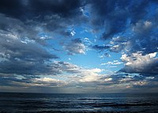

### Summer

The summer in Tamil Nadu runs throughout March, April and May and is characterized by intense heat and scant rainfall across the state.

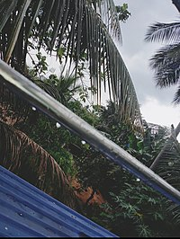The state has three distinct periods of rainfall: advanced rainfall; rainfall from the tropical cyclones emerging in the neighbourhood of the Andaman Islands during the Retreat of Monsoons(October–November): and the North-East monsoon during the months of October–December, with dominant northeast monsoon winds from the western disturbances emerging over the Bay of Bengal. The dry season is from February to early June. Mid-June to December is the monsoon months.

Since the state is entirely dependent on rains for recharging its water resources, monsoon failures lead to acute [water scarcity](https://en.wikipedia.org/wiki/Water_scarcity) and severe droughts.

Tamil Nadu is classified into seven agro-climatic zones: north-east, north-west, west, southern, high rainfall, high altitude hilly, and Cauvery Delta (the most fertile agricultural zone)

## Statistics

### Temperature

|  |  |  |  |  |  |  |  |  |  |  |  |  |  |
| --- | --- | --- | --- | --- | --- | --- | --- | --- | --- | --- | --- | --- | --- |
| **Average temperatures in various cities of Tamil Nadu (°C)**[[2]](https://en.wikipedia.org/wiki/Climate_of_Tamil_Nadu#cite_note-WB_normals-2)[[3]](https://en.wikipedia.org/wiki/Climate_of_Tamil_Nadu#cite_note-WU_normals-3)[[4]](https://en.wikipedia.org/wiki/Climate_of_Tamil_Nadu#cite_note-WC_normals-4) | | | | | | | | | | | | | |
| **—** | **Winter (Jan**  **– Feb)** | | **Summer (Mar – May)** | | | **Monsoon (Jun – Sep)** | | | | **Post-monsoon (Oct – Dec)** | | | **Year-round** |
| **City** | **Jan** | **Feb** | **Mar** | **Apr** | **May** | **Jun** | **Jul** | **Aug** | **Sep** | **Oct** | **Nov** | **Dec** | **Avg** |
| [**Chennai**](https://en.wikipedia.org/wiki/Chennai) | 24 | 25 | 27 | 29 | 31 | 30 | 30 | 28 | 27 | 26 | 25 | 24 | 31 |
| [**Coimbatore**](https://en.wikipedia.org/wiki/Coimbatore) | 25 | 26 | 28 | 29 | 29 | 27 | 25 | 26 | 25 | 24 | 23 | 24 | 29 |
| [**Madurai**](https://en.wikipedia.org/wiki/Madurai) | 25 | 27 | 29 | 31 | 32 | 30 | 29 | 28 | 27 | 25 | 24 | 25 | 32 |
| [**Tiruchirapalli**](https://en.wikipedia.org/wiki/Tiruchirapalli) | 25 | 26 | 28 | 29 | 31 | 32 | 30 | 29 | 29 | 27 | 25 | 24 | 32 |

### Precipitation

|  |
| --- |
| **Average precipitation in various cities of Tamil Nadu (mm)**[[2]](https://en.wikipedia.org/wiki/Climate_of_Tamil_Nadu#cite_note-WB_normals-2)[[3]](https://en.wikipedia.org/wiki/Climate_of_Tamil_Nadu#cite_note-WU_normals-3)[[4]](https://en.wikipedia.org/wiki/Climate_of_Tamil_Nadu#cite_note-WC_normals-4) |
| **—** | **Winter (Jan – Feb)** | | **Summer (Mar – May)** | | | **Monsoon 1 (Jun – Sep)** | | | | **Monsoon 2 (Oct – Dec)** | | | **Year-round** |
| **City** | **Jan** | **Feb** | **Mar** | **Apr** | **May** | **Jun** | **Jul** | **Aug** | **Sep** | **Oct** | **Nov** | **Dec** | **Total** |
| [**Chennai**](https://en.wikipedia.org/wiki/Chennai) |  |  |  |  |  |  |  |  |  |  |  |  |  |
| [**Coimbatore**](https://en.wikipedia.org/wiki/Coimbatore) |  |  |  |  |  |  |  |  |  |  |  |  |  |
| [**Madurai**](https://en.wikipedia.org/wiki/Madurai) |  |  |  |  |  |  |  |  |  |  |  |  |  |
| [**Tiruchirappalli**](https://en.wikipedia.org/wiki/Tiruchirappalli) |  |  |  |  |  |  |  |  |  |  |  |  |  |

## Control technology requirements

In place of or in combination with air quality standards and emission control standards, governments may choose to reduce air pollution by requiring regulated parties to adopt emissions control technologies (i.e., technology that reduces or eliminates emissions). Such devices include but are not limited to [flare stacks](https://en.wikipedia.org/wiki/Gas_flare), [incinerators](https://en.wikipedia.org/wiki/Incineration), [catalytic combustion](https://en.wikipedia.org/wiki/Catalytic_combustion) reactors, [selective catalytic reduction](https://en.wikipedia.org/wiki/Selective_catalytic_reduction) reactors, [electrostatic precipitators](https://en.wikipedia.org/wiki/Electrostatic_precipitator), [baghouses](https://en.wikipedia.org/wiki/Baghouse), [wet scrubbers](https://en.wikipedia.org/wiki/Wet_scrubber), [cyclones](https://en.wikipedia.org/wiki/Cyclonic_separation), [thermal oxidizers](https://en.wikipedia.org/wiki/Thermal_oxidizer), [Venturi scrubbers](https://en.wikipedia.org/wiki/Venturi_scrubber), [carbon adsorbers](https://en.wikipedia.org/wiki/Adsorption#Activated_carbon), and [biofilters](https://en.wikipedia.org/wiki/Biofilter).

The selection of emissions control technology may be the subject of complex regulation that may balance multiple conflicting considerations and interests, including economic cost, availability, feasibility, and effectiveness.[[12]](https://en.wikipedia.org/wiki/Air_quality_law#cite_note-12) The various weight given to each factor may ultimately determine the technology selected. The outcome of an analysis seeking a technology that all players in an industry can afford could be different from an analysis seeking to require all players to adopt the most effective technology yet developed, regardless of cost. For example, the [United States Clean Air Act](https://en.wikipedia.org/wiki/United_States_Clean_Air_Act) contains several control technology requirements, including Best Available Control Technology (BACT) (used in [New Source Review](https://en.wikipedia.org/wiki/New_Source_Review)), Reasonably Available Control Technology (RACT) (existing sources), Lowest Achievable Emissions Rate (LAER) (used for major new sources in non-attainment areas), and Maximum Achievable Control Technology (MACT) standards.

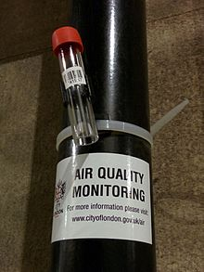

# **Air pollution measurement**

**Air pollution measurement** is the process of collecting and measuring the components of [air pollution](https://en.wikipedia.org/wiki/Air_pollution), notably [gases](https://en.wikipedia.org/wiki/Gases) and [particulates](https://en.wikipedia.org/wiki/Particulates). The earliest devices used to measure pollution include [rain gauges](https://en.wikipedia.org/wiki/Rain_gauge) (in

studies of [acid rain](https://en.wikipedia.org/wiki/Acid_rain)), [Ringelmann charts](https://en.wikipedia.org/wiki/Ringelmann_scale) for measuring [smoke](https://en.wikipedia.org/wiki/Smoke), and simple [soot](https://en.wikipedia.org/wiki/Soot) and dust collectors known as [deposit gauges](https://en.wikipedia.org/wiki/Deposit_gauge).[[1]](https://en.wikipedia.org/wiki/Air_pollution_measurement#cite_note-brimblecombe-1) Modern air pollution measurement is largely automated and carried out using many different devices and techniques. These range from simple absorbent test tubes known as [diffusion tubes](https://en.wikipedia.org/wiki/Diffusion_tube) through to highly sophisticated [chemical](https://en.wikipedia.org/wiki/Chemistry) and [physical](https://en.wikipedia.org/wiki/Physics) sensors that give almost real-time pollution measurements, which are used to generate [air quality indexes](https://en.wikipedia.org/wiki/Air_quality_index).

### Small-scale static pollution monitoring

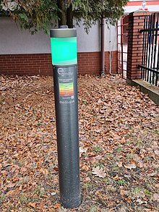

Unlike low-cost monitors, which are carried from place to place, static monitors continuously sample and measure the air quality in a particular, urban location. Public places such as busy railroad stations sometimes have active air quality monitors permanently fixed alongside platforms to measure levels of nitrogen dioxide and other pollutants.[[19]](https://en.wikipedia.org/wiki/Air_pollution_measurement#cite_note-19) Some static monitors are designed to give immediate feedback on local air quality. In Poland, EkoSłupek air monitors measure a range of pollutant gases and particulates and have small lamps on top that change colour from red to green to signal how healthy the air is nearby.

|  |  |  |  |  |  |  |  |  |  |  |  |  |  |  |  |  |  |
| --- | --- | --- | --- | --- | --- | --- | --- | --- | --- | --- | --- | --- | --- | --- | --- | --- | --- |
| Stn Code | Sampling Date | | State | | City/Town/Village/Area | | Location of Monitoring Station | | Agency | | Type of Location | | SO2 | NO2 | RSPM/PM10 | | PM 2.5 |
| 38 | ######## | | Tamil Nadu | | Chennai | | Kathivakkam, Municipal Kalyana Mandapam, Chennai | | Tamilnadu State Pollution Control Board | | Industrial Area | | 11 | 17 | 55 | | NA |
| ######## | | Tamil Nadu | | Chennai | | Kathivakkam, Municipal Kalyana Mandapam, Chennai | | Tamilnadu State Pollution Control Board | | Industrial Area | | 13 | 17 | 45 | | NA |
| ######## | | Tamil Nadu | | Chennai | | Kathivakkam, Municipal Kalyana Mandapam, Chennai | | Tamilnadu State Pollution Control Board | | Industrial Area | | 12 | 18 | 50 | | NA |
| ######## | | Tamil Nadu | | Chennai | | Kathivakkam, Municipal Kalyana Mandapam, Chennai | | Tamilnadu State Pollution Control Board | | Industrial Area | | 15 | 16 | 46 | | NA |
| ######## | | Tamil Nadu | | Chennai | | Kathivakkam, Municipal Kalyana Mandapam, Chennai | | Tamilnadu State Pollution Control Board | | Industrial Area | | 13 | 14 | 42 | | NA |
| ######## | | Tamil Nadu | | Chennai | | Kathivakkam, Municipal Kalyana Mandapam, Chennai | | Tamilnadu State Pollution Control Board | | Industrial Area | | 14 | 18 | 43 | | NA |
| ######## | | Tamil Nadu | | Chennai | | Kathivakkam, Municipal Kalyana Mandapam, Chennai | | Tamilnadu State Pollution Control Board | | Industrial Area | | 12 | 17 | 51 | | NA |
| ######## | | Tamil Nadu | | Chennai | | Kathivakkam, Municipal Kalyana Mandapam, Chennai | | Tamilnadu State Pollution Control Board | | Industrial Area | | 13 | 16 | 46 | | NA |
| ######## | | Tamil Nadu | | Chennai | | Kathivakkam, Municipal Kalyana Mandapam, Chennai | | Tamilnadu State Pollution Control Board | | Industrial Area | | 10 | 19 | 50 | | NA |
| ######## | | Tamil Nadu | | Chennai | | Kathivakkam, Municipal Kalyana Mandapam, Chennai | | Tamilnadu State Pollution Control Board | | Industrial Area | | 15 | 14 | 48 | | NA |
| ######## | | Tamil Nadu | | Chennai | | Kathivakkam, Municipal Kalyana Mandapam, Chennai | | Tamilnadu State Pollution Control Board | | Industrial Area | | 14 | 16 | 32 | | NA |
| ######## | | Tamil Nadu | | Chennai | | Kathivakkam, Municipal Kalyana Mandapam, Chennai | | Tamilnadu State Pollution Control Board | | Industrial Area | | 14 | 14 | 29 | | NA |
| ######## | | Tamil Nadu | | Chennai | | Kathivakkam, Municipal Kalyana Mandapam, Chennai | | Tamilnadu State Pollution Control Board | | Industrial Area | | 13 | 17 | 17 | | NA |
| ######## | | Tamil Nadu | | Chennai | | Kathivakkam, Municipal Kalyana Mandapam, Chennai | | Tamilnadu State Pollution Control Board | | Industrial Area | | 15 | 16 | 44 | | NA |
| ######## | | Tamil Nadu | | Chennai | | Kathivakkam, Municipal Kalyana Mandapam, Chennai | | Tamilnadu State Pollution Control Board | | Industrial Area | | 12 | 17 | 25 | | NA |
| ######## | | Tamil Nadu | | Chennai | | Kathivakkam, Municipal Kalyana Mandapam, Chennai | | Tamilnadu State Pollution Control Board | | Industrial Area | | 13 | 16 | 29 | | NA |
| ######## | | Tamil Nadu | | Chennai | | Kathivakkam, Municipal Kalyana Mandapam, Chennai | | Tamilnadu State Pollution Control Board | | Industrial Area | | 11 | 18 | 29 | | NA |
| ######## | | Tamil Nadu | | Chennai | | Kathivakkam, Municipal Kalyana Mandapam, Chennai | | Tamilnadu State Pollution Control Board | | Industrial Area | | 15 | 16 | 41 | | NA |
| ######## | | Tamil Nadu | | Chennai | | Kathivakkam, Municipal Kalyana Mandapam, Chennai | | Tamilnadu State Pollution Control Board | | Industrial Area | | 14 | 17 | 43 | | NA |
| ######## | | Tamil Nadu | | Chennai | | Kathivakkam, Municipal Kalyana Mandapam, Chennai | | Tamilnadu State Pollution Control Board | | Industrial Area | | 14 | 14 | 42 | | NA |
| ######## | | Tamil Nadu | | Chennai | | Kathivakkam, Municipal Kalyana Mandapam, Chennai | | Tamilnadu State Pollution Control Board | | Industrial Area | | 14 | 17 | 54 | | NA |
| ######## | | Tamil Nadu | | Chennai | | Kathivakkam, Municipal Kalyana Mandapam, Chennai | | Tamilnadu State Pollution Control Board | | Industrial Area | | 15 | 19 | 62 | | NA |
| ######## | | Tamil Nadu | | Chennai | | Kathivakkam, Municipal Kalyana Mandapam, Chennai | | Tamilnadu State Pollution Control Board | | Industrial Area | | 14 | 15 | 66 | | NA |
| ######## | | Tamil Nadu | | Chennai | | Kathivakkam, Municipal Kalyana Mandapam, Chennai | | Tamilnadu State Pollution Control Board | | Industrial Area | | 11 | 16 | 40 | | NA |
| ######## | | Tamil Nadu | | Chennai | | Kathivakkam, Municipal Kalyana Mandapam, Chennai | | Tamilnadu State Pollution Control Board | | Industrial Area | | 14 | 17 | 56 | | NA |
| ######## | | Tamil Nadu | | Chennai | | Kathivakkam, Municipal Kalyana Mandapam, Chennai | | Tamilnadu State Pollution Control Board | | Industrial Area | | 15 | 17 | 50 | | NA |
| 38 | ######## | | Tamil Nadu | | Chennai | | Kathivakkam, Municipal Kalyana Mandapam, Chennai | | Tamilnadu State Pollution Control Board | | Industrial Area | | 12 | 14 | 49 | | NA |