MINI PROJECT REPORT – 11
Submitted by
Girichandran Ar
[26120072]
Under the guidance of
Dr. S. Rajalakshmi
For the Subject
Full Stack Web Development
(26CS5801)

DEPARTMENT OF COMPUTER SCIENCE & ENGINEERING
SHIV NADAR UNIVERSITY CHENNAI
KALAVAKAM
OCTOBER 2026
UAR-Q OPD Live Queue
A PERT-Based, Uncertainty-Aware Framework for Real-Time Outpatient Waiting-Time Estimation and Queue Management

1. Problem Statement
Outpatient departments often have queues whose waiting times change when consultations take longer than expected, doctors are delayed, or emergency patients are prioritised. A token number alone does not tell a patient how long they may wait. UAR-Q OPD Live Queue provides a simple webpage to view queue status and an estimated waiting time, while staff and doctors update token progress.

2. Motivation
Uncertain waiting time can make patients leave the waiting area too early or repeatedly ask staff for updates. A shared live queue can reduce confusion by showing token status and a time estimate. The project also demonstrates how a baseline estimation method can later be compared with data-driven prediction models.

3. Users and Scope
- Patient: requests a token, then tracks the live queue position and PERT wait range for that token.
- Staff: calls a token or marks it delayed, waiting, or emergency.
- Doctor: marks a consultation as completed.
- Scope: one demonstration OPD queue, token creation, queue listing, a server-side PERT waiting-time engine with a best, expected, and worst-case range, staff status updates, doctor completion, and five-second refresh.
- Limitations: the current version uses illustrative consultation durations, does not calculate clinically validated predictions, does not subtract the time already spent in the current consultation, polls every five seconds instead of using WebSockets, and uses demo in-memory authentication instead of production-grade patient and staff accounts.

4. System Architecture
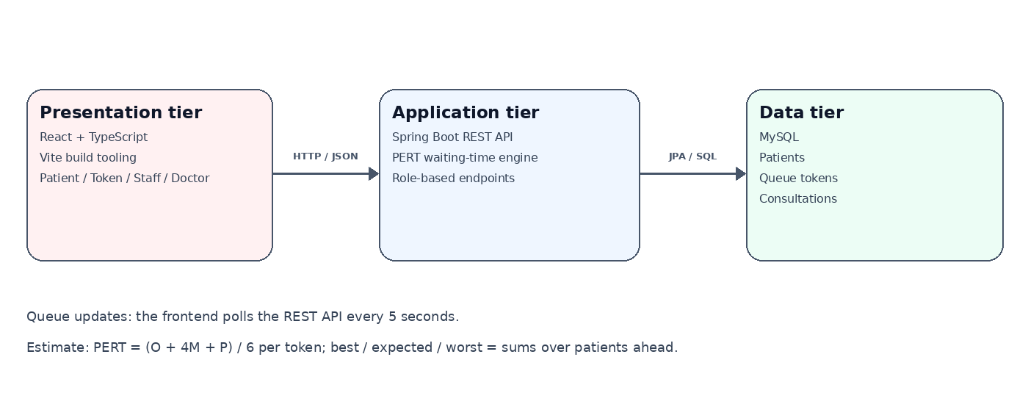
Figure 1: Three-tier system architecture
The application follows a three-tier structure. The React and TypeScript interface renders the patient, token, staff, and doctor views and polls the API every five seconds, Spring Boot validates requests and runs the PERT waiting-time engine and role checks, and MySQL stores patients, queue tokens, and consultation records.

5. Database Design
The database uses three related tables. A patient may have multiple queue tokens. A queue token may have zero or one consultation record. Primary keys identify rows and foreign keys maintain relationships.
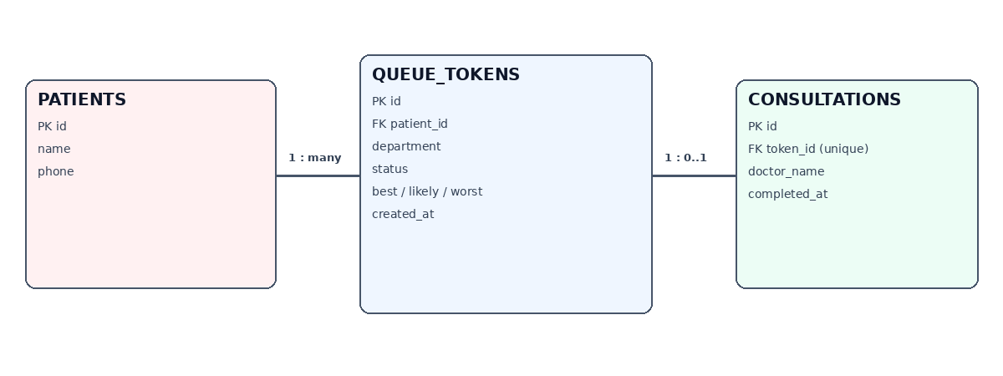
Figure 2: Entity-relationship diagram

Tables
- patients: id (primary key), name, phone.
- queue_tokens: id (primary key), patient_id (foreign key), department, status, best_minutes, likely_minutes, worst_minutes, created_at.
- consultations: id (primary key), token_id (unique foreign key), doctor_name, completed_at.

6. Waiting-Time Estimation
The system uses PERT, a simple estimate based on three durations. O is the optimistic or best-case time, M is the most likely time, and P is the pessimistic or worst-case time.
Expected consultation time = (O + 4M + P) / 6
For example, if O = 5 minutes, M = 10 minutes, and P = 20 minutes, the expected time is (5 + 4 × 10 + 20) / 6 = 10.8 minutes, rounded to 11 minutes in the interface. Queue estimates are illustrative and should not be treated as medical advice or validated hospital forecasts.
A patient's expected wait is the sum of the PERT times of the patients ahead, including the consultation in progress. The best and worst cases are the sums of the best and worst durations. When staff mark an emergency or a delay ahead of the patient, the expected and worst-case values are widened by fixed illustrative factors (1.6 and 1.9 for an emergency, 1.4 and 1.5 for a delay), and emergency tokens are served ahead of ordinary waiting tokens. Default durations depend on the department and are illustrative.

7. Technology Selection
- React and TypeScript: typed components for the patient view (token, department, queue position, PERT countdown, range bars, scenario banners, sound alert, and simulator), the token form, and the staff and doctor panels.
- qrcode-generator (npm): generates a QR code for the current simulator payload or for a live token link.
- Vite: development server and production build tooling for the React and TypeScript frontend.
- Spring Boot: expose REST endpoints and keep request handling separate from the UI.
- Spring Data JPA: map Java entities to MySQL tables and provide common database operations.
- MySQL: persist patient, token, and consultation data.
- Spring Security: protect staff and doctor endpoints with demo role-based access and BCrypt-hashed in-memory passwords.

8. Modules and REST APIs

Frontend modules
- Patient view: token, queue position, PERT countdown, range bars, QR code, and fallback banner.
- Live connection: tracks one token and refreshes every five seconds.
- Token form: creates a token with required-name and phone-format validation.
- Staff and doctor panels: sign in, update token status, and record completed consultations.
- Countdown logic: updates PERT time every second; polling does not reset it unless the estimate changes.

REST API list
- GET /api/queue — all tokens in creation order (public; masked name, no phone).
- GET /api/tokens/{id} — one token (public, same masked view).
- GET /api/tokens/{id}/wait — PERT estimate: people ahead, best, expected, worst (public).
- POST /api/tokens — creates a patient and queue token (public demo endpoint).
- GET /api/staff/queue — full queue with name and phone (STAFF role).
- PUT /api/staff/tokens/{id}/status — updates a token status (STAFF role).
- GET /api/doctor/queue — active tokens, name only (DOCTOR role).
- POST /api/doctor/tokens/{id}/complete — completes a consultation (DOCTOR role).

9. Security and Validation
- Token creation checks name and department (not blank, length limits) and an optional phone pattern.
- Token status accepts only WAITING, CALLED, IN_CONSULTATION, DELAYED, EMERGENCY, or COMPLETED.
- Staff and doctor APIs require different roles using HTTP Basic authentication.
- Demo passwords are stored as BCrypt hashes in memory, but HTTP Basic over plain HTTP is not secure. Do not deploy this configuration publicly.
- Public endpoints show only a masked name initial and no phone; a real deployment still needs unguessable token links.

10. Project Folder Structure
uarq_opd_project/
backend/
database.sql
pom.xml
src/main/java/com/uarq/opd/
UarqOpdApplication.java
config/
controller/
model/
repository/
service/
src/main/resources/application.properties
src/test/java/com/uarq/opd/
frontend/
index.html
package.json
tsconfig.json
vite.config.ts
src/App.tsx
src/main.tsx
src/components/
README.md

11. Implementation Summary
The React and TypeScript frontend keeps the simulator, PERT countdown, range display, QR generation, sound alert, and manual fallback, and adds a token form and staff and doctor panels. In live mode it polls the Spring Boot API every five seconds. The backend validates token requests, saves patients and tokens in MySQL, calculates the PERT estimate in a service class, supports staff status updates and doctor completion, and returns a privacy-reduced public view.

Key backend logic
@PostMapping("/tokens")
@ResponseStatus(HttpStatus.CREATED)
public TokenView create(@RequestBody NewTokenRequest request) {
String name = request.name() == null ? "" : request.name().trim();
String department = request.department() == null ? "" : request.department().trim();
String phone = request.phone() == null ? "" : request.phone().trim();
if (name.isEmpty() || department.isEmpty()) {
throw new ResponseStatusException(
HttpStatus.BAD_REQUEST, "Name and department are required");
}
// length and phone-format checks omitted here for brevity
Patient patient = patients.save(
new Patient(name, phone.isEmpty() ? null : phone));
QueueToken token = new QueueToken();
token.setPatient(patient);
token.setDepartment(department);
int[] d = WaitTimeService.defaultDurations(department);
token.setBestMinutes(d[0]);
token.setLikelyMinutes(d[1]);
token.setWorstMinutes(d[2]);
return TokenView.of(tokens.save(token));
}
The complete source code is provided separately in the project ZIP file.

12. Setup and Execution
- Install Java 17 or later, Maven, Node.js 18 or later, and MySQL.
- Run backend/database.sql in MySQL to create the database and related tables.
- Set the MySQL username and password in backend/src/main/resources/application.properties, or in the DB_USERNAME and DB_PASSWORD environment variables.
- From the backend folder, run: mvn spring-boot:run
- From the frontend folder, run: npm install
- Then run: npm run dev and open the local URL printed by Vite.
- Create a token from the Get token tab, then sign in as staff (staff / staff123) and doctor (doctor / doctor123) to test status updates and completion. On the Patient tab, choose Connect to MySQL queue to see the live wait.
- Optionally run mvn test in the backend folder to run the automated unit and API tests.

13. Output Screenshot
The figure below shows the React and TypeScript interface. The patient view (left) is in simulator mode, so its values are illustrative; the token form and staff sign-in are on the right. Choosing Connect to MySQL queue switches the patient view to live values from the Spring Boot API.
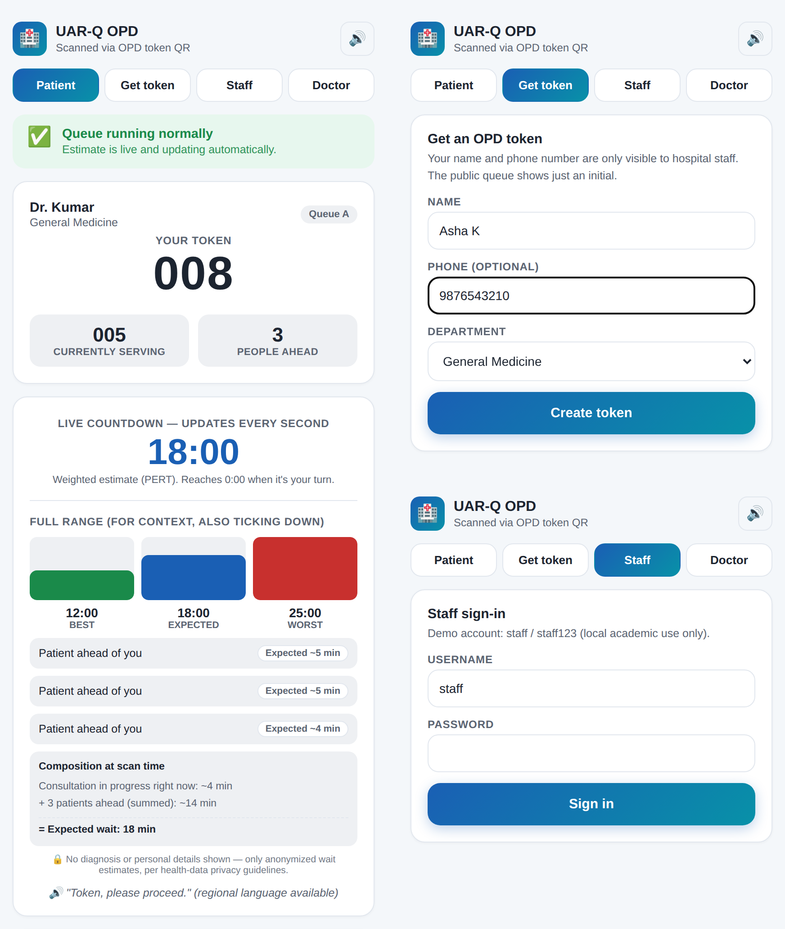
Figure 3: UAR-Q OPD Live Queue interface (patient view, token form, and staff sign-in)

14. Validation Test Cases
Test | Input | Expected result
Valid token | Name and department supplied | Token is created and appears in queue.
Missing name | Name left empty | Frontend required validation or backend 400 response.
Missing department | Department omitted from API request | Backend returns 400 Bad Request.
Invalid status | Status set to UNKNOWN | Backend rejects the status with 400 Bad Request.
Staff update | Valid staff credentials and status | Token status is updated.
Wrong role | Doctor credentials used on staff endpoint | Request is denied.
Unknown token | Request a token ID that does not exist | API returns 404 Not Found.
Doctor completion | Valid doctor credentials and token ID | Token becomes COMPLETED and consultation is recorded.
Invalid phone | Phone entered as "abc" | Form pattern check or backend 400 response.
Completed token locked | Staff changes the status of a COMPLETED token | Backend returns 409 Conflict.
Public privacy | Request GET /api/queue without credentials | Only a masked name initial is returned; no phone number.
Wait estimate | One consultation in progress and one patient waiting ahead | Expected wait is the sum of their PERT times; people ahead = 1.

15. Inference
The project demonstrates the main flow of a three-tier web application: a React interface sends requests to Spring Boot, the backend applies validation, role checks, and a PERT waiting-time engine, and MySQL stores queue records. PERT provides an understandable baseline estimate when only three duration estimates are available, and the best, expected, and worst-case range shows the patient the uncertainty.

16. Future Extensions
- Replace sequential token numbers in the tracking link with unguessable identifiers and print the QR code on each token card.
- Subtract the time already spent in the current consultation instead of using its full expected duration.
- Replace example consultation durations with anonymised historical data.
- Compare PERT with mean, exponential smoothing, regression, and tree-based models using chronological validation and MAE/RMSE.
- Replace the summed PERT best and worst cases with calibrated prediction intervals validated on historical data.
- Use WebSockets for push updates instead of five-second polling.
- Add secure database-backed authentication (the demo accounts are only hashed in memory), audit logs, role-based data filtering, HTTPS, and deployment secrets.
- Add waiting-room display and accessible notifications for called tokens.

17. Conclusion
UAR-Q OPD Live Queue is a practical academic prototype for token management and waiting-time communication in an outpatient department. It combines a React and TypeScript frontend, Spring Boot REST backend, role-protected staff and doctor actions, and a MySQL relational database. Its PERT estimate, shown as a best, expected, and worst-case range, establishes a baseline for later data-driven prediction work.

References
- Course assignment brief: 26CS5801 – Full Stack Web Development, Mini Project.
- Spring Boot documentation: https://spring.io/projects/spring-boot
- React documentation: https://react.dev/
- MySQL documentation: https://dev.mysql.com/doc/
- Spring Security documentation: https://docs.spring.io/spring-security/reference/
- Vite documentation: https://vite.dev/
- TypeScript documentation: https://www.typescriptlang.org/docs/
- Malcolm, D. G., Roseboom, J. H., Clark, C. E., and Fazar, W. (1959). Application of a technique for research and development program evaluation. Operations Research, 7(5), 646–669.

