**Lab 4**

Before you start this lab, please make sure you have read this week’s material. Complete the following:

**Lab A:**

1. Create an HTML file named ***Lab4a.html****.*
2. The page will display a countdown to a rocket blasting off. Use a button to start the countdown. The countdown sequence (10 -1) should display on the web page and should display BLASTOFF! At the end. You may, if you wish, add a rocket image. Use while, do while and for loops to implement the same functionality.
3. Save your work.

**Lab B:**

1. Create an HTML file named ***Lab4b.html***.
2. Using a loop of your choice, display the following:

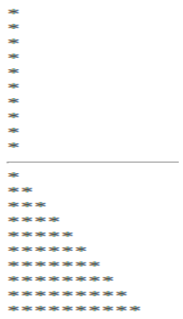

1. Save your work.

**Lab C:**

1. Create an HTML file named ***Lab4c.html****.*
2. Ask the user to enter a word. If the word is not “quit”, keep asking the user to input a word. If the word is “quit” stop harassing the user and display all previous words.
3. Save your work.

**Programming Challenge:**

Create an HTML file named Lab4_Challenge.html. Your code should allow users to customize the web page by selecting a background color for the page, color and font for the text, and changing the text. The following function shows you how to change the background color, font color and font family. Your page should offer the user more options than just the ones shown here. Use switch statements.

<html>

<head>

<title>Programming Challenge</title>

<script>

function customize()

{

document.body.bgColor = “lavender”;

document.getElementById(“p1”).style.color = “red”;

document.getElementById(“p1”).style.fontFamily = “Arial”;

//don’t forget to add a line of code to change the text…

}

</script>

</head>

<body>

<p id=”p1”>Hi there!</p>

<input type=”button” onclick=”customize()” value=”customize” />

</body>

</html>

Zip your work and name the file Lab4_yourfirstname_yourlastname.zip. Upload it to blackboard.