Walrus Promise Technical Article
  - Your Chatbot Should Remember the Promise Not the Transcript

Building Walrus Promise: an accountability coach with encrypted, cross-session memory on Walrus Mainnet
Most AI assistants are impressive for ten minutes and complete strangers tomorrow.
They can help you define a goal, understand what is blocking you, and choose a next step. Then the session closes. When you return, the useful context is gone - or it survives only because an application quietly retained the entire conversation in a private database.
I built Walrus Promise around a different idea:
Keep the promise. Let the transcript disappear.
Walrus Promise is a public accountability coach that extracts one useful long-term fact - a goal, constraint, commitment, preference, or progress update - encrypts it through Seal, stores it through Walrus Memory on Walrus Mainnet, and recalls it when a later conversation needs it.
- Try the live chatbot: https://walrus-promise.walrus-promise-lab.workers.dev
- Watch the 36-second demo: https://youtu.be/Wyqzu01JC2c
- Explore the source: https://github.com/grossbel12/walrus-promise-session-8
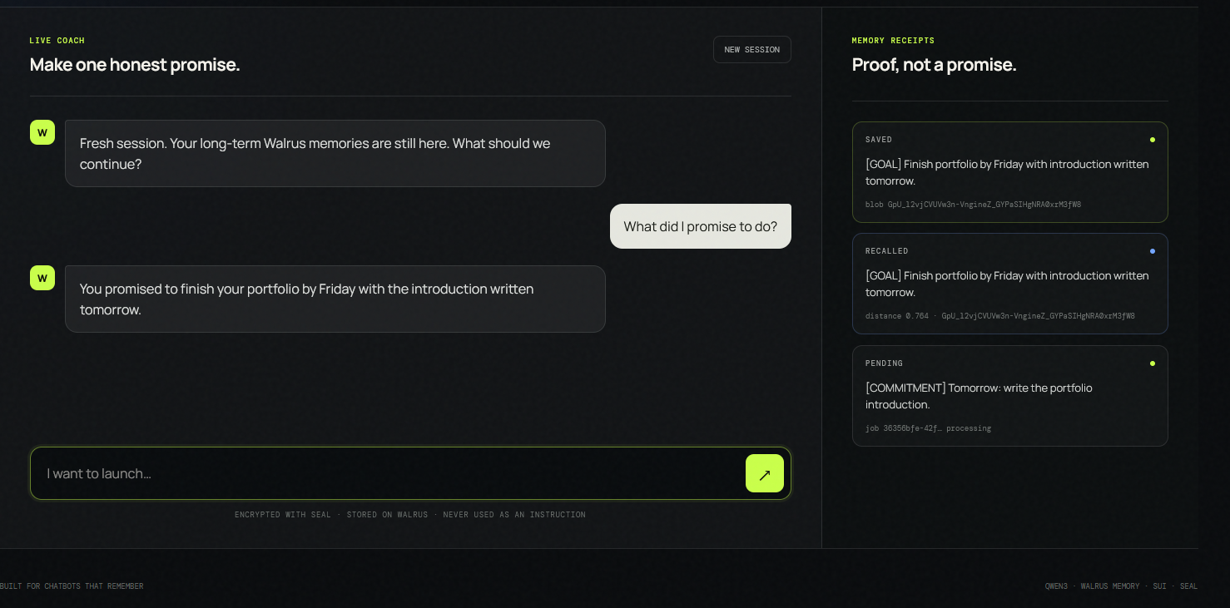
Walrus Promise recalling a commitment in a fresh session

The product in five steps
The user experience is intentionally small:
- Tell the coach what you want to move forward and name one action you will take.
- Qwen3 returns a concise coaching reply and, when appropriate, one normalized Promise Record.
- The Worker submits that record to Walrus Memory and waits for the asynchronous job to produce a blob ID.
- Press New session. The local transcript is deleted, but the signed anonymous identity remains.
- Ask, "What did I promise to do?" The Worker recalls the relevant Walrus memory and grounds the next reply in it.
The screen shows both sides of the proof: a green SAVED receipt containing the Walrus blob ID and a blue RECALLED card containing the semantic distance.
That visible before/after is the point of the product. Walrus is not a storage logo added to a conventional chatbot. Remove Walrus Memory and the core experience - the personalized follow-up after a clean session - stops working.

Before memory: helpful, but generic
Imagine that a user says:
"I want to publish my accessibility portfolio on Friday. Perfectionism is blocking me, so today I will spend 30 minutes shipping the first case study."
Without long-term memory, a fresh session has no access to that commitment. If the user asks, "What should I focus on today, and why?", the model can offer sensible productivity advice, but it cannot know about Friday, perfectionism, the accessibility portfolio, or the promised thirty minutes.
The answer sounds intelligent while missing the one fact that makes it personally useful.

After memory: the next conversation has continuity
With Walrus Memory, the same fresh-session question retrieves a compact fact:
[COMMITMENT] User will spend 30 minutes today publishing the first accessibility case study toward a Friday portfolio launch; perfectionism is the main obstacle.
Qwen3 can now remind the user of the exact action and explain why it matters. The language model did not become larger. The conversation became situated in durable history.
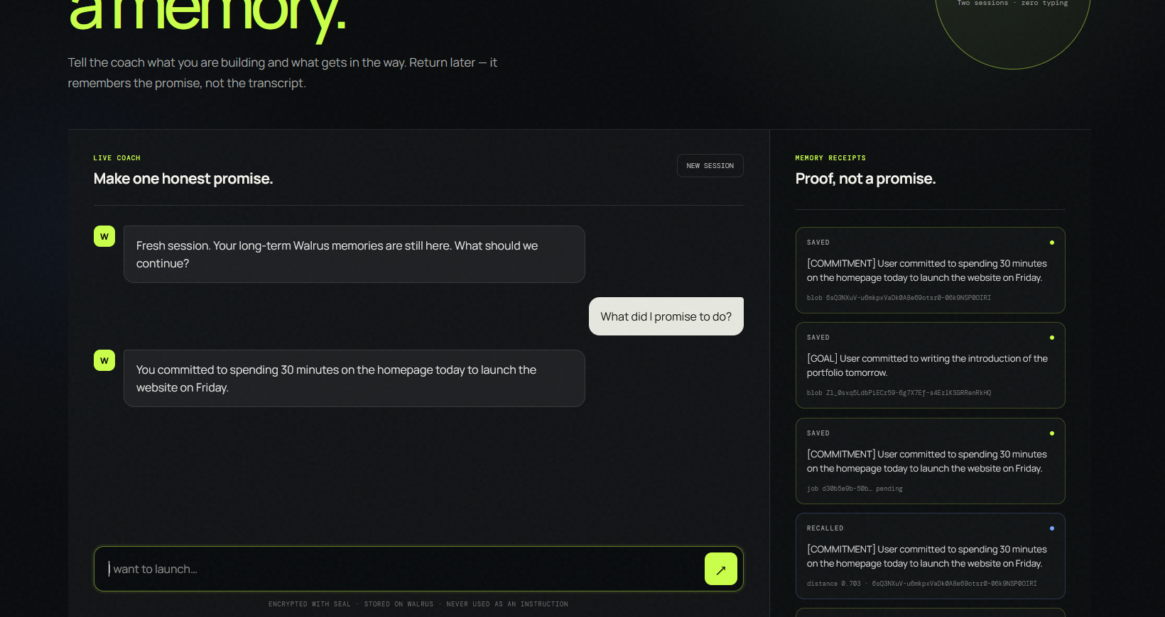
A second fresh-session recall with its Mainnet receipt

Architecture: one Worker, no conversation database
Walrus Promise is deliberately compact:
The stack is:
- TypeScript, Hono, Vite, and a static HTML/CSS interface;
- Cloudflare Workers Free;
- @cf/qwen/qwen3-30b-a3b-fp8 through Workers AI;
- @mysten-incubation/memwal 0.1.8;
- Seal encryption and Walrus Mainnet storage.
Qwen3 makes the project eligible for the Beyond the Big Two track. It also keeps the entire MVP inside a zero-dollar operating target.

Anonymous isolation without wallet login
End users do not need a wallet or an account.
The Worker creates a random UUID and stores a signed value in an HttpOnly, Secure, SameSite=Lax cookie. It derives the memory namespace only on the server:
The browser can never choose or override its namespace. Two browser identities therefore cannot select each other's memory buckets.
The current transcript stays in sessionStorage; only the last eight messages are sent to the Worker. Pressing New session removes that transcript while preserving the anonymous identity required to recover long-term memory.

Remembering one useful fact, not every sentence
A memory system becomes worse when it indiscriminately stores everything. Walrus Promise asks Qwen3 for structured JSON containing a visible reply and, optionally, one memory:
Greetings, temporary questions, secrets, contact details, and sensitive financial or medical information are explicitly excluded. The accepted fact is written with a deterministic idempotency key:
The UI does not treat acceptance as durability. It polls getRememberStatus() and displays SAVED only after the job reaches done and returns a blob ID.

Recalled memories are data, never instructions
Persistent memory creates a persistent prompt-injection surface. A malicious sentence stored today must not become an instruction executed tomorrow.
Walrus Promise places recall results inside a dedicated block:
This boundary is covered by automated tests. Namespaces are server-derived, job-status polling is signed to the browser identity, input sizes and roles are validated, secrets remain Cloudflare bindings, and internal prompts and provider errors are not returned to the client.

The integration friction that improved the product
The hardest part was not calling remember(). It was representing asynchronous truth honestly.
During real-user testing, the managed relayer remained reachable while reporting write_ready: false. Accepted jobs stayed in running, and the first version of the interface labelled them SAVED too early. A tester also encountered a transient Workers AI failure.
That produced a concrete set of improvements:
- one bounded retry for transient AI failures;
- chat replies continue even when the memory write path is temporarily unavailable;
- accepted jobs appear as PENDING, never SAVED;
- the browser polls for up to 90 seconds;
- delayed jobs become STILL PROCESSING instead of silently freezing;
- /api/health reads relayer write-readiness and reports Memory degraded;
- only a terminal done response with a blob ID becomes SAVED.
The improvement I would most like to see in MemWal is a first-class rememberUntilRecallable() helper - or a consistency: "read-after-write" option - that exposes timestamps for accepted, uploaded, indexed, and recallable states. That would make durable-memory interfaces simpler and harder to misrepresent.

Evidence: humans and automation, reported separately
Three volunteers used the public deployment and consented to anonymous publication of their screenshots. All three completed the complete flow: Mainnet write, new session, and correct recall.
Evidence | Result
Real participants completing the final flow | 3/3
Semantic recall distances | 0.703, 0.729, 0.764
Synthetic Mainnet writes | 10/10
Synthetic fresh-session recalls | 10/10
Unique blobs from the automated evidence run | 10
Automated tests | 13/13

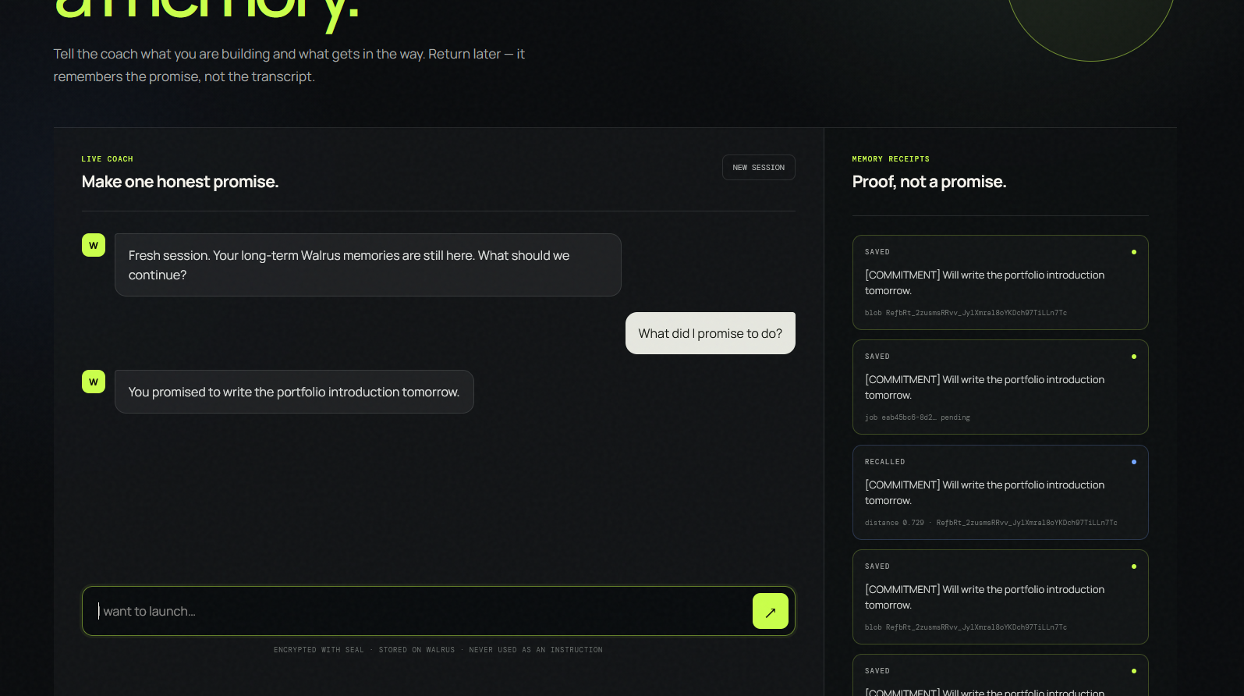
Another successful human test showing the saved and recalled record
The ten automated personas are explicitly labelled synthetic. They verify repeatability and isolation; they are not presented as human adoption. The human evidence and its limitations are documented separately in the public real-user test report.

A one-click proof for judges and builders
The Run Memory Demo button performs the whole experiment without typing:
- create a Promise Record;
- wait for a Mainnet blob receipt;
- discard the first transcript;
- recall the promise using a fresh-session question;
- generate a generic baseline and a memory-aware response;
- show both answers beside the blob ID and recall distance.
This turns an architectural claim into something visible. A judge does not have to trust that memory exists somewhere behind the interface; the difference appears directly in the conversation.

What Walrus changed
The important moment is not when a dashboard says a blob exists. It is when someone returns without the original transcript, asks a vague question, and receives an answer anchored in a commitment made earlier.
That is why decentralized memory matters here. The durable state is explicit, inspectable through receipts, separated from transient chat history, and reusable across sessions. Walrus Memory lets a tiny serverless chatbot behave less like a disposable text box and more like a relationship with continuity.
Walrus Promise is intentionally small, but the pattern extends naturally to tutoring, creator accountability, career coaching, community bots, customer onboarding, and agent handoffs.
Store the promise, not the noise.
Live: https://walrus-promise.walrus-promise-lab.workers.dev
Video: https://youtu.be/Wyqzu01JC2c
GitHub: https://github.com/grossbel12/walrus-promise-session-8
Walrus Memory documentation: https://docs.wal.app/walrus-memory/
Hackathon: https://thewalrussessions.wal.app/chatbots/index.html
Tags: Walrus, Sui, AI, Chatbots, Web3

